1. ACR Respiration



1. ACR Respiration w/ respect to controls



1. ACR Photosynthesis



1. ACR Photosynthesis w/ respect to controls



1. ACR Fv/Fm

two way anova to assess effects of wound, temperature, and interaction of wound~temperature while controlling for timepoint and genotype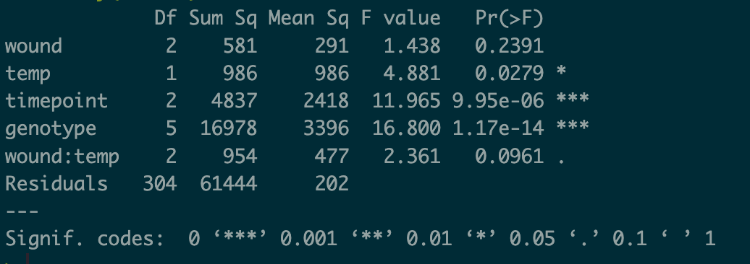

* The "wound" factor does not appear to have a statistically significant effect on the response variable as its p-value (0.2391) is greater than the commonly used significance level of 0.05.
* The "temp" factor, on the other hand, is statistically significant with a p-value of 0.0279, suggesting that it has a significant impact on the response variable.
* The "timepoint" factor is highly statistically significant (p-value: 9.95e-06), indicating a significant effect on the response variable.
* The "genotype" factor also shows a highly significant effect with a very low p-value (1.17e-14), suggesting that it has a substantial impact on the response variable.
* The interaction term "wound:temp" has a p-value of 0.0961, which is marginally significant, indicating that the combined effect of "wound" and "temp" may have an influence on the response variable.

1. ACR growth
2. POR Respiration standardized by nothing (normalized by vol and hour)
3. POR Respiration standardized by initial weight
4. POR Fv/Fm (missing initial timepoint)