**Interpretation of Results**

There are two maps provided, which actually covers geovisualization of the density of the electric vehicle charging stations and also the distribution of population in Berlin. The goal of the analysis is to identify the areas with potential demand for additional EV charging infrastructure, based on the population density and the existing station infrastructure.

### Observations (Charging Stations - First Map):

1. In this map, the density of the electric charging stations across Berlin is highlighted and the regions are color coded according to the concatenation of those stations
2. In particularly central areas, which are the urban areas of Berlin, there is a slightly higher concatenation of the charging stations, which demonstrates that the accessibility is high. These are the red areas.
3. In yellow areas, there are fewer charging stations. These areas are the ones around the center of Berlin and peripheral regions, which suggests that the infrastructure is limited. But it is interesting that the amount of charging stations goes up a bit for some more peripheral areas.
4. An exception are Biesdorf (PLZ 12683) and Mahlsdorf (PLZ 12623) in the east of Berlin, where the highest density of charging stations can be seen. The

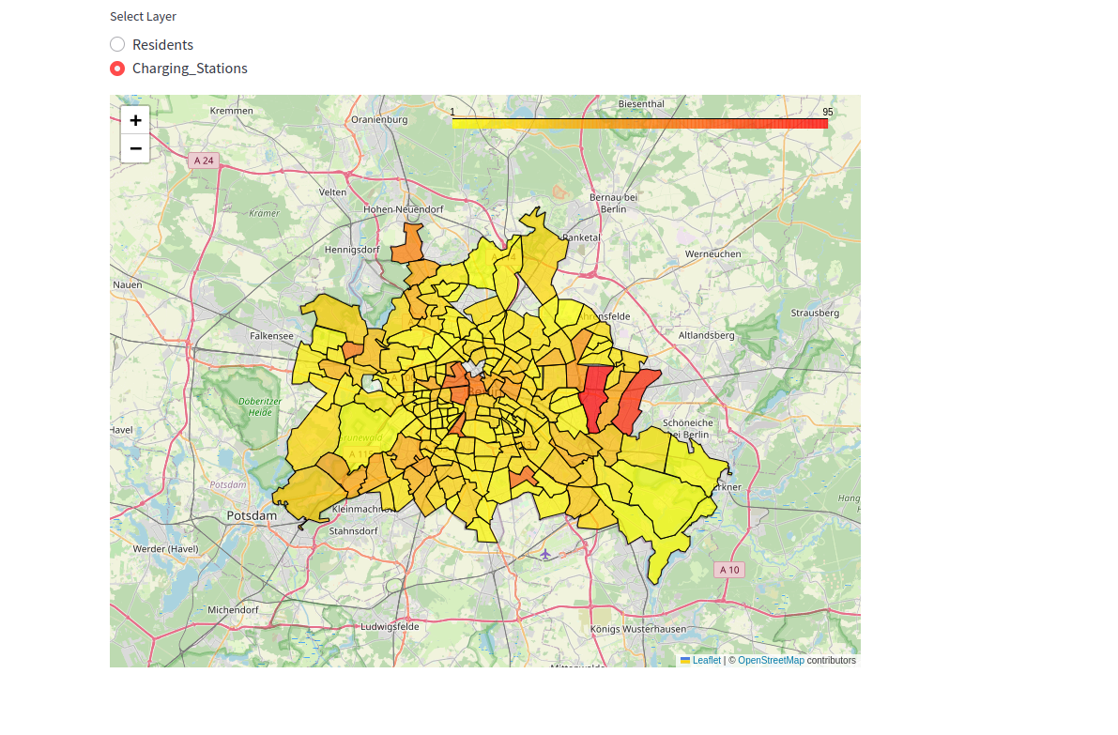

### Residents (Second Map)

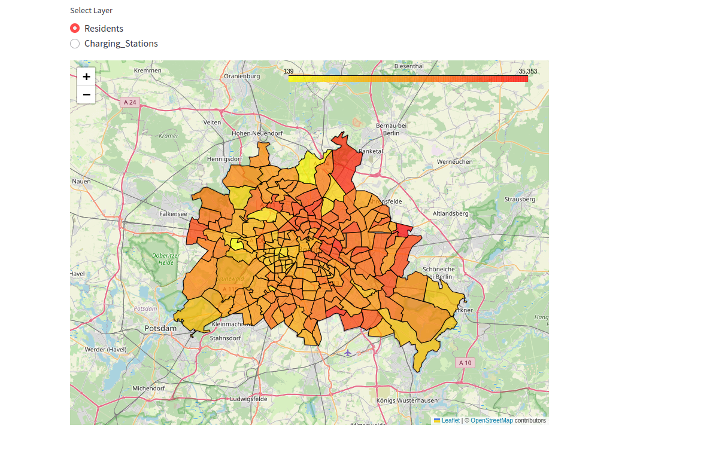

The central Berlin areas are slightly more densely populated (the red areas), which are actually gradually transitioning to lower densities (yellow areas), which are in the outer regions. In general there appear to be more people per squaremeter living in the Northern and Eastern districts of Berlin, especially Karow (PLZ 13125) in the North East has a dark red color. Also in the South East there are some areas that have a higher population density, like Rudow (PLZ 12353).

### The Deep Analysis

For additional charging stations, high demand can be identified as these are areas with high population density, but the number of charging stations are relatively low

An example is:

* Central Berlin Outskirts: The regions which are orange in the population density map, but they are yellow in the charging stations map), the demands here are unsatisfied.
* The regions to northeast or southeast are peripheral regions with sparse station infrastructure, however the moderate population densities indicate the potential demand.
* Due to higher usage in the urban areas, central areas are apparently equipped with the charging stations
* There is less public infrastructure in areas with combination of detached housing and lower population density private charging stations solutions are available.

**Conclusion: Quick Analysis of Maps and Demand For Additional Electric Charging Stations Following Analyzing Both Geovisualizations**

The main conclusions that can be drawn from the visualizations are as follows:

• The northeastern and central parts of Berlin have a high population density, suggesting that there may be a need for EV charging stations.

• The number of available charging stations is demonstrated by the color-coded EV station map. The higher concentration of stations is indicated by the darker red zones.

• In areas where the population is quite dense, the higher density of charging stations on the stations map does not sit well with some parts of the population map. If we talk more specifically, then: ▪ Central Berlin ▪ Northeastern Berlin ▪ Eastern Outer Areas

**Locations Recommended for the EV Stations**

◦ Central Berlin: Despite the existence of some infrastructure, more stations are required to keep up with the population density,

◦ Northeast Berlin: Particularly in areas with a high population density, such as 13057, which appears to be quite less by the number of charging stations currently in place.

◦ Eastern Outer Areas: The identified few regions with modest station coverage and moderate to high population densities.

**According to the visualizations**, the Berlin postal codes listed below seem to need more EV charging stations because of their dense populations and scattered coverage of existing stations:

◦ Neukölln 12043: There is a lot of population living there. Even if there are stations with low to moderate densities, there are not enough of them in relation to the population. Opening new stations has a great number of possibilities.

◦ Falkenberg 13057: Despite having a high population density, this location appears to have less station coverage than it could have.

◦ Mitte 10119, 10178, and 10179: These neighborhoods are densely populated and great number of population is coming. Even though there are now enough stations in comparison to other areas, there are more stations which could surely be added.