
IT342-G5
SYSTEMS INTEGRATION AND ARCHITECTURE 1

FUNCTIONAL REQUIREMENTS SPECIFICATION (FRS)

Project Title:
Prepared By: Niña Isabelle C. Tupas
Date of Submission: May 5, 2026
Version: 1

Table of Contents
1. Introduction 3
1.1. Purpose 3
1.2. Scope 3
1.3. Definitions, Acronyms, and Abbreviations 3
2. Overall Description 3
2.1. System Perspective 3
2.2. User Classes and Characteristics 3
2.3. Operating Environment 3
2.4. Assumptions and Dependencies 3
3. System Features and Functional Requirements 3
3.1. Feature 1: 3
3.2. Feature 2: 3
4. Non-Functional Requirements 3
5. System Models (Diagrams) 4
5.1. ERD 4
5.2. Use Case Diagram 4
5.3. Activity Diagram 4
5.4. Class Diagram 4
5.5. Sequence Diagram 4
6. Appendices 4

Introduction

Purpose
This document defines the functional requirements of the Wildcat’s DEN system. It serves as a guide for developers, designers, and stakeholders to understand the expected behavior and features of the system.

Scope
Wildcat’s DEN is a web-based and mobile-supported venue booking system designed for students, faculty, and event organizers within CIT-U. The system allows users to browse venues, check availability, and book venues efficiently. It also provides administrative tools for managing venues and bookings.

Definitions, Acronyms, and Abbreviations
- API – Application Programming Interface
- JWT – JSON Web Token
- CRUD – Create, Read, Update, Delete
- UI – User Interface
- UX – User Experience

Overall Description

System Perspective
The system follows a three-tier architecture consisting of:
- Frontend (React Web and Android Mobile App)
- Backend (Spring Boot API)
- Database (PostgreSQL)

User Classes and Characteristics
- Students – Basic users who can browse and book venues
- Faculty – Users with similar privileges as students
- Organizers – External users who manage event bookings
- Administrators – Manage venues, bookings, and users

Operating Environment
- Web browsers (Chrome, Firefox, Safari, Edge)
- Android devices (Android 7.0+)
- Backend server (Spring Boot)
- PostgreSQL database

Assumptions and Dependencies
- Users have internet access
- System relies on REST API availability
- Database server is continuously accessible
- Authentication depends on JWT tokens

System Features and Functional Requirements
Describe each major feature of the system and its functional requirements.

Feature 1: User Authentication
Description: Allows users to register, log in, and log out securely using email and password.
Functional Requirements:
- Users can register with email, password, first name, and last name
- System validates email format and password strength
- Users can log in using registered credentials
- System generates JWT tokens upon successful login
- Users can log out and terminate their session

Feature 2:
Description: Enables users to browse venues, check availability, and book venues. Administrators manage venues and bookings.
Functional Requirements:
- Users can view a list of available venues
- Users can search and filter venues
- Users can view venue details (capacity, amenities, schedule)
- Users can submit booking requests
- System validates booking availability
- Users can view booking history and cancel bookings
- Admins can approve or decline bookings
- Admins can add, edit, and delete venues

Non-Functional Requirements
- Performance:
  - API response time ≤ 3 seconds
  - Supports at least 100 concurrent users
- Security:
  - HTTPS encryption
  - JWT authentication
  - Password hashing using bcrypt
- Usability:
  - Easy navigation across pages
  - Responsive design for web and mobile
  - Clear error messages
- Reliability:
  - System uptime should be high
  - Database consistency maintained
- Compatibility:
  - Works across modern browsers and Android devices

System Models (Diagrams)

ERD
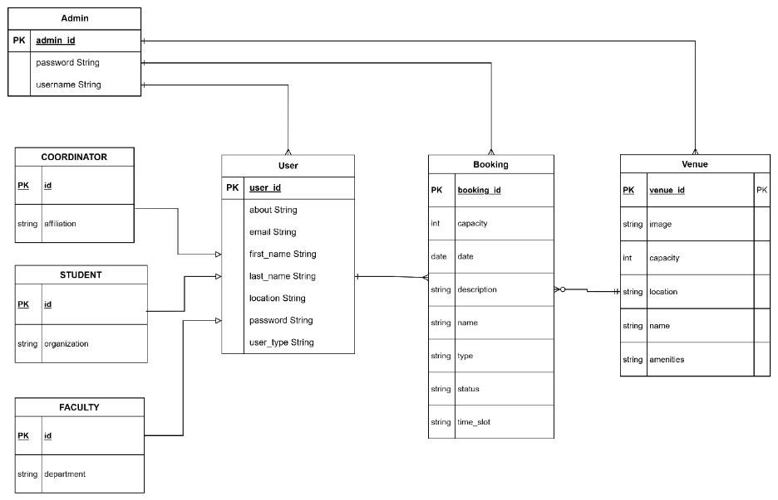

Use Case Diagram
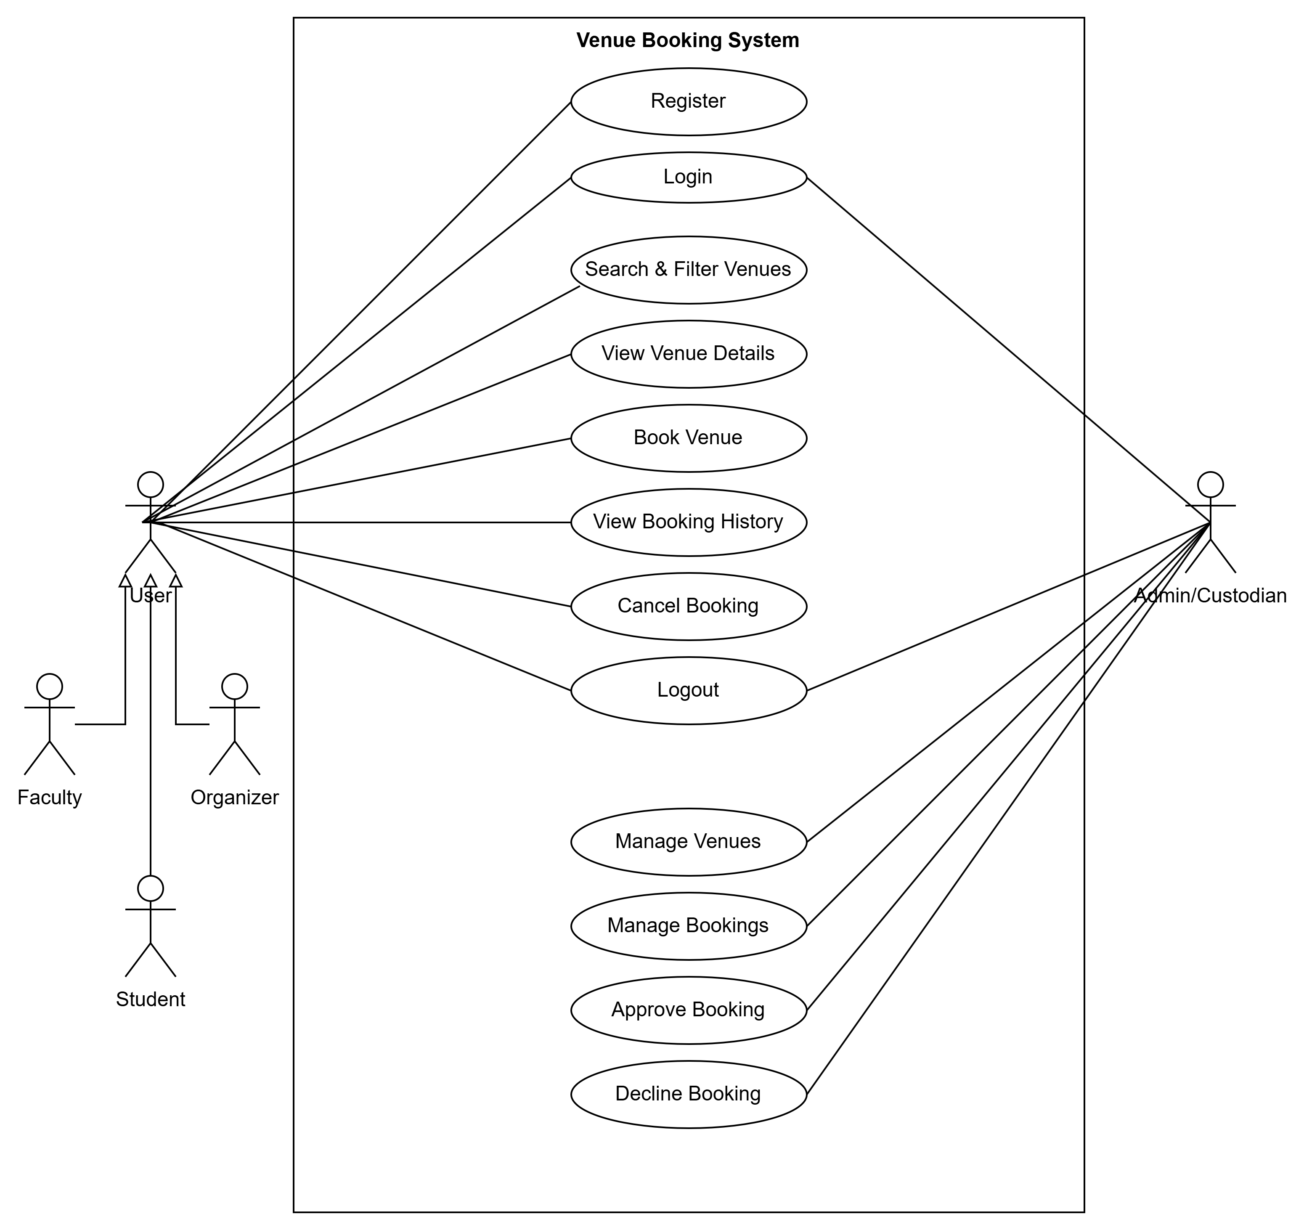

Activity Diagram
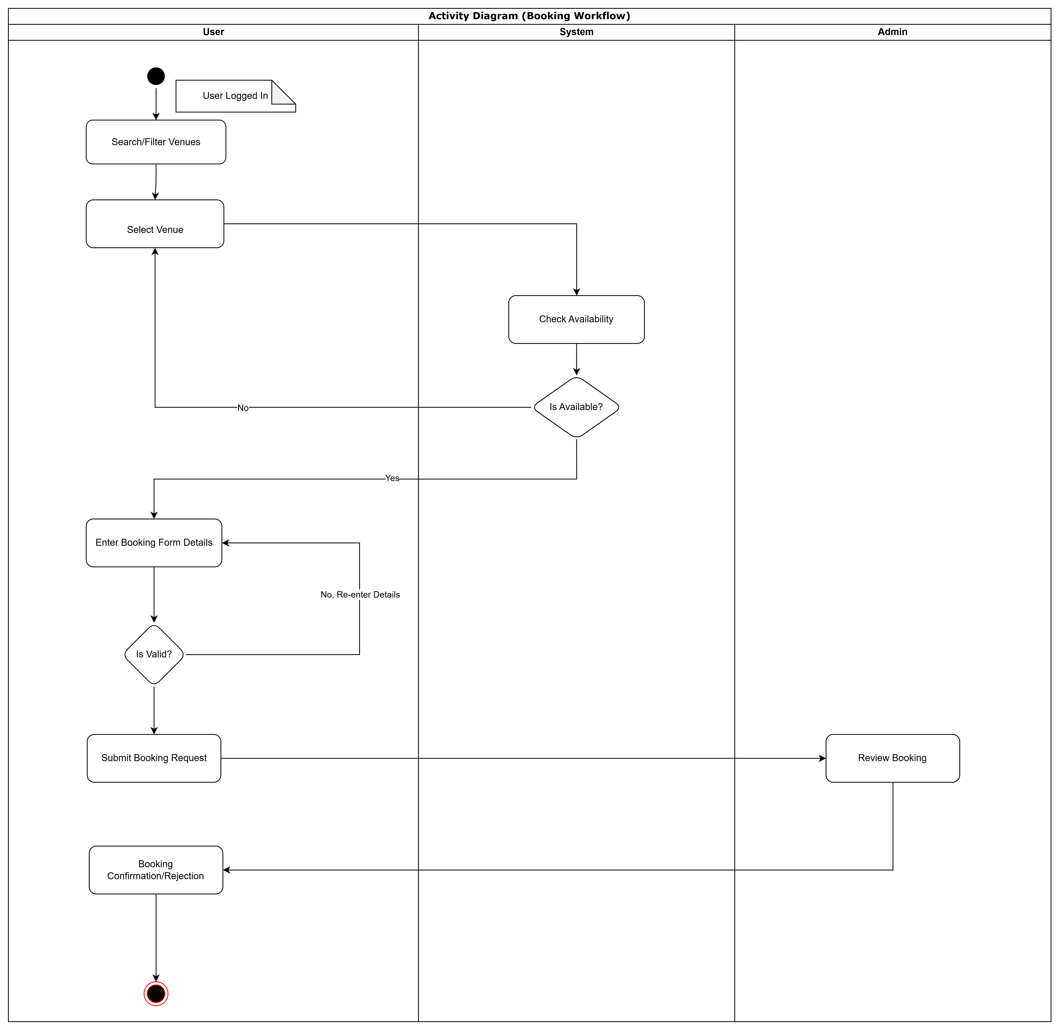

Class Diagram
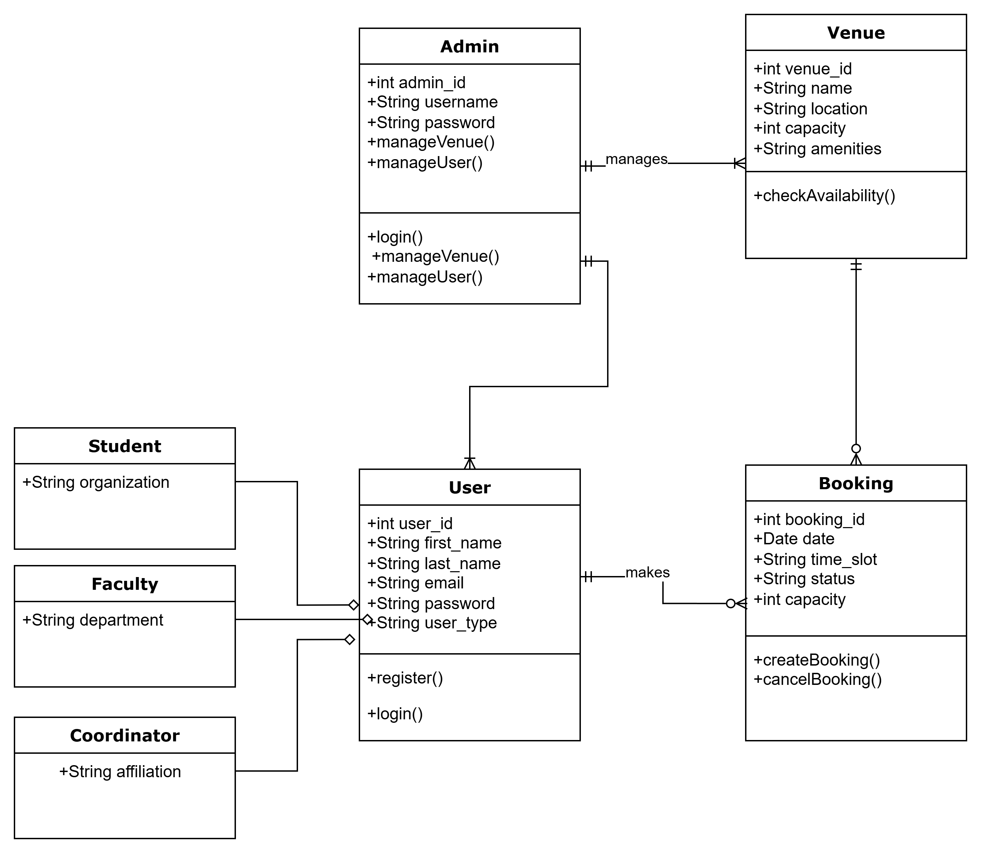

Sequence Diagram
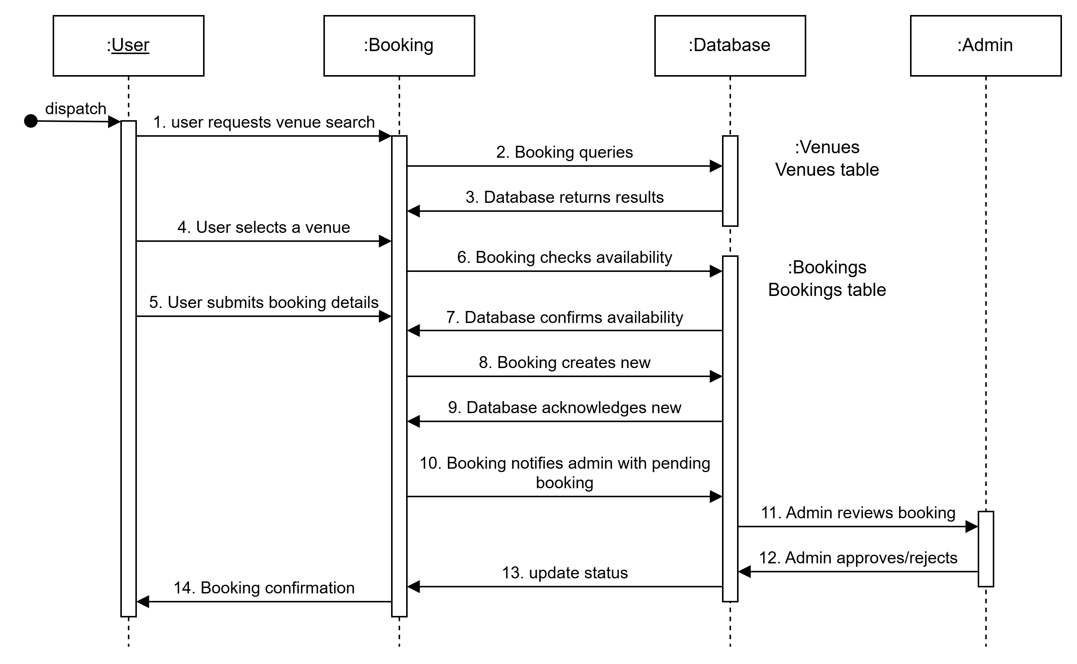

Appendices
WEB UI
- Register/Signup
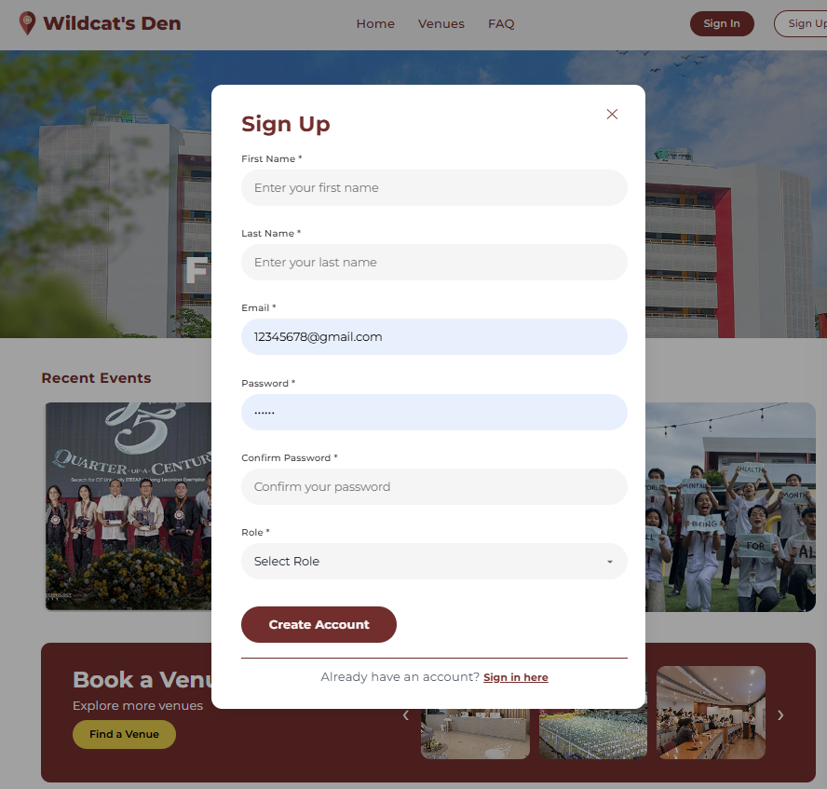
- Login/Signin
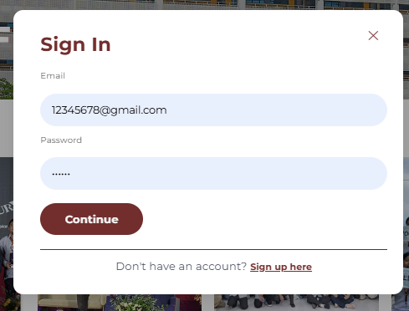

- Profile
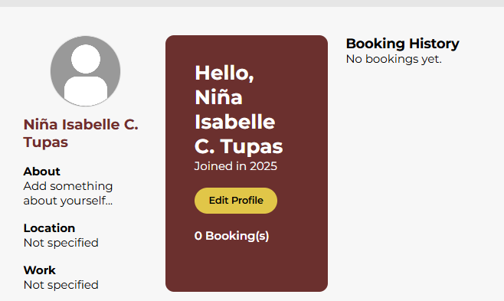

- Logout
