1. Download save the file to the designated folder.

HPK_HEDA_Public-main.zip

1. Unzip HPK_HEDA_Public-main.zip. Open HEDA folder. Double click HEDA.Rproj

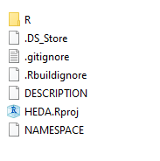

1. R studio will open automatically. Browse the top-right pane and click Build tab. Under Build tab, click Install and Restart. Then HEDA package is installed and called by library function.

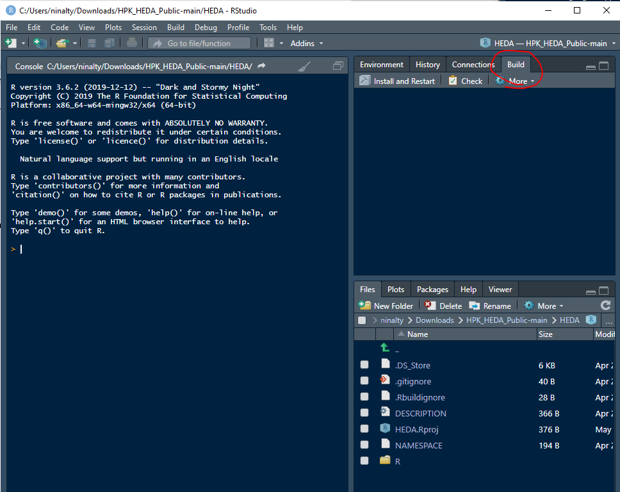

1. Before working on HEDA, four external packages are requested: dplyr, ggplot2, zoo and lubridate.
2. Once all the package are downloaded and called, open the test.R file. As for how each function is designed please read HEDA User Manual.pdf.