**Sprint 2 – Dolphin handoff**

Run Example:

Using the sample scripts from Professor Lundeen’s examples, the screenshots of the results are below.

Milestone 3:

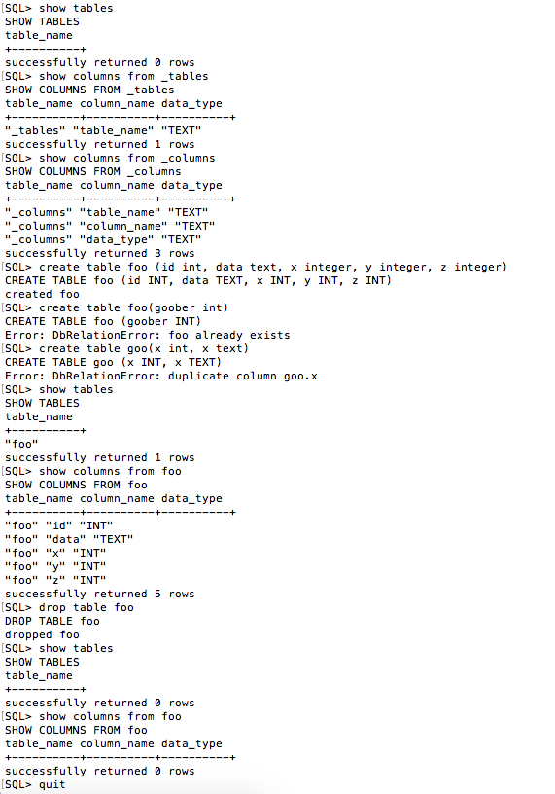

Milestone 4:

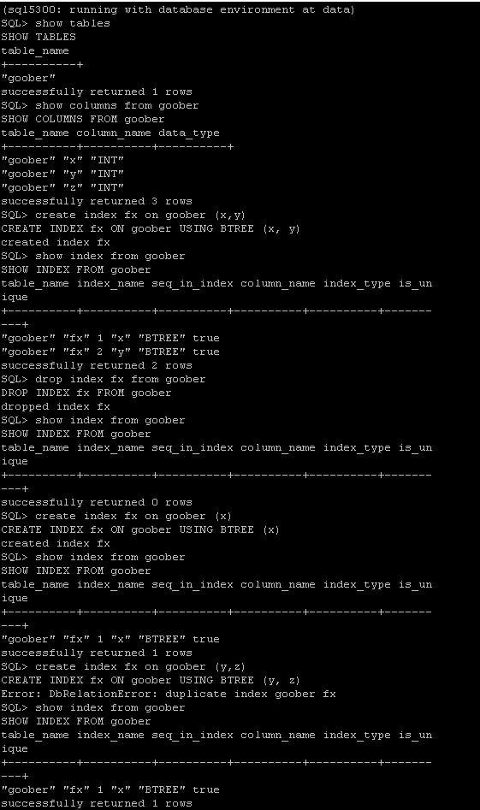

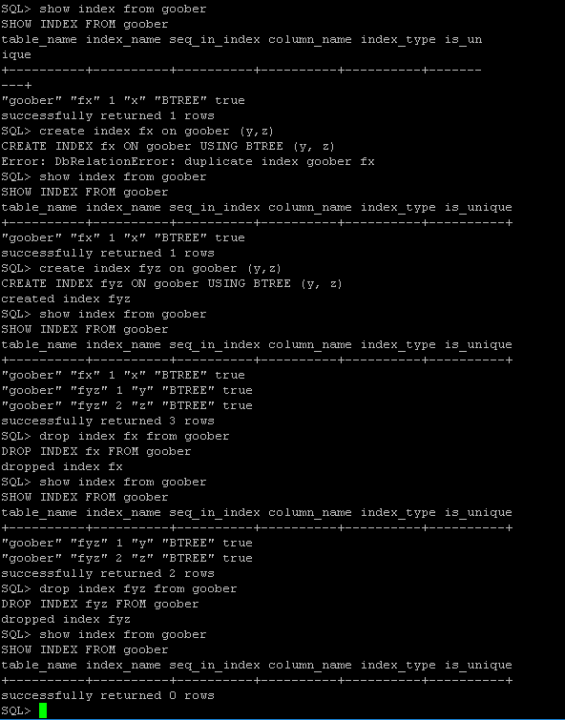

Overview: The program takes in an SQL command from the user and the main class take this command and call SQLParser to validate and break down the components for the parse tree. SQLExec takes data from the parser to execute the SQL statement.

For both tables and indices, there are three commands (Create, Show, Drop)

Once an appropriate command was selected, the SQLExec talks with schema_tables, heap_storage and DbIndex. The schema tables in schema_tables and Berkeley Database through heap_storage. In schema_tables there are three main classes (Tables, Columns, and Indices)

In milestone 3,

* Create_table keep information in the schema table consistent with the database. If there is an error, it is important for the function to roll back the rows.
* Drop_table slightly different in Milestone 3 and Milestone 4. It has an order that must be executed each time. Remove metadata of columns from table in _columns, remove the table, remove the metadata in _tables schema
* Show_tables just output the tables that we currently have in our database. It does not output the names of the schema tables (_tables, _columns).
* Show_columns output the columns that are associated with the table specified by the user.

In milestone 4:

* Create_index retrieve the underlying table, make sure that all the index columns exist in the table, insert a row for each column into _indices, get reference to the new index, and then create the index. For this milestone, the system just creates a dummy index.
* Drop_index use get_index to get a reference to the index and then drop the index. Index have to be drop first before dropping schema entries.
* Show_index just output (Table Name, Index Name, Column Name, Sequence in Index, Index Type, Is Unique). Index type should be BTREE.
* Drop_table removes any indices associated with the table, then drops the table. It has an order that needs to be executed. First, drop each index and remove the metadata of indices in _indices, remove metadata of columns of table in _columns schema, remove the table and then remove metadata of the table in _tables schema