Data analysis and visualization on Water Resources in China with Python

Chun-te lee
School of Mathematical Sciences, College of Science and Technology, Wenzhou-Kean University, Wenzhou, China
yue pan
Department of Mathematics, College of Science and Technology, Wenzhou-Kean University, Wenzhou, China

Abstract: According to recent water resources survey data, China’s water resource utilization has reached the poor level. This paper is aimed to analyze the current situation and characteristics of water resources in China. By our analysis, the total amount of water resources is rich, but the per capita share is low and regional precipitation distribution is uneven. In addition, the water and soil resources are not matched and the contradiction between supply and demand of water resources is seriously in disagreement. We perform the Linear and nonlinear regression models to find the relationships between time, precipitation, water resources and water consumption. Finally, we resort to the time series model to predict the total amount of water resources and water resources utilization in the next three years.
Key words: China, precipitation, water resource, water consumption

- Introduction
Water resources are the most commonly needed resources and one of the controlling factors of the ecological environment. At the same time, it is a strategic economic resource and an organic part of a country’s comprehensive national strength [1]. Against the backdrop of rapid population and economic growth, it can be seen that the global water consumption has been increased rapidly (see Fig. 1). China’s water resources problems are very prominent, such as water shortages and the high imbalance between water resources and agriculture between North and South, and the increase in water consumption and the deterioration of the environment have become important factors restricting my the country's social and economic development, and have received great attention from the government and society [3].
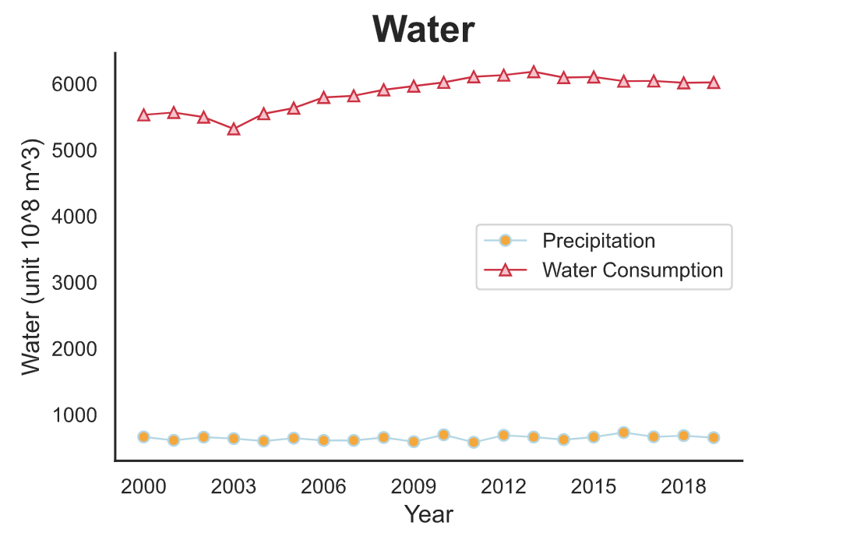
Figure 1

- Data Analysis on Water Resources

Data Selection: Collected data from Data China and Ministry of Water Resources of the People's Republic of China which can provide reliable and accurate data.

- Status and main characteristics of water resources in China
According to the data provided by the Ministry of Water Resources of the People's Republic of China, the average precipitation of China in the past 20 years is 646.215 mm, and the total annual average water resources of surface water and groundwater renewed through water cycle is 2746.3 billion cubic meters. China's water supply mainly comes from surface water (see Fig. 2), which provides drinking water for nearly 70% of China’s population and irrigation for about 40% of agricultural land. Due to the mutual conversion and replenishment of surface water and groundwater, the amount of groundwater resources that does not overlap with river runoff is about 0.11 trillion cubic meters.
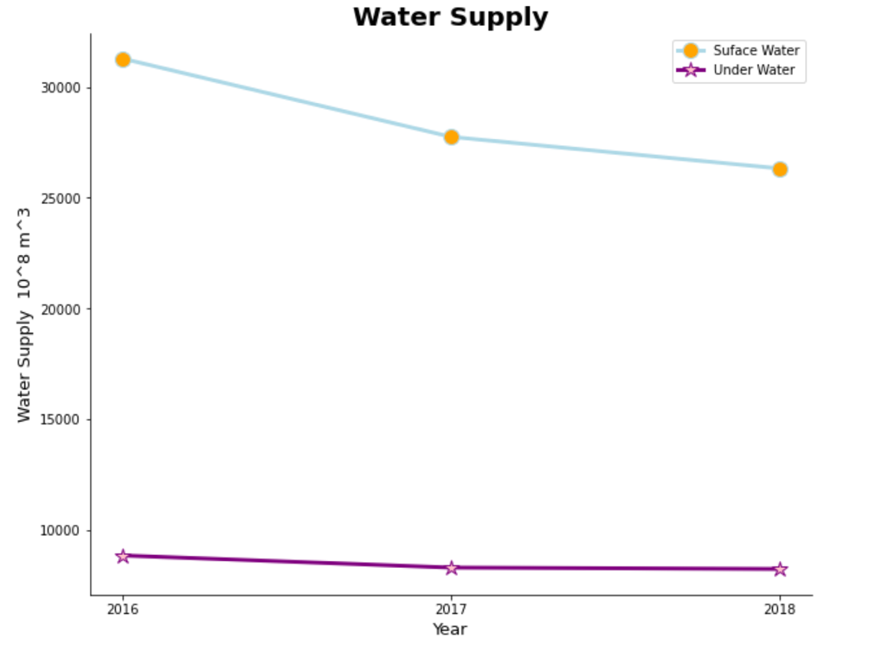
Figure 2: Water supply composition
From our data visualization, China's water resources and utilization may show the following characteristics:
- The total amount is abundant, but the per capita share is low. In the last 20 years, due to environmental changes, such as changes in land use and cover caused by climate change and human economic activities, precipitation and total amount of water resource in mainland China fluctuated and decreased slightly (see Fig. 3 and Fig. 4). The precipitation in northern China (such as North China, etc.) shows a significant downward trend. The per capita share of water resources is 2,200 m^3, which is about a quarter of the world per capita, ranking 110th in the world and listed as one of the 13 water-poor countries in the world.
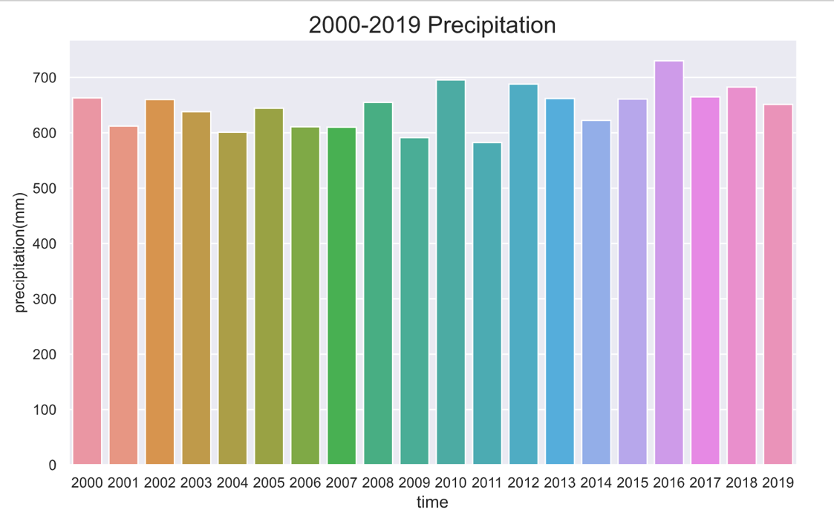
Figure 3: Precipitation
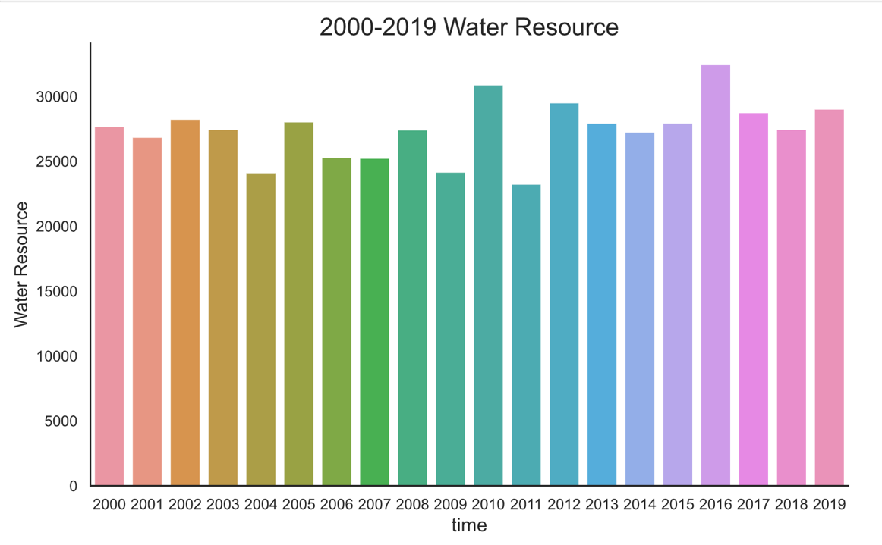
Figure 4: Water Resource
- Highly uneven distribution of water and agriculture between the North and the South. China's total water consumption is about 586.7 billion cubic meters, including 62% for agriculture, 21% for industry, 14% for domestic and 3% for other use. Based on the plot, it indicates that more and more water is being allocated to urban demand than ever before (see figure 5).
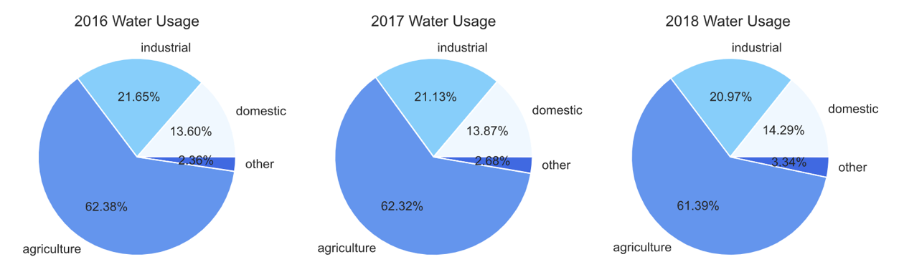
Figure 5:Sources of Demand

Through data visualization of the data in 2018 (see Fig. 6), precipitation in China is concentrated in the southeast coastal part.
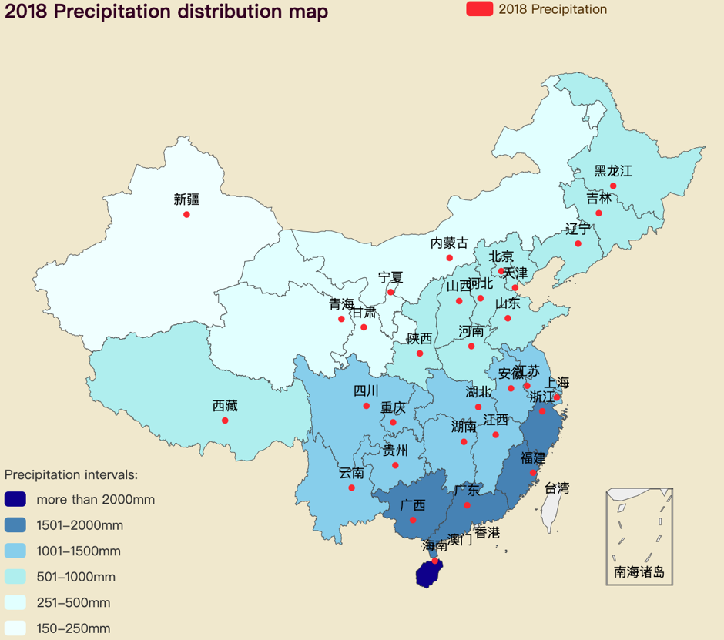
Figure 6: 2018 Precipitation

From Fig. 7, we can see that water resources are mainly distributed in the south, of which Tibet and Sichuan in the southwest have the most abundant total water resource.
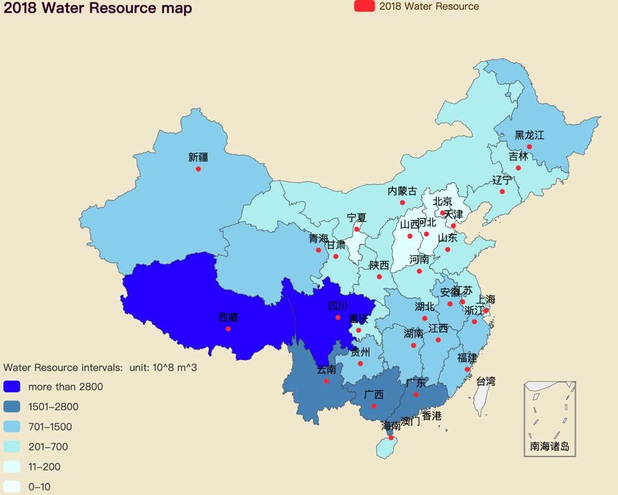
Figure 7: 2018 Water Resource Distribution Map
However, according to our figure, there are serious water shortage lines in Beijing, Tianjin, Hebei, Shanxi, Shandong, Henan, Ningxia and other regions. The reservoirs in central and southern China have large water storage capacity, among which Hubei, Yunnan and Guangxi province have the largest water storage capacity (see Fig. 8 )
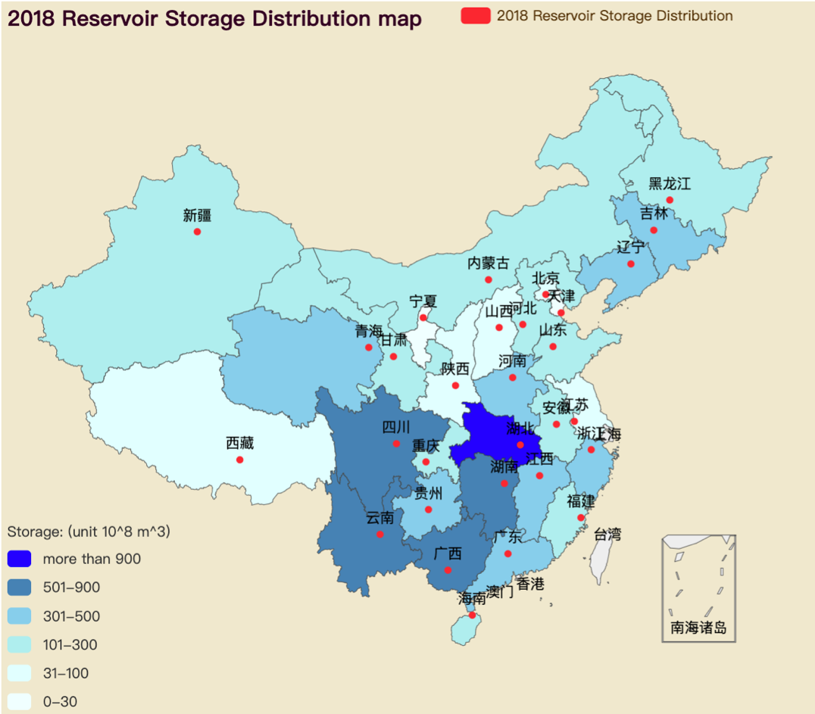
Figure 8: 2018 Reservoir Storage Distribution Map
Here we note that the water consumption in eastern China exceeds that of any other regions, especially provinces such as Jiangsu, Guangdong and Xinjiang (see Fig. 9 ).
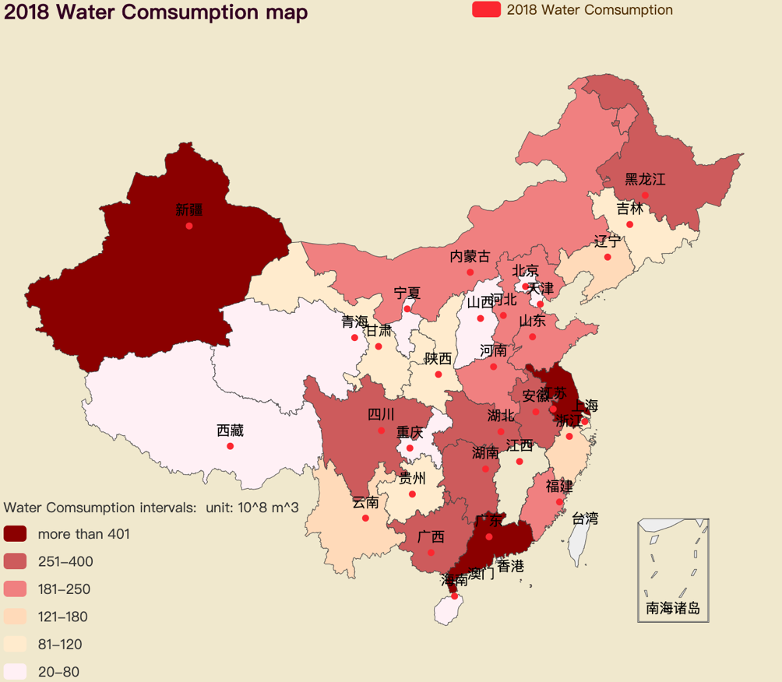
Figure 9: 2018 Water Consumption Distribution Map
We found that the land area of ​​the Yangtze River Basin and its southern region only accounted for 36.5% of the country, while its water resources accounted for 81% of the country. The arid North China Plain and its northern regions include many important agricultural provinces in the country, accounting for 63.5% of the country's water consumption, but its water resources only account for 19% of China's total water resources. The imbalance in the spatial distribution of water resources in China and the differences in population, arable land and resources are the characteristics of the mismatch of water resources, population and arable land resources in China.

- Correlation between precipitation and total water resources
- The data set contains multiple quantitative variables, and the purpose of analysis is usually to correlate these variables. To explore the relationship among time, precipitation, total water resource and total water consumption, I chose the function pairplot() function in Seaborn library to analyze the dataset, which can be used to plot multiple pairwise bivariate distributions in a dataset. (see Fig. 10 and Fig. 11)
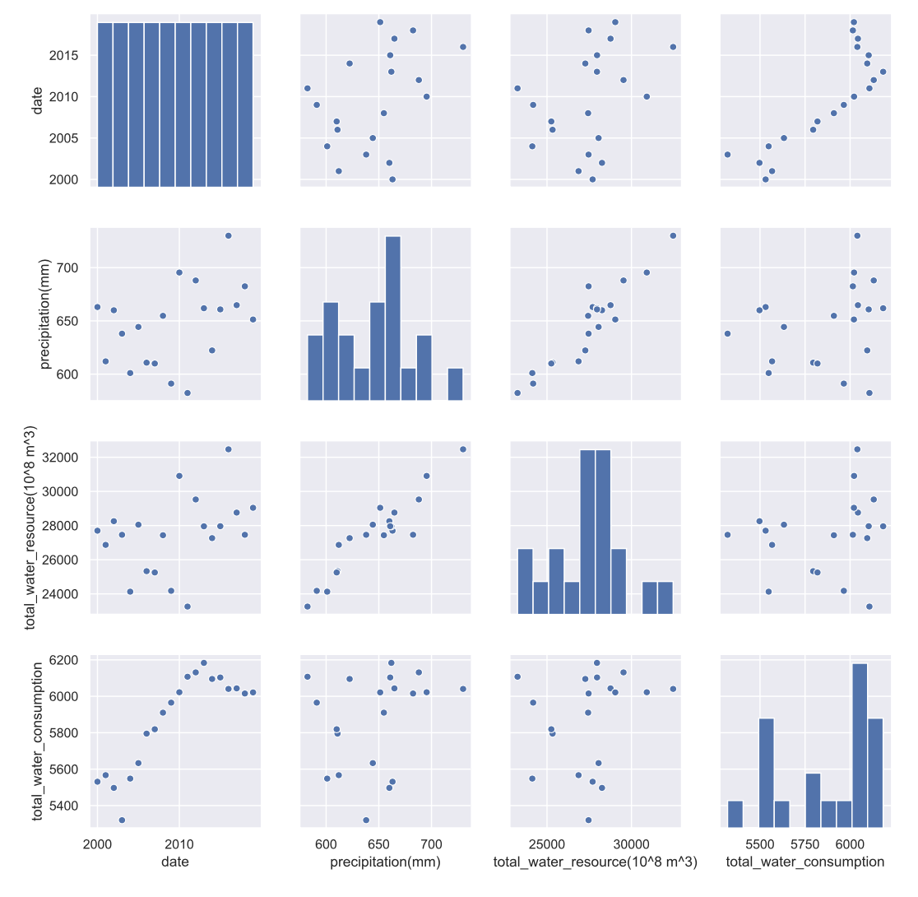
Figure 10: Correlation Plot

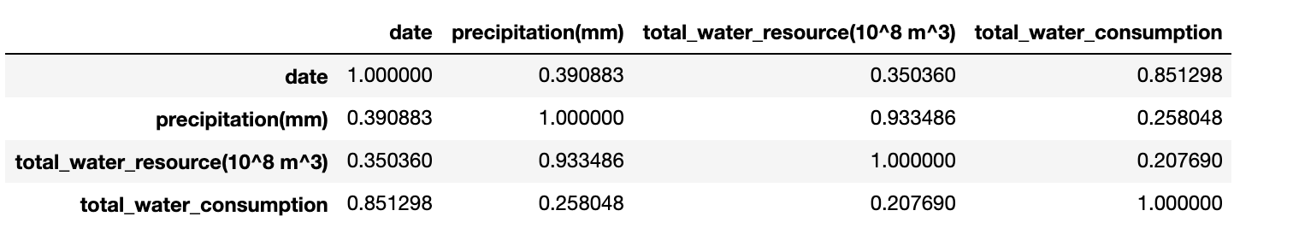
Figure 11: Correlation table
According to the results, we can see that there is a strong linear relationship between precipitation and total water resource, and there is also a correlation between date and total water consumption. I would analyze them case by case.

- Precipitation vs. total water resource:
In the original data, we recorded the total amount of precipitation and water resources in China for the past 20 years. These 20 pieces of data are divided into two parts: one part is used as training set to create regression model, and the other part is used as test set to verify the results of regression model. In a random sense, 40% of the 25 records were selected as the test set and the other 60% as the data of the training set. The training set data is substituted into the linear regression model to calculate the key parameter values, so as to calculate the slope value and slope in the regression model, and meanwhile calculate R square [2].
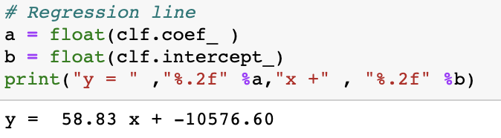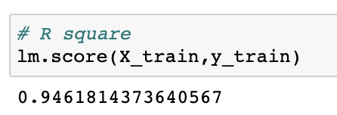
Then, the regression model was evaluated, and the independent variables in the test set were substituted into the regression model by using the test set data, and the results were compared with the dependent variables in the test set to evaluate the accuracy of the model. By comparing the differences between the two groups of data, we can see that the model is basically accurate, and allowed to draw a scatter plot.

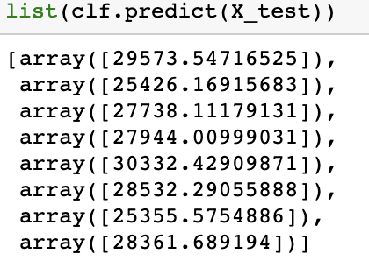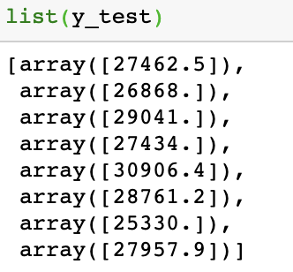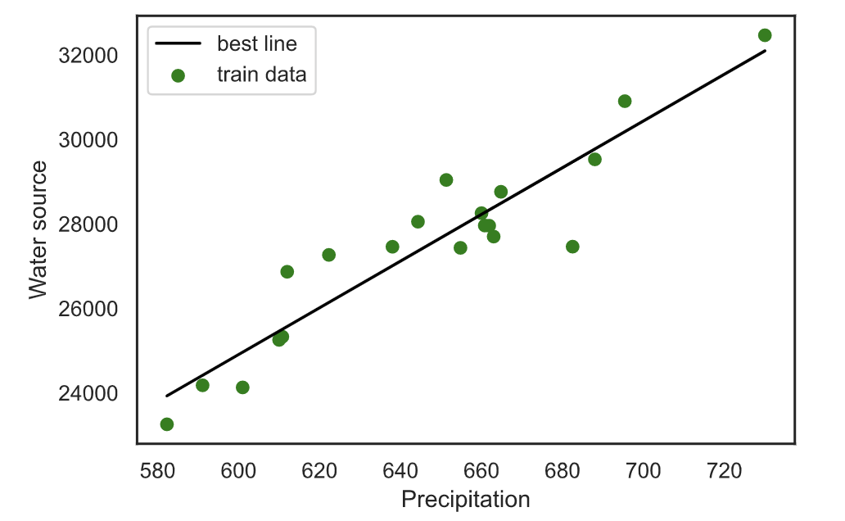
Figure 12: Scatter Plot
- Date time vs. total water consumption
As the previous Pair plots showed (see Fig. 10), there is no obvious a linear correlation between time and total water consumption. The greatest advantage of polynomial regression is that the measured point can be approximated by increasing the higher order term of x until it is satisfied. Next, I will select a relatively fit curve, used PolynomialFeatures method to linearize the nonlinear equation, and then fit it according to the method of linear regression. I establish the quadratic polynomial regression model and the cubic polynomial regression model, so as to get the most appropriate regression model through comparison. It can be seen from the fitting images that the cubic polynomial regression(degree = 3) model has a better fitting effect.(see Fig. 13)
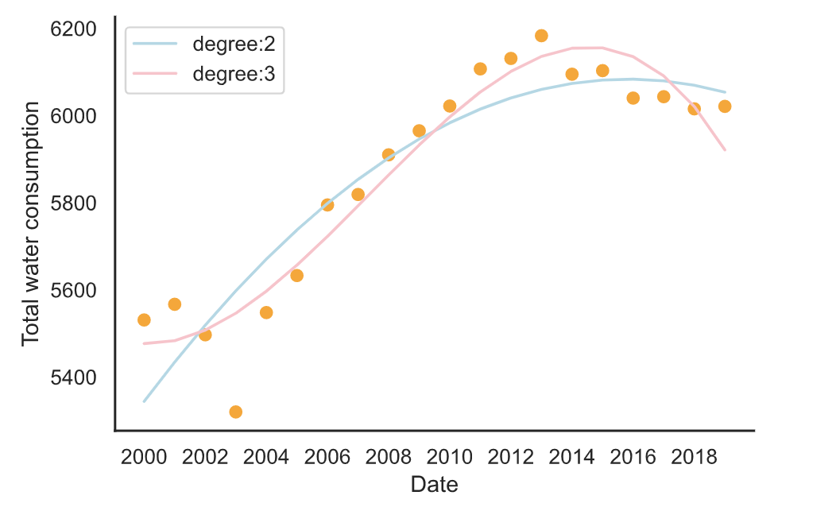
Figure 13

3. Prediction for total water resource
- Based on a dataset on total water resources over the last 20 years, we build time series data between 2000 and 2019, set ARM(3,0) model, imported time series data and used fit function to fit. Then the data between 2020 and 2022 were predicted, and finally the prediction results were plotted. (see Fig. 14)
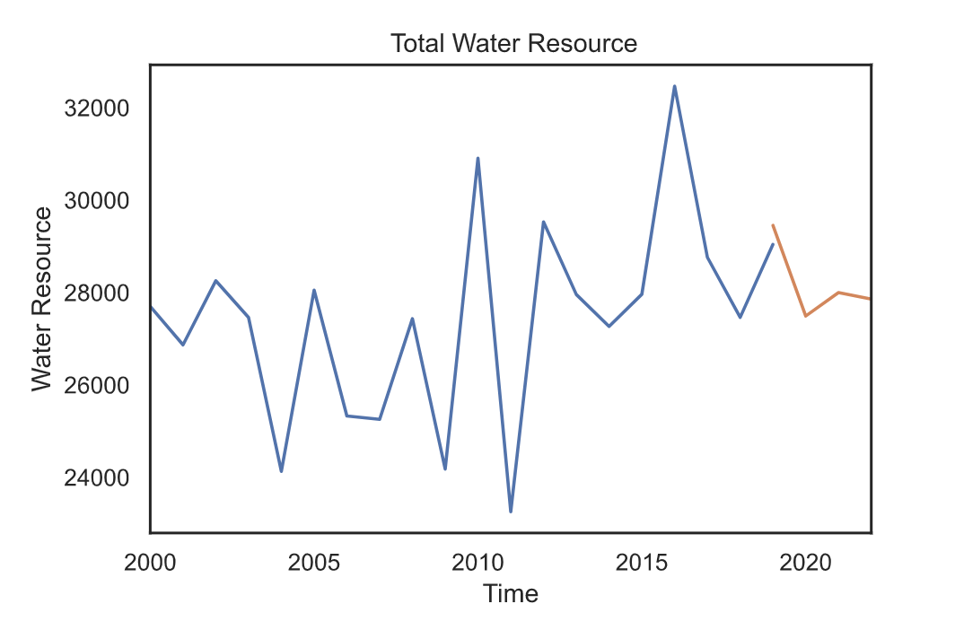
Figure 14: Prediction for Water Resource in next 3 years

- Total water consumption over the last 20 years
We use time series data between 2000 and 2019, and utilize ARM(3,0) model, imported time series data and used fit function to fit. Then the data between 2020 and 2022 were predicted, and finally the prediction results were plotted.
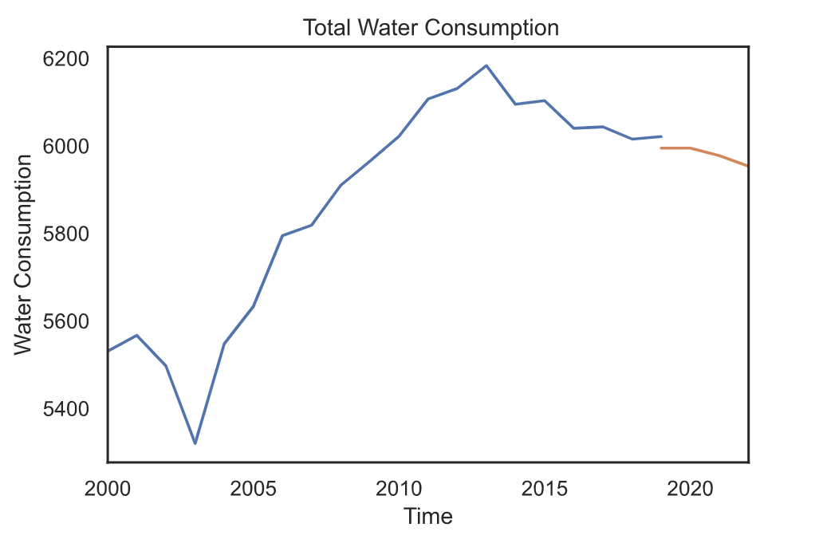
Figure 15: Prediction for Water Consumption in next 3 years
Final Prediction Results:
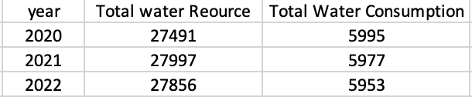

- Conclusion
Although the total amount of water resources in China is rich, the regional distribution is uneven, and the water and soil resources are not matched. The development and utilization of water resources in some northern areas have exceeded the carrying capacity of resources and environment, however, the total water consumption will not decrease. The situation of water resources is very serious. The sustainable utilization of water resources in the whole country has become the main restricting factor of the national sustainable development strategy. Therefore, in the 21st century, China must carry out large-scale reform and powerful measures, save water and improve water use efficiency [4] so as to alleviate the contradiction between supply and demand of water resources and realize the sustainable development of economy and society.

- References:
- Benestad et al., 2016 R.E. Benestad, D. Nuccitelli, S. Lewandowsky, K. Hayhoe, H.O. Hygen, R. van Dorland, J. Cook Learning from mistakes in climate research Theor. Appl. Climatol., 126 (3–4) (2016), pp. 699-703, 10.1007/s00704-015-1597-5

- Brodaric and Piasecki, 2016 B. Brodaric, M. PiaseckiEditorial: water data networks: foundations, technologies and systems, implementations, and uses. J. Hydroinf., 18 (2) (2016), pp. 149-151, 10.2166/hydro.2016.000

- Ellison D, et al. (2017) Trees, forests and water: Cool insights for a hot world. Glob Environ Change 43:51–61

- Peiyue Li & Hui Qian (2018) Water resources research to support a sustainable, China, International Journal of Water Resources Development, 34:3, 327-336, DOI: 10.1080/07900627.2018.1452723

