12/09/2026
10.00 am
Design direction: Portfolio of a Creative Developer/Technical Artist
Motivation: Professional portfolio + creative journal + project case study (lab)
G5 Requirements - Four pages:
- Home - hero, introduction & gallery - 3×3
- Work samples - video, images, descriptions
- About - Skills & Experience - acquisition timeline
- Contact - contact form + contact/social information

Colour Palette:
Rules:
- Use the defined primary, accent and secondary colors consistently.
- Use non-pure white background and text colors throughout all pages.
- Do not introduce new colors without a clear purpose.
- Maintain sufficient contrast between text and backgrounds (dark vs light).

PRIMARY / DARK
#172033 Navy
- headings
- navigation
- footer
- primary text
ACCENT
#FF6B4A Coral
- buttons
- active navigation
- important highlights
- hover states

SECONDARY
#3B82F6 Blue
- links
- secondary highlights
- timeline markers

BACKGROUND
#F7F4EE Warm off-whitte
MUTED TEXT
#667085 Secondary text

Typography:
Rules:
- Georgia is reserved for major headings or emphasis.
- Arial is used for body text, navigation, forms, buttons, other elements in general.
- Heading hierarchy must remain consistent across all pages.
- Body text should remain within the established readable size range.

- Titles (h1, h2, etc): Georgia
- Body (p, aside, button, nav, a, etc): Arial

Font Sizes:
H1
Large / 48–72px desktop
32–40px mobile
H2
32–44px desktop
24–32px mobile

H3
20–24px
Body(p)
16–18px

Small text
14px

Line height
Body: 1.5–1.7
Headings: 1.1–1.2

Spacing:
Rules:
- Use the established spacing scale rather than arbitrary values.
- Maintain consistent spacing between headings, paragraphs, cards and sections.
- Page sections should have consistent vertical rhythm.

3XL 8rem
2XL 5rem
XL 3rem
L 2rem
M 1.5rem
S 1rem
XS 0.5rem
2XS 0.2rem

Section → Section 5rem
Heading → paragraph 1.5rem
Card → Card 1.5rem
Button padding 1rem

Page padding 5vw

HOME:
- Introduce who I am, what I have created, purpose of the site (portfolio)

SAMPLES:
- 9x9 gallery – which will be used as menu to my work samples, from past courses, jobs and personal projects
- Sections with images, videos and explanations

ABOUT:
- Timeline with my school and work trajectory
HS > uni > teaching tutor > FP > job > Masters > job x4
CV info

CONTACT:
Form: name, email, subject, message, submit

variables → global typography → navigation → buttons → cards → forms → grid → responsive rules → page-specific styles.

HTML component and Layout:
Rules:
- First divide the HTML in section, like boxes that contain smaller boxes which contain different elements as well. Organised HTML ex. main > section > h1, img, p
section > nav > img, ul > (li>a*3)
- <nav>: will be used for the primary site navigation (menu) , it will contain a group of navigation links (<a>) that allow visitors to move between the four pages – will provide consistent navigation across all the pages.
- <main>: will be used for primary content of each page. This helps assistive technologies distinguish the main page content from navigation and footer content.
- <footer>: will be used to assist navigation at the bottom of the website, suggest a visit to my social media or related links attached to my work, and show website owner and creation date.
- <section>: will be used to separate independent elements within the main content, it will contain other elements such as headers, sub headers, paragraphs, images or videos.
- <ul>: unordered lists will be used to encapsule related elements, such as the navigation links, images, etc. <li> elements are placed inside.
- <button> elements use the same shape, padding, border, etc.
- Gallery cards share the same structure: section > h2 > a, p, img/video
There will be no <audio> elements.

Navigation:
Rules:
- Website will have a menu stuck at the top to navigate the different websites
- There will be a footer which will include a navigation element which will be used to navigate as well.
- Active (:active) page will be highlighted, such as hovered elements (:hover), using a contrasting colour chosen in the colour palette.

Custom CSS
--color-navy: #172033;
--color-coral: #FF6B4A;

--color-blue: #3B82F6;
--color-background: #F7F4EE;
--color-border: #D9D4CA;
--color-muted: #667085;

--font-size-3xl: 72px;
--font-size-2xl: 48px;
--font-size-xl: 32px;
--font-size-l: 40px;
--font-size-xm: 24px;
--font-size-m: 20px;
--font-size-s: 18px;
--font-size-xs: 16px;
--font-size-2xs: 14px;

--size-3XL: 8rem
--size-2XL: 5rem
--size-XL: 3rem
--size-L: 2rem
--size-M: 1.5rem
--size-S: 1rem
--size-XS: 0.5rem
--size-2XS: 0.2rem

--line-height-heading: 1.1–1.2;
--line-height-body: 1.5–1.7;

--site-padding: 5vw;
--site-padding-xs: 3vw;

--font-heading: Georgia, serif; --font-body: Arial, sans-serif;

Advanced CSS selectors:
- Advanced CSS selectors will be used to minimize the excess of classes, or ids:
Example: main { padding: var(--site-padding); }
    - main > .section{ padding: var(--site-padding); } - it will be used for all elements inside main which have a class section

- Pseudo classes will be used for interactions
Example: a:hover, a:active { color: var(--color-coral); }

- :focus will be used specifically for accessibility purposes:
Example: input:focus { border: 1px solid var(--color-coral); }

Accessibility:
This is meant to help people with disabilities to navigate the website, a big source of information about this can be found in the following website: w3_WAI
To follow the basic POUR Principles, the website will follow specific rules:
- As mentioned above, :focus styling will be implemented, this is triggered when the user clicks, taps on an element or selects it with the keyboard's Tab key – this makes elements keyboard accessible.
- A meaningful alternative text will be used for every image
- Semantic HTML is used consistently
- Colour is not the only method used to communicate meaning, for this I will use tools such as labels for <input> elements and symbols such as asterisks (“*”) to point out mandatory fields.
Layout:
- The same content width and page margins are used throughout the site.
- Grid layouts adapt to screen size.
- Content must never require horizontal scrolling on mobile.

15/09/2026
1 Basic HTML Layout of home, introduction of some CSS custom properties.
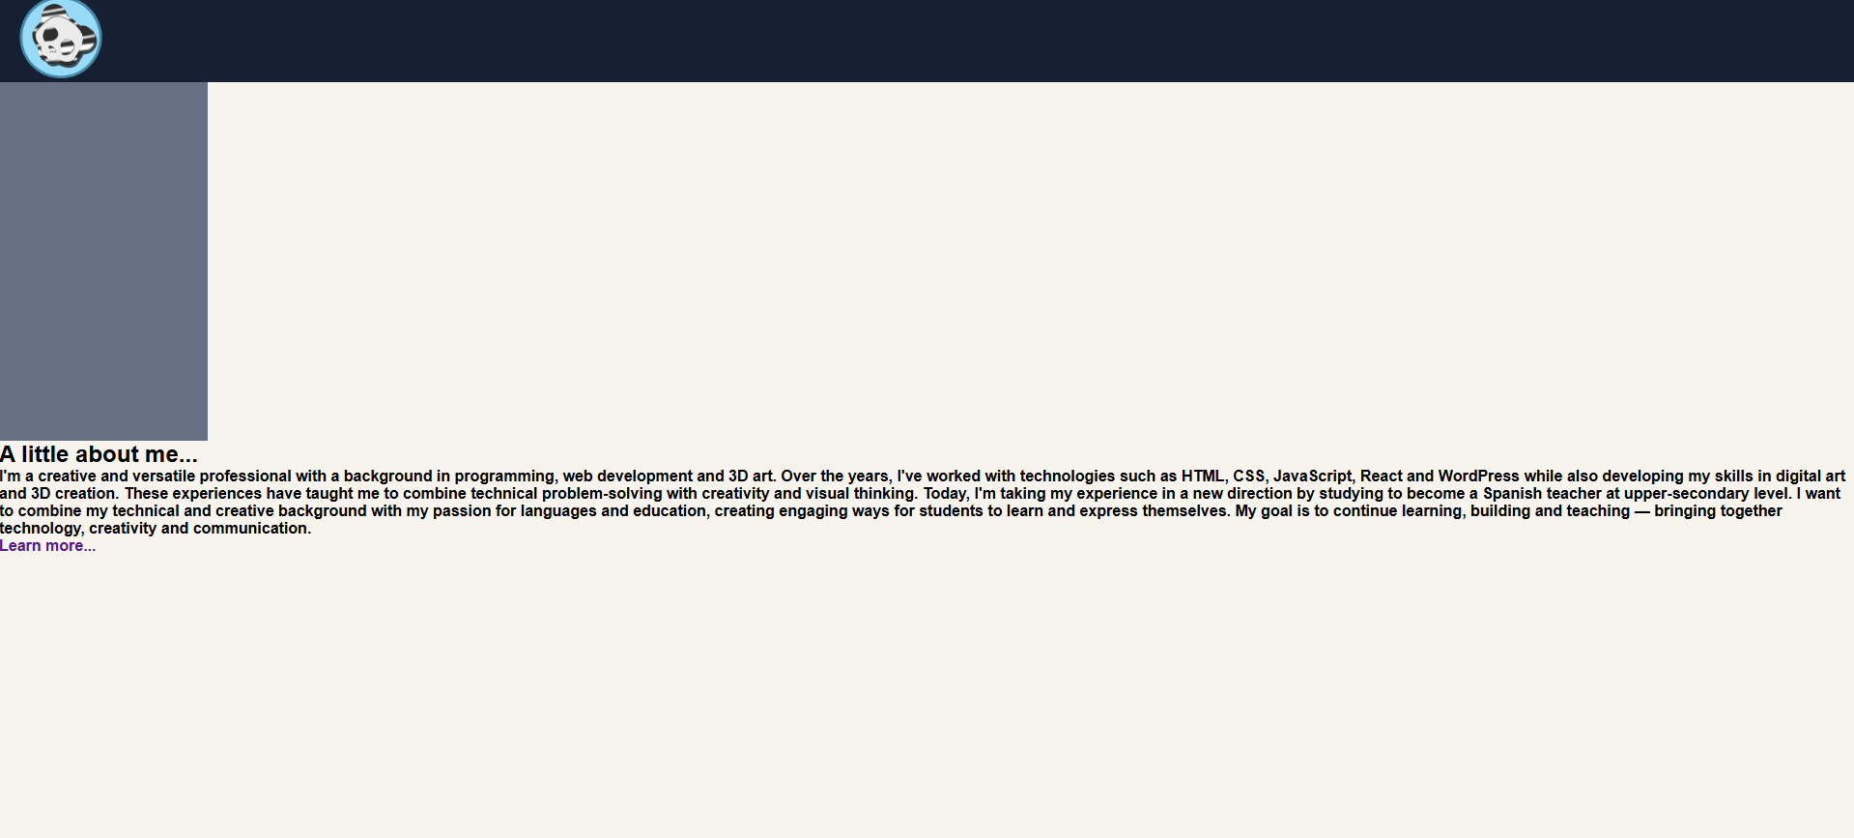
2 Navigation layout: header and footer, button “learn more”
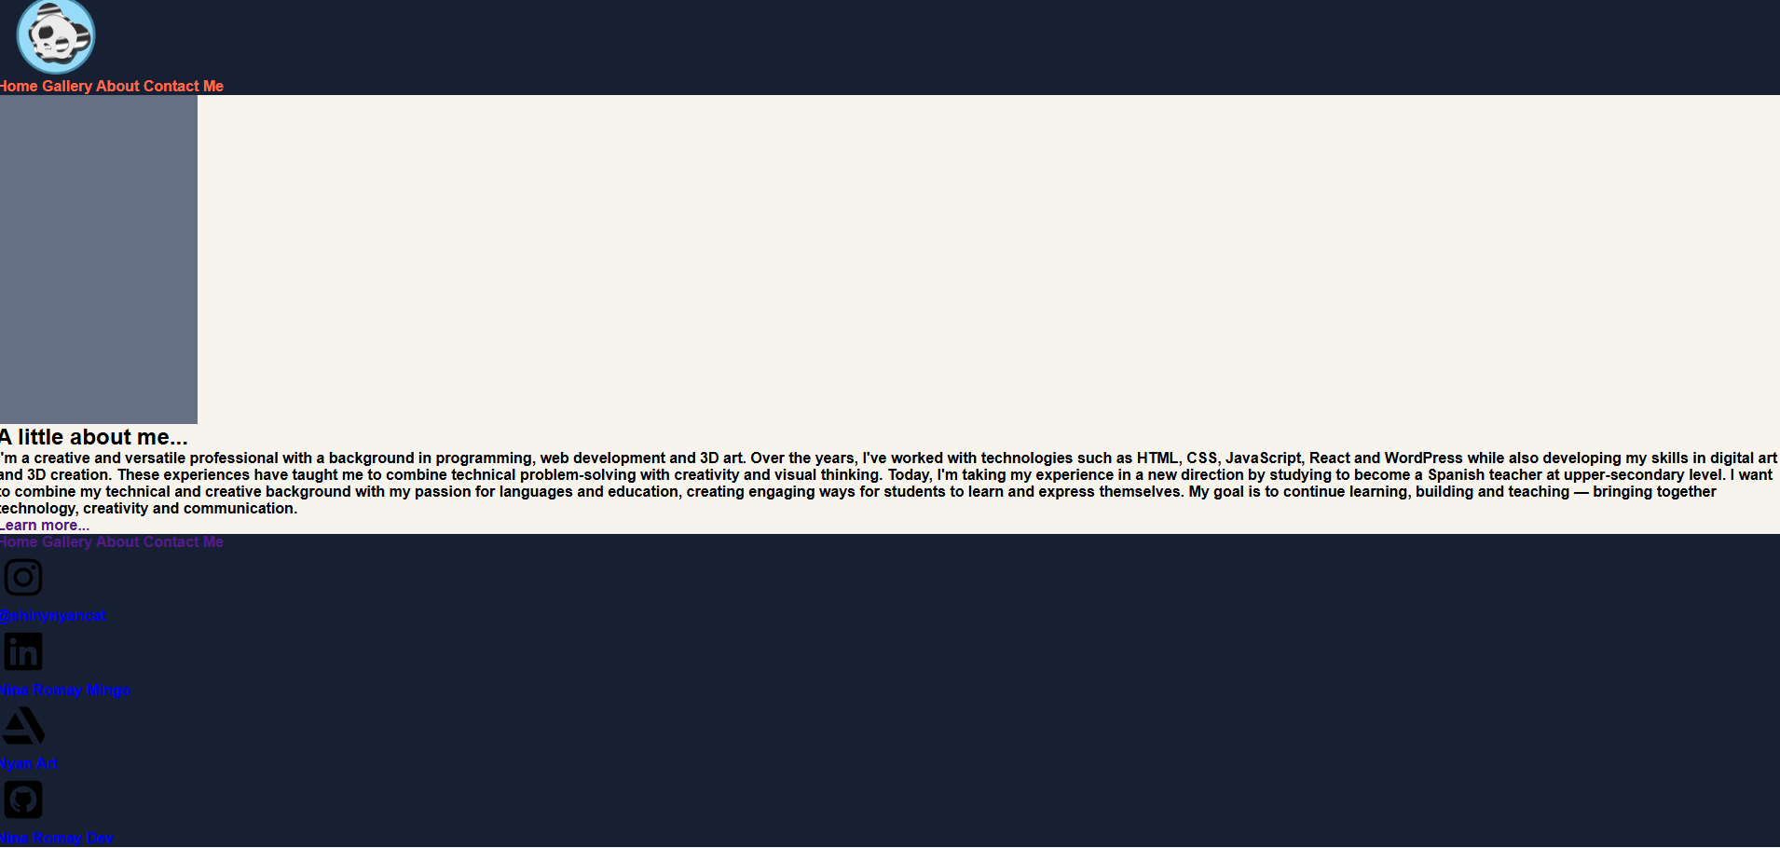
3 Addition of a hero image, this image was used in a previous personal website, GPS data deleted. At this point I created a basic html layout for the gallery as well.
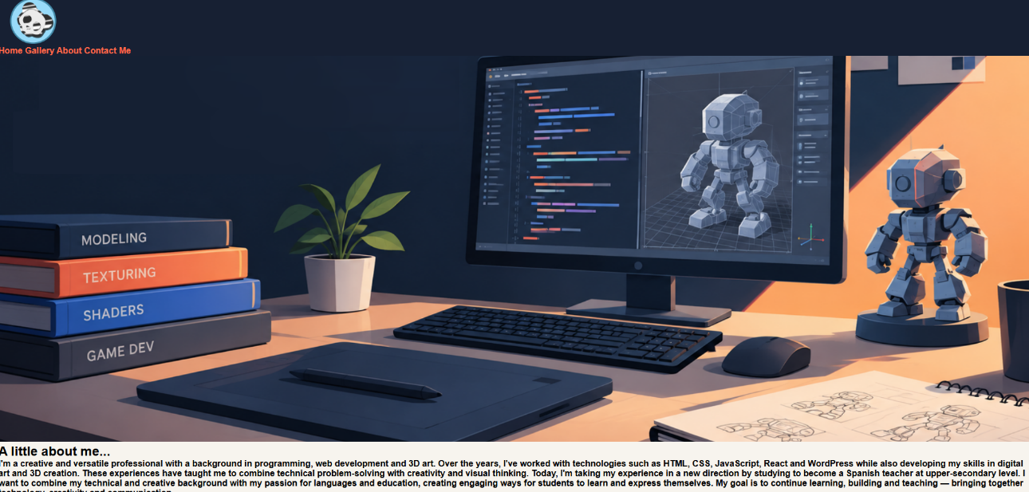
4 All HTML elements are present in the home, gallery and about pages at this point, CSS additions to make it look like a proper website.
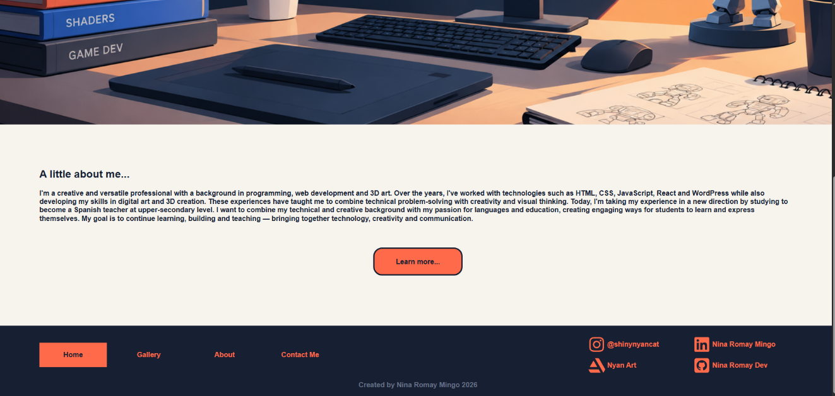
17/09/2026
5 Made some changes on the menu to look like it does now. Kept adding CSS to the other pages.
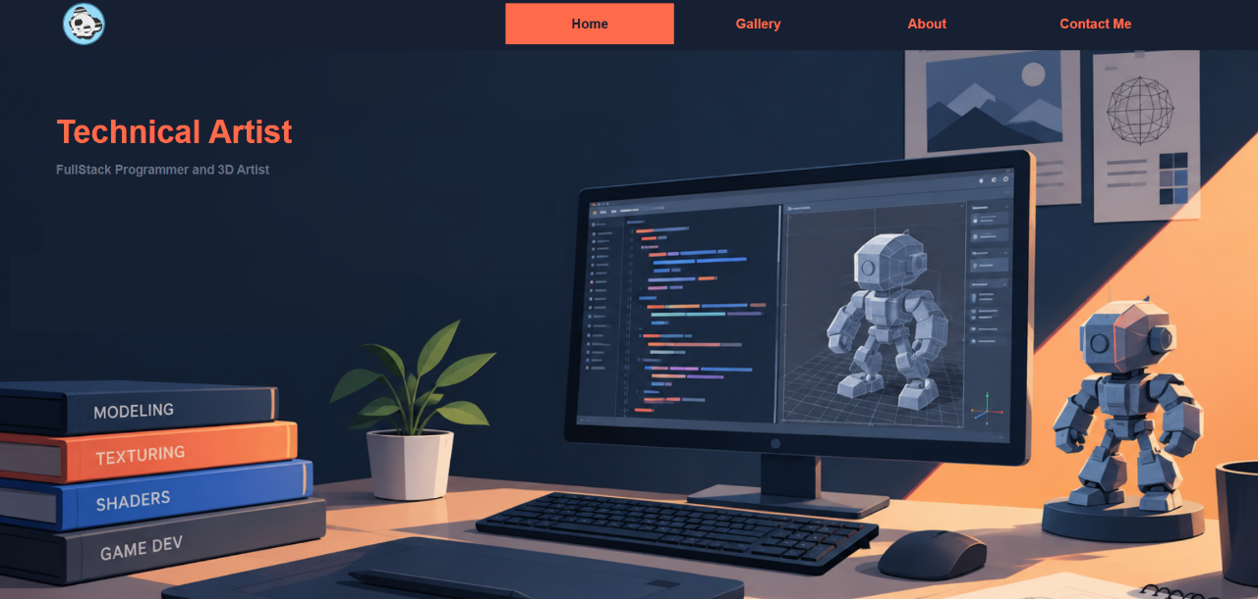
5 Added images to the html, CSS specifically to the animation of the images when hovered. Took away some HTML, because it was unnecessary – some images were prepared a day prior.
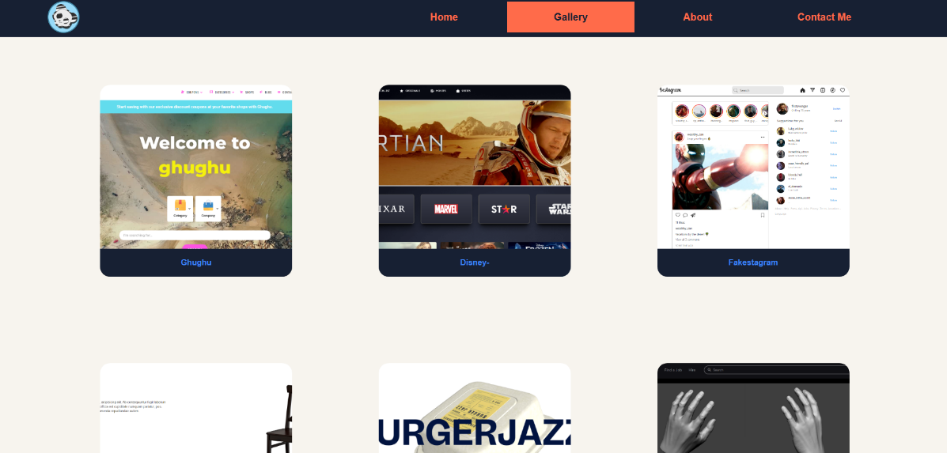
6 Added the private information about my career, both studies and job wise. Decided to keep the design as the vertical line.
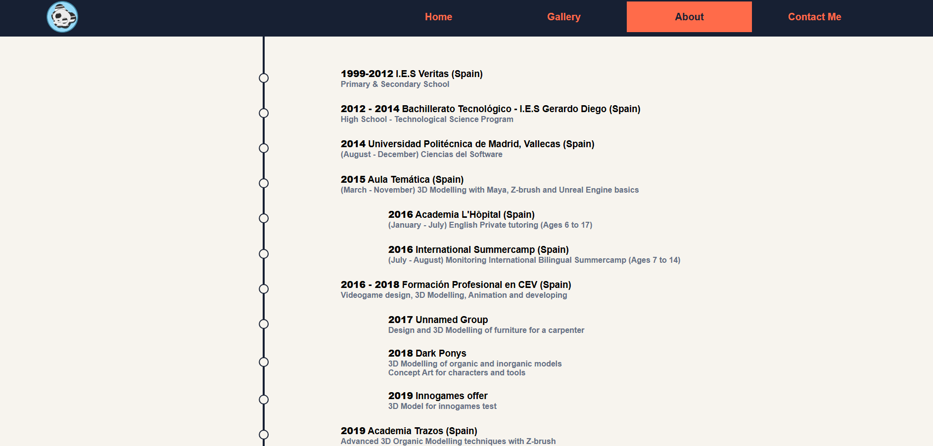
7 Added classes, ids and labels to the contact input, with this the very last HTML is in place and I investigated a way to make it functional but it requires either javascript or php, which is more than specified for this Lab.
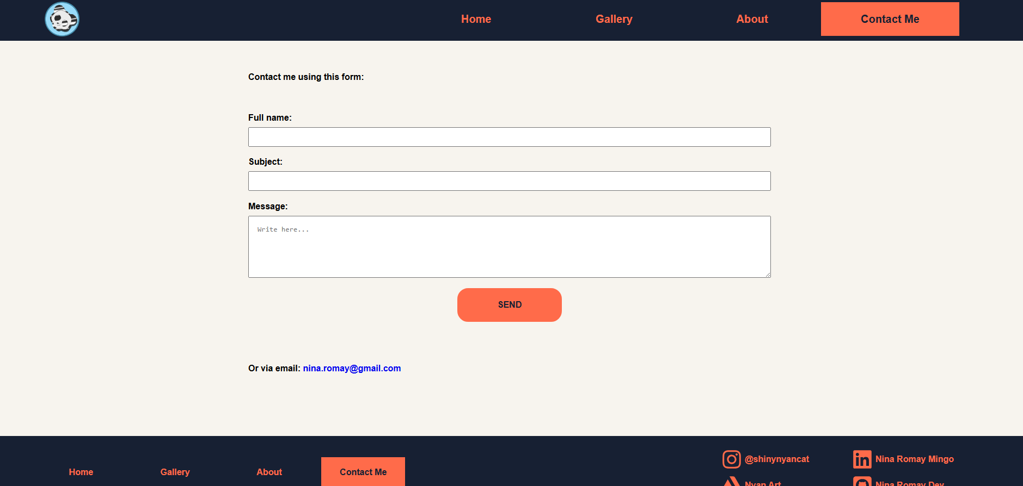
8 Checked responsive, added the required media queries to make the four pages responsive and look consistent. For this I used two chrome tabs with different widths, often pulling on them to see the behaviour of the media queries on the breaking points.
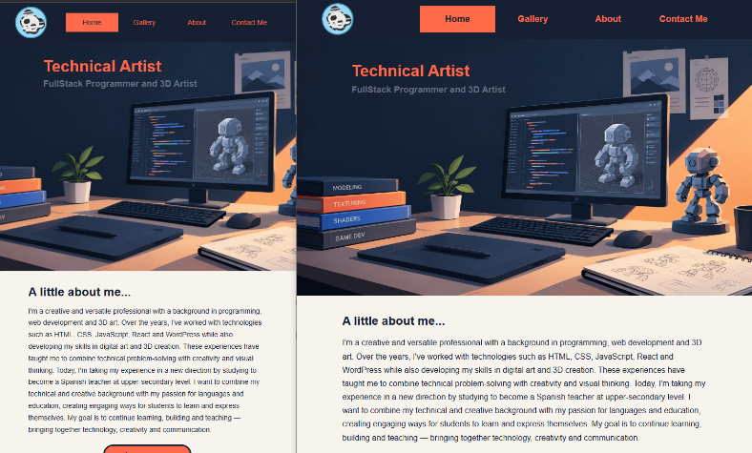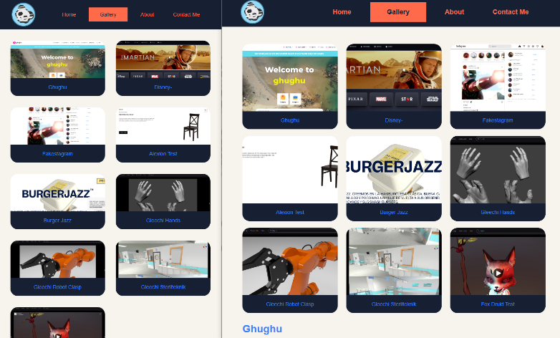
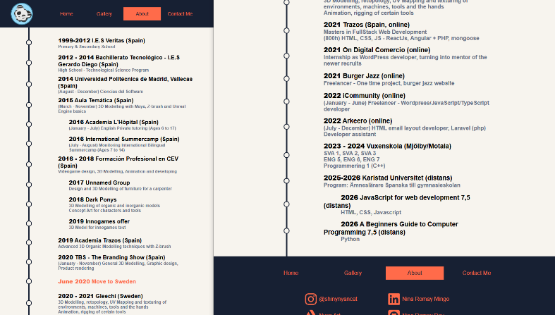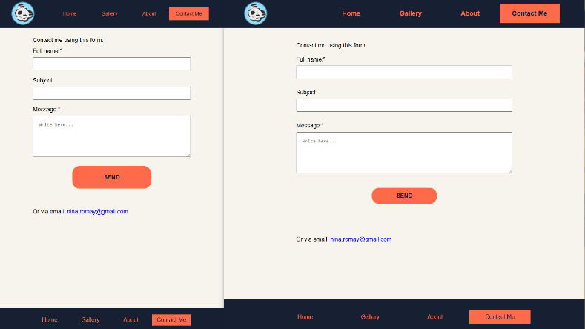

Design changes:
- Re-structured navigation to: header > nav > a instead of nav > ul > li > a, it added too many layers not necessary for this project.
- Re-sized the logo, originally I wanted to have a big logo but it looked too goofy.
- Changed menu design, bigger buttons which almost fill entirely the height of the nav bar. Originally I had smaller buttons, which was repurposed for the footer instead.
- Colour changes: Instead of navy and coral, the original design was going to use yellow and red, based on the Spanish flag (because I’m Spanish) but I decided to fit the hero image I chose and go with the colours displayed in the actual website.
- The hover animation for the gallery wasn’t planned originally, I had purposefully chosen not to use animations, but I changed my mind, preferring to use first a scale animation, ease-in-out, but the out animation looked off, thus I sped up the animation and decided to use ease-in only.
- Gallery was (as shown in picture 5) consisting of square images, I decided to use rectangular shapes instead. Leaving non exact squares for the responsive gallery.

Problems and solutions:
I did not come across big problems because I have experience programming. I found tedious to only use basic HTML and CSS, not being able to use any JavaScript, Tailwind CSS or even Bootstrap (specially for the social media logos).
My solution was to make a simple design and put myself in the place of someone with less experience., thus consciously avoiding more complex blocks of code.
I forgot to add an email label and input within the form. I added it last.
At times I consciously chose to use responsive friendly units like vw, which depend on the window width. I mainly used rem for scaling and px for the font size. I chose to keep colors hexadecimal and font families easy to read.
I actually had a problem with input showing it’s focus state; I wanted to change the border colour. I used someone’s post from Stackoverflow to find a suggestion which fixed the problem: using “outine: none;”.
Here is the design-system sheet: More is provided in the scanned pdf.
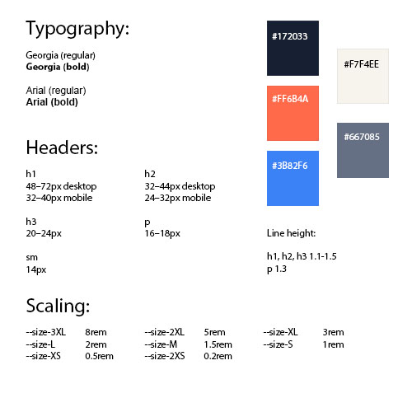
Comparison of two versions:
The earliest version vs the version with most CSS. The css styling makes the whole website look user-friendly and invites the user to navigate it, unlike the basic HTML layout without navigation nor styles, which looks unfinished and poor quality.

Seed
My seed was the words “visual story”. I saw it fit for my introduction, since I have experience as an artist and literally the purpose of the portfolio I built is the collection of images and descriptions of my past works, it becomes the definition of the portfolio.

Reflection
This project was an opportunity to refresh my early HTML and CSS skills into practice by creating a portfolio that presents my work, experience, and creative identity. My initial idea was to build a website that would function not only as a professional portfolio, but also as a creative journal and a collection of 9 project case studies. I wanted the result to be simple, consistent and easy to navigate while still reflecting my background as both an artist and a programmer.
The planning phase helped me establish a clear direction before starting the implementation. I defined the four main pages, created a colour palette, selected the typography, and established rules for spacing, layout, and component consistency. This design system made the development process more organised and helped me maintain a coherent visual identity throughout the website. The idea of a “visual story” became the foundation for the portfolio, connecting my artistic background with the purpose of presenting my previous work and experiences.
During development, I started with the basic HTML structure and gradually introduced CSS to improve the appearance and usability of the website. Working incrementally allowed me to see how each change affected the overall result. I also learned the importance of adapting an initial design rather than following it too rigidly. For example, I changed the navigation from a vertical list to a horizontal menu, adjusted the logo size, replaced the original yellow and red colour scheme with navy and coral, and changed the gallery images from square to rectangular shapes. These decisions improved the visual balance and made the final design feel more coherent.
Although I did not encounter major technical difficulties, the restrictions of using only basic HTML and CSS were sometimes frustrating, especially when I wanted to implement features that would normally benefit from JavaScript or external libraries. However, these limitations encouraged me to simplify my solutions and focus on what was necessary for the project. I also considered accessibility and responsiveness by using semantic HTML, meaningful image alternative text, visible focus states, labelled form fields, and media queries. Testing the website at different browser widths helped me understand how the layout behaved across screen sizes.
One aspect I found particularly interesting was how much the CSS improved the website compared with the initial HTML version. The structure and content were already present, but styling transformed them into a more polished and inviting experience. I am especially satisfied with the footer and the final navigation design, as well as the way the social media icons were adapted to match the visual identity.
Overall, I am proud of the result and the relatively short time it took to complete the coding, particularly considering how much time documenting the process required. This project reinforced the value of planning, consistency, experimentation, and documenting design decisions. It also served as a useful warm-up for the next lab, giving me the opportunity to reflect on how much can be achieved with fundamental web technologies alone.

