Cristina Romay Mingo (Nina) | ID: Cristina Romay Mingo 0005
Target Grade: 5 | GitHub: Porfolio_github
Some implemented features:

- “…” as a read more button for smaller screens to show the hidden text
- exchange subject input for a select
- form validation
- Name validation - right format
- Email validation - right format (regex)
- Selector validation - choice made
- Message validation - right format

Evidence button:
button to show text on small screens 1
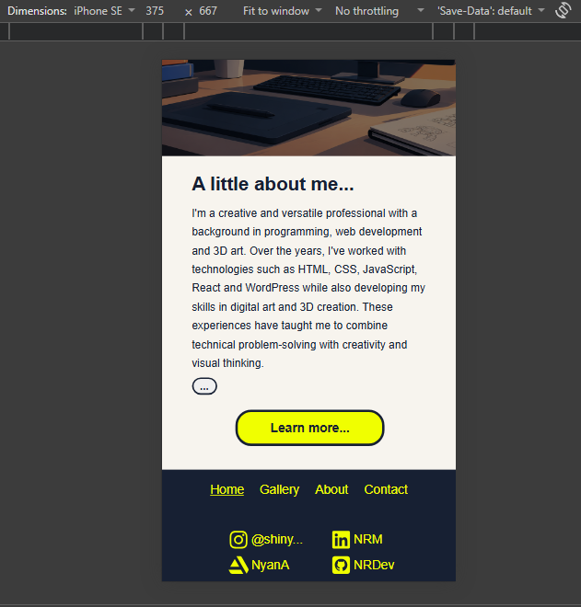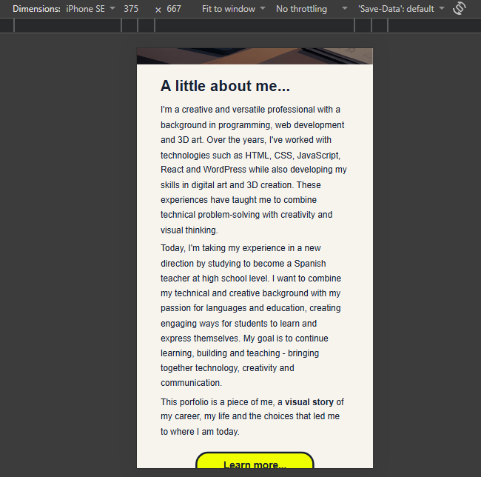
Evidence form validation:
Name starts with number Name is too short
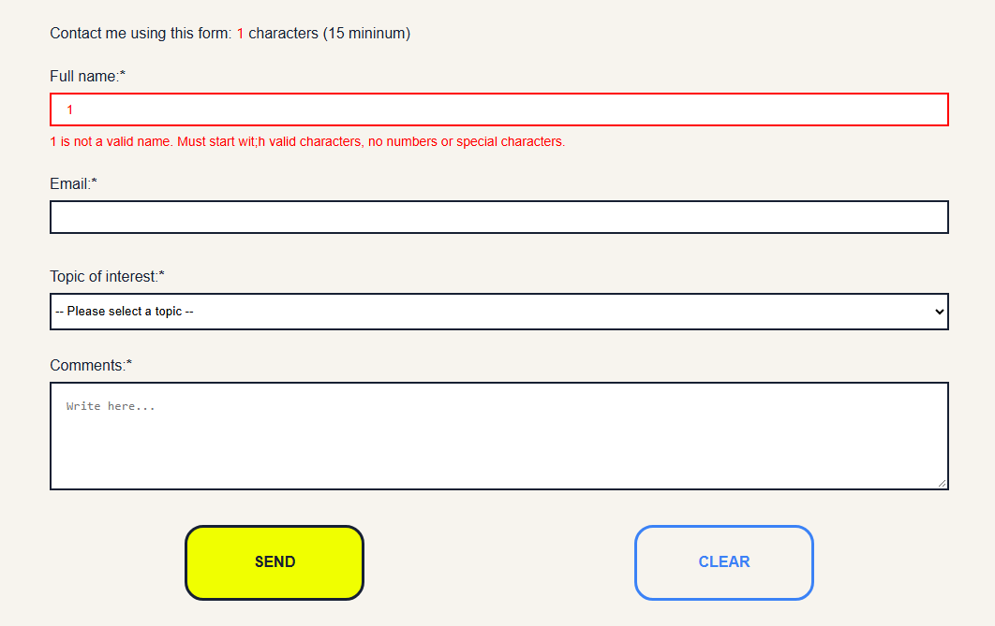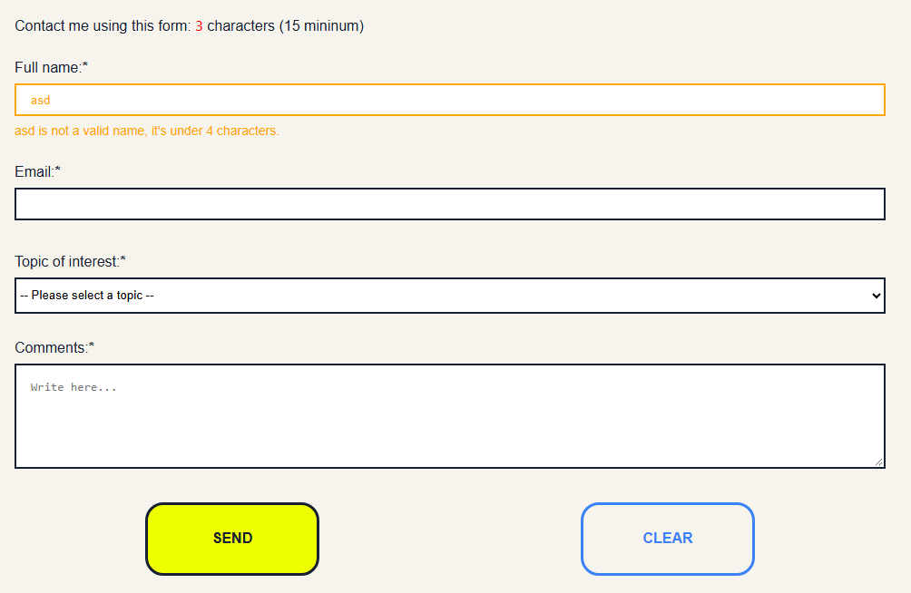

Email is empty Wrong format error
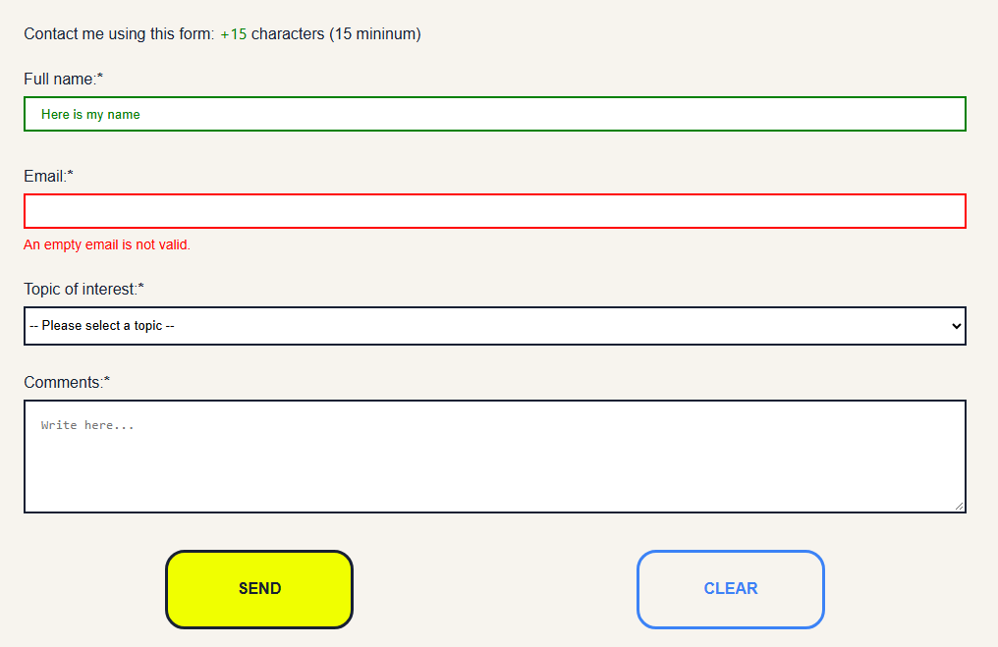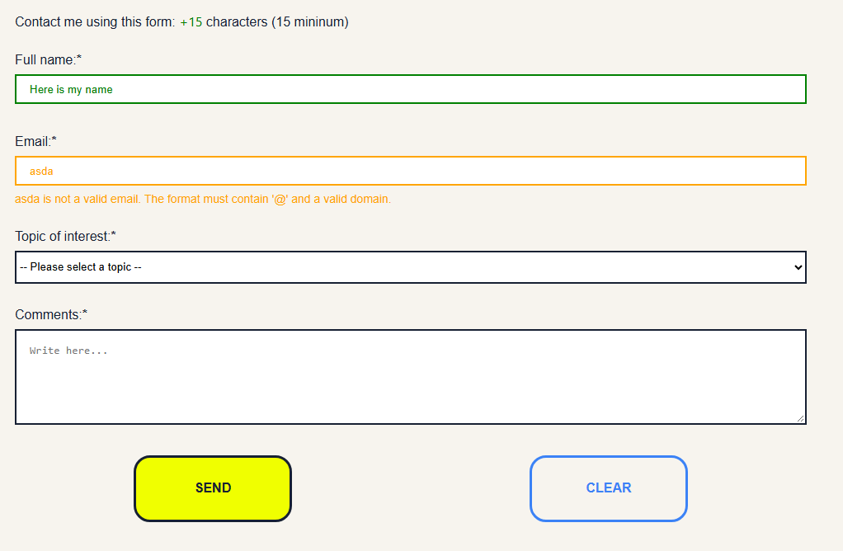
Valid selector interaction Too short message (after deleting)
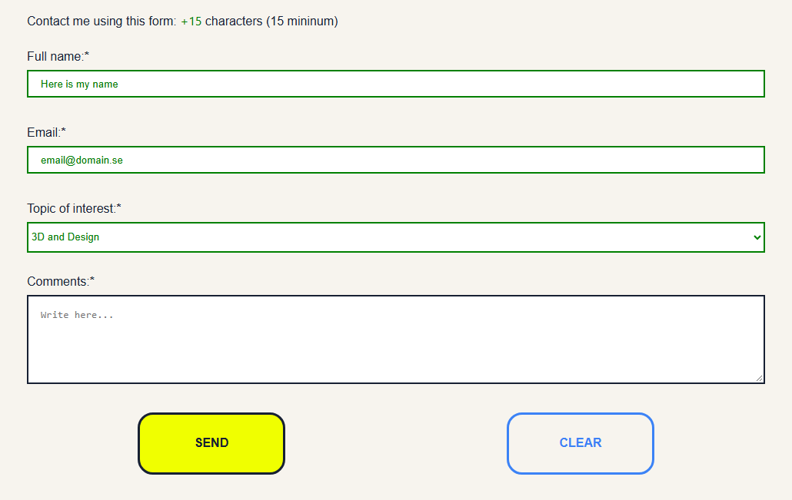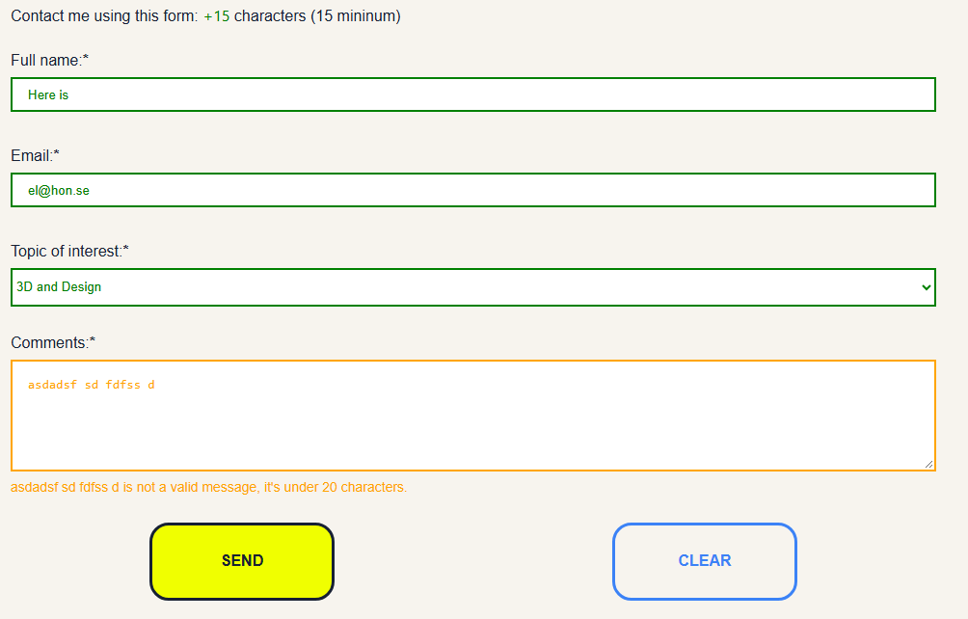
Everything is validated Successful message
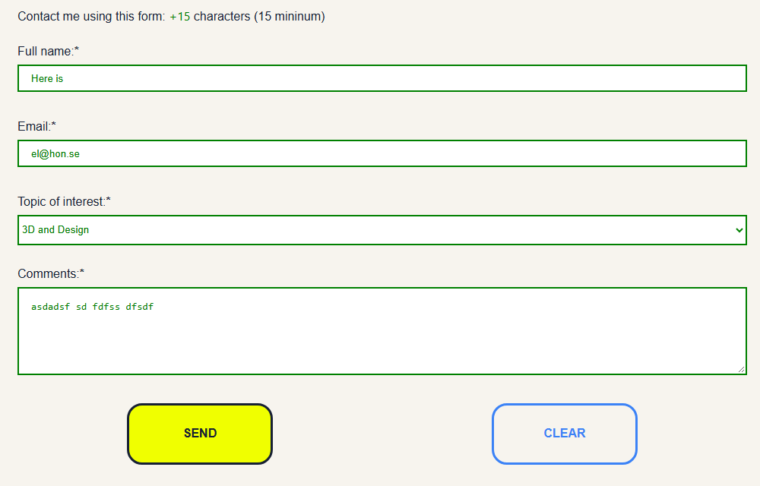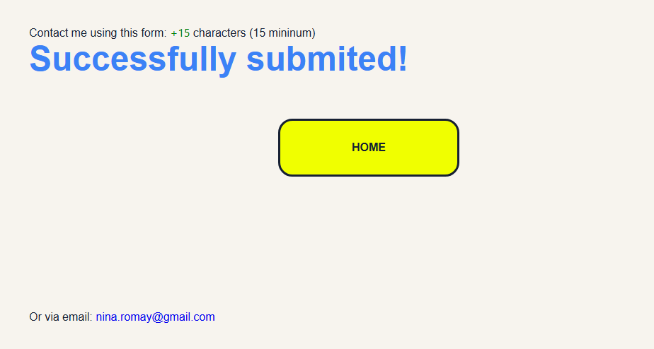

MAIN FUNCTIONS
“Read more” button
Main function: clickAndShow(showMe, hideMe)
Event: The user clicks the button with the id read-more.
How the event leads to a visible page update:
1. addEventListener "click” detects when the user clicks the button.
2. The event calls clickAndShow(fullTxt, readMore).
3. The function loops through every element with the class full-screen-txt.
4. Each element's display style is changed from "none" to "block", making the previously hidden text visible.
5. The readMore button is hidden by setting its display to "none".
The result is that the full text appears on the page and the “…” button disappears (small screens only)

Form validation
The form validates four fields and provides visual feedback: red for missing or invalid input, orange for unmet length or format rules, and green when a field is valid.
Text fields: name, email, and message
Each field is checked as the user types. The input is trimmed, tested against its rules, and styled accordingly. Errors appear beside invalid fields and clear when validation succeeds.
Field | Validation rules | Validity flag
Name | Must not be empty, must begin with a letter, and must contain more than four characters. | isName
Email | Must not be empty, must begin with a letter, match emailRegex, and contain more than eight characters. | isEmail
Message | Must not be empty, must begin with a letter, and contain more than 20 characters. | isMessage
A failed check displays an error and applies red or orange styling, depending on the rule. Passing all checks clears the error, applies green styling, and sets the field’s validity flag to true.

Subject selection
Main function and event: A click listener on subjectInput reads the selected value and uses subjectSelected to determine how to handle it. A selection applies the is-selected class, green styling, and sets isSubject to true; an empty selection triggers an error and red styling.
Difference and limitation: Subject validation runs on clicks and checks a selection, unlike the text fields, which validate while the user types. Also, subjectValue is a string, so checking subjectValue.value == "" will not reliably detect an empty value. The subjectSelected state also makes the result depend on the sequence of clicks.

Form submission and success message
Main function: The submit event listener attached to form.
Event: The user attempts to submit the form.
How the event leads to a visible page update:
1. e.preventDefault() stops the browser from submitting the form in its default way.
2. The code checks whether isName, isEmail, isMessage, and isSubject are all true.
3. If one or more flags are false, an alert displays: “You are missing information”.
4. If all flags are true, window.scrollTo(0, 0) scrolls the page to the top.
5. The code displays the success message “Successfully submited!” and adds a link back to index.html.
6. The form is hidden using form.style.display = "none".
The result is that the user sees a success message instead of the form.
Resetting the form after submission
The setTimeout() function schedules another update after four seconds.
When the delay ends, the code:
- Makes the form visible again using form.style.display = "flex".
- Hides the success message.
- Resets the form fields.
- Resets the character counter.
- Attempts to restore the input colours and borders.
This allows the form to return to its initial state after the confirmation has been displayed.
Note: The code does not send the form data to a server or email service. It displays a client-side success message only.

Shared validation and accessibility functions
Two helper functions support the name, email, and message validators.
- setError(input, error, message)
This function handles invalid input. It:
- Sets isValid to false.
- Saves an invalid field in invalidField, if one has not already been saved.
- Adds aria-invalid="true" to the input.
- Connects the input to its error message using aria-describedby.
- Displays the provided error message using error.textContent.
Visible update: The user sees an explanatory error message next to the relevant field. The “aria” attributes also provide information that can help assistive technologies communicate the error.
- clearError(input, error)
This function clears an error after the input becomes valid. It sets aria-invalid to "false", removes aria-describedby, and empties the error message.
Visible update: The error message disappears.
These functions centralise the error-handling logic, allowing the individual validators to reuse the same behaviour.
Live character counter
Main function: calculateTotal(arr)
Event: The user types into or deletes text from the name, email, or message fields.
How the event leads to a visible page update:
1. The input event listener attached to the form detects changes to its input fields.
2. The function calculateTotal(inputGroup) receives an array containing the name, email, and message inputs.
3. reduce() adds together the number of characters in those three fields.
4. liveCounter.textContent updates the displayed character count.
5. If the total reaches 15 characters, the counter displays "+15" in green. Otherwise, it displays the current total in red.
The result is an immediate visual indication of how much text the user has entered.

4. Problem solving: describe at least one real problem, what you tried and the solution that worked.
Struggle with form validation
After fixing my HTML and CSS to display a polished Clear button for the form, I started the form validation necessary steps, to put it short add HTML error labels, CSS styles and the validation through JavaScript .
As I didn’t know where to start since I don’t often use plain JavaScript for this, I researched existing documentation. I used the following:
https://developer.mozilla.org/en-US/docs/Learn_web_development/Extensions/Forms/Form_validation
and https://www.w3schools.com/js/js_validation.asp
To make it sturdier I chose to use regex, for which I used the following:
https://www.w3schools.com/js/js_regexp.asp
https://www.w3schools.com/jsref/jsref_obj_regexp.asp
https://developer.mozilla.org/en-US/docs/Web/JavaScript/Guide/Regular_expressions

Success button struggle
While preparing the success message I came across a problem: When I simplified the logic to a display toggle, the message would show once the text was submitted but once I tried to add more HTML elements to the span, everything was visible regardless submit was pressed or not.
My first fix was to delete the HTML inside the span I was using for said message, leaving it empty, and add it using JavaScript. But the problem grew in complexity because I wanted a “HOME” button to appear with the success text.
I researched different functions which could aid to my problem and after a short time I came across the “insertAdjacentHTML” function which completely solved the problem. After a few CSS tweaks and it was functional again.
Summary:
Feature | Event | Main function or logic |  | Visible result
Read more | Button click | clickAndShow() |  | Full text appears; button disappears
Character counter | Form input | calculateTotal() |  | Counter updates and changes colour
Name validation | Name input | Name validator | setError()  clearError() | Error message and  field colour update
Email validation | Email input | Email validator | setError()  clearError() | Error message and  field colour update
Message validation | Message input | Message validator | setError()  clearError() | Error message and  field colour update
Subject selection | Subject click | Subject validator |  | Selection styling or error feedback
Form submission | Submit | Form submission listener |  | Alert or success message; form hidden
Form reset | Four-second timeout | Callback inside setTimeout() |  | Form returns and fields are reset

5. Reflection: answer the three prompts below in your own voice.
Which interaction are you most confident explaining, and why?
The read more function is a simple button that shows the hidden part of the text. I’ve written this kind of event often.
How does your Git history show the way your solution changed during development?
I’ve tried to push specific parts of the code as I finished them, at times forgetting to, but nonetheless keeping a steady flow based on the code (like a full function) or interaction (something fully working).
If you had one more development session, what would you improve or test further?
If there would be a Lab number 3 I would use a framework to create the same thing, demonstrating how libraries and frameworks make development faster quite often.

Debugging evidences:
- Form validation Name validation debugging
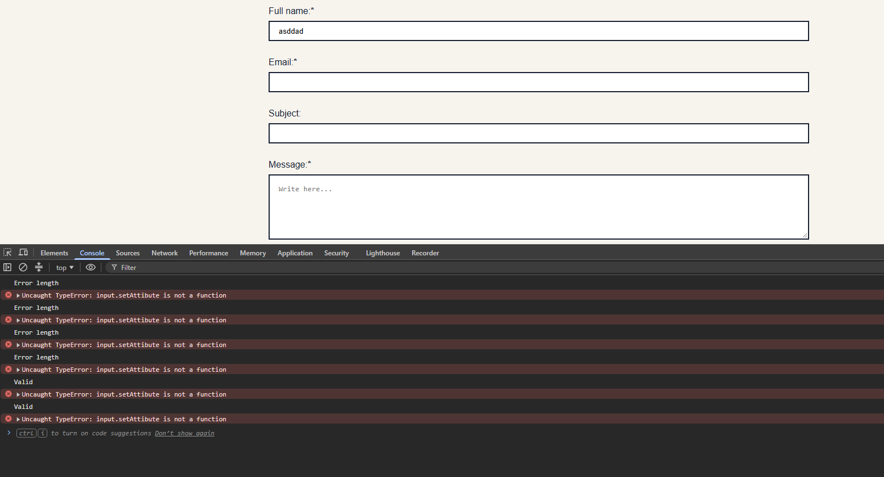
I misspelled the function, after correcting input.setAttibute to input.setAttribute things worked as supposed to.
- Size changer function
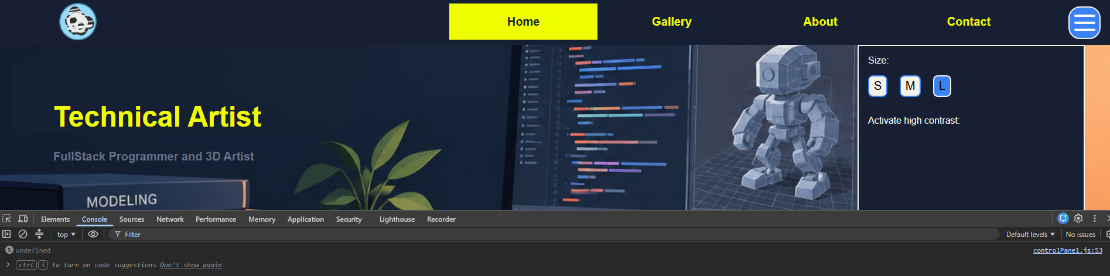
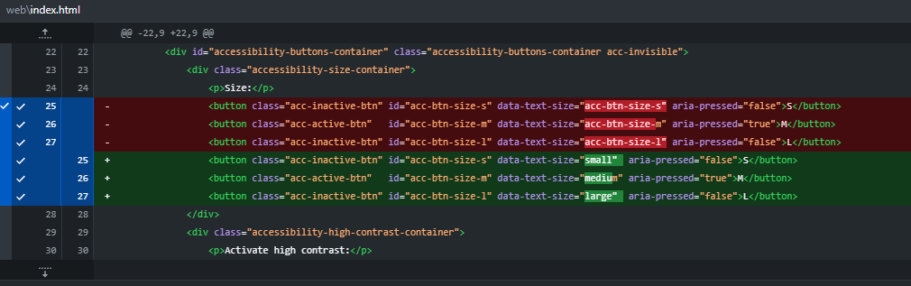
This commit shows the key change I had to make on the html for the size changer buttons to work, I had missed that the key in the fontSizes array had to match the data-text-size value since that was the reference I used to assign the size.
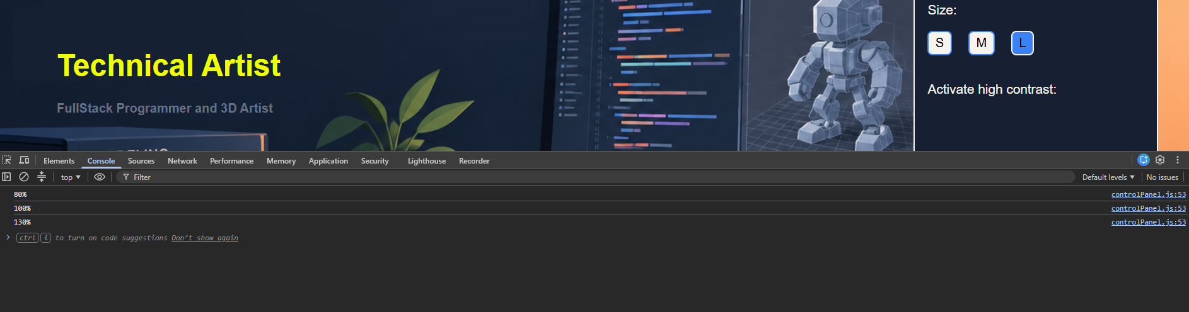
Filter and sort together:
- Normal:
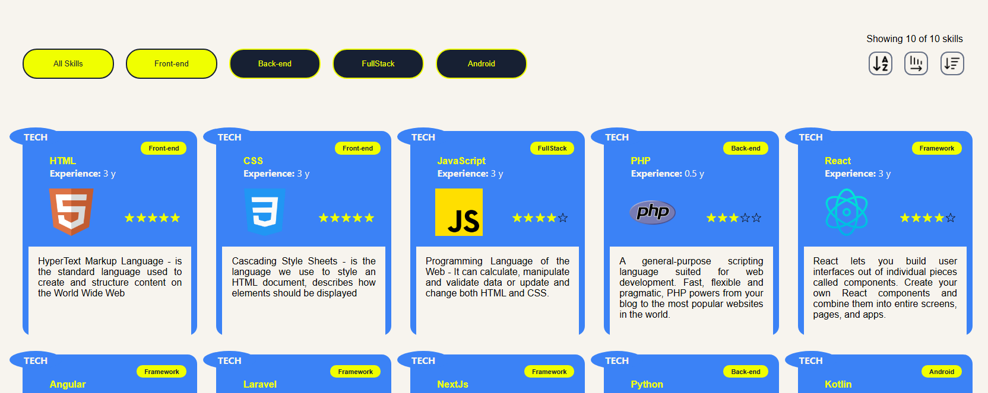
- Filtered:
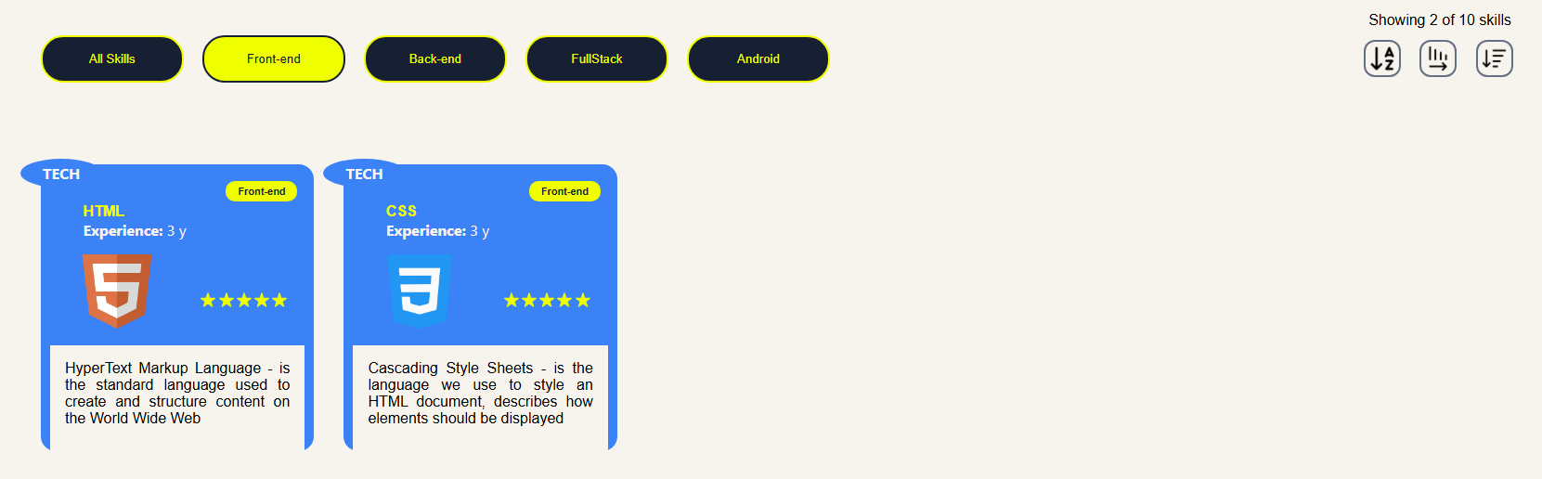
- Sorted & Filtered
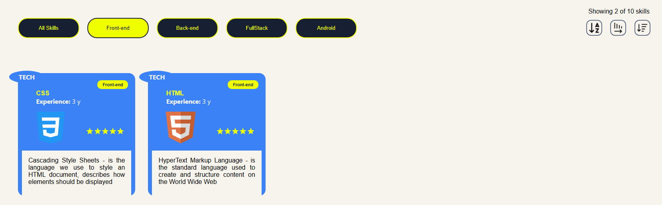

The skills in the cards are stored as an array of objects “skills”, with each object containing the required properties such as id, name, category, proficiency, yearsExperience, description, img and sort.
The cardGenerator(arr) function takes the array of skills, clears the card container, then loops through the array and creates a card for each item. It fills each card with the skill’s details, adds it to the page, and displays five star icons, filling as many as the skill’s proficiency rating. After rendering, it calls updateCards(arr), which saves the displayed items in currentCards and updates the skill counter to show how many items are displayed. This keeps the page’s data and count in sync and allows the rendering of the array of cards as its filtered and sorted.

Size buttons working proof:
- Small
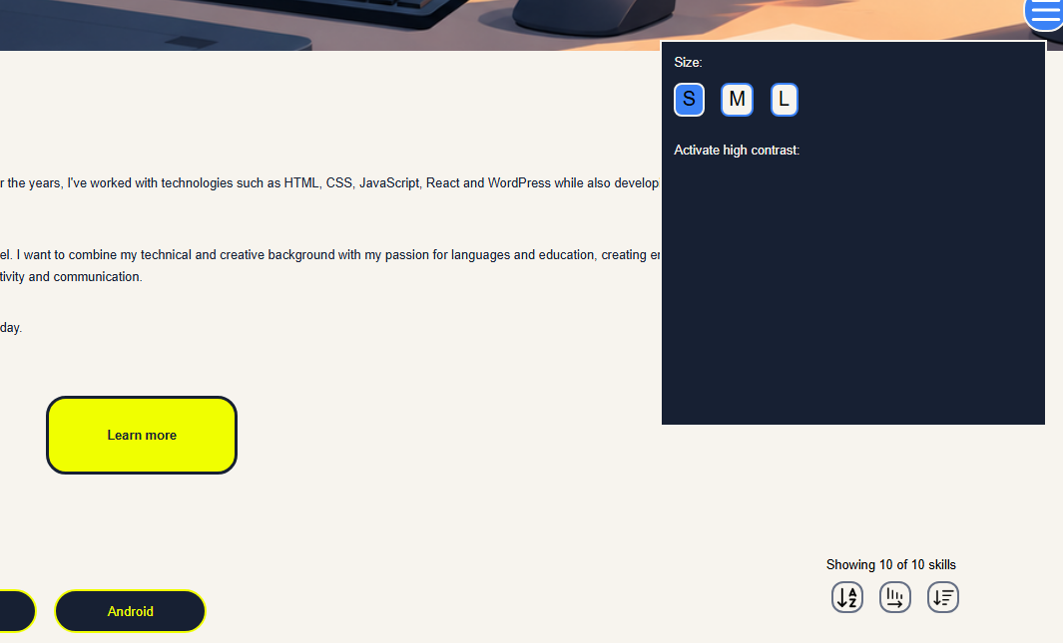

- Medium (default)

- Large
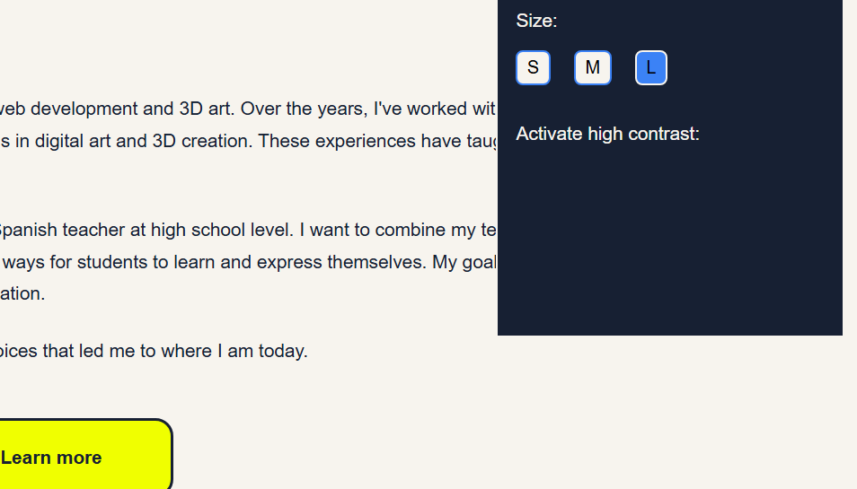

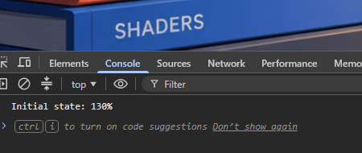
Saved size proof:

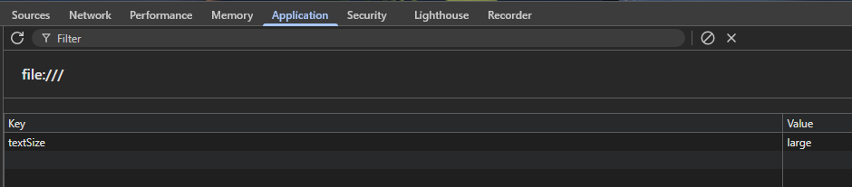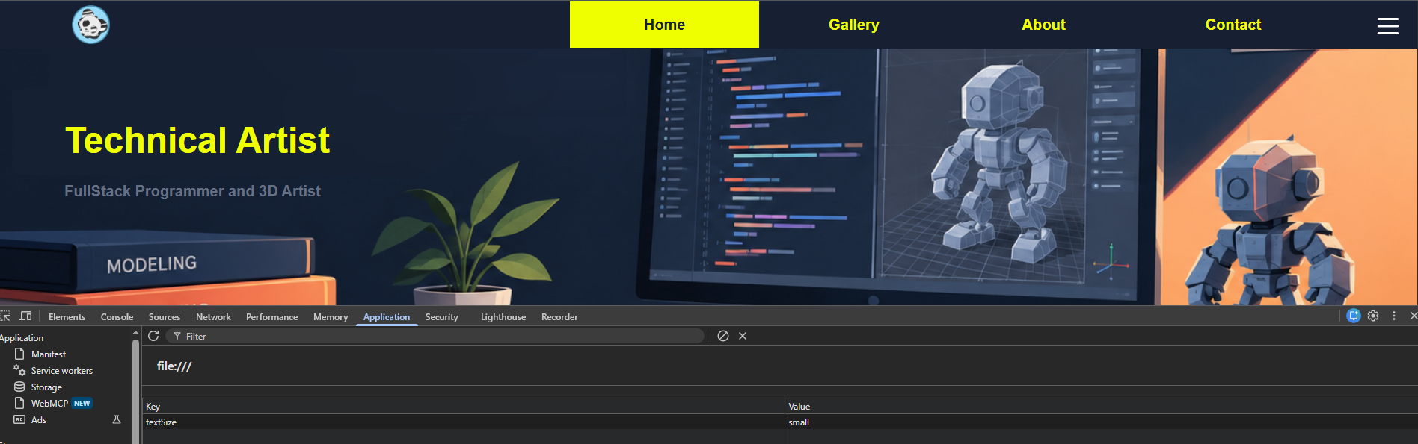

In the default view, the website uses its medium (M) text size and normal color theme. With Large text and High Contrast enabled, the text becomes larger and the high-contrast color variables are applied. The layout stays the same, while the text size and colors change:
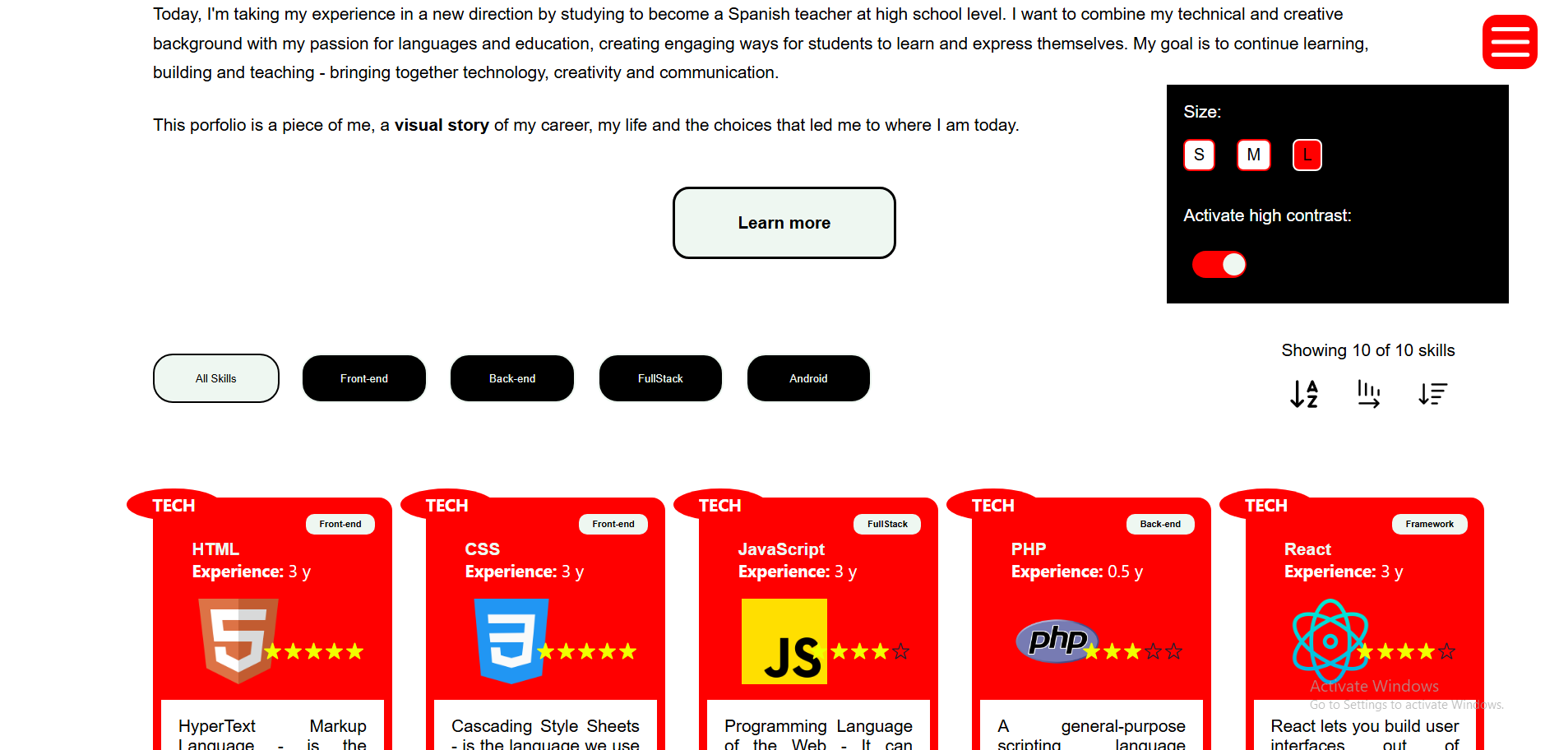

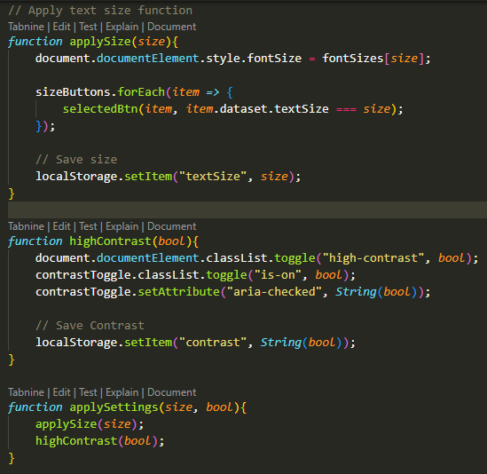
applySettings(size, bool) applies both accessibility preferences by calling applySize(size) and highContrast(bool).
- applySize(size) sets the page’s root font size using the matching value in fontSizes.It does this using a forEach loop which checks every button for a match. Then it updates the size buttons, so the chosen one appears selected, then saves the choice in localStorage as "textSize".
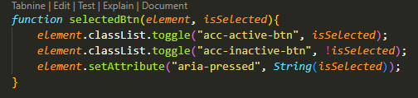
- highContrast(bool) adds or removes the high-contrast class on the root element, updates the switch’s appearance and aria-checked state, and saves the setting in localStorage as "contrast".
Together, these functions apply the selected settings and save them so they can be restored later on document load.

The persistence method I chose is localStorage. When a button in the Size part of the Accessibility panel is clicked, it saves the text size under "textSize" and when the slider is clicked, it saves the contrast state under "contrast".
These values remain in the browser’s localStorage after the page is closed or reloaded. When the DOM loads, the code reads the saved values with localStorage.getItem() and passes them to applySettings(), which restores the preferences.

Accessibility test: Using only the keyboard, I tabbed to the accessibility menu
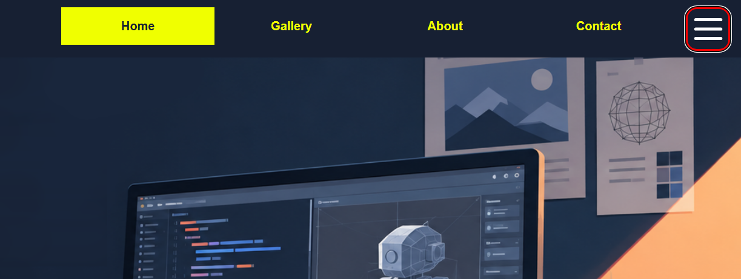

and pressed Space.
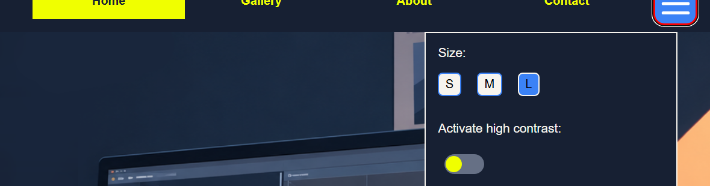
The switch changed state, aria-checked updated.
I continued tabbing till I reached the high contrast slider
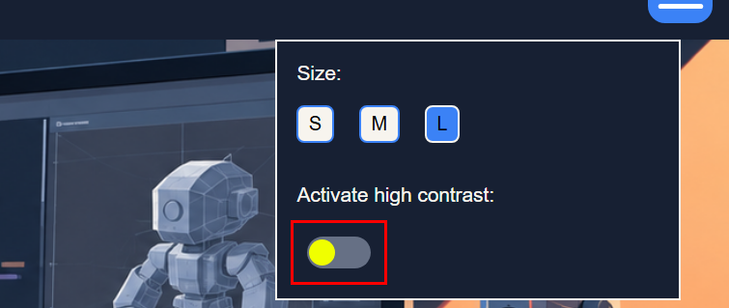
And pressed Enter.
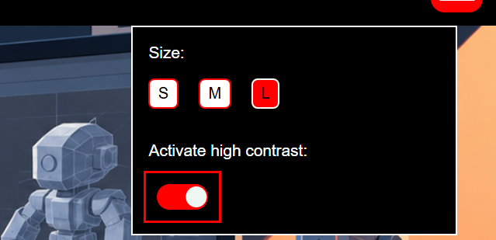
Colors changed successfully. This confirms keyboard access.

