Industry Analysis

Data Analytics in Online Banking

Name: Yi Yang

05/13/2020

ALY 6000 Section 09

Instructor: Carolyn Russo

**Introduction**

The world nowadays is incomplete without data. Enormous amounts of data are generated by users every day. Among them, about 80 to 90 percent of the data in any organization is unstructured and need to be analyzed. Data analytics, a branch of data science, provides a way to analyze large data sets and draw conclusions about them which can help organizations make informed business decisions.

Online banking, offers customers mobile or computer access to their financial accounts and do multiple financial transactions like depositing checks, transferring funds and paying bills electronically without visiting a banker in traditional branches. Since this field contains sensitive financial information of the customers, data collection and management become extremely important. With volumes of financial data sets, many companies are learning to leverage data analytics methods to enhance the services that they provide for their customers.

In this essay, we will discuss the emergence and evolution of online banking industry, how data analytics can benefit/disrupt online banking and how COVID-19 pandemic will change online banking and our society in the future.

**History of Online Banking**

Online banking, also known as internet banking, allows users to use a mobile device or a computer to conduct financial transactions including depositing checks, transferring funds, and paying bill electronically. Unlike traditional banks and credit unions, you do not need to spend some time waiting in a line to meet a banker face to face. Instead, you can access your financial account anytime with a bank’s mobile app or its website.

In order to access to the online banking service, users need to open up a new account and apply for debit/credit cards whether in a branch or through online portals. Then, they will be asked to create a password to secure their account. Once all of these basic steps are finished, they can use the service provided to do all their banking. For example, clients can just simply enter their account name and password, then they can instantly check their checking and savings account. Moreover, they can set up on the website for the electronical payment to monthly gas or electricity companies. Other services are offered like depositing checks by taking photos via a mobile app, making transfers through different banks, or reporting a change of address.

Online banking originally started in the early 1980s, was originally referred to the use of a terminal, keyboard, and TV to access the banking system through a phone line. In 1981, New York City was the first place in the U.S. to start trying to provide this service to clients. Four major banks including Citibank, Chase Manhattan, Chemical and Manufacturers Hanover made this home banking access available to their clients using the videotext system. Later in 1983, the first internet banking service was provided by The Bank of Scotland in the UK and was named “Homelink”. People had to connect through their TVs and telephones to send transfers and pay bills, which is considered as a cornerstone for later online banking service as we use it today.

Since people were not so willing to experience this new service, it did not gain much success until the mid-1990s. During this innovation period, many banks started to consider web-based banking as a new competitive strategy. In January 1994, online banking is built into Microsoft Money personal finance software and around 100,000 families start accessing bank accounts online. And the same year in October, Stanford Federal Credit Union became the first financial institution in the U.S. to provide internet banking to all of its clients. After a year, Presidential Bank became the first bank in the country to offer customers access to their accounts online. Then many other banks began to catch on after seeing the advantages of internet banking. In 1999, Bank of Internet USA was officially founded and made history as America’s oldest internet bank (Sarreal, 2019).

After that, customer use had grown rapidly. According to an online bank report in 2012, 8 US banks have at least 1 million online users each and 19 million US households are accessing bank accounts online (Pilcher, 2012). Also, Bank of America had become the first financial institution to gain over 3 million online banking customers which is about 20 percent of its overall customer base. By the year 2006, about 80 percent of banks in the U.S. offered online banking services, which had become mainstream.

At first, customers were not willing to try online banking service because of several reasons like not trusting its security features, not sure how to use it or not wanting to spend time creating accounts. However, the conveniences and benefits that internet banking brought has become more and more obvious to many customers. Meanwhile, banks which provide online banking services offer higher interest rate to attract clients. Moreover, saving time is big advantage to people who are busy with work and do not want to get into a line to transfer funds and deposit checks.

Overall, it is considered as an evolutional change to the traditional financial industry.

**Key Facts about Online Banking**

We just witness how online has evolved along the way since 1980s, and we may wonder how it rivals traditional branch banking globally and locally in the U.S. and Figure 1(Richter, 2015) below shows the percentage of banking customers from 2011 to 2014 among ways of banking. We can see from the graph that online takes about half of the total percentage and keep increasing from 2011 to 2014. While banking users are decreasing the use of Branch, Phone and ATM to deal with their financial transactions, Online and Mobile are becoming more and more popular.

Therefore, we can tell that online and mobile have become essential ways for customers to manage their financial services. Note that the difference between online and mobile banking is that online banking means people log into a certain bank’s website while mobile banking means people use a specific bank’s app to login into their account and access their financial information. The services offered by a bank might vary between these very similar methods. And the services provided by different banks vary as well.

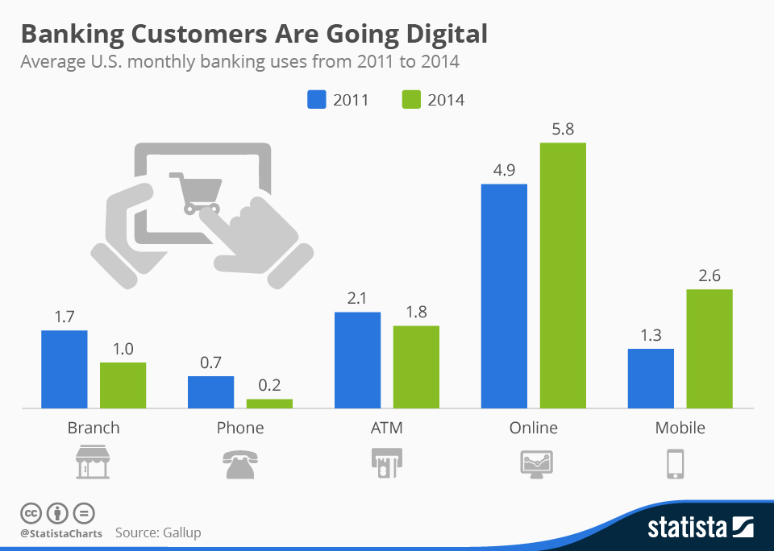

*Figure 1.* Graph about banking customers are using online banking more often. Adapted from “Banking Customers are going digital,” by Richter, Felix, 2015, November 10. Retrieved May 13, 2020, from <https://www.statista.com/chart/3986/banking-customers-are-going-digital/>

Besides, according to a representative survey provided by the Pew Research Center (Fox, 2013), 61% of internet users bank online and 35% of cell phone owners bank using their mobile phones (Figure 2).

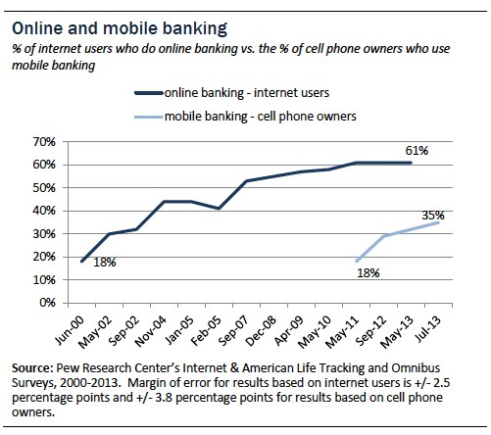

*Figure 2.* Graph of Online banking and mobile banking users increasing. Adapted from “Online and mobile banking,” by Fox, Susannah, 2013, August 7. Retrieved May 13, 2020, from <https://www.pewresearch.org/internet/2013/08/07/51-of-u-s-adults-bank-online/>

Furthermore, Figure 3 below shows that among all the online activities that people like to use, internet banking takes half of the percentage followed by job search, selling products. Also, young people who use internet banking that take about half of the population among all users.

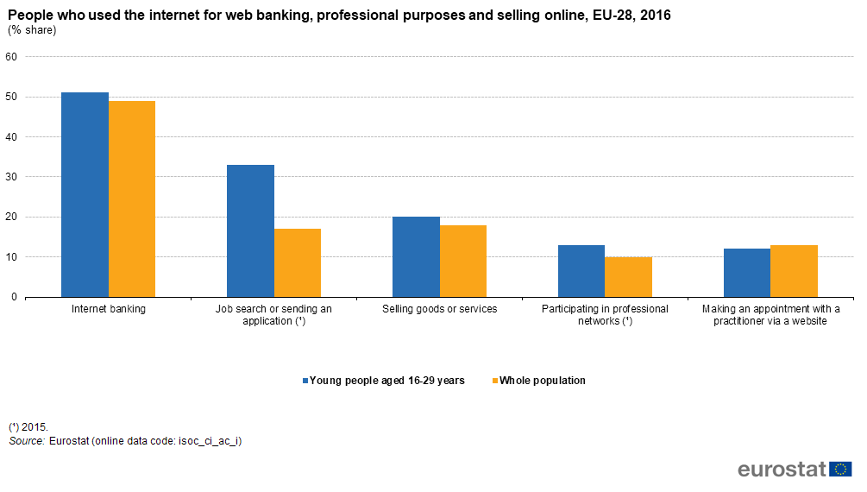

*Figure 3.* Graph of people who used the internet for various activities. Adapted from “People who used internet for web banking, professional purposes and selling online,” by EXT-G-Albertone, April 25, 2018. Retrieved May 13, 2020, from Europa.eu

**How Data Analytics Impacted/Disrupted Online Banking**

Based on the known fact we have just illustrated above that online banking users have increasing a lot and gradually challenges the dominance of physical branch banking, there generates numerous of financial data from users on the internet we need to store and manage well to earn clients’ loyalty. Hence, data analytics is used to better store their deposits, track their expenses, analyze and possibly predict their shopping behaviors.

One the one hand, applying data analytics into online banking industry can obtain a complete view of customers with profiling track customers’ spending pattern, decrease the risk of fraud, enhance customer experience and so on. Online banks or banks who provide online banking services are responsible for storing and securing clients’ private information and better improve their services by collecting feedback from the customers. Since banking customers generate an enormous amount of data every day by using smartphones, tablets and the internet, using big data analytics is a must choice for banks to better manage the data. Proper use of data analytics in online banking can not only bring time efficiency for customers but also help business better target the customers with the right kind of product.

On the other hand, the process of analyzing financial data could bring some concerns about customer security and privacy. The biggest concern for some people who are not willing to switch to online banking is the security and fear of financial loss. And applying big data technologies which involves data collection and data storage could possibly lead to the loss of massive customer data and increase the chance of exposure to the public. This disruption can bring a big financial loss to customers. Besides, financial business could loss the reputation and customer relation due to this. Thus, in order to better secure, banks need to set up risk rules and build up strong defense mechanisms. Banks with online banking services need to make sure their team of information security professionals who are responsible for using data analytical tools are diligent and trustworthy.

In addition, while most banks are adopting data analytics tools, many still remain in the experimental stage. Zaidi(2017) mentioned that, “according to a customer survey by Capgemini and EFMA in 2013 in North America, 60% of financial institutions felt that Big Data could be a competitive advantage, but only 37% had practical experience in managing Big Data and still others remain in their initial phase of experimenting with customer analytics”.

Last but not least, there is a gap between people who are using internet banking and people who are not. Young people who are familiar with using internet services tend to use internet banking more than elderly people who don’t know how to use internet banking.

**3 Data Analytics Tools toward Online Banking**

Considering the benefits that big data can bring to the online banking industry, here is a list of specific services using data analytics that could make the companies more competitive than others if being used properly.

* **Credit scoring**: Banks can apply predictive analytics to build up credit scoring models to predict people’ creditworthiness. Fico credit score is an example to predict customer’ behavior.
* **Customer analytics**: it helps banks understand customer’ shopping habits, customer’ feedback and product personalization
* **Fraud detection and prevention**: banks can use predictive analytics to better identify theft and encrypt transactional data

**Discover Stock Price in 2019 and Key Insights**

Figure 4 below shows the stock price change of a typical online bank named Discover in 2019-2020. Before 2020, it was keeping relatively stable. However, there is a great change- up and down in Feb-March 2020 due to COVID-19 pandemic. We can conclude that this crisis is hurting a lot to the online banking industry because lots of people are losing jobs and do not have salaries to the bank.

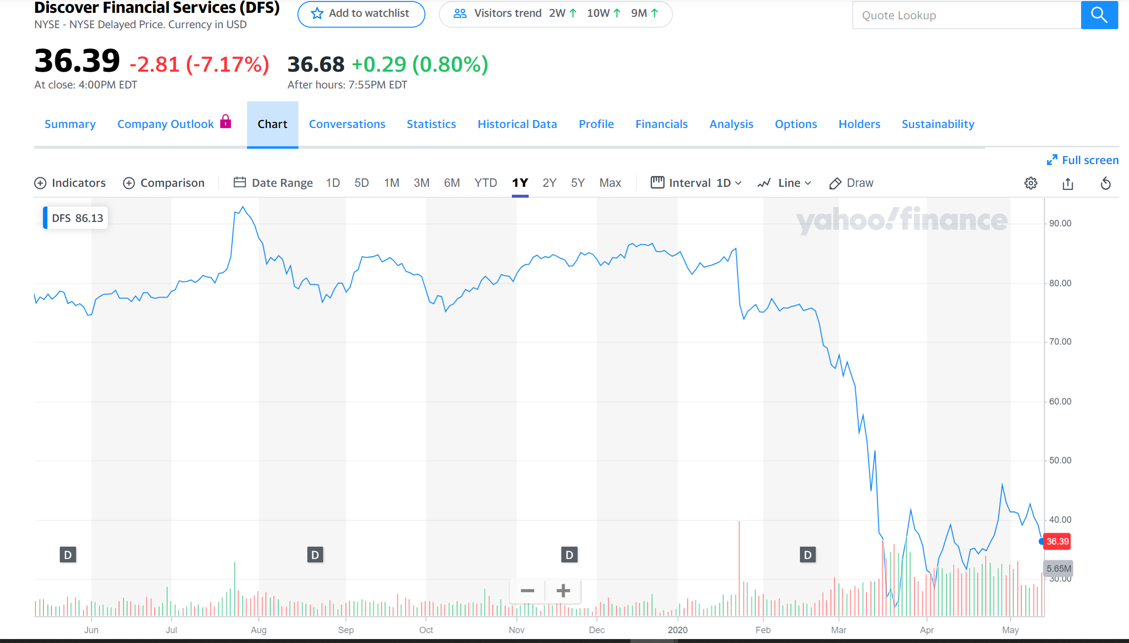

*Figure 4.* Discover Stock Price Change in 2019-2020. Retrieved May 13, 2020, from finance.yahoo.com.

**How Current Global Crisis Will Impact Online Banking**

This worldwide COVID-19 pandemic has not only hurt enormous people’s health but also hit hardly to the economic situation. Since the most efficient way to reduce the infection to this epidemic is to avoid personal contact, traditional branch banks are being forced to reduce office hours and online banking is being recommended. Another reason why online banking is increasing because using cash can be dangerous since it could spread coronavirus. According to a survey in Europe (“The impact of COVID-19 on the use of online banking”, 2020), among users between 55 and 64 years of age, 48% use online banking and there is 33% of users age between 65 and 74. Elderly people are less likely to use or know how to use online banking even though they are encouraged.

Even though this crisis has increased the use of online banking users, it still has brought significant issues we need to pay more attention. For example, security, customer service and digital channels to facilitate access to banking services should be enhanced in order to help customers get through this crisis (“The impact of COVID-19 on the use of online banking”, 2020).

In addition, since many small businesses are closed which lead to high percentage of employment rate, people have less income in the bank and decrease their shopping expenses, which can be a great hit to the online banking industry in the long term.

As for what the impact that this crisis will bring to our society in the future, the use of internet has become more and more widely used and people are getting more used to communicating with others via the internet. Services in the online banking industry might be more personalized and better meet customers’ needs.

**Conclusion**

In today’s digital world, data has become exceptionally essential that we cannot live without. Especially in the online banking industry, a giant amount of data is generated every day and are waiting to be organized well. Data analytics can be a great tool to help manage these data and help with banks make proper business actions. With analytics and big data in play and being used properly, financial companies could change their game.

This COVID-19 pandemic is a crisis but also an opportunity to online banks, so it is important for them to better utilize the data analytic tools to enhance their services so that they can stay competitive in this industry.

**References**

1. Frankenfield, Jake. (2020, May 4). Inverstopedia.com. *Online Banking.* Retrieved from <https://www.investopedia.com/terms/o/onlinebanking.asp>
2. Sarreal, Ruth. (2019, May 21). *History of Online Banking: How Internet Banking went mainstream.* Retrieved from <https://www.gobankingrates.com/banking/banks/history-online-banking/>
3. Pilcher, Jeffry. (2012, October 2). *Infographic: The History of Internet Banking (1983-2012).* Retrieved from <https://thefinancialbrand.com/25380/yodlee-history-of-internet-banking/>
4. Richter, Felix. (2015, November 10). *Banking Customers are going digital.* Retrieved from <https://www.statista.com/chart/3986/banking-customers-are-going-digital/>
5. Fox, Susannah. (2012, August 7). *51% of U.S. Adults Bank Online.* Retrieved from <https://www.pewresearch.org/internet/2013/08/07/51-of-u-s-adults-bank-online/>
6. EXT-G-Albertone.(2018, April 25).*People who used the internet for web banking, professional purposes and selling online.* Retrieved from <https://ec.europa.eu/eurostat/statistics-explained/index.php?title=File:People_who_used_the_internet_for_web_banking,_professional_purposes_and_selling_online,_EU-28,_2016_(%25_share)_BYIE18.png>
7. Zaidi, Deena. (2017, October 7). *Data Analytics in Banking.* Retrieved from <https://www.datasciencecentral.com/profiles/blogs/data-analytics-in-banking>
8. (2020, April 1). *The impact of COVID-19 on the use of online banking.* Mitek. Retrieved from <https://www.icarvision.com/en/the-impact-of-covid-19-on-the-use-of-online-banking>