A Co-Creation Framework for Eliciting Human Behavior Models to Support Crisis Risk Management: Evidence from Greece
Hossein Moradi  Université Grenoble Alpes, France  hossein.moradi@univ-grenoble-alpes.fr | Rouba Iskandar  Université Grenoble Alps, France  rouba.iskandar@univ-grenoble-alpes.fr
Julie Dugdale  Université Grenoble Alpes, France  julie.dugdale@imag.fr | Fanny Di Tursi  Université Grenoble Alpes, France  fanny.di-tursi@univ-grenoble-alpes.fr
Sebastian Rodriguez  RMIT University, Australia  sebastian.rodriguez@rmit.edu.au | Dhirendra Singh  CSIRO Data61, Australia  dhirendra.singh@data61.csiro.au
Dimitrios Tzempelikos  Municipality of Egaleo, Greece  tzempelikos@egaleo.gr | Athanasios Sfetsos  National Center for Scientific Research, Greece  ts@ipta.demokritos.gr

ABSTRACT
Human behavior models (HBMs) are representations of how individuals perceive risk, make decisions, and act during crises. These models are increasingly used in computational simulations to support disaster risk management, e.g., in assessing current or devising future evacuation strategies. However, current HBMs are often developed in an ad hoc manner and remain weakly grounded in empirical and participatory evidence. This limits the realism and transferability of simulations, ultimately reducing their value for crisis risk management. Accordingly, this paper presents a generalizable, iterative co-creation framework for eliciting HBMs. The framework translates contextual, social, and decision-making knowledge into validated, model-ready behavioral representations through empirical data, expert validation, and continuous stakeholder feedback. To evaluate the framework, it was applied in Egaleo, Greece, for earthquake and heatwave scenarios, where evacuation strategies were tested using agent-based simulations coupled with elicited HBMs. The results of simulations reveal significant differences in evacuation timing and spatial congestion.

Keywords
Human Behavior Model, Co-Creation Framework, Crisis Risk Management, Agent-based Model, Simulation-Based Decision Support

INTRODUCTION
Crisis management and disaster risk reduction increasingly rely on simulation-based tools to inform preparedness, response, and policy design across a wide range of hazards (Tasantab et al., 2021). From earthquakes and floods to heatwaves and cascading crises, the value of these tools depends on their ability to realistically represent how disruptions propagate through interconnected socio-technical dimensions (Moradi, Iskandar, Rodriguez, Singh, Dugdale, Tzempelikos, & Sfetsos, 2025). In this regard, although substantial progress has been made in modeling hazard processes, infrastructure performance, and mobility systems, the incorporation of human behavior models (HBMs), i.e., how individuals perceive risk, make decisions, and adapt their actions under stress and uncertainty, remains one of the most persistent sources of uncertainty (Abdel-Latif et al., 2023; Osman, 2010). Based on the current literature (Barnes et al., 2021; Greasley & Owen, 2016; Heppenstall et al., 2016; Kennedy, 2012; Pew, 2008), many simulation-based approaches still rely on simplified, weakly validated, or context-insensitive behavioral assumptions. This limits their realism and transferability to other situations, and ultimately restricts their use in people-centered crisis risk management. To address this, we propose a co-creation approach for the elicitation, validation, and operationalization of HBMs that are both empirically grounded and transferable across crises.
In this context, early HBMs were primarily based on physics-inspired approaches, most notably the social force model (Helbing & Molnár, 1995), which enabled the representation of crowd movement, congestion, and bottlenecks in constrained environments (X. Chen et al., 2018). While effective for capturing aggregate dynamics, these models were limited in representing individual decision-making, social interaction, and adaptive behavior (Wu et al., 2022). To overcome this, research progressively shifted toward the explicit representation of heterogeneous individuals with distinct attributes, perceptions, goals, and decision rules in diverse scenarios (An, 2012; Haer et al., 2017; Rufat et al., 2024). Other works have further advanced this line of research by incorporating cognitive architectures (Zainuddin & Shuaib, 2010), learning mechanisms (Romero & Escudero, 2023), and social interaction models (Ren et al., 2018) to capture how individuals adapt their behavior in response to evolving hazard conditions, information flows, and social influences (Moradi, Iskandar, Rodriguez, Singh, Dugdale, Tzempelikos, Sfetsos, et al., 2025a, 2025b). Despite these advances, however, the processes by which HBMs are elicited, validated, and adapted across different hazards and societal contexts often remain ad hoc, implicit, and tightly coupled to specific case studies rather than being guided by a generalizable methodological framework.
This paper addresses this methodological gap by proposing a general, iterative co-creation framework for the systematic development of HBMs that links contextual scenario definition, empirical data collection, and adaptive behavioral modeling within a continuous feedback loop. The framework structures HBM elicitation through three tightly coupled stages: (i) participatory scenario building, which captures the environmental, social, and decision-making contexts; (ii) data structuring and living scenario dataset construction, ensuring that the data is model-ready, inclusive, updatable; and (iii) behavioral model construction and adaptation, where behavioral variables are extracted, decision-making styles are derived and calibrated, and models are iteratively refined through stakeholder feedback. By explicitly embedding vulnerability, social diversity, governance conditions, and decision environments into the process, the framework moves beyond ad hoc behavioral specification and enables the development of empirically grounded, transferable, and simulation-ready HBMs across hazards, geographic settings, and population groups.
It is worth noting that a growing body of research has addressed each of the components reflected in the three stages above. Participatory and co-design approaches in disaster risk management have developed robust methods for eliciting stakeholder knowledge, co-creating scenario narratives, and strengthening contextual legitimacy (Lempert et al., 2023; Melles, 2021; Slinger et al., 2023). Survey-based behavioral studies and diverse HBM construction techniques, including theory-informed causal structures (Ng et al., 2025), behavioral profiles or archetypes (Tocchi et al., 2025), and probabilistic decision rules or thresholds (Guo et al., 2017), have advanced the representation of heterogeneous decision patterns under risk. Likewise, data engineering and structured data architectures have been extensively studied as mechanisms for modular data integration, versioning, and updating over time (Brown & Anderson, 2023; Davahli et al., 2020; Ding et al., 2022). However, these contributions largely remain confined to distinct methodological domains. Participatory processes often culminate in qualitative insights without systematically translating outcomes into structured, model-ready behavioral variables. Empirical behavioral studies frequently remain detached from operational simulation environments and do not explicitly feed back into scenario refinement. Data engineering practices, while methodologically mature, are rarely designed to function as a bridge between participatory scenario building and adaptive behavioral modeling. As a result, limited methodological guidance exists for systematically moving from co-created contextual understanding, to architecture-aligned empirical data, to validated and simulation-ready human behavior models that can be iteratively refined across hazards and settings. The contribution of the proposed co-creation framework lies precisely in formalizing this end-to-end translation and feedback logic into a structured, reproducible methodological workflow that bridges participatory practice, empirical data engineering, and simulation-based behavioral modeling.
Accordingly, the proposed framework advances the state of the art in three key ways:
- Advancing generalizable and reproducible HBM elicitation: We formalize a structured, hazard-agnostic framework that enables the systematic development of HBMs across different hazards, geographic contexts, and population groups, moving beyond case-specific and assumption-driven behavioral modeling.
- Advancing integrated empirical–participatory–adaptive workflows: The framework includes a continuous feedback loop that links participatory scenario building, survey-based empirical data, and adaptive behavioral modeling. This means that the derived HBMs are empirically grounded and dynamically updatable.
- Advancing the operationalization of people-centered behavior in simulations: By embedding vulnerability, social diversity, governance conditions, and decision environments directly into the HBM development process, the framework enables the construction of simulation-ready, transferable, and policy-relevant behavioral models for crisis risk management.
We demonstrate the operation of our framework in Egaleo, Greece, a seismically active urban area that is also exposed to heatwave risk (Papagiannaki et al., 2019). In the heatwave scenario, the framework is implemented up to the second stage by completing participatory scenario building and the development of a model-ready, living scenario dataset. For the earthquake scenario, the full framework is applied end-to-end. This includes empirical data collection, dataset development, and stakeholder-driven HBM elicitation, with the resulting HBM being integrated into an agent-based model (ABM). The resulting ABM-HBM simulations reveal notable differences in evacuation timing and spatial congestion when rich HBMs are used compared to simplified behavioral assumptions.
The remainder of this paper is structured as follows. Section 2 presents the proposed co-creation framework for eliciting HBMs, detailing its three stages and their interdependencies. Section 3 describes the implementation of the framework in the case study area of Egaleo, Greece, including the development of HBMs for earthquake and heatwave scenarios and the integration of the earthquake HBM into the ABM. Section 4 discusses the implications of the findings for crisis risk management and the broader applicability of the framework. Finally, Section 5 concludes the paper and outlines directions for future research.

FRAMEWORK OVERVIEW
This section describes the proposed framework for the systematic elicitation of HBMs, illustrated in Figure 1. The framework structures HBM development through three interlinked stages: Participatory Scenario Building, Living Scenario Dataset, and Behavioral Representation. Participatory Scenario Building specifies the environmental and system conditions, the population and social diversity, and the behavioral and decision environment through iterative stakeholder engagement. These scenario definitions are translated into the Living Scenario Dataset by designing surveys that measure them and organizing the collected data so that each scenario variable corresponds to a specific data item. Behavioral Representation then translates these inputs into HBMs through variable extraction, data-driven construction, calibration, validation, and iterative adaptation. Continuous feedback across these stages enables the progressive refinement of scenarios, data, and behavioral representations over time. Each stage is described in more detail in the following subsections.

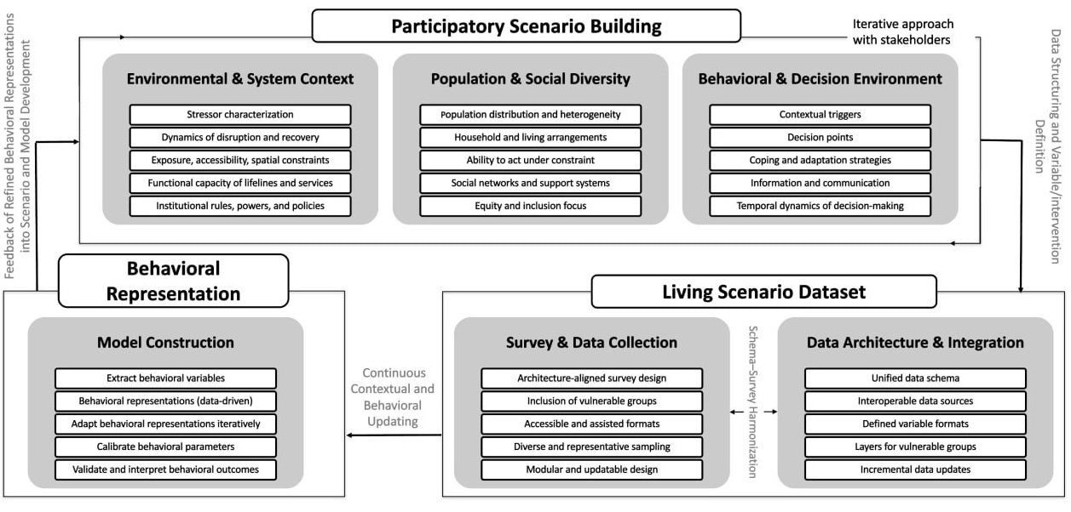
Figure 1. General Co-creation framework for HBM Elicitation

Participatory Scenario Building
Participatory Scenario Building is the foundation of the framework and defines the contextual space of human behavior. This stage establishes a shared understanding of the crisis setting through structured engagement with stakeholders, domain experts, and local actors. Rather than assuming predefined behavioral conditions, the framework treats scenarios as co-produced artifacts that evolve iteratively as new knowledge, evidence, and perspectives emerge. The objective of this stage is to formalize the system stressors, societal conditions, and decision environments that shape individual and collective behavior before, during, and after a disruptive event.
As illustrated in Figure 1, Participatory Scenario Building structures the foundations of HBMs along three complementary dimensions that are iteratively refined through stakeholder interaction: (i) Environmental and System Context, (ii) Population and Social Diversity, and (iii) Behavioral and Decision Environment. Specifically:
- Environmental and System Context characterizes the physical, infrastructural, and institutional conditions under which behavior unfolds, including the disruptive event and its temporal evolution, spatial configuration, infrastructure capacity and vulnerability, and governance and policy frameworks. These elements define the external constraints and enabling conditions that shape behavior and risk exposure.
- Population and Social Diversity captures social heterogeneity through population distribution, household structures, access to resources, ability to act, and social networks. Explicit attention to equity and inclusion ensures that vulnerable and marginalized groups are represented rather than implicitly averaged out.
- Behavioral and Decision Environment specifies the cognitive and informational conditions governing action, including contextual triggers, decision points, coping and adaptation strategies, communication channels, and the temporal dynamics of decision-making.
Insights from subsequent data collection and behavioral modeling stages are continuously fed back into scenario definitions, enabling stakeholders to revisit assumptions, refine system stressors, and adjust behavioral expectations. By structuring scenario definition along these three dimensions and embedding it within a co-creation loop, Participatory Scenario Building establishes a direct conceptual bridge between societal context and behavioral modeling, ensuring that subsequent data collection and behavioral representation remain locally grounded, socially differentiated, and decision-oriented.

Living Scenario Dataset
The Living Scenario Dataset operationalizes the outputs of Participatory Scenario Building into a structured, empirical, and updatable data layer that supports behavioral modeling. It forms the interface between scenario knowledge and quantitative behavioral representation by translating contextual, social, and decision-related dimensions into measurable inputs.
This stage is structured around two coupled components: (i) Survey and Data Collection Design, and (ii) Data Architecture and Integration. Together, they ensure that data acquisition aligns with the scenario while also being adaptable to evolving knowledge and emerging evidence. To this end:
- Survey and Data Collection Design is driven by the scenario defined during Participatory Scenario Building. Rather than relying on generic behavioral questionnaires, it supports survey instruments in which items are directly mapped to the three dimensions of the participatory process, ensuring consistency between scenario definitions and empirical measurements. The organization of survey items into separable thematic blocks allows incremental updates as scenarios evolve, new hazards are considered, or additional behavioral hypotheses emerge. Sampling strategies are also constructed to reflect spatial, social, and demographic heterogeneity, as well as varying levels of vulnerability.
- Data Architecture and Integration organizes the collected inputs within a consistent data organization that uses shared variable definitions and formats, supporting interoperability, traceability, and structured behavioral extraction. Variables are defined in forms that correspond directly to downstream behavioral modeling needs, enabling linkage between observed responses and formal behavioral representations. Data are organized to distinguish individual responses, population subgroups, vulnerability profiles, and decision contexts, allowing these dimensions to be analyzed separately or in combination. Incremental data updates are supported, enabling the dataset to evolve as new information becomes available and successive scenario iterations are conducted.
By coupling scenario-driven survey design with a consistent and incrementally updatable organization of empirical data, the Living Scenario Dataset provides the empirical backbone of the proposed framework. It enables behavioral representations to be grounded in locally relevant, socially differentiated, and empirically anchored information.

Behavioral Representation
Behavioral Representation constitutes the final stage of the framework. In this stage, the collected information is translated into HBMs suitable for simulation. Behavioral Representation provides the computational realization of the behavioral knowledge by extracting behavioral variables, constructing behavioral representations, calibrating model parameters, and iteratively refining the resulting models through validation and feedback, and it is intentionally defined in a model-agnostic manner. While archetype-based agent representations (F. Chen et al., 2014), i.e., groups of agents sharing similar decision-making patterns and response behaviors, are used in our case study (Section 3), the framework equally supports alternative forms of behavioral representation, including rule-based agents, cognitive architectures, probabilistic decision models, or hybrid approaches, depending on the modeling objectives and available data.
Behavioral Representation comprises four processes:
- Behavioral Variable Extraction translates survey responses and contextual attributes into model-relevant behavioral variables that directly inform decision logic in simulation. These variables capture vulnerabilities and risk perception, social orientation, access to resources, behavioral intentionality, and other related factors shaping action. This step ensures traceability between observed behavioral patterns and their representation.
- Data-Driven Behavioral Model Construction uses the extracted variables to construct behavioral representations through clustering, classification, rule induction, or probabilistic modeling techniques. These representations may take the form of behavioral types, decision profiles, response functions, or cognitive structures, depending on the chosen modeling paradigm and simulation requirements.
- Calibration and Validation aligns the behavioral representations with empirical observations, expert judgment, and aggregate behavior patterns. Calibration procedures adjust behavioral parameters to ensure realism, while validation assesses the internal consistency of behavioral logic and the plausibility of resulting population-level dynamics under scenario conditions.
- Adaptive Refinement through Feedback enables the continuous adaptation of behavioral representations as new data become available, scenarios evolve, or discrepancies emerge between simulated and observed outcomes. Insights from simulation outputs, stakeholder evaluation, and empirical updates are fed back into earlier stages, supporting progressive model refinement over time.
In summary, by linking scenario definitions, empirical data, and formal behavioral models within an iterative feedback loop, the Behavioral Representation stage enables the deployment of transferable, simulation-ready HBMs for crisis risk management applications.

FRAMEWORK APPLICATION IN EGALEO, GREECE
This section describes how the proposed framework was applied to the case study of Egaleo, Greece, a dense urban municipality exposed to both seismic and extreme heat risks. The framework was used as a methodological pipeline to elicit, structure, and operationalize HBMs under real-world crisis conditions through close collaboration with local authorities, civil protection actors, and domain experts. Following the three stages introduced in Section 2, we first co-developed participatory scenarios that reflected the local multi-hazard context, population characteristics, and decision environments. These scenarios were then translated into empirical data through survey design and living dataset construction. Finally, the resulting data were used to derive formal behavioral representations. It should be noted here that the framework is applied end-to-end for the earthquake hazard, while for the heatwave scenario, it is applied up to the scenario building and survey design stages, providing a basis for future HBM elicitation. The heatwave case, therefore, serves only to illustrate the hazard-agnostic structure of the framework and its capacity to support future HBM elicitation across risk contexts.

Participatory Scenario Building in Egaleo
Participatory Scenario Building in Egaleo applied the three dimensions defined in Section 2 (i.e., environmental and system context, population and social diversity, and the behavioral and decision environment) within an iterative co-creation process (see Figure 1). In this stage, the hazard and system constraints were first characterized, and the demographic and social heterogeneity of the study area was formalized. Building on these foundations, the behavioral and decision environment was structured through successive refinements of response assumptions. Rather than producing a single static scenario, this process supported progressive elaboration of evacuation behavior. Specifically, for the earthquake scenario, development progressed as follows:
- Baseline scenario: all individuals comply with evacuation protocols.
- Capacity-aware scenario: compliance is maintained, and capacity limits at evacuation centers are introduced.
- Behavior-informed scenario: compliance assumptions are relaxed by integrating evacuation archetypes into the agent-based simulations.
Scenarios were further updated based on stakeholder feedback on the simulation results. For example, an initially assumed downtown green space was removed as a safety location due to expert concerns about tree density. Additional refinements reflected municipal priorities, such as testing evacuation outcomes when residents were pre-informed about designated safe locations. The process through which these scenario components were defined and refined across the three dimensions is described in detail below.
Environmental and System Context characterizes both the hazard stressor and the system within which behavior unfolds. For the earthquake scenario, the 7 September 1999 Athens earthquake (Lekkas, 2001) was adopted as the reference event, providing stressor characterization through locally relevant shaking intensity patterns derived from the USGS ShakeMap (Figures 2 (a)–(b)). These intensity patterns were translated into neighborhood-scale building damage estimates using the model proposed by (Iskandar et al., 2023), capturing exposure and spatial constraints that condition movement, accessibility, and shelter availability across the area (Figure 2 (c)). Differences in damage severity were further used to represent dynamics of disruption and recovery, reflecting heterogeneous temporal trajectories of accessibility across neighborhoods. System-level capacities were represented through assumptions on the functional capacity of lifelines and services, including the configuration and connectivity of road networks, emergency access routes, and the capacity of designated shelters and critical facilities. Institutional rules, powers, and policies were operationalized through civil protection procedures and municipal response practices, including officially designated assembly points, evacuation protocols, emergency communication strategies, and operational constraints governing access to damaged zones.
For the heatwave scenario, documented extreme heat events affecting Athens (Paravantis et al., 2017) were used to define the stressor characterization, including typical heatwave durations, intensity thresholds, and multi-day accumulation effects. Through iterative interaction with experts and local stakeholders, these hazard narratives were formalized to represent dynamics of disruption and recovery, capturing how prolonged exposure, nighttime heat persistence, and cumulative stress influence temporal patterns of risk and response. Heatwave impacts were further structured to reflect exposure and spatial constraints by accounting for building quality, urban density, green space availability, and access to cooling resources. System-level response capacity was represented through assumptions on the functional capacity of lifelines and services, including electricity and water reliability, mobility and public transport infrastructure, healthcare system capacity, and the availability of cooling centers and other cooling infrastructure. Institutional rules, powers, and policies were operationalized through variables reflecting emergency response preparedness, service prioritization, and operational capacity during extreme heat events. In Egaleo, these included cooling centers, health and social care outreach programs, public communication protocols, mobility adjustments, and community-based assistance schemes, shaping the formal intervention environment within which residents operate. As summarized in Table 1, all this structuring transformed heatwave impacts into a set of explicit, behaviorally relevant context variables.
Population and Social Diversity defines how differences in population composition, distribution, and social conditions constrain or enable individual behavior during crises. In this study, we focus on the area shown in Figure 2(c), corresponding to the zone for which detailed earthquake damage estimation was conducted. This study area comprises approximately 5000 residents, for whom demographic distributions were obtained from municipal records and census data. These baseline datasets were used to parameterize the synthetic population and ensure that population-level characteristics were grounded in official statistics. Building on this foundation, the population distribution and heterogeneity component was operationalized by formalizing heterogeneity through items like age, health status, income level, housing conditions, and spatial distribution. Furthermore, household and living arrangements captured whether individuals lived alone, in family units, or in multigenerational households, shaping coordination and caregiving needs. The ability to act under constraint was represented through mobility limitations, chronic illness, pregnancy, and caregiving responsibilities, directly affecting evacuation feasibility and access to cooling. Social networks and support systems captured differences in information access, informal assistance, and reliance on external support. An explicit equity and inclusion focus ensured that older adults, individuals with mobility or health limitations, low-income households, residents living alone, and caregivers were represented as distinct behavioral groups rather than averaged within the population. These variables are summarized in Table 2.
Behavioral and Decision Environment defines the cognitive, informational, and temporal conditions under which individuals make decisions and adapt their actions during crises. In Egaleo, this dimension was operationalized by structuring hazard situations into staged decision environments (pre-event preparedness, impact and immediate reaction, short-term response, and sustained disruption), each associated with specific contextual triggers and decision points, such as whether to evacuate or remain, when to act, where to go, and whom to prioritize. Stakeholder engagement was also used to identify how information and communication channels and official warnings influence perceived risk, decision credibility, and compliance. Finally, by considering institutional rules, powers, and policies, we specified coping and adaptation strategies, ranging from informal support and self-organized sheltering to the use or avoidance of formal services, while accounting for the temporal dynamics of decision-making as conditions evolve. For example, in case of an earthquake, when multiple officially designated evacuation areas were available (institutional rules, powers, and policies), and an individual selected a designated site as a coping strategy (behavioral and decision environment), congestion or capacity limits at that location triggered a revision of the initial plan, leading individuals to redirect toward nearby alternative locations (temporal dynamics of decision-making).
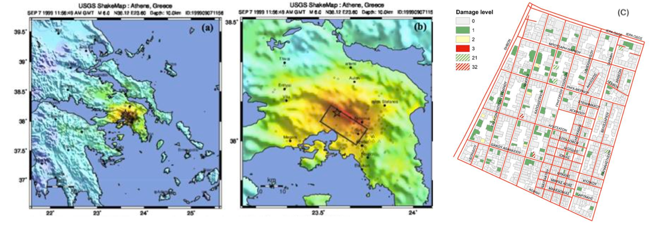
Figure 2. (a) USGS ShakeMap showing regional ground-shaking intensity during the 1999 Athens earthquake (Mw 6.0). (b) Localized shaking intensity in the western Athens basin; the star indicates the location of Egaleo relative to the earthquake source. (c) Model-based building damage estimation for the Egaleo road network, where colors represent increasing damage severity from low to high, corresponding to predicted structural damage levels.
Table 1. Heatwave characterization variables used to formalize the environmental and system context.
Factor | Description | Factor | Description
Intensity of heatwave | Mild / Moderate / Severe | Cooling Centers Access | None / Access
Heatwave Duration | Single-day / Multi-day | Electricity Reliability | Low / Medium / High
Time of Day (Heat Profile) | Daytime / Nighttime | Water Access & Quality | Low / Medium / High
Humidity Level | Low / Medium / High | Public Transport Conditions | Poor / Acceptable / Good
Urban vs Rural Setting | Rural / Suburban / Urban | Healthcare System Capacity | Low / Medium / High
Building Type & Quality | Poor / Average / Good | Emergency Response Preparedness | Low / Medium / High
Green Space Availability | Low / Medium / High | Local Climate Norms | Low / Medium / High
Air Conditioning in Homes | None / Partial / Full | Other Cooling Infrastructure | None / Limited / Good

Table 2. Population and social diversity variables used as behavioral signatures for HBM.
Factor | Description | Factor | Description
Age Group | Children / Adults / Older Adults | Household Composition | Alone/Family/ Multigenerational
Gender | Male / Female | Caregiver Role | None / Caregiver
General Health | Healthy / At-Risk | Language & Literacy | Limited / Moderate / Fluent
Chronic Illness | No / Yes | Communication Means | Radio/TV / Phone / Internet
Mobility Disability | No / Yes | Social Support Network | Weak / Moderate / Strong
Pregnancy / Infant Status | None / Pregnant / Infant Present | Community Support Norms | Low / Medium / High
Income Level | Low / Medium / High | Education Level | Low / Medium / High
Homelessness Risk | No / Yes

Construction of the Living Scenario Dataset in Egaleo
The Living Scenario Dataset in Egaleo integrates the outputs of Participatory Scenario Building with Survey and Data Collection and is designed to operationalize the co-created scenarios. For the heatwave crisis, the Living Scenario Dataset is currently being developed through Survey and Data Collection, which is still ongoing. The questionnaire was designed to translate the heatwave-related context into measurable variables, with items covering thermal exposure conditions, access to cooling resources and services, health-related constraints, and access to information. In line with the framework, the survey explicitly accounts for vulnerable groups, including older adults, individuals with health conditions, and residents with limited access to cooling devices. The remainder of this section focuses on the earthquake scenario, for which the Living Scenario Dataset has been completed and subsequently used for HBM construction.
For the earthquake scenario, the associated questionnaire followed an architecture-aligned survey design, with items explicitly mapped to the environmental and system conditions, population characteristics, and decision environments identified during scenario co-creation. To ensure coherence with the framework, the survey was structured around two complementary logics. First, it captured what individuals are able to do, reflecting capacities, resources, constraints, and social conditions grounded in the environmental and system context and population and social diversity dimensions. For example, items assessed access to safe spaces, household composition, health vulnerabilities, and caregiving responsibilities. Second, it captured when and under what conditions individuals act, reflecting the behavioral and decision environment dimension through questions on decision triggers, response timing, information use, and adaptive behavior under evolving conditions. Here, particular attention was given to the inclusion of vulnerable groups, with targeted outreach and assisted survey completion to accommodate older adults, individuals with health or mobility limitations, low-income households, and residents facing literacy or language barriers. By structuring survey items around capacity to act and timing of action, the questionnaire operationalized the co-created scenarios in a form directly compatible with downstream behavioral variable extraction and model construction.
The resulting survey comprised 121 responses, as described in Table 3. Although the survey sample (N=121) is relatively small compared to the approximately 5000 residents in the study area, a stratified sampling strategy was applied to ensure coverage across key population strata. Specifically, respondents were recruited to reflect variation across neighborhoods, age groups, household compositions, and identified vulnerability profiles defined during Participatory Scenario Building. Rather than relying on simple random sampling, the stratified approach intentionally sought proportional representation of socially and spatially differentiated groups, including vulnerable subpopulations, thereby reducing the risk that particular segments of the community would be underrepresented. Comparison with municipal demographic distributions indicates that the main population strata (e.g., age structure, gender distribution, educational levels, and vulnerable people) are reflected in the sample. Note here that the survey was not designed to produce statistically representative prevalence estimates at the population level; rather, it serves to elicit and validate distinct behavioral patterns, decision logics, and response archetypes. Population-level distributions used in the simulation model are anchored in census and municipal data, while the survey informs the structure and parameterization of behavioral diversity. This separation ensures that the behavioral representation is empirically grounded without relying on the survey alone for demographic representativeness.
Data Architecture & Integration organized the responses under a unified data schema (in this case study, a single questionnaire version was deployed, ensuring internal consistency across all variables). Defined variable formats ensured compatibility with downstream behavioral modeling. As summarized in Table 3, core demographic variables (age, gender, and education) were stored alongside explicit layers for vulnerable groups, enabling differentiated analysis rather than population averaging. This structure supported interoperable data sources, allowing survey data to be directly linked to behavioral representations, and accommodated incremental data updates as new responses or scenario iterations were added.
Table 3. Sample demographic characteristics (N=121)
Age |  | Gender |  | Educational level
Under 18 | 2% | Female | 63% | Never went to school | 2%
18-24 | 16% | Male | 36% | Primary level | 7%
25-39 | 25% | Prefer not to answer | 1% | Secondary level | 33%
40-64 | 53% |  |  | Higher education | 56%
65 and older | 5% |  |  | Prefer not to answer | 2%

Earthquake behavioral representation in Egaleo
In this case study, archetype-based representations were adopted as the HBM structure. Given the modest sample size (N = 121), clustering was employed as an exploratory tool to identify coherent behavioral patterns rather than to estimate statistically representative prevalence rates within the population. The purpose of clustering was to reveal structured differences in evacuation timing, destination choice, protective behavior, and social coordination, thereby informing the form of behavioral diversity embedded in the model. Importantly, the survey and census data play distinct roles within the framework. The survey informs the structure and qualitative differentiation of behavioral archetypes (i.e., how people decide and act) while population-level composition in the simulation (e.g., age distribution, household structure, vulnerability prevalence) is anchored in census and municipal datasets. Archetype proportions in the synthetic population are therefore aligned with demographic distributions rather than inferred solely from the survey sample. This separation ensures that the resulting HBM is empirically grounded in observed behavioral patterns while avoiding overreliance on a small sample for population-level statistical inference.
Clustering was restricted to decision-relevant behavioral signatures identified during Participatory Scenario Building and operationalized in the questionnaire. Variable selection followed three principles: direct correspondence to explicit decision points within the staged earthquake response environment, behavioral relevance for evacuation modeling, and sufficient variability across respondents to enable meaningful differentiation. The clustering inputs, therefore, captured the primary evacuation decision (evacuate or remain), response timing (delay categories), intermediate protective or social actions (e.g., searching for household members), destination choice (near building, undefined open space, or designated assembly point), and social coordination (evacuate alone or with others). Contextual and attitudinal attributes (such as perceived building safety, preparedness level, and trust in authorities) were intentionally excluded from cluster formation to avoid demographic or perceptual factors dominating behavioral grouping. These attributes were instead used post hoc to interpret and characterize the resulting archetypes (Tables 4–6). Prior to clustering, categorical variables were consistently encoded, ordinal variables were treated as ordered to preserve rank structure, and missing responses were handled through variable-wise exclusion to avoid imputing behavioral decisions.
Clustering was implemented using a hierarchical procedure in Treensight, applied to the selected behavioral variables. Hierarchical clustering was chosen as an exploratory approach because it allows examination of nested similarity structures without requiring the number of clusters to be specified a priori. The resulting dendrogram was inspected at multiple cut levels to explore alternative partitioning solutions. Candidate solutions were evaluated based on (i) behavioral distinctiveness across key evacuation dimensions (decision to evacuate, delay, destination, and social coordination), (ii) interpretability of resulting behavioral profiles, (iii) relative balance of cluster sizes, and (iv) practical relevance for evacuation planning. The seven-cluster solution was retained because it provided a clear and behaviorally meaningful differentiation between evacuation patterns while maintaining parsimony and avoiding excessive fragmentation into small respondent groups. The plausibility and usefulness of this solution were further assessed through structured feedback with municipal and civil protection stakeholders, consistent with the calibration and validation stage of the framework. The resulting archetypes are summarized in Tables 4–6.
Table 4. Socio-demographic characteristics of the identified archetypes
Archetypes | Demographic signatures
 | Age | Gender | Education | Income | Has disability | Care giving | Household composition
Prepared Stay-at-Home | 25-39 and >64 | Female | Higher education | >40 k | Likely | Unlikely | Couple Household without Children or Group Adults
Reluctant Evacuator | <39 | Female | Higher education | 10 - 20 k | Likely | Likely | Couple Household with Children or Single Parent
Social Reluctant Evacuator | 40-64 | Female | Primary level | 30 - 40 k | Likely | Likely | Single Adult or Single Parent
Protective Evacuator | 40-64 | Female | Secondary level | 30 - 40 k | Likely | Unlikely | Couple Household with Children or Single Parent
Social Protective Evacuator | 25-39 | Male | Higher education | 20 - 30 k | Unlikely | Unlikely | Couple Household with Children or Single Parent
Proactive Evacuator | 18-35 | Female | Higher education | 10 - 20 k | Unlikely | Likely | Multigenerational Household
Social Proactive Evacuator | 40-64 | Male | Secondary level | 20 - 30 k | Unlikely | Likely | Couple Household with Children or Single Adult

Table 5. Characteristics of the identified archetypes for earthquake evacuation in Egaleo
Archetypes | Knowledge/Preparedness
 | Feeling prepared for an earthquake | Received information on behaviors | Knowledge of recommended actions in the street | Knowledge of recommended actions at home | Knowledge of recommended actions at work | Knowledge of Designated Open spaces
Prepared Stay-at-Home | Yes | No | Yes | Yes | Yes | No
Reluctant Evacuator | No | Yes | No | No | No | No
Social Reluctant Evacuator | No | No | No | No | No | No
Protective Evacuator | Yes | Yes | Yes | Yes | No | No
Social Protective Evacuator | Yes | No | No | No | No | No
Proactive Evacuator | No | Yes | Yes | Yes | Yes | Yes
Social Proactive Evacuator | Yes | Yes | Yes | Yes | Yes | Yes

Table 6. Behaviors of the identified archetypes for earthquake evacuation in Egaleo
Archetypes | Behaviors
 | Evacuation Decision | Intermediate Action | Final Destination | Evacuates with Others | Delay (min)
Prepared Stay-at-Home | No | - | - | - | -
Reluctant Evacuator | Yes | No | Near Building | Yes, Evacuates with Everyone | 1-5
Social Reluctant Evacuator | Yes | Yes | Near Building | No, Evacuates Alone | 1-5
Protective Evacuator | Yes | No | Undefined Open Space | Yes, Evacuates with Everyone | 1-5
Social Protective Evacuator | Yes | Yes | Undefined Open Space | Yes, Evacuates with Everyone | 6-15
Proactive Evacuator | Yes | No | Designated Open Space | Yes, Evacuates with Someone | 6-15
Social Proactive Evacuator | Yes | Yes | Designated Open Space | Mixed | <1

For each archetype, dominant categorical values and modal characteristics were identified to summarize its socio-demographic and behavioral profile. Tables 5 and 6 summarize the core behavioral attributes of each archetype across the main decision points. Prepared Stay-at-Home archetype represents individuals who generally trust the structural safety of their building, report relatively high levels of preparedness, and are inclined to stay indoors, especially in low-rise buildings. Reluctant Evacuators and Social Reluctant Evacuators both tend to evacuate only when strong cues or visible damage are present. However, Social Reluctant Evacuators prioritize staying physically close to family and friends and are more likely to delay movement until their social circle moves. Protective Evacuators and Social Protective Evacuators systematically prioritize the safety of dependents (children, older adults, or people with limited mobility), often spending additional time confirming that household members or relatives are safe before moving to an open area. In the social variant, this protective focus extends to neighbors and close contacts. Finally, Proactive Evacuators and Social Proactive Evacuators are characterized by early, self-initiated evacuation, frequent use of predefined assembly points, and strong reliance on personal knowledge of evacuation procedures; again, the social variant places greater emphasis on coordinated departure with others and on mutual assistance during movement. These behavioral patterns are systematically linked to distinct socio-demographic and attitudinal profiles.
To operationalize these archetypes within the census-based synthetic population, the dominant socio-demographic characteristics summarized in Table 4 were treated as signature profiles for each behavioral type. Using municipal and census datasets, we generated a synthetic population of approximately 5000 residents reflecting the local age distribution, gender composition, household structure, education levels, and available vulnerability indicators. Each synthetic individual was then assigned to an archetype using an attribute-matching procedure, where agreement across key attributes (e.g., age group, gender, household composition, caregiving status, disability, and other available variables) was used to identify the best-aligned archetype profile. The resulting archetype distribution in the synthetic population (Figure 4) therefore reflects the proportion of individuals whose census-based characteristics best match each archetype’s signature profile. In this way, survey data inform the definition and interpretation of behavioral types, while census and municipal data determine their prevalence within the modeled population.
The plausibility and interpretability of the derived archetypes were assessed based on the calibrate behavioral parameters element via a structured feedback session with local stakeholders, consistent with the expert-engagement loop defined in the framework (Figure 1). Municipal officials, civil protection representatives, and technical experts reviewed the archetype definitions and associated behavioral tables and evaluated their realism, coverage of observed response patterns, and relevance for evacuation planning (Figure 3). Overall, the feedback confirmed that the archetypes reflected recognizable behavioral types observed in past drills and earthquake events in Egaleo (i.e., validate and interpret behavioral outcomes). Stakeholders emphasized the importance of Reluctant Evacuators as a key group for targeted risk communication, while Social Proactive Evacuators were identified as potential facilitators of collective action during preparedness and response. Based on this feedback, minor refinements to archetype labels and descriptions were introduced to ensure consistency with local terminology and practice.
Through this process, the Behavioral Representation stage in Egaleo delivered a multi-archetype earthquake HBM that is firmly anchored in Living Scenario Dataset yet sufficiently compact and interpretable for practical use by stakeholders. The combination of data-driven clustering, socio-demographic characterization, and participatory validation ensures that the resulting behavioral types are both empirically grounded and locally meaningful. The next section explains how these archetypes were integrated into the ABM. The goal of the simulation was to explore how differences in decision timing, social coordination, and protective behavior translate into distinct patterns of evacuation dynamics and congestion across the urban network.

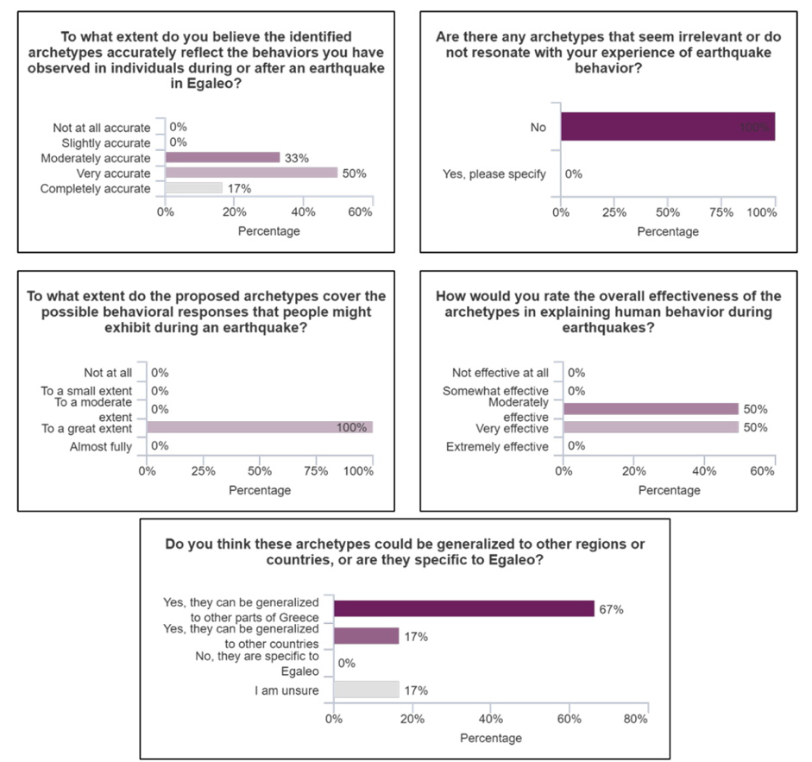
Figure 3. Experts’ feedback on the behavioral archetypes for earthquake response in Egaleo

EARTHQUAKE EVACUATION SIMULATION WITH ARCHETYPE-BASED HBM
Building on the behavioral archetypes described in Section 3, we operationalized these patterns within the ABM platform to examine how socially differentiated decision-making shapes evacuation dynamics. The simulation was implemented in MATSim (W. Axhausen et al., 2016), which provides the mobility and network execution engine. Seven archetypes represent the dominant behavioral logics within Egaleo’s population, and their prevalence within the simulated population (Figure 4) was determined as described in Section 3. We now describe how these archetypes were integrated into the simulation environment.
To operationalize the derived archetypes within the evacuation simulation, we adopted a Belief–Desire–Intention (BDI) architecture as the cognitive layer governing agent decision-making (Caillou et al., 2017). The BDI model structures behavior into three components: beliefs, representing an agent’s perception of its environment and internal state; desires, representing goals or priorities the agent seeks to achieve; and intentions, representing the concrete actions the agent commits to executing. In this study, each archetype corresponds to a distinct configuration of beliefs, goal priorities, delay parameters, and action rules. Archetypes, therefore, do not merely label agents; they define how agents interpret hazard conditions, prioritize objectives, and commit to actions during evacuation. For example, consider a Social Protective Evacuator under strong shaking conditions. The agent’s beliefs include perceived building risk, awareness of dependent household members, and knowledge of nearby open spaces. The dominant desire for this archetype is to ensure the safety of dependents before self-evacuation. This generates an intention sequence: first, confirm the status of children, vulnerable household members, or relatives (intermediate action), then evacuate toward an open space after a moderate delay or after visiting them. By contrast, a Proactive Evacuator forms the belief that evacuation is immediately necessary, prioritizes reaching a designated assembly point, and commits to rapid departure with minimal delay. A Prepared Stay-at-Home, under similar perceived shaking, maintains a belief in structural safety and forms the intention to remain indoors unless perceived risk exceeds a defined threshold. In this way, the survey-derived behavioral differences are translated into differentiated cognitive rules governing departure timing, intermediate actions, and destination choice.
Figure 5 illustrates the layered integration between the BDI cognitive architecture and the MATSim platform. At the application layer, archetype-specific hazard perception–response logic is implemented within the BDI application module, while MATSim’s application layer executes physical mobility actions such as trip initiation, routing, and movement along the transport network. These components are connected through the system layer, where the BDI system communicates intentions to the MATSim system via defined interfaces. Intentions (e.g., evacuate to an official assembly point, remain indoors, or search for household members) are transmitted as executable actions, which MATSim processes using its traffic simulation engine, accounting for link capacities, network structure, and congestion effects. At the generic layer, MATSim continuously returns system states, such as road accessibility and congestion levels, to the BDI layer as perceptual updates. These percepts modify agent beliefs and may trigger revised intentions, enabling adaptive behavior as conditions evolve. This layered coupling ensures that archetype-specific cognitive processes directly shape mobility dynamics while remaining modular from the transport simulation engine, allowing evacuation outcomes to emerge from heterogeneous decision-making rather than uniform behavioral assumptions.
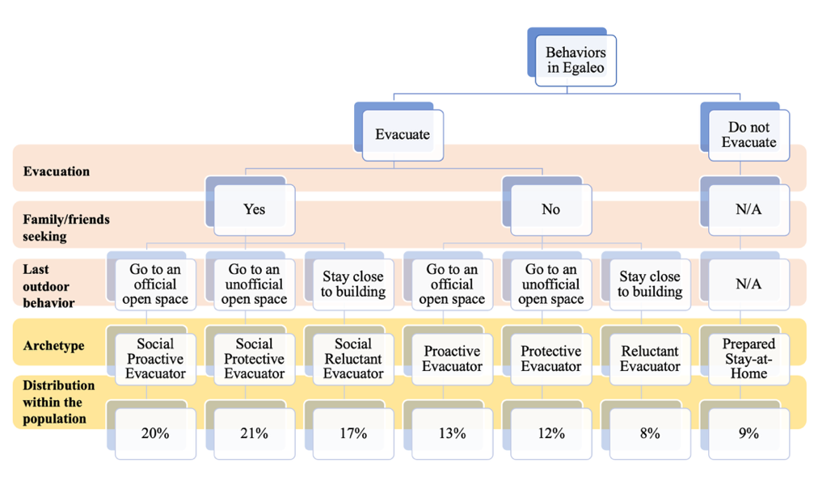
Figure 4. Distribution of archetypes identified in the Egaleo study area.
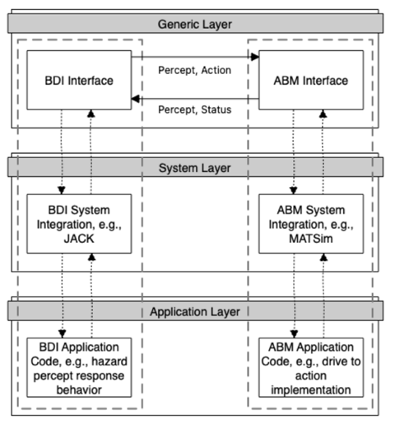
Figure 5. The architecture of ABM-BDI integration used to execute simulations.
To execute the simulations, we first generated a routable street network and a spatially synthetic population for Egaleo (Figure 6). The synthetic population reflects household distributions, residential densities, and demographic characteristics derived from municipal data and the Living Scenario Dataset. The routable network was constructed from OpenStreetMap and enhanced to reflect realistic pedestrian evacuation conditions, removing non-walkable segments, linking disconnected components, and embedding validated safe open spaces (O1–O15 in Figure 6) as evacuation destinations. The combination of a behaviorally calibrated synthetic population, detailed street topology, and archetype-specific decision logic ensures that emergent evacuation patterns result from both individual reasoning and the physical constraints of the city.
We conducted comparative simulations under two behavioral assumptions: (1) a uniform evacuation model in which all residents immediately walk to the nearest open space along shortest-path routes; and (2) an HBM-informed scenario in which each agent was stochastically assigned an archetype by sampling from the empirical archetype distribution, and decision execution followed probabilistic rules governing archetype-specific delays, intermediate actions (e.g., searching for household members), and destination choice. As illustrated in Figure 7(a), the uniform model generates highly synchronized departures and concentrates flows on a small set of main corridors toward central destinations. In Figure 7(b), the HBM-informed simulation produces temporally staggered movement and route diversity because agents differ in departure timing and intermediate actions: reluctant archetypes delay evacuation, socially oriented archetypes first move to locate family or neighbors, and proactive archetypes depart early toward designated assembly points. This behavioral heterogeneity shifts demand from only the shortest paths to a broader set of alternative routes across the street network, leading to a more dispersed utilization pattern and reducing extreme concentration on a few links relative to the uniform baseline. These differences demonstrate how the elicited behavioral structure changes the timing and spatial distribution of evacuation flows compared with a single-rule assumption.

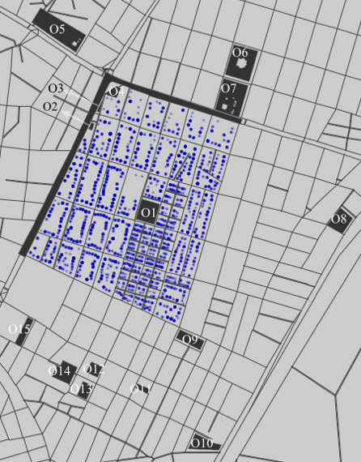
Figure 6. Generated routable network (black lines) and synthetic population (blue dots) for Egaleo.

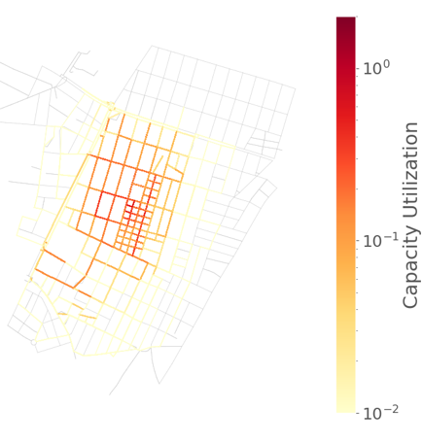 | 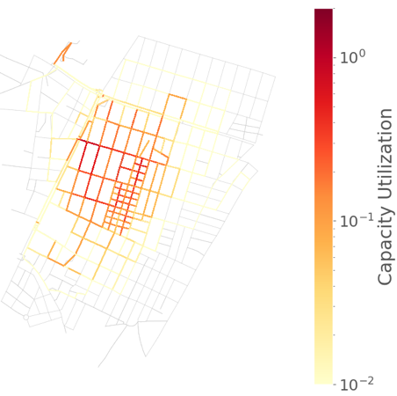
(a) Simplistic HBM where everyone seeks a near safe place | (b) Road link use with the elicited HBM

Figure 7. Comparing the utilization of roads as a fraction of total carrying capacity.

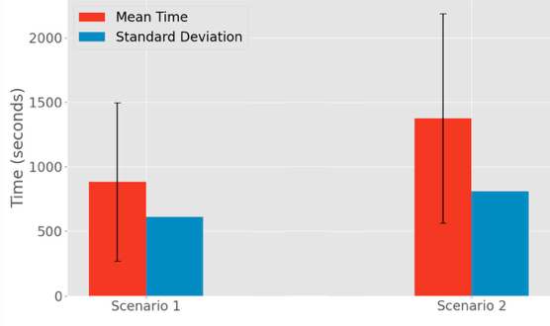
Figure 8. Mean and standard deviation of time spent on the street network under two simulation scenarios: Scenario 1 (simplistic HBM) and Scenario 2 (elicited HBM).
To further quantify these differences, we computed aggregate indicators of the time agents spend on the street network (Figure 8). The results show that incorporating archetype-driven decision-making substantially alters evacuation dynamics. Under the HBM-informed simulation, the mean time spent on the street increases by approximately 60% compared with the uniform baseline scenario. This increase reflects the combined effects of heterogeneous departure delays, intermediate social and protective actions (such as locating family members), and more diverse destination choices across archetypes. In addition, the standard deviation of street time is higher in the behavior-informed scenario, indicating greater temporal dispersion of movement. This confirms that behavioral heterogeneity not only changes how road links are utilized (Figure 7), but also affects how long individuals remain exposed in the street network before reaching safety.
The implications of these differences extend beyond model fidelity. Local stakeholders emphasized that the archetype-driven patterns aligned with their operational experience during past crises, particularly regarding delayed evacuation among reluctant groups and the strong role of family-seeking behavior. The HBM-based simulations brought these dynamics into sharp focus, revealing operational blind spots (such as vulnerable populations who may not evacuate promptly or congestion emerging from lateral movement toward social contacts) that homogeneous models systematically overlook. This enhanced behavioral realism supports more effective preparedness planning, targeted communication strategies, and crisis response decision-making, demonstrating the value of integrating co-created HBMs into simulation-based risk management tools.

CONCLUSION
This paper advances crisis risk management research by introducing a generalizable, iterative co-creation framework for eliciting HBMs that are empirically grounded, stakeholder-informed, and simulation-ready. The core contribution is methodological: we formalize a reproducible pipeline that (i) defines crisis scenarios through participatory specification of environmental and system conditions, population and social diversity, and the behavioral and decision environment; (ii) operationalizes these dimensions within a Living Scenario Dataset using architecture-aligned survey instruments and a modular, updatable data structure; and (iii) translates the resulting evidence into validated behavioral representations. The application in Egaleo, Greece demonstrates this logic in practice: the earthquake case implements the full framework, from co-defined scenarios and survey deployment to archetype derivation and validation, while the heatwave case shows how the same architecture transfers across hazards and establishes a consistent empirical basis for future HBM construction.
Beyond methodological rigor, the paper demonstrates why behaviorally realistic models matter for preparedness planning and response operations. By integrating elicited earthquake archetypes into a BDI cognitive layer coupled with a MATSim agent-based evacuation model, we show that crisis dynamics change substantially when heterogeneous decision-making, social coordination, and delayed responses are explicitly represented. Compared to a simplified assumption in which all individuals immediately evacuate to the nearest safe location, the HBM-informed simulation produces more diverse route choices, staggered departure times, and differentiated destination selection. These behaviors redistribute pedestrian flows across a broader portion of the street network, including lower-capacity and less frequently used streets, and expose congestion patterns that homogeneous models either exaggerate or fail to detect. Importantly, local stakeholders assessed the resulting archetype-driven patterns as plausible based on their operational experience, indicating that the co-created HBM supports people-centered risk management by improving the realism of evacuation assessments and informing targeted communication, routing, and support measures for distinct behavioral groups.
Future work will extend the framework in three complementary directions. First, applying the same co-creation pipeline to additional hazards (e.g., floods, wildfires, cascading events) and additional governance contexts will strengthen transferability claims and support a comparative multi-hazard library of behavioral mechanisms. Second, the Living Scenario Dataset can be expanded with longitudinal and near-real-time inputs (e.g., repeated surveys, operational data, sensing, or learning-based updates), enabling HBMs to evolve with changing risk perception, infrastructure conditions, and institutional practices, which is an essential step toward integration within digital-twin workflows for crisis preparedness and response. Third, future implementations can deepen participatory validation through structured exercises and interactive simulation sessions, allowing stakeholders to test interventions iteratively, challenge assumptions, and refine behavioral representations as part of routine planning cycles. Through these extensions, the proposed framework provides a pathway toward more adaptive, transparent, and socially grounded simulation-based decision support for crisis risk management.

ACKNOWLEDGEMENTS
This work was supported by the C2IMPRESS and JUSTSAFE projects under the European Union’s Horizon Europe Framework Programme (HORIZON) (grant agreements No. 101074004 and No. 101215174, respectively), and by ATLAS, funded by MICIU/AEI/10.13039/501100011033 and co-funded by the European Union.

REFERENCES
Abdel-Latif, A., Saad–Eldien, A., & Marzouk, M. (2023). System dynamics applications in crisis management: A literature review. Journal of Simulation, 17(6), 800–817. https://doi.org/10.1080/17477778.2022.2088306
An, L. (2012). Modeling human decisions in coupled human and natural systems: Review of agent-based models. Ecological Modelling, Modeling Human Decisions, 229, 25–36. https://doi.org/10.1016/j.ecolmodel.2011.07.010
Barnes, B., Dunn, S., Pearson, C., & Wilkinson, S. (2021). Improving human behaviour in macroscale city evacuation agent-based simulation. International Journal of Disaster Risk Reduction, 60, 102289. https://doi.org/10.1016/j.ijdrr.2021.102289
Brown, P. A., & Anderson, R. A. (2023). A methodology for preprocessing structured big data in the behavioral sciences. Behavior Research Methods, 55(4), 1818–1838. https://doi.org/10.3758/s13428-022-01895-4
Caillou, P., Gaudou, B., Grignard, A., Truong, C. Q., & Taillandier, P. (2017). A Simple-to-Use BDI Architecture for Agent-Based Modeling and Simulation. In W. Jager, R. Verbrugge, A. Flache, G. de Roo, L. Hoogduin, & C. Hemelrijk (Eds.), Advances in Social Simulation 2015 (pp. 15–28). Springer International Publishing. https://doi.org/10.1007/978-3-319-47253-9_2
Chen, F., Yue, X., Yang, X., & Ge, T. (2014). Study on classification of personality-based brand archetype from the perspective of internet. China Communications, 11(7), 153–160. https://doi.org/10.1109/CC.2014.6895394
Chen, X., Treiber, M., Kanagaraj, V., & Li, H. (2018). Social force models for pedestrian traffic – state of the art. Transport Reviews, 38(5), 625–653. https://doi.org/10.1080/01441647.2017.1396265
Davahli, M. R., Karwowski, W., Gutierrez, E., Fiok, K., Wróbel, G., Taiar, R., & Ahram, T. (2020). Identification and Prediction of Human Behavior through Mining of Unstructured Textual Data. Symmetry, 12(11). https://doi.org/10.3390/sym12111902
Ding, X., Gan, Q., & Bahrami, S. (2022). A systematic survey of data mining and big data in human behavior analysis: Current datasets and models. Transactions on Emerging Telecommunications Technologies, 33(9), e4574. https://doi.org/10.1002/ett.4574
Greasley, A., & Owen, C. (2016). Behavior in Models: A Framework for Representing Human Behavior. In M. Kunc, J. Malpass, & L. White (Eds.), Behavioral Operational Research: Theory, Methodology and Practice (pp. 47–63). Palgrave Macmillan UK. https://doi.org/10.1057/978-1-137-53551-1_3
Guo, Y., Gasparrini, A., Armstrong, B. G., Tawatsupa, B., Tobias, A., Lavigne, E., Coelho, M. de S. Z. S., Pan, X., Kim, H., Hashizume, M., Honda, Y., Guo, Y.-L. L., Wu, C.-F., Zanobetti, A., Schwartz, J. D., Bell, M. L., Scortichini, M., Michelozzi, P., Punnasiri, K., … Tong, S. (2017). Heat Wave and Mortality: A Multicountry, Multicommunity Study. Environmental Health Perspectives, 125(8), 087006. https://doi.org/10.1289/EHP1026
Haer, T., Botzen, W. J. W., de Moel, H., & Aerts, J. C. J. H. (2017). Integrating Household Risk Mitigation Behavior in Flood Risk Analysis: An Agent-Based Model Approach. Risk Analysis, 37(10), 1977–1992. https://doi.org/10.1111/risa.12740
Helbing, D., & Molnár, P. (1995). Social force model for pedestrian dynamics. Physical Review E, 51(5), 4282–4286. https://doi.org/10.1103/PhysRevE.51.4282
Heppenstall, A., Malleson, N., & Crooks, A. (2016). “Space, the Final Frontier”: How Good are Agent-Based Models at Simulating Individuals and Space in Cities? Systems, 4(1), 9. https://doi.org/10.3390/systems4010009
Iskandar, R., Al Tfaily, B., Cornou, C., Bard, P.-Y., Guillier, B., Harb, J., Lacroix, P., Adjizian-Gérard, J., Beck, E., Dugdale, J., Salameh, C., Saliba, N., & Zaarour, R. (2023). Estimating urban seismic damages and debris from building-level simulations: Application to the city of Beirut, Lebanon. Bulletin of Earthquake Engineering, 21(13), 5949–5990. https://doi.org/10.1007/s10518-023-01768-x
Kennedy, W. G. (2012). Modelling Human Behaviour in Agent-Based Models. In A. J. Heppenstall, A. T. Crooks, L. M. See, & M. Batty (Eds.), Agent-Based Models of Geographical Systems (pp. 167–179). Springer Netherlands. https://doi.org/10.1007/978-90-481-8927-4_9
Lekkas, E. (2001). The Athens earthquake (7 September 1999): Intensity distribution and controlling factors. Engineering Geology, 59(3), 297–311. https://doi.org/10.1016/S0013-7952(00)00119-8
Lempert, R. J., Busch, L., Brown, R., Patton, A., Turner, S., Schmidt, J., & Young, T. (2023). Community-Level, Participatory Co-Design for Landslide Warning with Implications for Climate Services. Sustainability, 15(5). https://doi.org/10.3390/su15054294
Melles, G. (2021). Participatory Co-design for Sustainable Development. In Partnerships for the Goals (pp. 839–849). Springer, Cham. https://doi.org/10.1007/978-3-319-95963-4_47
Moradi, H., Iskandar, R., Rodriguez, S., Singh, D., Dugdale, J., Tzempelikos, D., & Sfetsos, A. (2025). A Framework for Constructing Agent-based Models for Evaluating Emergency Evacuation Procedures; A Case Study Applied to Egaleo, Greece. 58th Hawaii International Conference on System Sciences, Proceedings of the 58th Hawaii International Conference on System Sciences. https://hal.science/hal-04906043
Moradi, H., Iskandar, R., Rodriguez, S., Singh, D., Dugdale, J., Tzempelikos, D., Sfetsos, A., Bakogianni, E., Pavlidi, E., Díaz, J., Ribas, M., Moragues, A., & Estrany, J. (2025a). Enhancing Disaster Evacuation Planning with Cognitive Agent-Based Models and Co-Creation. European Journal of Sustainable Development, 14(3), 1–11. https://doi.org/10.14207/ejsd.2025.v14n3p1
Moradi, H., Iskandar, R., Rodriguez, S., Singh, D., Dugdale, J., Tzempelikos, D., Sfetsos, A., Bakogianni, E., Pavlidi, E., Díaz, J., Ribas, M., Moragues, A., & Estrany, J. (2025b). Improving evacuation policies through agent-based modeling and stakeholder engagement in hazard-prone areas. International Journal of Disaster Risk Reduction, 119, 105280. https://doi.org/10.1016/j.ijdrr.2025.105280
Ng, M., Herbert, N., Ram, N., & Wong-Parodi, G. (2025). Examining individuals’ protective behavioral decision-making dynamics over repeated risks of heat waves in the American West. Journal of Risk Research, 28(12), 1420–1443. https://doi.org/10.1080/13669877.2025.2603989
Osman, M. (2010). Controlling uncertainty: A review of human behavior in complex dynamic environments. Psychological Bulletin, 136(1), 65–86. https://doi.org/10.1037/a0017815
Papagiannaki, K., Diakakis, M., Kotroni, V., Lagouvardos, K., & Andreadakis, E. (2019). Hydrogeological and Climatological Risks Perception in a Multi-Hazard Environment: The Case of Greece. Water, 11(9), 1770. https://doi.org/10.3390/w11091770
Pew, R. W. (2008). More Than 50 Years of History and Accomplishments in Human Performance Model Development. Human Factors, 50(3), 489–496. https://doi.org/10.1518/001872008X288493
Ren, Y., Cedeno-Mieles, V., Hu, Z., Deng, X., Adiga, A., Barrett, C., Ekanayake, S., Goode, B. J., Korkmaz, G., Kuhlman, C. J., Machi, D., Marathe, M. V., Ramakrishnan, N., Ravi, S. S., Sarat, P., Selt, N., Contractor, N., Epstein, J., & Macy, M. W. (2018). Generative Modeling of Human Behavior and Social Interactions Using Abductive Analysis. 2018 IEEE/ACM International Conference on Advances in Social Networks Analysis and Mining (ASONAM), 413–420. https://doi.org/10.1109/ASONAM.2018.8508282
Romero, D., & Escudero, P. (2023). Adaptive Learning in Agent-Based Models: An Approach for Analyzing Human Behavior in Pandemic Crowding. Applied System Innovation, 6(6), 113. https://doi.org/10.3390/asi6060113
Rufat, S., Comby, E., Lhomme, S., & Santoni, V. (2024). Context matters when evacuating large cities: Shifting the focus from individual characteristics to location and social vulnerability. Environmental Science & Policy, 162, 103925. https://doi.org/10.1016/j.envsci.2024.103925
Slinger, J. H., Cunningham, S. C., & Kothuis, B. L. M. (2023). A co-design method for including stakeholder perspectives in nature-based flood risk management. Natural Hazards, 119(3), 1171–1191. https://doi.org/10.1007/s11069-023-06139-y
Tasantab, J. C., Gajendran, T., Owi, T., & Raju, E. (2021). Simulation-based learning in tertiary-level disaster risk management education: A class-room experiment. International Journal of Disaster Resilience in the Built Environment, 14(1), 21–39. https://doi.org/10.1108/IJDRBE-04-2021-0045
Tocchi, G., Pittore, M., & Polese, M. (2025). Identifying urban and rural settlement archetypes: Clustering for enhanced risk-oriented exposure and vulnerability analysis. Natural Hazards and Earth System Sciences, 25(9), 3665–3692. https://doi.org/10.5194/nhess-25-3665-2025
W. Axhausen, K., Horni, A., & Nagel, K. (Eds.). (2016). The Multi-Agent Transport Simulation MATSim. Ubiquity Press. https://doi.org/10.5334/baw
Wu, W., Chen, M., Li, J., Liu, B., & Zheng, X. (2022). An Extended Social Force Model via Pedestrian Heterogeneity Affecting the Self-Driven Force. IEEE Transactions on Intelligent Transportation Systems, 23(7), 7974–7986. https://doi.org/10.1109/TITS.2021.3074914
Zainuddin, Z., & Shuaib, M. (2010). Modification of the Decision-Making Capability in the Social Force Model for the Evacuation Process. Transport Theory and Statistical Physics, 39(1), 47–70. https://doi.org/10.1080/00411450.2010.529979

The heatwave questionnaire is available here: https://github.com/HossseinMoradi/HeatwaveQuestionnaire
The earthquake questionnaire is available here: https://github.com/HossseinMoradi/EQQuestionnaire
https://www.treensight.com/
https://matsim.org/

