

Basic legal citation

Report



November 6, 2015

For Legal Information Institute

Basic Legal Citation

for Legal Information Institute

Feasibility Study

Harish Sethumadhavan

Aiswarya Jami

Akshay Tata

Brenda Martis

Devi Snigdha Muppala

Sania Nagpal

Joao Curcio

Yihui Fu

November 6, 2015

Table of Contents

1 Introduction 5

1.1 Project general overview 5

1.1.1 Purpose and Scope 5

1.1.2 Objectives and Goals 5

1.2 Current systems 5

2 Proposed System Requirements 7

2.1 Overview 7

2.2 Functional Requirements 7

2.2.1 Task 1: Website 7

2.2.2 Task 2: Conversions 7

2.3 Usability Requirements 7

2.3.1 Author View 8

2.3.2 User View 8

2.4 Non-functional Requirements 8

3 Requirement models 9

3.1 Use Case Diagrams 9

3.2 Use Case Specifications 10

3.2.1 Search Content 10

3.2.2 Download ebook 11

3.2.3 Buy .mobi ebook 11

3.2.4 Edit Content 11

3.2.5 Add Content 12

3.3 Use Case Scenarios 12

3.3.1 Scenario 1 – A law student using the website. 12

3.3.2 Scenario 2 – The author edits content on the website. 12

3.3.3 Scenario 3 – Visitor wishes to download an e-book 13

3.3.4 Scenario 4 – Author, Prof Martin wants to generate all formats of e-books 13

4 Preliminary Design 15

4.1 System Architecture 15

4.2 Workflow 15

4.3 Website Design Considerations 15

4.4 Generic File generator 18

5 Project Progress 20

5.1 Gantt Table & Gantt Chart 20

# Introduction

## Project general overview

### Purpose and Scope

Writing a book as complex as **Introduction to Basic Legal Citation**, and maintaining the book updated every year is a high demanding endeavor. If only the book was maintained as a website, would the workload of updating it be a matter of writing an HTML file with the contents of legal writing. However, the author Prof. Peter Martin has another three formats for his book, and each format has its own specific characteristics. Therefore, he has to re-write the same book another three times, one for each format. He also needs to keep track of his progress, so that all versions would be consistent. These tasks are accomplished manually. Furthermore, when the book was published as a webpage, there was not a concern to create a mobile-friendly and interactive design, which is almost a necessity nowadays. That's where our team enters.

Our objective is to design and build a modern, mobile-friendly version of the Basic Legal Citation site that improves the display of explanatory text, and adds a greater interactivity to the presentation of examples and supplementary information. We’re also improving the content maintenance process to support efficient updating and output of the website and various eBook formats, in which the client only needs to write the content once and have it updated in all formats.

### Objectives and Goals

The main objective of this project is to design a website with good user experience, and a mobile friendly version has to be implemented. The website should also provide functionality for the user to search for a citation/keyword in the website.

The secondary objective is provide an editor interface to the author which can allow him to edit the content of the website. The updated content is supposed to be reflected in the other three formats: ePub, mobi and PDF. The changes can be done only by the author and none other. The author can have an option to reflect the changes to in any other formats without manually having to repeat the updating process. On the other side, the application also should allow user to view the content hosted on the website and should be able to generate different formats of the same content (HTML, ePub, mobi and PDF).

## Current systems

There is a website that provide users to view the legal citation content. The content of this is also available in three different formats:

1. A pdf version;
2. A version in mobi format designed for use on the Kindles as well as other e-readers or apps using this format;
3. A version in ePub format for e-readers or apps that work with it.

However, currently there is no generic framework available that can do instant conversion of markup text into different format. The author doesn’t have any interface to generate different formats of the updated content. There is no mobile friendly version of the website that has been implemented yet.

# Proposed System Requirements

## Overview

The project involves the following two major tasks that can be implemented individually and the requirements for both these tasks are detailed in the further sections.

1. Website redesign and implementation
2. Conversion of the documentation from HTML to other formats

## Functional Requirements

### Task 1: Website

1. Redesign the layout of the website to make it look more modern and user friendly.
2. The website has to be responsive to different screen sizes, i.e., it has to be mobile friendly.
3. The display of explanatory text, interactive presentation examples, and supplementary information has to be improved. This subtask will involve the following features

* change webpage color scheme
* add tabbed panes
* add navigation tabs
* add pop-up menus
* add clickable keywords
* transform the tables into a more interactive presentation

1. The website has to be crawlable. This is to say that the website should allow its pages to be indexed by a search engine.
2. The following are the **optional** features that we have agreed upon:
   * An effective search box
   * An interface for author’s content management

### Task 2: Conversions

1. Convert multiple HTML files to one file of the following output format:

* PDF
* ePub

1. The author interface may not need to be web-based.
2. Conversion to the other formats such as Mobi format, either from HTML or ePub is **optional**.

## Usability Requirements

The application will have two interfaces, the author side and the user side. The author is the person who owns the content on the website and is also responsible for the perpetual updating of the same. The user base would be thousands of law students or legal professionals who use this website as a resource to understand the legal writing and learn how to cite the legal sources.

### Author View

The author view will consist of an editor interface that will allow editing of the content on the website. This updated content is to be reflected in three formats (HTML, ePub and PDF). Once the author decides to publish these changes, he will have an option to reflect the changes in any of the other formats without manually having to repeat the updating process.

### User View

The user view allows the user to view the Basic Legal Citation document hosted on the website in the form of classified web pages and markups, in the case of the website. These users typically use screen-readers to access the Internet. The user can access the document from any browser on a computer or a hand-held device. The user interface can be either a website, eBook on kindle, a mobile document reader or a pdf file.

The web application will have hyperlinks/buttons to aid the user in one of the following functionalities:

* The ability to navigate to the index/help page
* To open a new page that contains detailed description of a citation
* To download the document in any of the available formats
* To navigate among the different pages within the website
* To navigate to any external references. Example: A blog post.

To download the Basic Legal Citations document, the following requirements have to be met from the user side:

* The user’s computer/device has to be relatively up-to-date to perform the download.
* The computer/device should have enough space to store the document.
* It is the user’s responsibility to download the relevant software in order to read the downloaded format. For example, to read the PDF format, a PDF reader such as Adobe Reader might be required.

## Non-functional Requirements

1. **Reusability and Maintenance**: The website must be easily maintainable once it is handed over back to the client with a descriptive user manual.
2. **Scalability**: The website already has up to a million users. The website must be scalable enough to cater to an even larger number of users in future.
3. **Consistency**: One of the major concerns of the client is to maintain consistency among the different formats. Although the website has more interactivity than the other three formats, the interactivity will be maintained in a different presentation in other formats.
4. **Extensibility**: The application has to be extensible so as to allow administrators to add features not available in the initial release. The possible extensions in this project is to support conversion of more formats of the document.
5. **Compatibility**: The application must function correctly when ported to the Cornell Law School server and be compatible with mainstream browsers including Safari, Chrome, Firefox, IE9, Edge, etc.

# Requirement models

## Use Case Diagrams

As discussed above, there are two different user roles: a visitor and the author. In general, a visitor will view the content, download one or more formats of the e-book, even buy a mobi format eBook if the visitor would like to. Meanwhile, the author will manage the content, like add, edit, or delete the content, generate e-books, and public content updates. This is described in Figure 1. The detailed use case specifications and use case scenarios are listed in the following section.

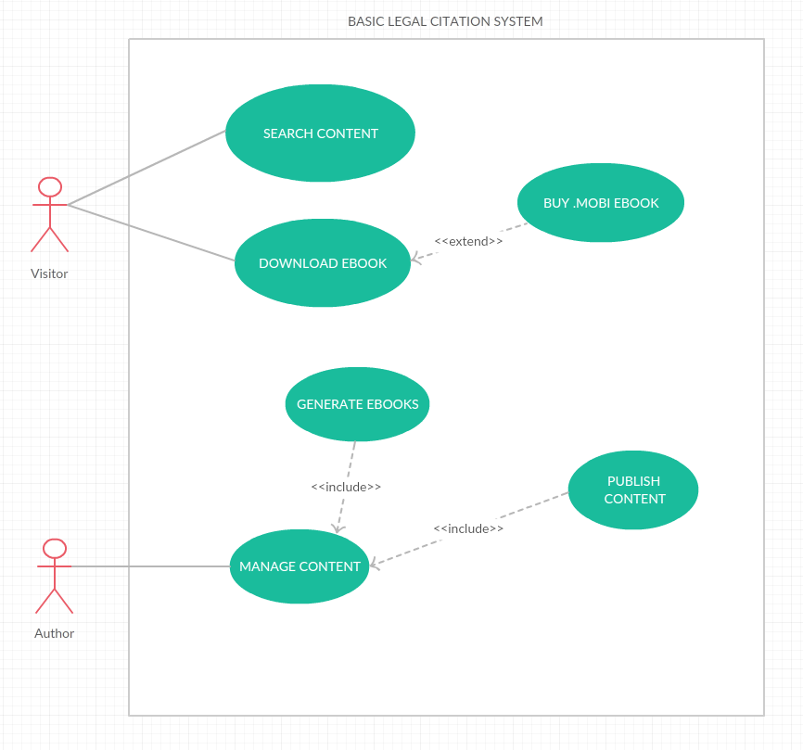

Figure 1: Use Case Diagrams for Basic Legal Citation

## Use Case Specifications

### Search Content

**Summary**: The visitor performs a search for content on the Basic Legal Citation website using keywords and phrases.

**Preconditions**: The Basic Legal Citation must be open in a compatible browser. The visitor must be able to type a keyword for search purposes.

**Trigger**: The visitor clicks on the search button or press enter after inputting a keyword or phrase on the search bar.

**Course of Events**

1. The Basic Legal Citation website displays a field for text-based search.

2. The user enters the search terms into the field and confirms the search by clicking a button or pressing the enter button.

3. The Basic Legal Citation search bar determines the appropriate results based on the terms used for searching.

4. The Basic Legal Citation website displays the search results with relevant information in metadata.

5. The visitor selects the search result to jump to.

6. The Basic Legal Citation website displays the page associated with that result.

**Alternate paths** - *No results*

2b. The basic legal citation search bar cannot find any search results matching the terms.

3b. The basic legal citation displays an error page indicating that the terms match no result in the website.

4b. The visitor search for a new term on the search bar or cancels the search by navigating to another section of the website.

**Alternate paths** - *Cancel search*

This could occur in step 4b chiefly.

1c. The visitor cancels the search by clicking in a link on the website or hitting the back button on the browser.

2c. The basic legal citation website displays the appropriate page.

### Download eBook

**Summary**: The visitor selects from a dropdown menu which eBook format they want to download and click on the link to finish downloading.

**Preconditions**: The Basic Legal Citation must be opened in a compatible browser, the visitor must own a compatible reader device for the book format downloaded.

**Trigger**: The visitor clicks on the download link

**Course of Events**

1. The visitor goes to the menu and selects the format he wants to download - mobi, PDF or ePub.

2. The Basic Legal Citation website redirects the visitor to the download page.

3. The visitor completes the download of the e-book to a local directory on his laptop.

### Buy .mobi eBook

**Summary**: As a convenience, the visitor can have the mobi eBook sent directly to their Kindle. To do this the visitor selects buy mobi on the menu, and they’re redirected to Amazon to purchase the eBook for kindle.

**Preconditions**: The Basic Legal Citation must be opened in a compatible browser, the visitor must have or create an Amazon account, the visitor must own a Kindle.

**Trigger**: The visitor clicks on buy mobi eBook

1. The Basic Legal Citation website redirects the visitor to the amazon purchase page for the mobi eBook.

2. The visitor logs into their account using their amazon credentials.

3. The visitor makes a payment to amazon for the mobi eBook, will be charged $0.99 in most cases.

4. The amazon website sends the mobi eBook to the visitor’s kindle.

### Edit Content

**Summary**: Using an HTML editor, the author can edit the content from the book.

**Preconditions**: The author must use HTML as a markup language. The author must have access to the original HTML files, the system and the server. The author must use an HTML editing tool compatible to his machine.

**Trigger**: The author opens a selected HTML file in the editor.

1. The author selects an existing HTML file from the server.

2. The author opens the HTML file in any editing tool.

3. The author makes the appropriate changes using HTML as markup language and save those changes to the files.

4. The author publishes those changes in the website and update eBooks on the website and on Amazon.

### Add Content

**Summary**: Using an HTML editor, the author create new content for the eBook.

**Preconditions**: The author must use HTML as a markup language. The author must have access to the system and the server. The author must use an HTML editing tool compatible to his machine.

**Trigger**: The author opens the editing tool and creates an HTML file.

1. The author selects an existing HTML file from the server.

2. The author opens the HTML file in any editing tool.

3. The author makes the appropriate changes using HTML as markup language and save those changes to the files.

4. The author publishes those changes in the website and update eBooks on the website and on Amazon.

## Use Case Scenarios

### Scenario 1 – A law student using the website.

**Primary Actor:** Andrew, The law student

**Precondition:** Active Network Connection

**Basic flows of Events:**

* Andrew accesses the website.
* Andrew goes to the home page.
* Andrew navigates through the website and finds the topic he wants to study.
* To study the various examples, he uses the markup tags on the website to understand better.
* Once the studying is done, he closes the website.

### Scenario 2 – The author edits content on the website.

**Primary actors:** Prof Martin, author

**Preconditions:**

* Web browser on a system connected to the internet.
* Author has appropriate credentials to log in to the server.

**Basic flow of events:**

1. The author must access the server using his credentials.
2. The author will access the pages to which he has to make edits.
3. The author uses the markup language (based on HTML) to make the changes.
4. The author publishes the changes to the website.
5. Our system will automatically pull the newest HTML from the website and convert it to other formats like PDF, ePub and mobi and the website will be updated with the links for downloads.

### Scenario 3 – Visitor wishes to download an e-book

**Primary Actor:** Gordon, The law student

**Precondition:** Active Network Connection

**Basic flows of Events:**

1.   Gordon accesses the website.

2.   Gordon goes to the home page.

3.   Gordon clicks on download e-books.

4.   Based on the the type of e-book Gordon clicks on one of the following

a.   basic_legal_citation.mobi

b.   basic_legal_citation.epub

c.    basic_legal_citation.pdf

5.   The corresponding e-book is downloaded in the format clicked on.

### Scenario 4 – Author, Prof Martin wants to generate all formats of e-books

**Primary Actor:** Prof Martin, the author

**Precondition:**

* Active Network Connection
* A table of content in HTML
* Metadata, CSS, and a cover for the eBook

**Basic flows of Events:**

1.   Prof Martin accesses the website.

2.   Prof Martin logs in using his credentials which verifies he has edit rights to the content.

3.   Prof Martin clicks on generate files.

4.   The application responds with an alert (Successful or Unsuccessful).

**Alternative Flow:**

1.   The author, Prof Martin is not validated

a.   The application responds with an error alert.

2.   The generation for various formats fail.

a.   The application responds with an appropriate error alert.

# Preliminary Design

## System Architecture

The system has been designed as a client-server architecture. For this system, the clients are the mobile or desktop browsers viewing the HTML pages on the server. The author can also create new HTML pages and upload them to the server. The visitors of the site can then see the most recently updated content on the site. Additionally, the clients can also request to download different publishing formats - PDF, ePub, etc., stored on the server.

## Workflow

The author uses DreamWeaver, a web design tool and HTML and CSS editor, to add or edit pages stored on the server. Additionally, the server allows the author to trigger a creation of PDF, ePub or mobi format from the HTML5 content hosted on the site.

Once the files have been uploaded to the server, the Visitors of the web site can download or view the contents.

The choice of DreamWeaver was made because the author is already familiar with it and he’s used to uploading HTML pages to the server.

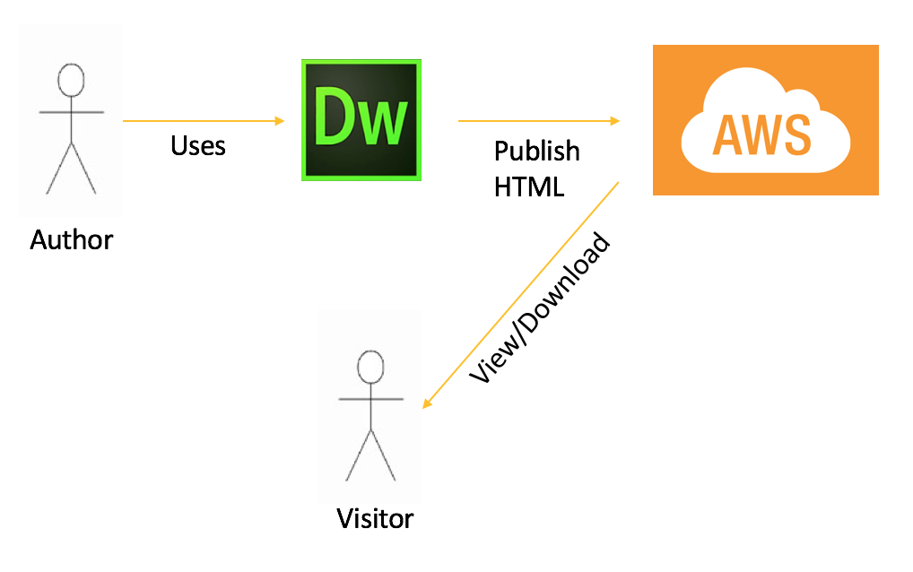

Figure 2: Overview of the Workflow

## Website Design Considerations

The revamped website currently has 2 navigation bars - one on the top right part of the page and the other on the left pane. The navigation layout is similar to the current legal citation website. This was intentionally designed to aid the frequent users of the site by trying to maintain a consistent layout.

However, the color scheme of the website has been changed to make the website look more appealing and modern. In additional to these, the navigation panes have been designed to be more interactive by expanding or collapsing upon a click.

The entire website is more responsive and screen size independent now. The website dynamically rearranges its navigation panes and content depending upon the screen size of the client devices. Also, the site rearranges the layout and content when the browser is resized.

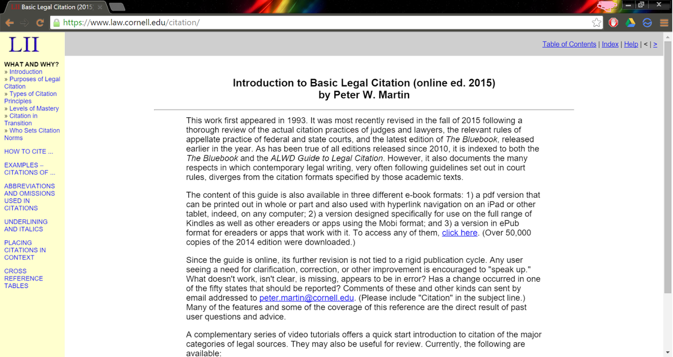

Figure 3: Current Basic Legal Citation Website

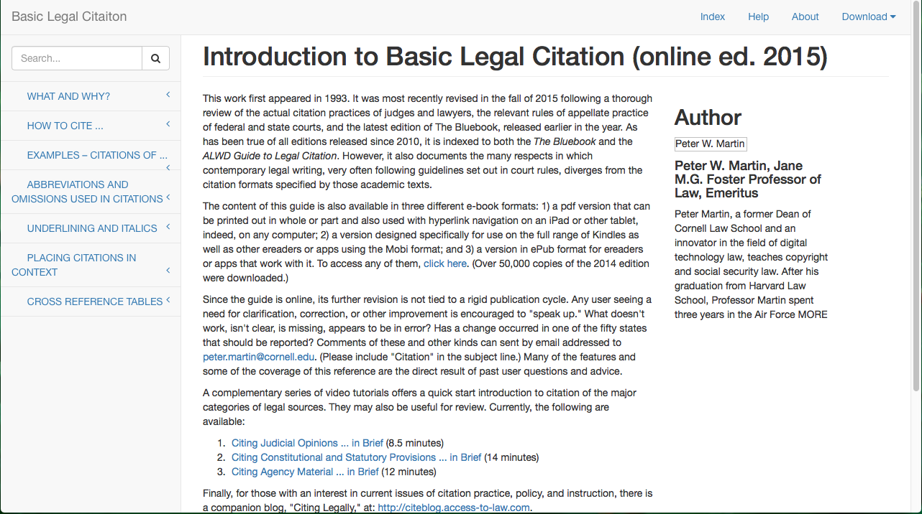

Figure 4: New Version of the Website

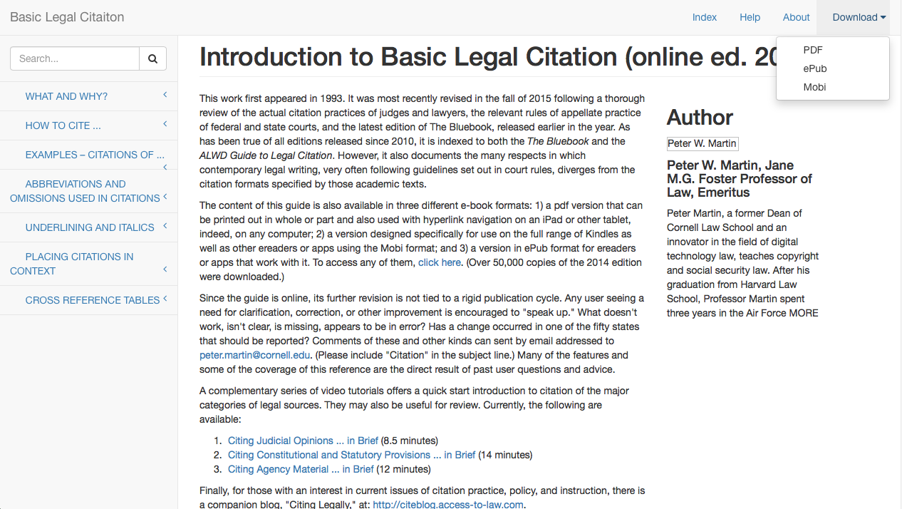

Figure 5: Demo of the Dropdown Menu for Downloading eBooks.

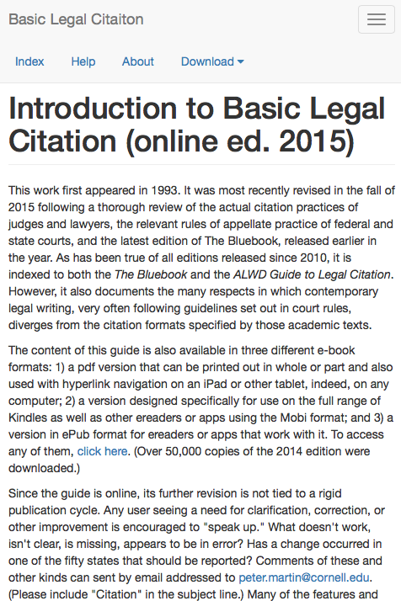

Figure 6: Demo of the Website Content Layout on a Resized Screen

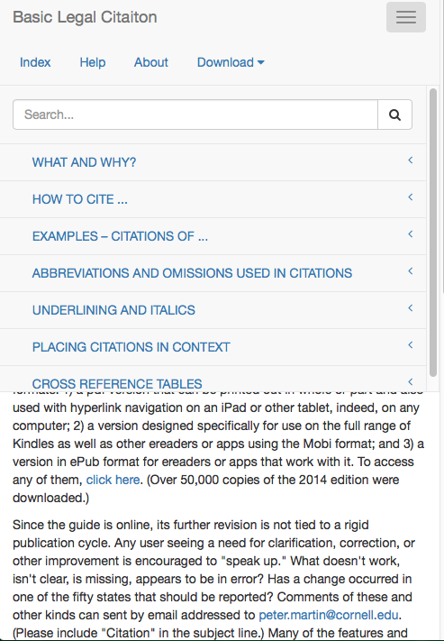

Figure 7 Demo of the Navigation Bar on a Resized Screen

## Generic File generator

The file generator is to convert HTML pages into various publishing formats viz. PDF and ePub. A lot of converter tools were researched for use in this project. But, all of them had pitfalls and need to be customized for use in this project.

A few tools that were considered are:

* Html-pdf https://github.com/sanianagpal/node-html-pdf
* Softcover https://www.softcover.io/
* Calibre http://calibre-ebook.com/

The pitfalls of the other tools are:

* Html-pdf - can only convert to the PDF format
* Softcover - a generic framework that has been designed for book publishing. This framework allows easy authoring of a book and subsequent conversion to PDF, HTML website and ePub. The design layouts were consistent across sources too. But, this tool requires the author to write his book using Latex and this stymied its use in our project.
* Calibre - a very powerful tool with a lot of configuration options. But, since the existing LII site has a lot of tags like <iframe> and large tables, there were in-consistent styles and overlapping of text with tables in the converted PDF.

We’ve narrowed down upon Calibre for use in our project. Though the tool can’t be used as-is, we intend to customize the code or write interfacing scripts that would eliminate the <iframe> and convert the large tables into other mobile friendly publishing formats.

In addition to these, we also have to make a markdown language using HTML5, to name various objects in the existing site. For instance, the keyword “BB” in the site refers to “Blue book - a book on uniform system of citation”. Such keywords have to be tagged using a schema so that we can implement efficient searching based on such tags.

# Project Progress

As we have decided earlier, we are following spiral development model for our current standing. The team is on the expected schedule. In the first iteration, the team has clear understanding of the requirements defined by consultation with the client to establish the application. In addition, the team has built prototypes for an interactive and mobile friendly website and a converter from HTML files to PDF and ePub files. Before starting the second iteration, a user testing will be scheduled in the week of October 26th to 31th to provide more feedback for the next iteration.

In the second iteration, the team has added more interactive aspects to the website, including highlighting for examples snippets and use of pop-ups for examples display. We’re employing a HTML based tags for search purposes in the website files. And have postponed the consistency of the file generator tests to the next iteration. The HTML tags are currently being created to be fully compatible with XHTML, and we will have a DTD file to analyze the consistency of the tags we create in XHTML. We have implemented an early version of the search bar, in which we use our tags to make a proper metadata search for the list of states table.

In the third iteration, the team will improve the compatibility of the new website with calibre. Finish the implementation of the search bar, and the tagging of the website. We’re studying the possibility of using HTML5 instead of XHTML + DTD, since HTML5 performs better in mobile devices, despite being worse for eBook conversion. And we’re going to enhance the website interactivity based on user testing and client testing. We plan on having the system completed and tested by third iteration.

## User Testing

In the first iteration, the group implemented few pages of a mobile-friendly website, started the research in XHTML tags, and glanced over the conversion to ePub and PDF using calibre. To create interactivity, the team removed the <iframes> from the website and created a new expand-collapse panel to replace them.

In the second iteration, the group has analyzed the input from the client regarding the changes made in the website. The client was discontent with the expand-collapse feature, the highlight color used for citation, and the look on the links to expand the examples, as a consequence, we replaced them with popups with a button to display the examples, and used a more vivid color for the citation’s highlighting, as required by the client. Also in this iteration, we modified a few of our previous XHTML tags, after input from the Dr. Sylvia, to make them easier for future maintenance, and current implementation.

## Gantt Table & Gantt Chart

The schedule as proposed in the feasibility study is slightly been changed. The Gantt table and Gantt Chart has been updated accordingly.

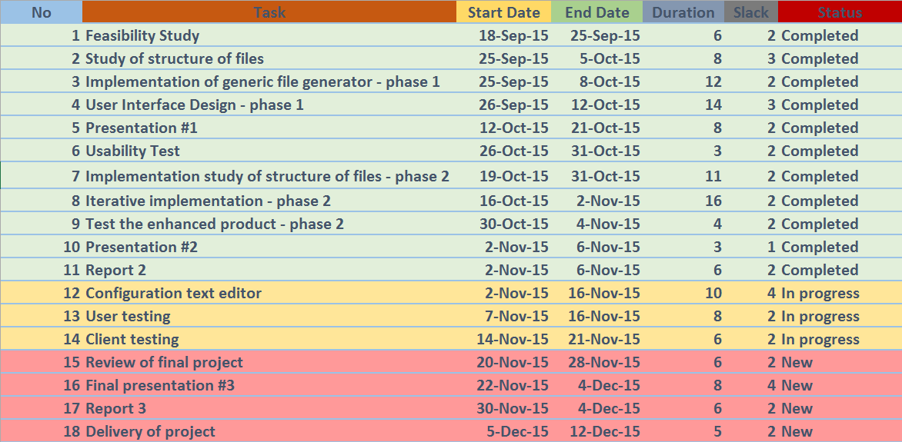

Figure 8: Gantt Table

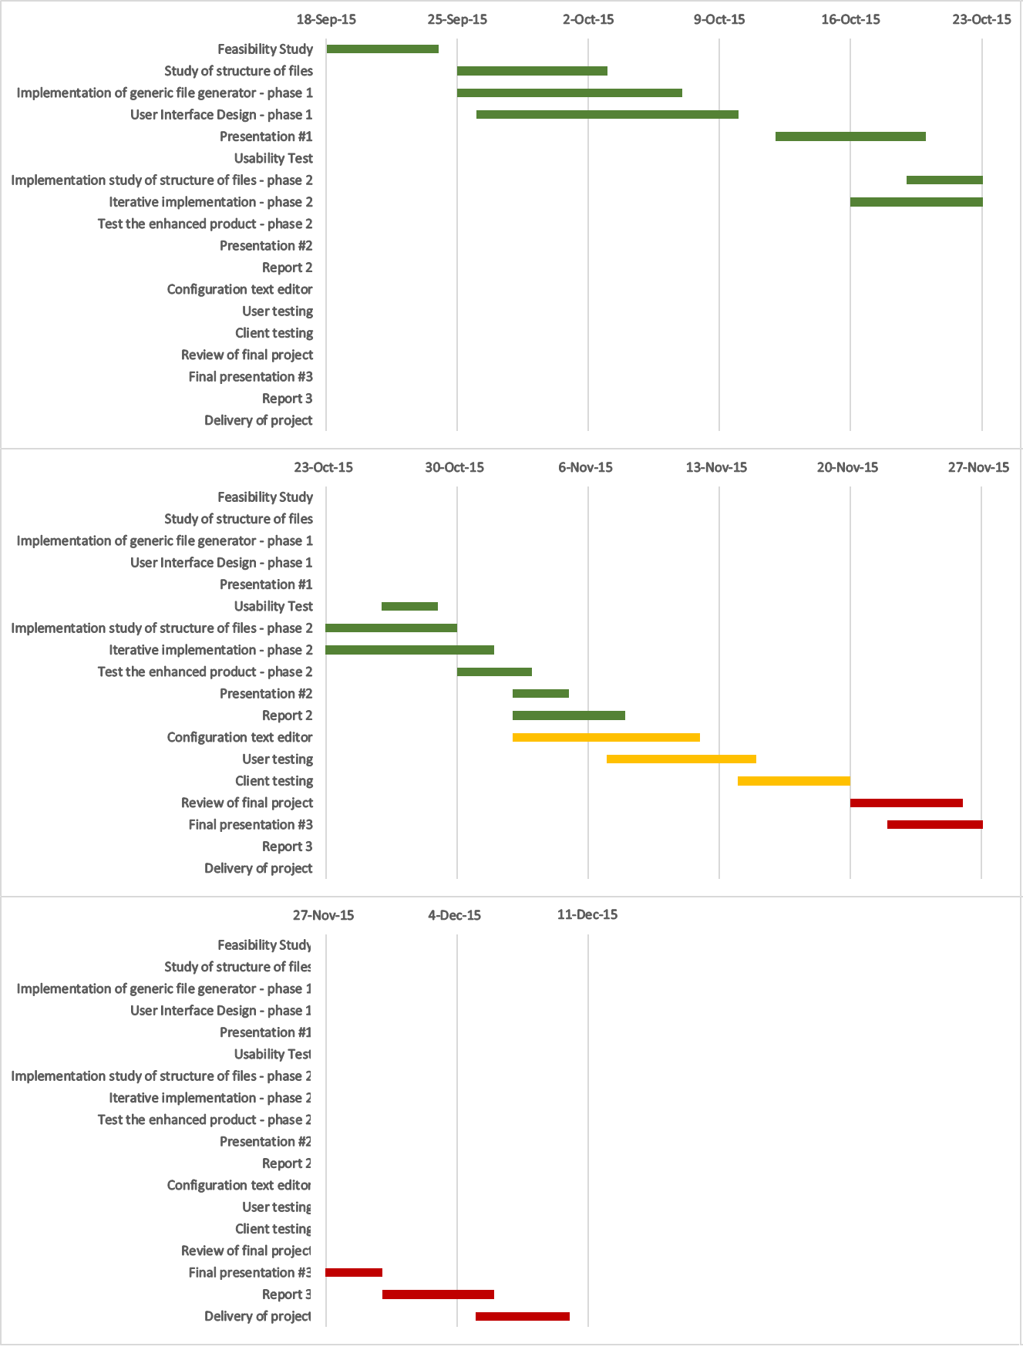

Figure 9: Gantt Chart