

Basic legal citation



December 14, 2015

For Legal Information Institute

Basic Legal Citation

for Legal Information Institute

Report 4

Aiswarya Jami

Akshay Tata

Brenda Martis

Devi Snigdha Muppala

Harish Sethumadhavan

Joao Curcio

Sania Nagpal

Yihui Fu

December 15, 2015

Table of Contents

1 Introduction 5

2 System and Program Design 5

2.1 System Architecture 5

2.2 Website Design 6

2.3 Conversion to Mobile Reader Formats 7

3 Refinements based on Feedback 8

4 New Featured added in Iteration 3 9

4.1 Website 9

4.1.1 Build AngularJS iframes for Initial example text-box. 9

4.1.2 State’s table using effective search bar for all tables. 10

4.1.3 Selected tab highlight on navigation pane. 11

4.1.4 Worked on all the above changes either manually or through python scripts. 12

4.1.5 Worked on efficient conversion from web pages to pdf and ePub. 12

5 Refinements in Iteration 3 13

5.1 Pop-ups are draggable on the screen of a desktop. 13

5.2 Mobile Friendly Website 13

5.3 Collapsible side-bars for navigation 14

5.4 Tagging 14

5.5 Refined the PDF conversion. 15

5.6 EPUB conversion 15

5.7 Deployable Author View 15

5.8 Linearization of tables. 16

5.9 Tag search 17

6 Original Goals and Comparison with Final Results 17

6.1 Goals 17

6.2 Comparison with Final Results 17

6.3 Optinal Requirements Met 18

7 Testing 18

7.1 Testing 18

7.2 Test Plan 18

7.3 Test Results 19

7.4 Compatibility Testing 19

7.5 Acceptance Testing 19

8 Progress 20

# Introduction

Our client, Prof. Peter Martin, co-founder of Cornell’s Legal Information Institute (LII) is the author of the basic legal citation book and website - <https://www.law.cornell.edu/citation/>. His work is an important resource used by law students, paralegals, lawyers and anyone who wants to learn about the rules of legal citation.

Citizens of the US are subject to a variety of laws made by city, county, state and federal governments. These laws have been formulated as Statutes, Regulations, Ordinances and Common Law. Each of the 50 states and Washington D. C. have their own rules to cite each of these laws. Also, if a verdict passed by one court is to be cited in another court, the rules of citation change again. Such nuances have been explained in Prof. Peter Martin’s book and website.

Currently, the professor has maintained his website as static HTML pages. He also has maintained the same content in other formats viz. PDF, ePub and Mobi. When he updates the contents of his book each year, he first updates the website and then manually updates the content to each of the 3 other portable formats. Besides the manual labor involved in this process of updating, it may lead to inconsistencies across formats.

Our project’s main goal is to create a system that allows the client to publish updates to the website, easily convert the current version of the site into other portable formats and also to make the site more interactive and mobile-friendly.

The requirements can be seen as two separate project threads:

1. Converting the existing website into a mobile-friendly, modern and interactive version.
2. Creating a framework that allows conversion of the website into mobile portable formats – PDF, ePub and mobi.

# System and Program Design

## System Architecture

The system has been designed as a client-server architecture. For this system, the clients are the mobile or desktop browsers viewing the HTML5 pages on the server. The author can also create new HTML5 pages and upload them to the server. The visitors of the site can then see the most recently updated content on the site. Additionally, the clients can also request to download different publishing formats - PDF, ePub, etc., stored on the server. There is a separate author view for editing the website files and publishing the updated PDF and ePub versions to the website.

*Figure: System Architecture 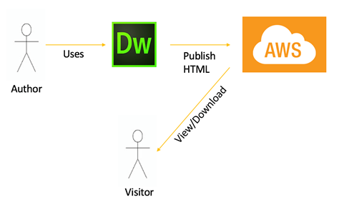*

## Website Design

The revamped website currently has two navigation bars - one on the top right part of the page and the other on the left pane. The navigation layout is similar to the current legal citation website. This was intentionally designed to aid the frequent users of the site by trying to maintain a consistent layout.

However, the color scheme of the website has been changed to make the website look more appealing and modern. In additional to these, the navigation panes have been designed to be more interactive by expanding or collapsing upon a click.

The entire website is more responsive and screen size independent now. The website dynamically rearranges its navigation panes and content depending upon the screen size of the client devices. Also, the site rearranges the layout and content when the browser is resized.

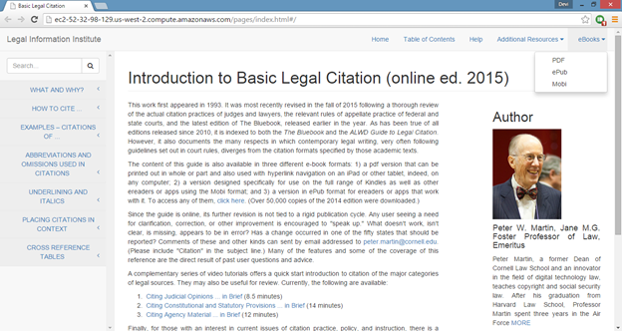*Figure: New version of the website with drop down menu for downloading different formats on the right*

The new website has been developed using HTML5. The reason for choosing HTML5  is its cross browser compatibility and support for mobile devices. The use of HTML5 also facilitated defining of new tag types and a markdown language. This aided tagging various objects in the existing site. For instance, the keyword “BB” in the site refers to “Blue book - a book on uniform system of citation”. Such keywords have to be tagged using a schema so that efficient searching can be implemented based on such tags.

## Conversion to Mobile Reader Formats

The application will have two interfaces, the author side and the user side. The author is the person who owns the content on the website and is also responsible for the perpetual updating of the same. The user base would be thousands of law students or legal professionals who use this website as a resource to understand the legal writing and learn how to cite the legal sources.

A file converter is used to convert HTML5 pages hosted on the site into various publishing formats, viz. PDF and ePub.

After thorough research on various converters, we decided to use the following tool for conversion:

**Calibre**         http://calibre-ebook.com/

Calibre is a free and open source software which supports many file formats and mobile devices. It facilitates easy editing and conversion into different digital formats.

Though the tool can’t be used as-is, we’ve written interfacing scripts that would eliminate the interactive parts of the website, such as dynamic search fields and popups, from being converted into mobile reader formats. The various tasks involved were:

1. A “ignore-on-convert” attribute that’s to be applied to any tags that should not be in the e-books;
2. A script to linearize some of the large tables in the website, in order to display them nicely in both formats;
3. CSS files for the formatting in the e-books, which differs a lot from the website formatting;
4. Create HTML files with table of contents, preface and half title page.
5. Reformat most of the original HTML files adding ebook specific classes and ids in order for the conversion to work properly;

# Refinements based on Feedback

In this iteration, the group has analyzed the feedback given for second iteration from the client and the user regarding the changes to be made in the website.

As a consequence, we have made the following changes:

1. Different fonts, colors

We have used different CSS to customize our font scheme. From dashboard to layout appearance we have given importance for user’s look and feel. There is a high contrast between background and text. We have used light background color so that there is no much contrast from the content.

1. Worked on text styling, and modified content on the main page.

We have given the same text styling for those having the same level of importance. We have not used any different font type to highlight important points. We could not see any kind of disruption between flows of our sentences.

1. Worked on having font size adaptable to the browser settings, this allows the web page to take the web browser settings set by the user.

It is sometimes difficult to read the text as its size varies in different browser settings. We have made the font and text size default for all the browsers. We even have a text resizer for mobile version.

1. Background color in a pop up was replaced with stronger color

After performing user testing with a law school student, one of the changes suggested by the user is to have a stronger background color in a popup. This would allow the user to easily distinguish the text with the highlighted examples.

We have considered this suggestion and have implemented a stronger background color for popup. This new color is now shown in the figure below.

 *Figure: Stronger background colors for popups*

1. In the navigation pane, we highlighted the selected tab

Navigation pane has provided number of options to us. We have a search box at the top which will allow us to search for text. We have also highlighted the portion of the text in the navigation bar.

1. Text styling was modified

We have used *justified* text align properties to the text. Every line of our document has equal width. Left margin and right margin are straight. We have not added any text decoration property to the text. We have also added, *text-transform* property to specify uppercase and lowercase letters in a text.

1. Made layout changes in the website design

A very flexible design is given to the website. Images, panels can be automatically adjusted. There is no question of layout break. Our website support elastic layouts and flexible grids with the help of CSS. We have created one main style sheet.

The other feedback received after Iteration 2 is also considered and appropriate improvements were made in the next iteration as described in the next section.

# New Featured added in Iteration 3

## Website

### Build AngularJS iframes for Initial example text-box.

Since the website Basic Legal Citation is a theoretical book illustrating various ways of citing cases, the author has given many examples in every section. These examples are presented in an iframe element on the HTML pages. This works well for a website. However, since the client had a requirement that the HTML pages have to be converted to other ebook formats, the detection of an iframe in an HTML page was not possible when the calibre tool was used for the HTML to ebook conversion.

These iframes have to be replaced with an alternate elements which will still communicate the same purpose while being in a structure convertible to other e-books formats. To make this possible, we have implemented an AngularJS Box which looks similar to an iframe and has the same functionality. The example box on the new website looks as in the screenshot below.

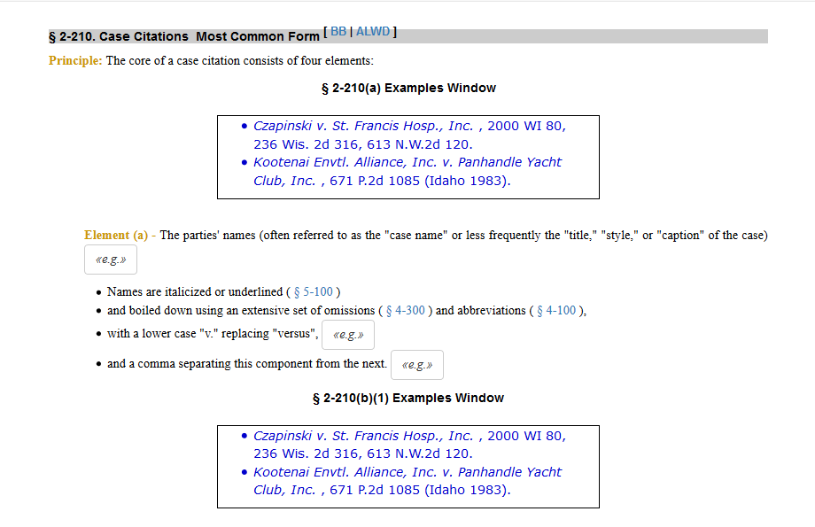

*Figure: Text-boxes before examples*

### State’s table using effective search bar for all tables.

As we progressed through this project, we have always been looking for better and faster ways to implement our solutions. Initially we did not have any nature of dynamism on objects on the website. A table was simply a static one and if the user were seeing the content on a smaller device, he/she had to scroll down for content which would interrupt reading flow. To prevent this and to provide a better user interface component, we added dynamisms on the table. If you had 50 states, all the user has to do is search the keyword in the search bar and the table would shrink by returning strings where there is a match. Because this content would also be available in static formats such as PDF and Epub, we have carefully written our parsers so that this interactivity is ridden off while conversion. 1.1.1. This allows efficient search which retrieves results using substring match.

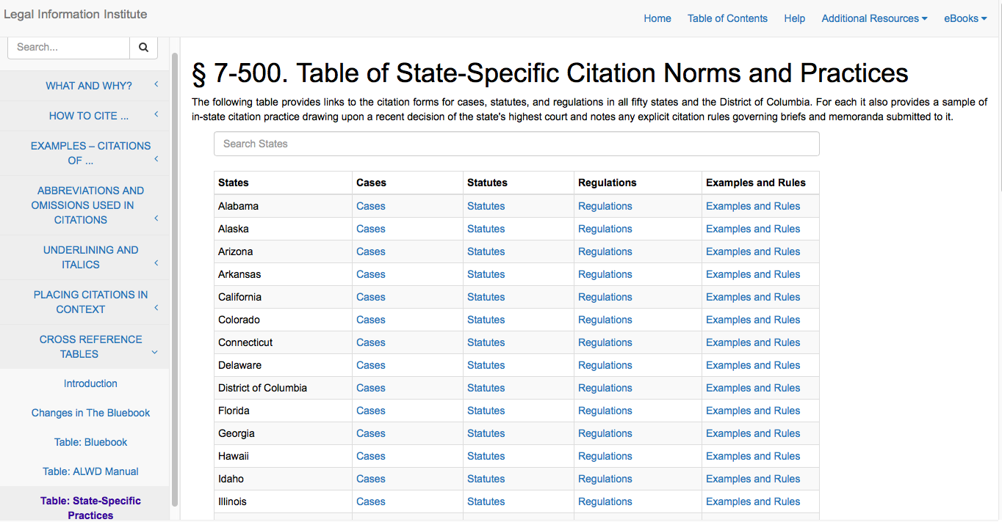

*Figure: there is a search bar above and when you search for states the table size decreases dynamically so that the user need not scroll until bottom to find states*

### Selected tab highlight on navigation pane.

One of the goals of our project was to improve the aesthetics of the website and we reformed a static website to make it look better. We have added a navigation pane on the left for users to browse through the columns. Initially the users wouldn’t know which section they were currently in while browsing the website and to make it more clearer, we added clear bold blue highlighting. This is how the website looks like now:

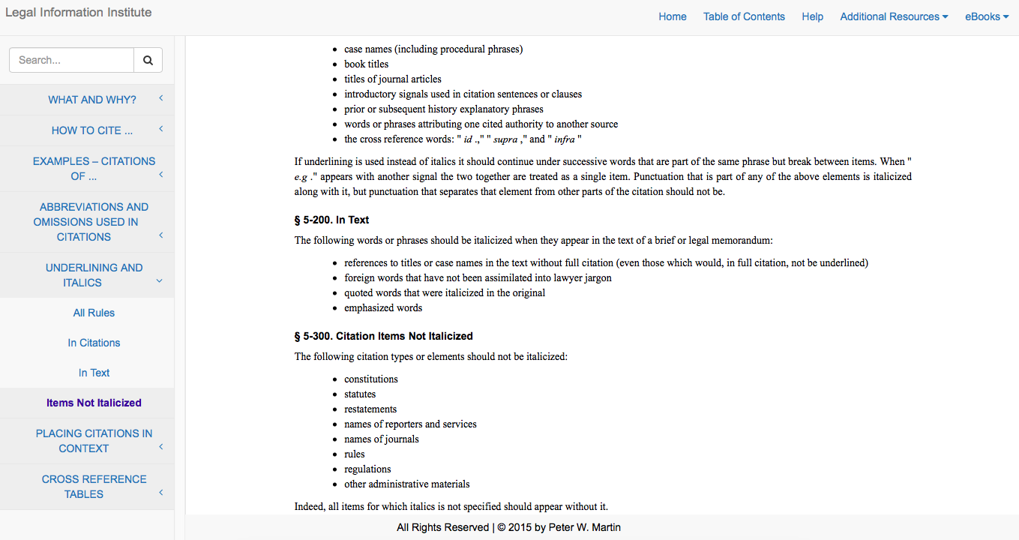

*Figure: the dark blue highlight on the left, prompts the user about the section he/she is in.*

### Worked on all the above changes either manually or through python scripts.

* Fix the broken hyperlinks.
* Introduced “Ignore-on-convert” class.
* Fixed indentation.
* Improved CSS styling.

### Worked on efficient conversion from web pages to pdf and ePub.

This involves following subparts:

* **Remove iFrames:** The differences between the original website and the ebook hosted on it, have to be maintained in our conversion as well. The one important difference that we found was that, the author has excluded the initial example textbox in the ebook. While converting our new website into an ebook, to exclude the initial example boxes, we have written a script which skips these elements that should not appear on the ebook.
* “**Ignore-on-convert” class:** The process explained in the previous section is implemented by using a special class called “ignore-on-convert”. There are many other elements on the website which should not be present on the ebook, for example, buttons, a few hyperlinks, etc. All of these elements are given an attribute class during the website construction phase. Before conversion, a script is written to skip all these elements.
* **Linearization of tables:** Many of the tables present in the Basic Legal Citation website were too large to fit in the eBook formats. In order to make the table information flows better in the eBooks, one parser function was created for each large table, and the table was converted into an unordered list (or a paragraph) identical to the formatting style present in Prof. Martin’s original eBook.
* **Mobile:** In the third iteration, the team examined the performance of the website on a mobile device, and increased the number of supported screen by adding more CSS media query breakpoints for key elements. The following six figure demonstrate the display of the website on Apple iPhone 5, Google Nexus 7, and Apple iPad, both in portrait and landscape mode. The testing was conducted on a screen simulator, not on real devices

# Refinements in Iteration 3

## Pop-ups are draggable on the screen of a desktop.

The following two figures give a demonstration of the draggable pop ups on a desktop screen. For mobile device, the pop up can not be dragged around, but the background text can be scrolled up and down, providing the same interactivity.

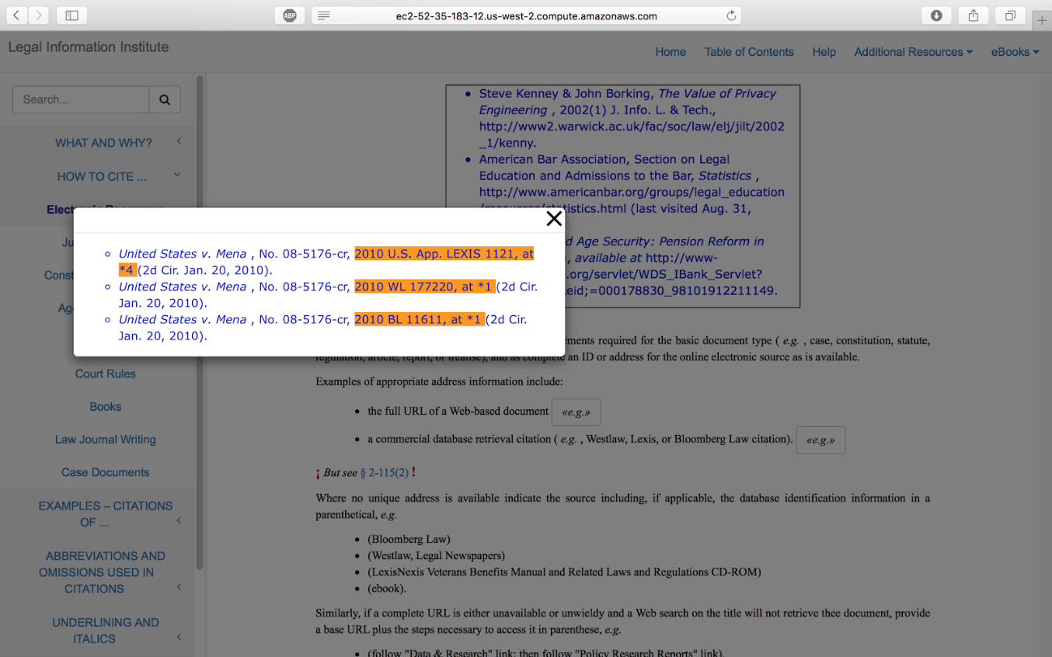

*Figure: A pop up window dragged to another position on the screen*

## Mobile Friendly Website

The site has been made mobile friendly by using “@media” breakpoints in the CSS files. The layout of the site will wrap down to accommodate various screen sizes and this was tested on mobile and tablet devices of different screen sizes.

## Collapsible side-bars for navigation

To fit the screen sizes of mobile devices, the sidebar on a desktop version will be collapsed into three lines on the top on a small screen.

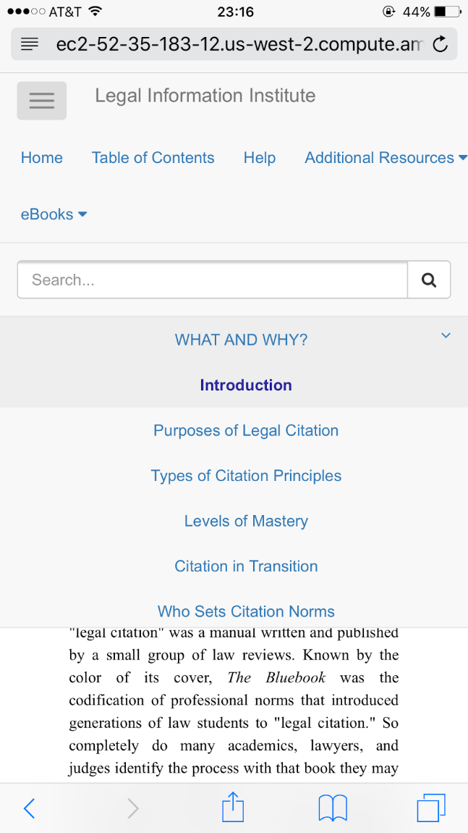

*Figure 8: The expanded sidebar*

## Tagging

Added HTML5 tags to the website pages. Some of them are <citation>, <abbreviation> etc with different attributes. These tags were added using a schema so that efficient searching can be implemented based on such tags.

This involved manually proof-reading all the HTML pages and adding relevant tags. A documentation of the identified tags, their meanings and their usage was submitted to the client for facilitating the future maintenance of these tags.

## Refined the PDF conversion.

For the PDF conversion we created a CSS file to handle the different styling between the website and the PDF version maintained by Prof. Martin. We strived to maintain a formatting as similar as possible to the one created by Prof., and we achieved this goal in almost all of the aspects.

The conversion was done using Calibre as support. In this iteration we added a lot of missing features to the PDF, such as page numbers, a complete table of contents and a title page.

We also needed parser scripts to ignore certain interactive aspects of the website and to linearize a few of the tables, making the website fully compatible with a PDF conversion.

## EPUB conversion

The EPUB conversion followed a similar path to the one used for PDF. The main difference is that we strived to create a CSS styling that was both compatible with EPUB and MOBI, as we had planned on converting the EPUB output into MOBI. We successfully created this PDF to emulate the EPUB styling of the book, and using the same parsers and the Calibre tool, we can create in real time an EPUB (and PDF) version of the website. Using EPUB we can also create a MOBI version of the website with no problem.

## Deployable Author View

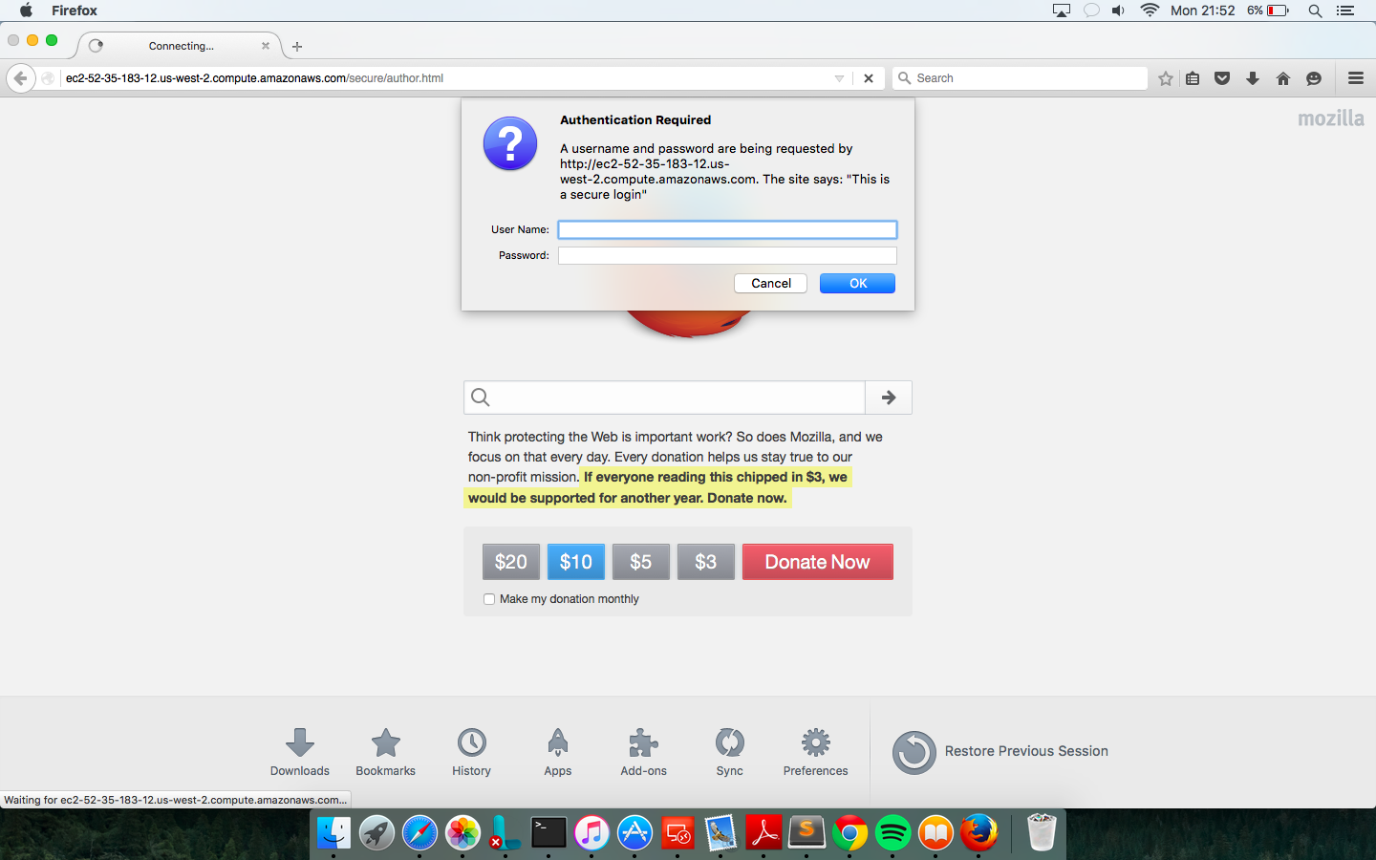

*Figure: The authentication window looks like as above*

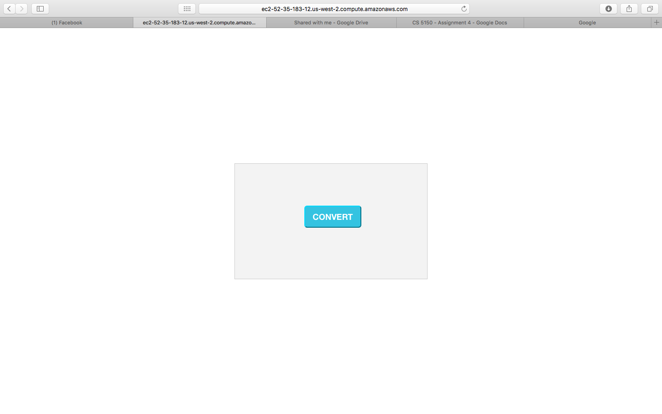

*Figure: The “CONVERT” button.*

One of the goals of this project is to give the author(ie. in this case Prof. Martin) a platform to convert the content of the website into three formats namely, PDF, Epub and Mobi while retaining all the relevant and vital formatting. Due to time constraints, we in conjunction with the client decided to focus only on the the first two formats. The Author view is a restricted view that only the author of the website would be allowed to access. The way we have approached this goal is the author would be provided a private link. Once the author hits this link on the browser, will be prompted with an authentication window. We have done this for security reasons, to avoid unauthorized access, leading to a compromised website. Once the author enters credentials, we offer a simple UI with a single “Convert” button. Once the author has made changes to the website and would like to convert it, he has to click the button and we show him the conversion live in progress and a link to view the converted files once the conversion is completed. The moment author clicks on the link he will be presented with two files PDF and Epub, which he can download and use them according to his discretion.

## Linearization of tables.

Many of the tables present in the Basic Legal Citation website were too large to fit in eBook formats. In order to make the information present in the eBooks flows better, one parser function was created for each large table, and the table was converted into an unordered list (or a paragraph) identical to the formatting style present in Prof. Martin’s original eBook.

## Tag search

A basic implementation of Search was done using the HTML5 tags. The pages that contain the searched tag are displayed using hyperlinks. The user can go to that particular page and view the relevant text.  Further work can be done on this to point the user to exact section of the page which requires some computation on the server end.

As we have decided earlier, we are following spiral development model for our current standing. The team is on the expected schedule. In the first iteration, the team has clear understanding of the requirements defined by consultation with the client to establish the application. In addition, the team has implemented a few pages to build a prototype for an interactive and mobile friendly website and a converter from XHTML files to PDF and ePub files. To create interactivity, the team removed the <iframes> from the website and created a new expand-collapse panel instead, to display citation examples. A user testing was scheduled in the week of October 26th to 31th to provide more feedback for the second iteration.

# Original Goals and Comparison with Final Results

## Goals

* **Mobile-friendly website:** Our team's goal is to design and to build a modern, mobile-friendly version of the Introduction to Basic Legal Citation website.
* **Interactive and much cleaner website:** The client wished for an interactive website which meant he specifically wanted changes in the font, the way pop-ups are animated, the way citations got highlighted.
* **Converter to other formats:** The client wanted the content to be converted to pdf, epub and mobi without going to individual files and making changes.
* **Author view to convert file formats:** The client wanted an author view dedicated to the author for executing the conversions.
* **HTML markup tagging:** To make search easier based on legal citation semantic.

## Comparison with Final Results

* **Mobile-friendly website:** We have delivered a mobile friendly website as stated by the client and it works on all different mobile browsers. We have also adjusted the font to accommodate for smaller screens
* **Interactive and much cleaner website:** The client wished for an interactive website which meant he specifically wanted changes in the font, the way pop-ups are animated, the way citations got highlighted.  We have incorporated these changes after series of iterations and feedback from the client. We have added interactive, draggable popups so that it does not distort the content on the website, we have also justified content and kept citation examples unjustified as per the request. We have made changes the left selection navigation bar. We have added dark highlighting to the popups. We have also removed iFrames from the initial website and have maintained boxes.
* **Converter to other formats:** The client wanted the content to be converted to pdf, epub and mobi without going to individual files and making changes. We have successfully designed a framework for the conversion to go through. It now successfully converts in all three formats and by intelligently ignoring our web framework code.
* **Author view to convert file formats:** The client wanted an author view dedicated to the author for executing the conversions. We have implemented an author view that gives the user a dedicated view to perform the conversion to specified formats, based on a single click.
* **HTML markup tagging:** To make search easier based on legal citation semantic. Added HTML5 tags to the website pages. Some of them are <citation>, <abbreviation> etc with different attributes. These tags were added using a schema so that efficient searching can be implemented based on such tags. This involved manually proof-reading all the HTML pages and adding relevant tags. A documentation of the identified tags, their meanings and their usage was submitted to the client for facilitating the future maintenance of these tags. These tags were used to search for specific citations.

## Optinal Requirements Met

* Mobi conversion was initially dropped and was only to be implemented if we had enough time to complete the project. We have successfully implemented mobi and delivered our mandatory requirements
* Search Bar: The search bar uses tags that help in searching for citations, abbreviations, etc. We have successfully implemented this.

# Testing

## Testing

Testing is a technique used in [user-centered](https://en.wikipedia.org/wiki/User-centered_design) [interaction design](https://en.wikipedia.org/wiki/Interaction_design) to evaluate a product by testing it on users. It also gives us a direct input on how real life users work with the system. It is a also a clear sign to test if our system is working on how it is intended to. For this project since we have developed our system in spiral model, we have conducted user and client testing on the completion of every iteration. Our client, Prof Martin along with his team tested our system and provided extensive feedback on his likes and dislikes.

For client testing, we have invited our client Prof Martin along with his team to perform testing on our system. Our client then provided with extensive feedback and suggestion on the working and design of the system clearly stating his likes and dislikes. They also suggested scope of improvements and ideas on how to make it better.

## Test Plan

For user testing, our group invited a student from law school to perform user testing. We choose to work with a law school student as he is our target audience and also well familiar with the existing system, its working and use cases. The user testing was performed remotely, by sending files of the prototype to the testers. There was no prior demonstration or training on how to navigate through the website or citing examples using the book basic legal citation.

Both the client and the user were required to evaluate the left and the complete system and report any changes that they would like to have. The feedback was collected through emails as well.

## Test Results

We collected feedback from the user and client through emails. We have incorporated the feedback provided and suggested changes into our system. We have also closely analyzed the feedback provided with client and his team to decide on worthiness of the user feedback and if it would be efficient to add it to the system.

The client and user testing done for iteration 1 and 2 is included in the previous reports submitted to the professor. Please refer to Basic legal citation report 1 and report 2 for more information regarding testing, test plans, test results and feedback given by both client and the user.

For Iteration 3, we have conducted user testing with a law school student. The process of recruiting and testing is similar to previous iterations and as explained above. The feedback provided by the user is as follows.

1. The website looks very sharp.
2. Efficient scroll bars separating web site content with side navigation bar.
3. Suggested to possibly rename the left hand menus to make it easier for the law students to use.

The group discussed the feedback provided by the user with the client and his team. We have collectively decided not to rename any menu items on the sidebar as students are well trained with the existing system and would not like to add unwanted confusion.

## Compatibility Testing

The desktop website works on major web browsers like Safari (9.0.2), Chrome (Version 45), Microsoft Edge and Firefox (Version 42). In the testing, we found that the bottom bar for copyright cannot be properly displayed on Firefox. Additionally, the mobile website works as designed on iOS Safari 9 and Chrome 47.

## Acceptance Testing

The final product was delivered to the client and acceptance testing was done to ensure that it meet his requirements.

Since the client is not used to the modern web technologies used in the product, a meeting was arranged to demonstrate its features to the client. Important use cases such as adding pages, adding new example window pop-ups and setting up navigation links on the sidebars were explained.

The author view, which eases his effort to convert the site’s contents into other portable formats were also explained.

A document explaining the deployment instructions were delivered to the client. Another meeting was arranged with Legal Information Institute’s technology infrastructure expert, so that the site can be re-deployed on any server.

# Progress

We have delivered all requirements and have successfully completed the project in the given timeline.

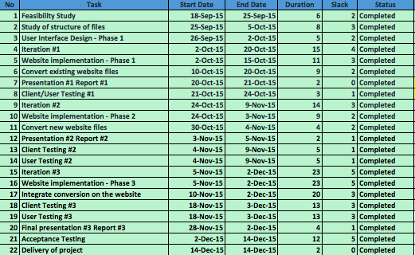

*Figure: The Gantt Table*