**10-year Back-casting**

**The approach**

This approach to career planning is a task of back-casting, not forecasting. You’re thinking about your ideal career and life. You’re not thinking about decisions you’re taking now. You’re not thinking about how your current situation would pan out if extrapolated into the future.

Remember, 10 years is long enough that you could change your whole life – get a new degree and even (another) PhD.

This process requires lots of list making and comparing. If lists don’t work for you try other ways of documenting things. These could include mind-maps, sticky notes or a mood board. Whatever system you use, it’s important that the items and ideas are clear so you can compare, contrast and recall them.

**The process**

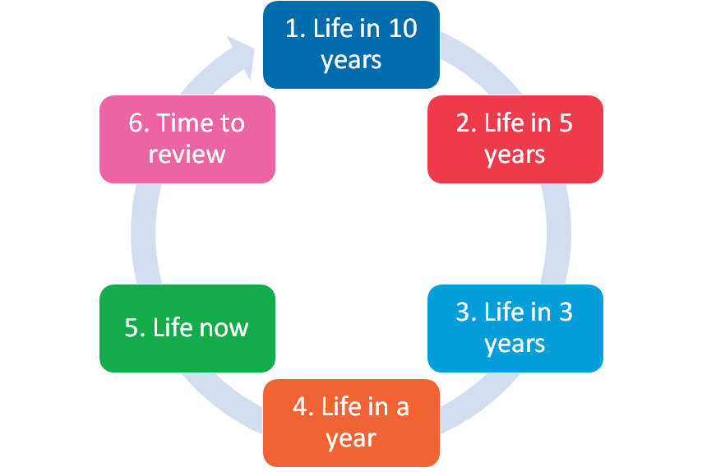

**Let’s examine the detail**

### What will life be like (for you) in 10 years?

Consider both your work as well as personal life. For example:

* Will you be in a relationship?
* How will you be living – in a place you own, or a place someone else owns?
* Where will you be living – the same city/country as now, or somewhere else?
* Will you have kids?
* What will your role be in relation to others around you?
  + Will you be a/the major carer?
  + Will you be a/the major income earner?
* How much will you be earning?
* What will you be doing for money?
* What qualifications, skills or experience do you have?
* What will your mentors be doing?
* What does your working week look like?
  + Will you work have fixed or flexible working hours?
  + Will you work more or less than 30-40 hours per week?
  + Will weekend or after hours’ work be involved?
  + Will you travel overseas or interstate?
* How would you answer [questions on the Census](http://www.abs.gov.au/websitedbs/censushome.nsf/home/2011hhftranscript%5C)?

Thinking of the answers could be overwhelming. If so, consider just the following:

* What will you be doing for money?
* Where will you be living?
* What will your (average) working week look like?

The answers don’t need to be detailed, and your whole response might be limited to one paragraph.

### What does that imply for life in 5 years?

So, you have an idea of what life looks like in 10 years. But, what does that mean for life five years before that? Ask yourself:

* What are the work-roles required to get you to your 10 year goals?
  + If you want to be in research, what’s your required publication rate (realistically)?
  + What about grant income?
* Are you working at a university or a research institute or in industry/government?
* What qualifications, skills or experience do you have?
* What will your mentors be doing?
* What does the average work week look like?
* Are you applying for a promotion? Or did you just get one?
* Are you saving to buy your first house/investment? Or did you just get one?
* Are you just completing a (Masters) degree?
* Where will you be living?
* How much will you be earning?
* How would you answer [questions on the Census](http://www.abs.gov.au/websitedbs/censushome.nsf/home/2011hhftranscript%5C)?

Again, if there’s too much to consider just focus on the same three questions:

* What will you be doing for money?
* Where will you be living?
* What will your (average) working week look like?

As per above, the answers don’t need to be detailed, and your whole response might be limited to one paragraph.

### What does that mean for life in 3 years?

Repeat the process for three years.

However, at this point there needs to be some continuity between your current situation and your projected self. For example, if you’re in the first or second year of your PhD (now), then in three years you’ll be completing (or have completed) your PhD. So, that should be on the list. You’ll probably be in or about to start your first Post-Doctoral role (i.e. your first job after your PhD). So, that should be on the list too. It should also relate to (most) of your current experiences and expertise.

Again, answering similar questions will help you understand what your life will need to look like in three years – so that you meet your 10 year goals.

* What are the work-roles required to get you to your five-year goals?
  + If you want to be in research, what’s your required publication rate (realistically)?
  + What about grant income?
* Are you working at a university or a research institute or in industry/government?
* What qualifications, skills or experience do you have?
* What does the average work week look like?
* What will your mentors be doing?
* Are you applying for a promotion? Or did you just get one?
* Are you saving to buy your first house/investment? Or did you just get one?
* Are you just completing a (Masters) degree?
* Where will you be living?
* How much will you be earning?
* How would you answer [questions on the Census](http://www.abs.gov.au/websitedbs/censushome.nsf/home/2011hhftranscript%5C)?

Again, if there’s too much to consider just focus on the same three questions:

* What will you be doing for money?
* Where will you be living?
* What will your (average) working week look like?

At this point, more detail is required. But still not heaps. Perhaps as much as a page.

### What does that mean for life in a year?

Now, the process might be getting a little scary. But, bear in mind we overestimate how much we can get done in a week, but under estimate what can get done in a year. So, you have plenty of time.

Again, repeat the earlier processes:

* What are the work-roles required to get you to your three-year goals?
  + If you want to be in research, what ‘s your required publication rate (realistically)?
  + What about grant income?
* What qualifications, skills or experience do you have?
* What does the average work week look like?
* How much of your thesis have you written?
* How much of your PhD have you completed?
* Where will you be living?
* How much will you be earning?
* Are you looking for a job (paid or volunteer)?
* What will your mentors be doing?
* How would you answer [questions on the Census](http://www.abs.gov.au/websitedbs/censushome.nsf/home/2011hhftranscript%5C)?

Again, if there’s too much to consider just focus on three questions:

* What will you be doing for money? (i.e. What progress will you have made on your PhD?)
* Where will you be living?
* What will your (average) working week look like?

At this point, more detail is required. But still not heaps. Perhaps as much as a page.

### What does that mean (for you) now?

So, we have arrived at today – now.

* What’s the difference between now and your 12-month self?
* What do you need to start doing to bridge that gap?
  + What needs to be started now so that it can be achieved within 12 months?
  + What can start later, but still be achieved in 12 months?
  + What can you do on your own?
  + What needs the help or support of others?

Break the next 12 months down into a series of four 90 day blocks (i.e. groups of three months).

Now, look at those blocks and note those that might be particularly busy and those that are more open. For example, in Australia (Southern Hemisphere) the Dec-Jan period might be listed as busy if you plan to take holidays. Similarly, during Jan-Feb it might be difficult to access your supervisor or senior researchers because they are busy writing grants. Conversely, US or European (Northern Hemisphere) based-students might find Jun-Jul busy with holidays.

But, these same busy periods might be when you can get more work done if you’re still collecting data or writing up your work. For example, you might have better access to equipment. There might be fewer people around to distract you.

Once you have the 90 day blocks planned out, allocate different career building activities to each block. Some will likely span several blocks; others will not. Some might even span the entire year.

What’s the highest priority – focus on it

What are the second and subsequent priorities – note them down, and consider avoiding them until you have your first priority in hand. i.e. second and subsequent priorities tend to serve as distractions to our main focus. So, we suggest focusing on one item in each 3-month block, rather than trying to simultaneously develop four different skills.

This section will be detailed. It will include four 90 day plans. Each 90-day plan might have three to five dot points, listing the main foci for that period, how you know if you’ve achieved your intent, the impact of success or failure and how you will reward yourself for achievements/milestones. Make sure the plan follows the SMART goal rules.

### Review and Implement

You now have a description of your life in:

* 10 years
* five years
* three years
* one year.

You also have a plan to achieve your one-year goal, and thus put you on a path to achieving your ten-year goal.

Look across the plan and consider – is it plausible? Does it all make sense?

If yes, great! Start taking action on the items in your first 90-day block.

If not, change the plan so it does make sense.

Now, set yourself a reminder to review the 90 day plans every – you guessed it – 90 days. Set a second reminder to review your entire plan every 12 months. Starting from 10 years and working backwards.

Good Luck!

Need help? Contact:

Dr Richard Huysmans

[Richard.huysmans@ravencg.com.au](mailto:Richard.huysmans@ravencg.com.au)

0412 606 178