**Skills in Need**

**The approach**

This approach to career planning is to identify the skills for the future. It aims to create a worker who’s in high demand; one who has the skills required by the future workforce.

This process requires lots of list making and comparing. If lists don’t work for you try other ways of documenting things. These could include mind-maps, sticky notes or a mood board. Whatever system you use, it’s important that the items and ideas are clear so you can compare, contrast and recall them.

**The process**

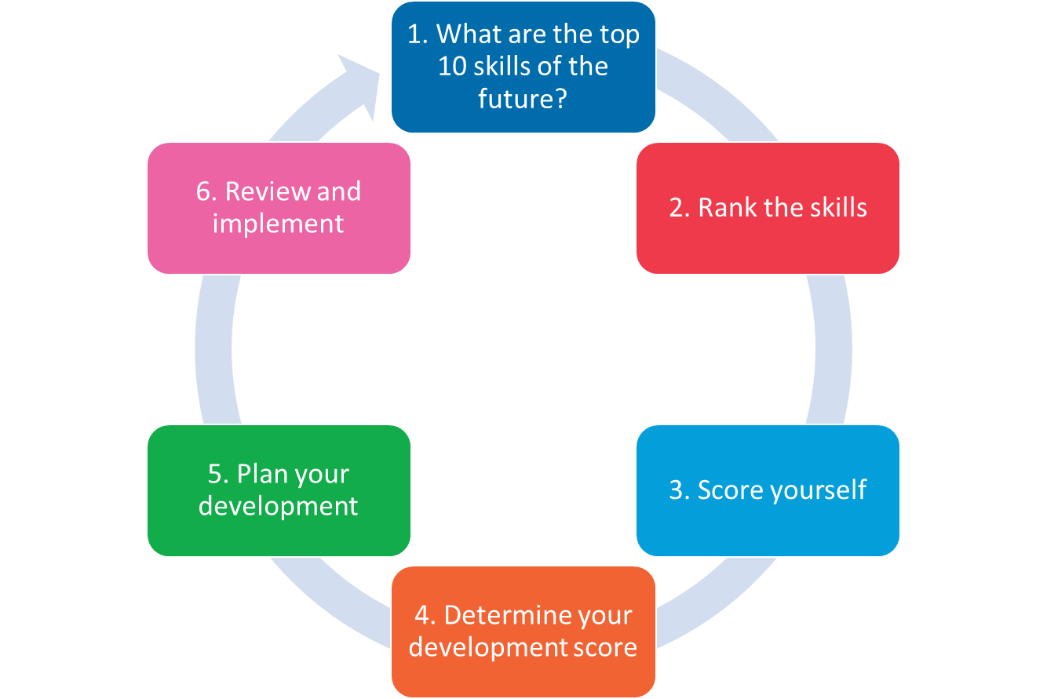

**Let’s examine the detail**

1. What are the top 10 skills of the future?

Using the web, identify the top 10 skills for the future of work. Here are some places you could start:

* <https://www.pwc.com.au/pdf/future-of-work-report-v23.pdf>
* <http://www.ceda.com.au/research-and-policy/research/2015/06/workforce>

You’ll find that governments, private (consulting) companies, not-for-profit organisations and universities (research centres) focused on workforce and economic development publish jobs and/or skills for the future reports every few years, if not annually.

Some reports will rank the skills, including comparing them to previous reports and/or current trends. Other reports will just list them.

It’s important the list you choose is relevant. Consider the following:

* Avoid picking a list that is specific to an industry or sector (unless you’re really sure that’s the industry or sector you’ll work in).
* Try to use a list developed for your country of interest (or the international economy).
* Focus on skills, rather than jobs of the future (it’s often said the jobs of the future do not even exist yet).
* Make sure the list defines each skill, that way you can more easily assess your competency.

1. Rank the skills.

If the list you’re using has a priority order, great, use it to score each item on the list.

It’s critical to score inversely to importance. That is the top skills should be scored lower than the bottom ranked skills. This helps weight your final analysis towards the more highly-important skills.

For simplicity, you should give the top three items a score of 1, the middle four a score of 2, and the final three a score of 3. Of course, if you wish to make things more complex – go ahead. Bear in mind, a broader scoring system will bias for (or against) items lower or higher on the list.

In early 2016, the World Economic Forum Published a list of top ten skills for 2020 (see below). Using these items as an example, we would focus on the 2020 list (not the 2015 list). Items 1 – 3 (Complex Problem Solving, Critical Thinking and Creativity) would all be allocated a score of 1. Whereas Service Orientation, Negotiation and Cognitive Flexibility would all be allocated a score of 3. Everything in between gets a 2.

|  |  |
| --- | --- |
| Top 10 skills | |
| In 2020 | In 2015 |
| 1. Complex problem solving | 1. Complex problem solving |
| 1. Critical thinking | 1. Coordinating with others |
| 1. Creativity | 1. People management |
| 1. People management | 1. Critical thinking |
| 1. Coordinating with others | 1. Negotiation |
| 1. Emotional intelligence | 1. Quality control |
| 1. Judgment and decision making | 1. Service orientation |
| 1. Service orientation | 1. Judgment and decision making |
| 1. Negotiation | 1. Active listening |
| 1. Cognitive flexibility | 1. Creativity |

1. Score yourself

For each skill, give yourself a score of how well you perform that skill. Make sure you thoroughly read the report and associated description of the skill to understand what’s being described. Think about how you might (currently) be using that skill in your PhD, work or social life. If you find it difficult to score yourself, chat it through with one or more colleagues.

Better performance should be given a higher score. For simplicity, a three scale approach is suggested:

* Have the skill (3)
* Needs work (2)
* Absent (1)

Again, if you wish to make things more complex – go ahead. Bear in mind, a broader scoring system will bias for (or against) items lower or higher on the list.

1. Determine your development score

Each skill should now (theoretically) be allocated three numbers (see below):

* Its priority or rank order – as determined by the author of the skills for the future list.
* Skill rank – a number you allocated against the skill based on its position in the list.
* Your score – your self-rating of your ability in that specific skill.

Multiply the *Skill Rank* by *My Score* to get a *Development Score* for all skills in the list (see below).

|  |  |  |  |  |
| --- | --- | --- | --- | --- |
| **Future skill** | **Rank order** | **Skill rank** | **My score** | **Development score** |
| Complex Problem Solving | 1 | 1 | 2 | 2 |
| Critical Thinking | 2 | 1 | 3 | 3 |
| Creativity | 3 | 1 | 1 | 1 |

1. Plan your development

Re-ordering the list based on *Development Score* (lowest at the top) will give you a priority order for skills to develop. So, in our example above, Creativity would be the first, followed by Complex Problem solving, then Critical Thinking.

The intent of the scoring system is to make choosing the skills to develop easier. Essentially, you should be focusing on the highest ranked, worst skill you have (from the list), until it’s no longer your worst or it’s no longer as highly ranked.

As a PhD student, you will (likely) be competing for jobs with other PhD students. Thus your self-ranking (and therefore the effort you put into developing each skill) could take into account your performance relative to your peers.

However, such an approach is fraught as you do not want to get into the habit of regularly comparing yourself to others. Instead, it might be better to focus on developing a skill (or habit that forms a skill) every three months. Thus, the top four items on your development list become the skills to build over the next 12 months.

For some skills, you may argue they will develop naturally as part of a PhD (from our list above that might be critical thinking or complex problem solving). Therefore, you might decide to skip working on those and focus on others that are less likely the focus of a PhD (from our list above that might be Creativity or Service Orientation). However, it’s also worth considering if those skills (the ones forming part of a PhD) are developing at a sufficient pace; if not you might focus on them a little more.

For the top (four) items on your list of skills to develop, make a plan for each. The plan might include getting experience, completing a formal qualification, seeking out a mentor, a combination of all three – or something entirely different.

Break the next 12 months down into a series of four 90 day blocks (i.e. groups of three months).

Now, look at those blocks and note those that might be particularly busy and those that are more open. For example, in Australia (Southern Hemisphere) the Dec-Jan period might be listed as busy if you plan to take holidays. Similarly, during Jan-Feb it might be difficult to access your supervisor or senior researchers because they are busy writing grants. Conversely, US or European (Northern Hemisphere) based-students might find Jun-Jul busy with holidays.

But, these same busy periods might be when you can get more work done if you’re still collecting data or writing up your work. For example, you might have better access to equipment. There might be fewer people around to distract you.

Once you have the 90 day blocks planned out, allocate different career building activities to each block. Some will likely span several blocks; others will not. Some might even span the entire year.

What’s the highest priority – focus on it.

What are the second and subsequent priorities – note them down, and consider avoiding them until you have your first priority in hand. i.e. second and subsequent priorities tend to serve as distractions to our main focus. So, we suggest focusing on one item in each 3-month block, rather than trying to simultaneously develop four different skills.

This section will be detailed. It will include four 90 day plans. Each 90-day plan might have three to five dot points, listing the main foci for that period, how you know if you’ve achieved your intent, the impact of success or failure and how you will reward yourself for achievements/milestones. Make sure the plan follows the SMART goal rules.

1. Review and implement

Look at the plan and consider – is it plausible? Does it all make sense?

If yes, great! Start taking action on the items in your first 90-day block.

If not, change the plan so it does make sense.

Now, set yourself a reminder to review the 90 day plans every – you guessed it – 90 days. Set a second reminder to review your entire plan every 12 months, starting from the list of skills required for the future of work.

Good Luck!

Need help? Contact:

Dr Richard Huysmans

[Richard.huysmans@ravencg.com.au](mailto:Richard.huysmans@ravencg.com.au)

0412 606 178