**Work I Love**

**The approach**

This approach to career planning involves working out your career goals by starting to think about what you love doing.

This process requires lots of list making and comparing. If lists don’t work for you try other ways of documenting things. These could include mind-maps, sticky notes or a mood board. Whatever system you use, it’s important that the items and ideas are clear so you can compare, contrast and recall them.

**The process**

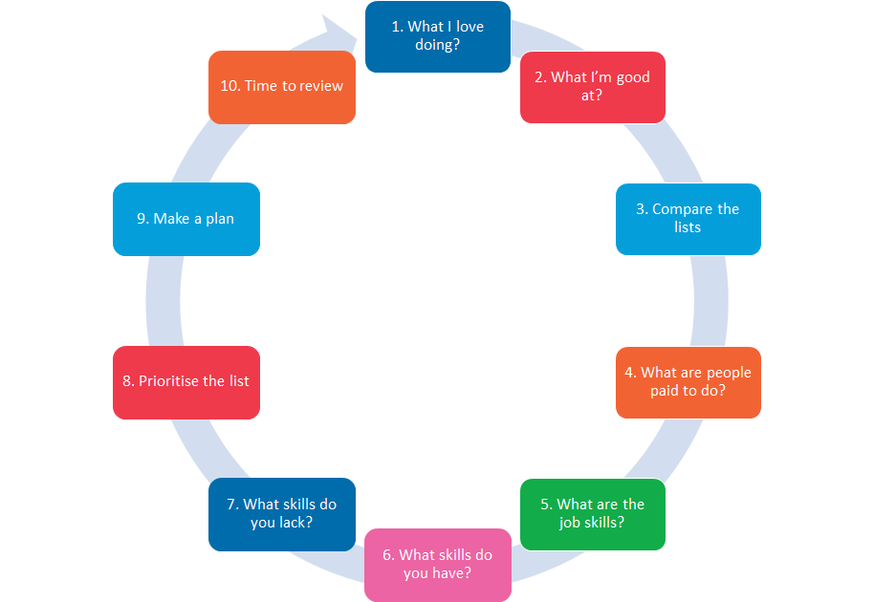

**Let’s examine the detail**

1. List the things you love to do.

Think about all of the things you love or like to do. At this stage, don’t limit the list. It should include everything. For some people the list will include their research, as well as their personal interests. For others, the list might not include both. For some it could include music, art, sport, writing. At this stage you’re being expansive and open-minded.

1. What are you good at?

Next, make a list of all of the things you’re good at, or have done well. Again, be expansive, but make sure the list is limited to what you’re good at or have done well. If you’re going to put something down, you need to be in the top 30% or so. Being in the top 30% is the equivalent to your current situation. Having completed a degree, an honours year (or equivalent) and started a PhD you are in the top 30% (or better) of your age-matched peers.

1. What is on the two lists?

Now, compare the two lists. What’s on both? That is, what items do you both like doing and are good at? Bring all of those items together.

1. What are people paid to do?

It’s time to get pragmatic. You’re talking about your career here, after all. So, what from Item 3 are people paid to do? To be clear, this isn’t what you can be paid to do (we’ll get to that in a few steps), but ‘what are people paid to do?’

Highlight all the items from your list at Item 4 that people are paid to do

1. What skills are needed for those jobs?

For each highlighted job, make a list of the skills and experiences required to do that work.

If research is highlighted, you’ll need to have a PhD. You’ll probably also need to be a good writer of grants and journal articles. You’ll probably need to be a good communicator in general (i.e. you’ll need to speak well at conferences and seminars, as well as design high quality research posters). If you intend on being part of a research group, you’ll need to work well in a team, and probably develop your leadership and followship skills. Project management might also be on the list, same with budget management. Data analysis, critical thinking and knowledge of various research methodologies will be essential to success.

You should perform the same kind of analysis for each job. Being specific is good, but it will take time. So, consider stopping at five or 10 items and then revisit the lists at a later date or at the end of the process.

Also, it might be worth prioritising the job listing – particularly if the skills and experiences are divergent. It will help later when it comes to selecting the skills and experiences you develop now, versus later in your PhD (or even after it).

1. What skills do you have?

Now, we come to the skills you have. For each job and skill set listed at Item 5, highlight the ones you already have.

For example, as a PhD student, you probably have some writing skills, as well as other communication skills (e.g. oral presentation and general verbal communication). You might also have good analytical skills, as well as critical thinking.

1. What skills do you need?

All of the un-highlighted items now become the skills you need to develop.

1. Prioritise the list

Some things, such as analytical skills as well as critical thinking, you might consider yourself underdeveloped. However, a good PhD should cover those well. So you might determine that they are lower priorities.

However, you might lack leadership, project management and budget management. Although project management is part of managing your PhD, you might feel more explicit training would be useful, so you might prioritise that higher. Leadership and budget management might be things you feel are useful later in your career, not immediately following your PhD, so you prioritise them lower.

1. Make a plan

For the top (four) items on your list of skills to develop, make a plan for each. The plan might include getting experience, completing a formal qualification, seeking out a mentor, a combination of all three – or something entirely different.

Break the next 12 months down into a series of four 90 day blocks (i.e. groups of three months).

Now, look at those blocks and note those that might be particularly busy and those that are more open. For example, in Australia (Southern Hemisphere) the Dec-Jan period might be listed as busy if you plan to take holidays. Similarly, during Jan-Feb it might be difficult to access your supervisor or senior researchers because they are busy writing grants. Conversely, US or European (Northern Hemisphere) based-students might find Jun-Jul busy with holidays.

But, these same busy periods might be when you can get more work done if you’re still collecting data or writing up your work. For example, you might have better access to equipment. There might be fewer people around to distract you.

Once you have the 90 day blocks planned out, allocate different career building activities to each block. Some will likely span several blocks; others will not. Some might even span the entire year.

What’s the highest priority – focus on it.

What are the second and subsequent priorities – note them down, and consider avoiding them until you have your first priority in hand. i.e. second and subsequent priorities tend to serve as distractions to our main focus. So, we suggest focusing on one item in each 3-month block, rather than trying to simultaneously develop four different skills.

This section will be detailed. It will include four 90 day plans. Each 90-day plan might have three to five dot points, listing the main foci for that period, how you know if you’ve achieved your intent, the impact of success or failure and how you will reward yourself for achievements/milestones. Make sure the plan follows the SMART goal rules.

1. Review and implement

All being well, you should have the following lists:

1. What you like doing.
2. What you’re good at.
3. The intersection between 1 and 2.
4. What items at 3 people are paid to do.
5. Skills required for those jobs noted at item 4.
6. Skills you currently have to perform the jobs at item 5.
7. Skills you need to develop to perform the jobs at item 5.
8. Priority skills to build.
9. Things to do over the next 12 months (divided into three month blocks).

Now, review to make sure you’re happy with what you’ve done and the implication for the work you’re about to do. If you’re not happy, make a change.

If you’re happy – start!

Good Luck!

Need help? Contact:

Dr Richard Huysmans

[Richard.huysmans@ravencg.com.au](mailto:Richard.huysmans@ravencg.com.au)

0412 606 178