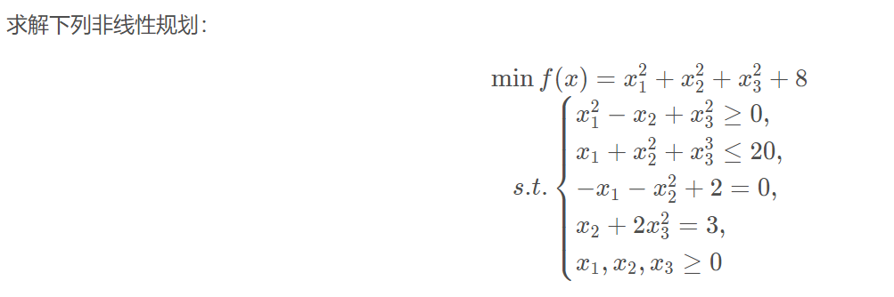

from scipy import optimize as opt
import numpy as np
from scipy.optimize import minimize

# 目标函数
def objective(x):
return x[0] ** 2 + x[1] ** 2 + x[2] ** 2 + 8

# 约束条件
def constraint1(x):
return x[0] ** 2 - x[1] + x[2] ** 2 # 不等约束

def constraint2(x):
return -(x[0] + x[1] ** 2 + x[2] ** 2 - 20) # 不等约束

def constraint3(x):
return -x[0] - x[1] ** 2 + 2

def constraint4(x):
return x[1] + 2 * x[2] ** 2 - 3 # 不等约束

# 边界约束
b = (0.0, None)
bnds = (b, b, b)

con1 = {'type': 'ineq', 'fun': constraint1}
con2 = {'type': 'ineq', 'fun': constraint2}
con3 = {'type': 'eq', 'fun': constraint3}
con4 = {'type': 'eq', 'fun': constraint4}
cons = ([con1, con2, con3, con4]) # 4个约束条件
x0 = np.array([0, 0, 0])
# 计算
solution = minimize(objective, x0, method='SLSQP', bounds=bnds, constraints=cons)
x = solution.x

print('目标值: ' + str(objective(x)))
print('答案为')
print('x1 = ' + str(x[0]))
print('x2 = ' + str(x[1]))

# ----------------------------------
# 输出：
# 目标值: 10.651091840572583
# 答案为
# x1 = 0.5521673412903173
# x2 = 1.203259181851855

