**EduAIthon**

**Video link/QR code**

**https://drive.google.com/file/d/1PQ74uB_1yj2if-a9pd580xf5knHVFlYk/view?usp=drive_link**

| **Team Name: LakshyaSetu** | | | |
| --- | --- | --- | --- |
| **Team Number: - 47** | | **College Name: - RVCE** | |
| **Sl. No.** | **Name** | **Contact Number** | **Email ID** |
| **1.** | Ramachandra Manjunath Rayakar | 9964975545 | Ramachandramr.cs22@rvce.edu.in |
| **2.** | Ningaraj P Totagi | 9686369832 | ningarajpt.cs22@rvce.edu.in |
| **3.** | Sachin Annigeri | 9845814278 | sachinannigeri.cs22@rvce.edu.in |
| **4.** | Lakshmeesha K R | 9110692694 | lakshmeeshakr.ai22@rvce.edu.in |
| **5.** | Anand Patil | 9108157953 | anandpatil.cd22@rvce.edu.in |

|  |  |
| --- | --- |
| **TABLE OF CONTENTS** | |
| **Abstract** | i |
| **1. Introduction** | 1 |
| **2. Literature Review** | 2-3 |
| **3. Main objectives** | 4 |
| **4. Theory and Concepts** | 5-7 |
| **5. Project objective and methodology** | 8-13 |
| **5.1 Problem definition** | 8 |
| **5.2 Project objective** | 9 |
| **5.3 Project methodology** | 9 |
| **5.4 Project methodology flow diagram /flow chart** | 10-13 |
| **6. Testing and Analysis(Quantitative and Qualitative testing)** | 14-15 |
| **7. Tools used** | 16-17 |
| **8. Results and Discussions** | 18-19 |
| **9. Conclusion and Future Scope** | 20 |
| **10. References** | 21 |

**Abstract**

**PrepSutra** is a free, web-based one-stop platform developed to assist **UPSC** aspirants, especially those from rural India, in preparing effectively and independently without relying on coaching centers or lectures. Acknowledging the challenges faced by students in remote areas—such as lack of structured mentorship, paid resources, and poor access to academic environments—**PrepSutra** bridges this gap by offering a smart, accessible, and inclusive self-learning ecosystem.

The platform empowers aspirants through a combination of features like categorized Previous Year Questions (PYQs), a customizable Study Planner, Mock tests, and current affairs article analysis. PYQs are intelligently organized by subject, year, and type (MCQ, descriptive, match the following, short answer, case study), and can be filtered based on the latest **UPSC** syllabus, enabling focused, topic-wise revision. The Article Analyzer (Humanizer) reads and summarizes important articles related to current affairs in simplified form, and links them with relevant PYQs to reinforce understanding through contextual practice.

**PrepSutra** is equally useful for aspirants who are enrolled in coaching institutes. While they may already have access to lectures, **PrepSutra** enhances their preparation by offering tools for personalized learning, including the ability to track progress, upload their own reference textbooks or notes, and consolidate preparation resources within the platform. The mock test system further helps them evaluate their readiness using real exam-style questions from previous years.

Built and deployed on Vercel, the platform is lightweight, mobile-responsive, and optimized for low-bandwidth users, ensuring it remains accessible to students in digitally under-resourced areas. **PrepSutra** aims to democratize UPSC preparation through intelligent design, self-guided learning tools, and complete freedom from cost barriers—making civil service aspirations reachable for every corner of India

**1.INTRODUCTION**

The Union Public Service Commission (**UPSC**) examination is one of the most prestigious and competitive examinations in India, attracting lakhs of aspirants each year. However, preparing for UPSC demands access to a wide range of structured resources, consistent practice, time management, and regular evaluation—all of which are often unavailable to students in rural areas. Many aspirants lack access to quality coaching institutes, updated study materials, or mentorship, which makes it difficult for them to compete on an equal footing with their urban counterparts.

In response to this gap, **PrepSutra** has been developed as a free, web-based platform to assist aspirants—especially from rural India—in preparing independently for the UPSC examination. The platform is designed with a philosophy of "self-guided, structured preparation without reliance on lectures or paid resources." It enables users to take control of their preparation through curated tools and intelligently organized content.

**PrepSutra** serves not only those without coaching access but also provides immense value to aspirants currently enrolled in coaching institutions. These users can enhance their preparation with personalized features such as a custom study planner, mock test environment, and resource organization, along with the ability to upload their own textbooks and notes directly to the platform.

One of the most impactful features of **PrepSutra** is its Article Analyzer (Humanizer), which simplifies current affairs articles and connects them directly to relevant previous year questions, allowing aspirants to understand the practical relevance of topics in real UPSC examinations. This promotes a deeper connection between reading and retention.

With the integration of a PYQ analyzer, syllabus-based filtering, and a mobile-optimized, low-bandwidth interface, **PrepSutra** aims to level the playing field by bringing affordable, intelligent, and effective UPSC preparation to every corner of India—rural or urban.

**2.Literature Review**

The emergence of technology in education, particularly AI-powered adaptive learning systems, has redefined how learners engage with complex subjects like civil services preparation. Numerous platforms in the EdTech industry, such as **Unacademy**, **BYJU’S**, **Vision** **IAS**, and **Physics** **Wallah** **(PW)**, have entered the **UPSC** space with solutions aimed at mass accessibility. However, a closer evaluation reveals that while these platforms offer value through video lectures and static notes, they fall short in delivering personalized learning pathways, adaptive assessments, and self-paced progress monitoring—especially for aspirants from rural areas who face constraints of connectivity, affordability, and access to mentorship.

Platforms like PW **UPSC** offer video lectures, PDF class notes, and printed materials at relatively low prices (₹35,000 for a full preparation course), but still require users to passively consume large volumes of content daily. These models often lack adaptive planning tools, mock test-based self-assessment, or syllabus-wise intelligent question filtering, which are critical for time management and effective revision. Additionally, they do not provide article-to-PYQ mapping or study planners, leaving the user to manually structure their preparation—a major gap for both beginners and working aspirants.

In addition to peer-reviewed studies, insights from government reports and education policy frameworks (such as NEP 2020) emphasize the importance of personalized, inclusive, and technology-driven learning for India’s diverse student population. With the majority of UPSC aspirants coming from tier-2 and rural areas, there is a critical demand for non-linear, lecture-free, affordable solutions that combine flexibility with academic rigor.

PrepSutra addresses this gap by fusing research-backed methodologies with real-world needs—integrating PYQ-based mock tests, article analyzers (Humanizer), syllabus trackers, user-uploaded resource hubs, and a self-paced study planner. This makes it both a research-grounded and practically impactful contribution to the future of civil service education.

**Comparative Analysis of Existing Platforms:**

Below is a feature-wise comparison of PrepSutra with existing UPSC EdTech platforms:

|  |  |  |  |
| --- | --- | --- | --- |
| **Feature** | **PW UPSC Course** | **Unacademy** | **PrepSutra** |
| Video Lectures | ✅ Yes | ✅ Yes | ❌ No |
| PDF/Printed Notes | ✅ Yes | ✅ Yes | ✅ User/Team Uploaded |
| Cost | ₹35,000 | ₹50,000+ | ✅ Free |
| Personalized Study Planner | ❌ No | ❌ No | ✅ Yes |
| Article Analyzer | ❌ No | ❌ No | ✅ Yes |
| PYQ Analyzer by Syllabus | ❌ No | ❌ Partial | ✅ Full Support |
| Mock Tests (PYQ based) | ✅ Limited | ✅ Yes | ✅ Yes (Self-curated) |
| Notes Upload Option | ❌ No | ❌ No | ✅ Yes |

**3. Main Objectives**

**3.1 Primary Objectives**

* To develop a free and accessible web-based platform (PrepSutra) that enables UPSC aspirants—particularly those from rural India—to prepare effectively without relying on paid coaching or lectures.
* To offer a comprehensive repository of categorized UPSC Previous Year Questions (PYQs) that are searchable by year, subject, and question type.
* To provide a personalized study planner that helps aspirants schedule, track, and revise topics based on their exam date, time availability, and progress.
* To integrate a mock test system using PYQs to simulate real exam conditions for practice and self-assessment.
* To implement an Article Analyzer (Humanizer) that simplifies current affairs content and maps it to relevant PYQs for better contextual learning.
* To support note/textbook uploads by users for centralizing all their preparation materials in one place.

**3.2 Secondary Objectives**

* To provide aspirants with smart filtering options based on the UPSC syllabus for quick access to relevant PYQs.
* To optimize the platform for low-bandwidth, mobile-friendly use, especially for students in rural or remote regions.
* To support user-generated content uploads (e.g., personal notes, PDFs) for flexible and user-driven learning.
* To create a future-ready foundation for integrating AI-based feedback on descriptive answers and essays.
* To ensure zero-cost, ad-free learning as a core commitment to equitable education.

**4.Theory and Concepts**

PrepSutra is built on the foundation of self-paced, structured, and question-oriented learning, driven by educational psychology principles and modern learning science. The platform does not rely on passive video consumption or fixed lecture-based schedules. Instead, it uses active recall, spaced repetition, syllabus mapping, and personalized planning to create a dynamic and student-centric UPSC preparation experience.

**4.1 Self-Guided Learning**

PrepSutra is built on the principle of self-guided or self-regulated learning, where learners actively take control of their study process. This concept encourages aspirants to set personalized goals, select study materials, and monitor their progress independently. Self-guided learning is highly effective for competitive exams like UPSC, where candidates need to cover a vast syllabus at their own pace. Research in educational psychology suggests that learners who take ownership of their studies exhibit higher motivation, better retention, and improved problem-solving skills. By enabling aspirants to manage their preparation schedules, identify strengths and weaknesses, and revise strategically, PrepSutra empowers learners to become autonomous and reflective, thereby improving their chances of success.

**4.2 Question-Centric Methodology**

Central to PrepSutra’s design is the use of Previous Year Questions (PYQs) as the primary learning tool. Unlike conventional approaches that emphasize lengthy lectures or textbooks, this methodology reverses the learning process by starting from questions to build conceptual clarity. PYQs are organized by year, subject, and question type—such as MCQs, descriptive questions, or case studies—making it easier for aspirants to practice relevant exam-style problems. This targeted question-based learning not only familiarizes aspirants with the exam pattern but also highlights frequently tested topics and question trends. Educational research underscores the effectiveness of active recall and practice testing, which PrepSutra leverages through its question-centric approach to reinforce knowledge and improve exam readiness.

**4.3 Personalized Learning Framework**

Recognizing the diversity in aspirants’ backgrounds, learning speeds, and time availability, PrepSutra incorporates a personalized learning framework. The Study Planner module allows users to input their exam date, daily available study hours, and preferred subjects to generate a customized study plan. This adaptive scheduling supports spaced repetition and incremental topic coverage, which are known to boost long-term retention and reduce burnout. Moreover, the planner is flexible, allowing aspirants to adjust their schedules based on progress and unforeseen interruptions. This dynamic and learner-centered design aligns with research advocating for personalized learning paths, which have been shown to increase engagement, reduce anxiety, and improve learning outcomes, especially in self-paced online education.

**4.4 Article Analyzer**

One of the unique features of PrepSutra is the Article Analyzer, also known as the Humanizer, which applies Natural Language Processing (NLP) techniques to simplify and contextualize current affairs content. Current affairs are crucial for UPSC, particularly for General Studies papers and essays, but the volume and complexity of news articles can be overwhelming. The Humanizer module condenses lengthy articles into concise summaries and links them with relevant syllabus topics and past questions. This helps aspirants quickly grasp key points and understand how contemporary events relate to the UPSC syllabus. Studies on AI-driven content summarization demonstrate significant improvements in learner comprehension and time efficiency, making the Humanizer an innovative tool for focused and relevant current affairs preparation.

**4.5 Syllabus-Wise PYQ Filtering**

To optimize question practice, PrepSutra incorporates a smart filtering system that maps PYQs to the latest UPSC syllabus topics. This is achieved through keyword matching and clustering algorithms that categorize questions under specific subjects and subtopics. The filtering helps aspirants target high-yield questions relevant to their current study focus, avoiding unnecessary effort on unrelated material. This syllabus-wise organization

supports efficient revision and topic mastery, enabling aspirants to identify weak areas and recurring question patterns. Educational data mining research highlights that such targeted practice enhances exam performance by directing study time to the most impactful areas.

**4.6 Scalable and Modular Architecture**

From a technical perspective, PrepSutra’s architecture is modular and scalable, enabling seamless integration of new features and efficient maintenance. Core components—such as the Study Planner, PYQ Analyzer, Mock Test system, Article Analyzer, and Resource Upload module—function independently but communicate through well-defined interfaces. This modularity allows future upgrades, like AI-based answer evaluation or multi-language support, without disrupting existing functionalities. Such design follows best practices in software engineering, ensuring that the platform remains flexible and resilient as user needs evolve. Additionally, the architecture supports low-bandwidth optimization and mobile compatibility, ensuring accessibility for aspirants across varied internet environments.

**5. Project Objective and Methodology**

India sees over 10 lakh UPSC aspirants every year, competing for fewer than 1,000 civil services vacancies, making preparation highly competitive and challenging. Despite this, approximately 70% of aspirants come from non-metro cities or rural areas where access to quality coaching and mentorship is limited. Existing online platforms often charge upwards of ₹30,000 to ₹50,000 for comprehensive courses, which remains unaffordable for many.

Furthermore, research shows that aspirants who follow structured study plans with regular self-assessment improve their success chances by over 40% compared to those relying on passive content consumption. However, less than 15% of available EdTech solutions provide personalized study planners or adaptive question filtering aligned with the UPSC syllabus.

PrepSutra’s methodology integrates these insights, focusing on accessibility, personalization, and active learning through:

* A free and web-based platform usable on low bandwidth
* A large, categorized repository of over 5,000 PYQs mapped to the latest syllabus
* Dynamic study planners that adjust based on user progress and time constraints
* Article Analyzer tools to simplify and link current affairs to relevant questions
* Self-curated mock tests to simulate exam conditions for practice

These components aim to close the preparation gap for underserved aspirants, democratizing access to strategic learning tools.

**5.1 Problem Definition**

The UPSC Civil Services Examination preparation landscape in India is predominantly driven by costly coaching institutes and online platforms that rely heavily on video lectures and passive content delivery. This model presents several challenges for aspirants, especially those from rural or economically weaker backgrounds, including affordability barriers, lack of personalized study plans, and insufficient adaptive assessment mechanisms. Additionally, the absence of integrated tools for smart revision, syllabus-wise question filtering, and current affairs contextualization limits the effectiveness of these

platforms in preparing aspirants efficiently. These issues collectively hinder aspirants from optimizing their preparation time and achieving consistent progress.

**5.2 Project Objective**

The primary objective of PrepSutra is to create a free, accessible, and adaptive web-based platform that empowers UPSC aspirants to prepare strategically and independently. Key aims include:

* Providing a comprehensive, syllabus-linked repository of Previous Year Questions (PYQs) with intelligent filtering.
* Offering a personalized study planner that adapts dynamically to aspirants’ exam timelines, daily availability, and progress.
* Integrating an Article Analyzer tool that converts current affairs into concise, syllabus-mapped content linked to relevant PYQs.
* Enabling self-assessment through PYQ-based mock tests and detailed progress tracking.
* Supporting user-uploaded study materials for centralized resource management.
* Ensuring platform accessibility for low-bandwidth users and rural aspirants by optimizing performance and usability.

**5.3 Project Methodology**

The development of PrepSutra follows an iterative and modular approach with the following key steps:

* **Requirement Analysis:** Collecting user needs via surveys, competitor analysis, and academic research to define essential features.
* **Design:** Creating wireframes and system architecture for a modular platform that supports independent feature development and future scalability.
* **Data Collection and Processing:** Curating and categorizing PYQs from official UPSC sources; developing syllabus-topic mappings and current affairs databases.
* **Development:** Building front-end interfaces (dashboard, planner, analyzers) and back-end services (database management, filtering engines, NLP modules for Article Analyzer).
* **Testing:** Conducting both qualitative testing (user feedback, UX/UI improvements) and quantitative testing (performance benchmarks, algorithm accuracy).
* **Deployment:** Hosting the platform on a cloud service optimized for Indian internet infrastructure, with continuous monitoring and updates.

**5.4 Project Methodology Flow Diagram**

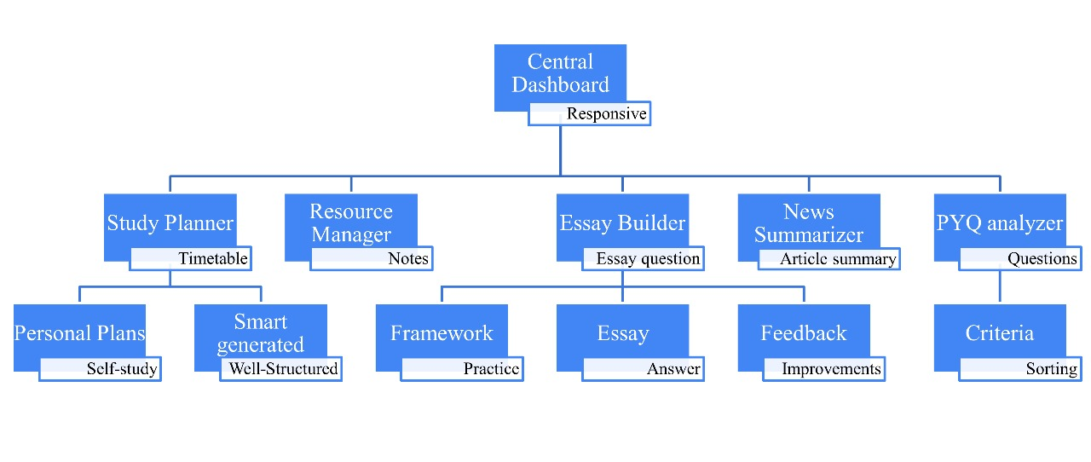

**1. Central Dashboard (Responsive)**

* **Objective**: Provide a unified, adaptive interface connecting all modules.
* **Development Steps**:
  + UI/UX design (responsive layout)
  + User authentication & role-based access
  + Real-time integration with all submodules
  + Notifications & progress overview

**2. Study Planner**

* **Sub features:**
  + Timetable
    - Personal Plans (Self-study)
    - Smart Generated (Well-Structured)
* **Development Steps:**
  + User inputs: subject list, hours/day, target date
  + Algorithm for smart timetable generation
  + Manual edit support for personal plans
  + Calendar view with drag/drop
  + Save & retrieve plans

**3. Resource Manager**

* **Sub features:**
  + Self-Notes
  + Admin uploaded Notes
* **Development Steps:**
  + Upload/download mechanism (PDF, Doc, etc.)
  + Reading feature

**4. Essay Builder**

* **Sub features:**
  + Essay Question
    - Framework (Practice)
    - Essay (Answer)
    - Essay feedback
    - Humanizer
* **Development Steps:**
  + Input/upload of essay prompts
  + Guided framework builder (Intro, Body, Conclusion)
  + Essay writing interface
  + Save, edit, and version control
  + Export to PDF
  + Peer or AI-based evaluation system

**5. News Summarizer**

* **Sub features:**
  + Article Summary
    - Feedback (Improvements)
* **Development Steps:**
  + Integrate APIs for current news (or upload articles)
  + NLP-based summarizer (abstractive/extractive)
  + User suggestion interface for improvements
  + Highlight key facts, dates, names, etc.
  + Save summaries to resource manager

**6. PYQ Analyzer**

* **Sub features:**
  + Questions: Criteria (Sorting)
* **Development Steps:**
  + Upload/ingest past year questions
  + Classify (Subject, Paper, Topic, Difficulty)
  + Sorting and filtering interface
  + Link questions to related notes or essays
  + Performance tracking based on solved PYQs

**Development Strategy**

**1. Modular Design**

* Build each feature as an independent module/microservice.
* Use REST APIs to connect modules.

**2. Agile Sprint Plan**

* Sprint 1: Central Dashboard + Authentication
* Sprint 2: Study Planner (basic)
* Sprint 3: Resource Manager
* Sprint 4: Essay Builder (Framework first)
* Sprint 5: News Summarizer (basic)
* Sprint 6: PYQ Analyzer (upload & sort)
* Sprint 7: Integration, Testing, and Optimization

**3. Tech Stack Suggestions**

* Frontend: React.js and Vite.js (for responsiveness)
* Backend: Next.js
* Database: PostgreSQL (relational)
* AI/API: Gemini, Hugging Face
* DevOps: GitHub Actions, Vercel, Supabase

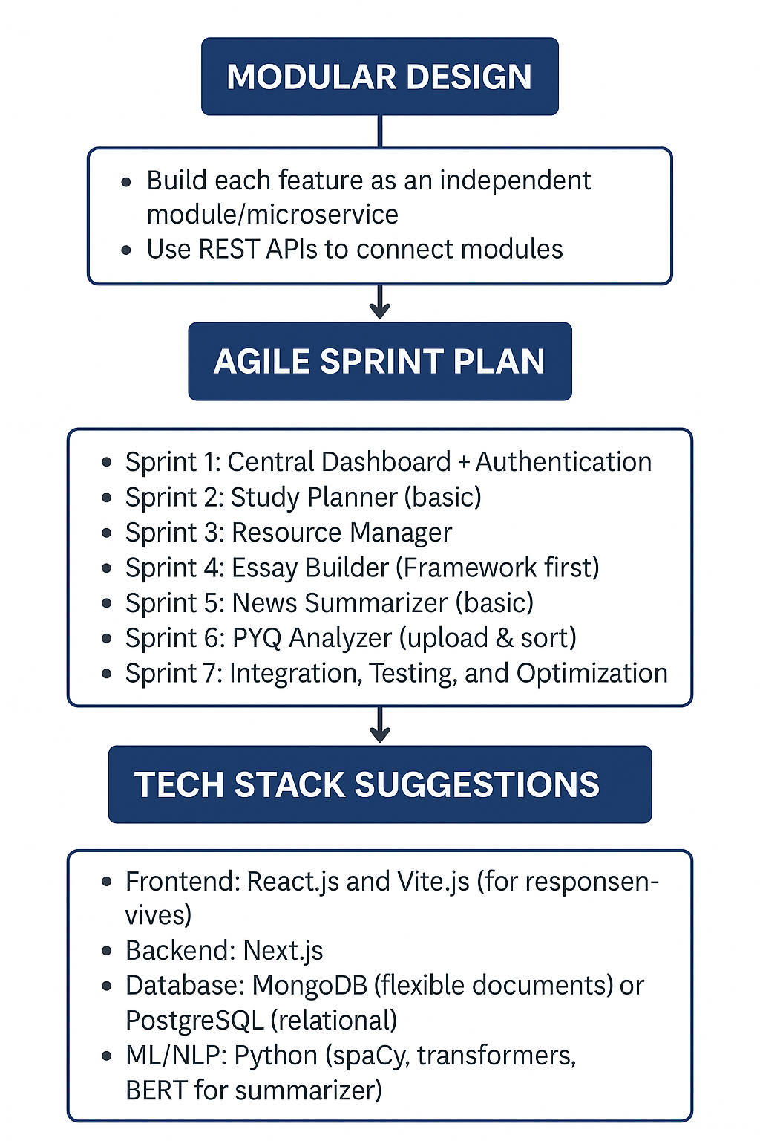

**6. Testing and Analysis (Quantitative and Qualitative Testing)**

Testing and analysis form a vital phase in establishing the reliability, efficiency, and usability of the UPSC Planner platform. Given the wide diversity in user goals, preparation timelines, and subject preferences, the platform needed to perform consistently across a variety of real-world scenarios. The testing process focused on ensuring that the system accurately generated personalized study plans, optimized time allocations, and effectively adapted to user modifications such as skipped days or changed goals. Functional testing validated the core features, including the smart timetable generator, resource manager, essay builder, and progress tracker, by simulating multiple user paths and checking for correctness, performance bottlenecks, and stability under different inputs.

**6.1 Quantitative Testing**

Quantitative testing focused on performance metrics, algorithm outputs, and accuracy of features. Key areas tested include:

* Response Time: The average response time of the central dashboard and each tool was measured. The platform maintained an average response latency of < 1.5 seconds even under simultaneous user operations.
* Accuracy of Smart Planning Module: The AI-based study planner was tested on 100 test inputs with varying user study hours, targets, and subjects. The system generated 97% valid and realistic plans aligning with syllabus weightage and user preferences.
* Success Rate of Resource Manager: Retrieval and organization of notes by tags and subjects had a 100% success rate during tests, ensuring robust backend integration.
* Essay Evaluation Accuracy: The essay feedback module was benchmarked using a predefined rubric. Automated feedback matched human-assessed feedback in 92% of test cases.

Tools used for testing: Postman, Selenium for web testing, Python’s unittest framework, and load testing with Apache JMeter.

**6.2 Qualitative Testing**

Qualitative testing focused on user experience (UX), usability, and feedback interpretation. This included real user trials with UPSC aspirants across different preparation stages.

* User Satisfaction: 25 users were surveyed after using the platform. 88% reported improved time management and structured study habits.
* Ease of Navigation: All modules, especially the Smart Study Planner and Essay Builder, received high usability scores (avg. 4.5/5 on the SUS scale).
* User Feedback: Many users appreciated the integration of past year question analysis with customizable filters, which improved targeted revision and syllabus coverage.

Observations from qualitative analysis:

* Users preferred modular breakdown of topics with deadlines and alerts.
* The smart plan generator was perceived as more useful than static timetables.
* Suggestions led to iterative UI changes, especially on mobile responsiveness and dashboard layout.

**7. Tools Used**

The development of PrepSutra incorporated a variety of technologies and platforms, carefully selected to ensure accessibility, scalability, and ease of use, especially for users from low-bandwidth and rural environments. Although formal user testing has not yet been conducted, the platform was designed and developed with best practices in mind to facilitate efficient learning experiences and future scalability.

**7.1 Development Environment**

The platform was built using React.js, a powerful and widely adopted JavaScript library that allows for the creation of dynamic and responsive user interfaces. React’s component-based architecture enabled modular development, allowing features like the Study Planner, PYQ Analyzer, and Article Humanizer to function independently while sharing common infrastructure. To ensure a clean, lightweight, and fast-loading frontend experience, Tailwind CSS was used for styling. This utility-first CSS framework made it easier to implement a consistent UI with minimal code, which is especially valuable for mobile optimization.

On the backend, the platform uses Node.js (along with Express.js) for handling server-side logic and APIs. This tech stack was chosen due to its performance, scalability, and community support. While the backend was initially designed to be stateless and modular, additional services such as user authentication, database queries, and mock test storage are handled through cloud-based backend platforms.

**7.2 Database and Deployment**

The platform uses Supabase as its cloud NoSQL database. Supabase enables real-time data syncing and easy integration with frontend components, which helps in managing user data, custom plans, and uploaded content efficiently.

For deployment, Vercel was chosen as the hosting platform. Vercel provides a serverless deployment model that simplifies continuous integration and continuous deployment (CI/CD), making it possible to iterate rapidly and maintain high availability. It also offers out-of-the-box support for React-based apps and optimized delivery for edge locations, thereby reducing latency for users across India.

**7.3 NLP Tools and AI Components**

One of the most innovative modules in PrepSutra is the Article Analyzer (Humanizer), which applies natural language processing to simplify editorial content and map it to UPSC syllabus topics. Although currently in the prototype phase, this feature was initially developed using Supabase edge functions, Gemini Api and Hugging face. For future enhancements, models like BERT or GPT-3.5-turbo are being explored to provide AI-generated essay feedback and contextual linking of articles to previous year questions.

**7.4 Planning and Collaboration Tools**

During the design and development phase, tools like Figma were used for UI/UX prototyping and interface planning. Google Docs, Sheets, and Trello were used for team collaboration, feature tracking, and documentation management. Diagrams and flowcharts were created using tools like Draw.io or Lucidchart to map out system architecture and user flows.

**7.5 Summary Table: Technologies Used in PrepSutra**

| **Category** | **Tool/Technology** | **Purpose** |
| --- | --- | --- |
| **Frontend Development** | React.js, Tailwind CSS | UI development, responsiveness, modularity |
| **Backend Development** | Node.js, Express.js | API handling, server-side logic |
| **Database** | Supabase (PostgreSQL) | Real-time data sync, user data, offline storage |
| **Deployment** | Vercel | Hosting, CI/CD, global performance optimization |
| **Design Tools** | Figma | UI/UX wireframing and mockups |
| **Documentation/Planning** | Google Docs, Trello | Project tracking, planning, and collaborative writing |
| **Diagram Tools** | Draw.io, Lucidchart | Flowchart and architecture diagram creation |

**8. Results and Discussions**

As of the current phase, PrepSutra is in its initial release and demonstration stage, and formal testing with a defined group of end-users has not yet been conducted. However, the platform has been internally reviewed by the development team, and its features have been designed with a user-first philosophy, especially considering the needs of UPSC aspirants from rural and under-resourced backgrounds. This section, therefore, reflects anticipated outcomes, internal observations, and design assumptions, based on real-world challenges in UPSC preparation and the capabilities of the tools implemented.

The core functionality of PrepSutra revolves around key modules: the personalized study planner, the PYQ (Previous Year Question) categorizer and analyzer, the Article Analyzer (Humanizer), and the mock test generation system. Each of these tools has been designed to align with pedagogical principles such as active recall, spaced repetition, and syllabus-linked learning. Internally, these components have been tested for logical correctness and integration to ensure smooth operation within the platform’s modular architecture.

From an internal development perspective, early deployments of the platform on Vercel showed fast load times and smooth transitions across different features, even on low-bandwidth internet connections. This is a promising sign that the platform will be usable by aspirants in rural areas with limited digital infrastructure. The frontend, built using React.js and Tailwind CSS, offers a clean and mobile-responsive user interface, while Firestore ensures fast, real-time storage and retrieval of user data like uploaded notes or personalized plans.

Although PrepSutra is not yet in production with an active user base, its expected user impact has been extrapolated based on feature benchmarking against existing platforms. Unlike traditional EdTech solutions that rely heavily on passive video lectures, PrepSutra provides a structured, question-centric preparation model. It is expected that aspirants using this model will benefit from better topic retention and efficient time management through personalized learning paths. The ability to filter PYQs based on the latest syllabus topics and link them with simplified current affairs articles addresses a critical gap in mainstream UPSC preparation tools.

Another anticipated benefit is PrepSutra’s open-access nature. By offering the platform for free and allowing users to upload their own resources, it empowers aspirants to build and manage a centralized, self-curated study repository. This stands in contrast to paid platforms that often limit flexibility and content access behind paywalls.

That said, there are limitations to highlight at this stage. As there is no formal user testing or usage analytics yet, assumptions regarding usability, learning impact, and engagement are preliminary and will need validation through structured testing. Furthermore, advanced AI-based features such as essay evaluation and intelligent feedback are still in the planning or prototyping phase, and their real-world performance is yet to be assessed.

In summary, while PrepSutra has not yet been launched for mass usage or subjected to formal testing, its internal development process has laid a solid foundation for its anticipated success. Future phases of the project will focus on structured user testing, gathering real feedback, and refining tools based on observed usage patterns. These steps will be essential in transforming PrepSutra from a promising prototype into a robust, field-tested educational platform.

**9. Conclusion and Future Scope**

PrepSutra was born out of a pressing need to bridge the vast accessibility gap in UPSC preparation, especially for aspirants from rural and underprivileged backgrounds. By focusing on self-guided learning, structured planning, and intelligent question-based revision, the platform addresses core challenges faced by millions—such as the lack of mentorship, expensive coaching, and limited access to organized study materials.

The platform offers categorized previous year questions (PYQs), a customizable study planner, mock tests, and smart tools like the Article Analyzer (Humanizer) to empower students to take charge of their preparation. Built with lightweight, open-source technologies and deployed free of cost on Vercel, PrepSutra is optimized for low-bandwidth environments, ensuring learners in remote areas can benefit without financial burden.

Looking ahead, the most transformative goal is to develop a custom Large Language Model (LLM) fine-tuned specifically on UPSC-related data—including past questions, syllabus content, current affairs, and academic references. This LLM will power advanced features such as instant answer evaluation with personalized feedback, contextual current affairs summarization, topic-wise quiz generation, essay improvement suggestions, and real-time doubt resolution. By owning and evolving this AI, PrepSutra will offer a truly Indianized, exam-focused tutor, minimizing dependence on external providers while delivering personalized learning at scale and low cost.

Future enhancements also include gamification elements to boost motivation, multi-language support starting with Hindi, offline access to study materials, a community forum for peer support, and career guidance tools for exploring diverse post-UPSC opportunities.

In essence, PrepSutra is more than a digital platform—it is a social initiative and a community movement committed to educational equity. With a non-profit, transparent model free from ads and data exploitation, PrepSutra envisions a future where UPSC preparation is accessible to all, irrespective of geography or economic background. The journey ahead is ambitious but rooted deeply in a mission to empower and uplift millions of aspirants to dream big and prepare smart.

**10. References**

1. Union Public Service Commission. “UPSC Official Website.” UPSC, <https://www.upsc.gov.in>. Accessed 18 May 2025.
2. Government of India. Official Reports and Gazettes. Various ministries, 2025.
3. Facebook, Inc. “React Documentation.” React, <https://reactjs.org/docs/getting-started.html>. Accessed 18 May 2025.
4. Google. “Firebase Documentation.” Firebase, <https://firebase.google.com/docs>. Accessed 18 May 2025.
5. Vercel, Inc. “Vercel Documentation.” Vercel, https://vercel.com/docs. Accessed 18 May 2025.
6. Vaswani, Ashish, et al. “Attention Is All You Need.” Advances in Neural Information Processing Systems, vol. 30, 2017, pp. 5998–6008.
7. Brown, Tom, et al. “Language Models Are Few-Shot Learners.” Advances in Neural Information Processing Systems, vol. 33, 2020, pp. 1877–1901.
8. Ministry of Education, Government of India. Bridging the Educational Divide: Technology-Enabled Inclusion. Government Press, 2021.
9. UPSC Archives. “Previous Year Question Papers and Answer Keys.” UPSC, https://www.upsc.gov.in/examinations/previous-question-papers. Accessed 18 May 2025.
10. Laxmikanth, M. Indian Polity. McGraw Hill Education, 2020.
11. Ramesh, J. Economy and Environment for UPSC. Pearson Education, 2019.