Edf2Mat© Matlab Toolbox
  - Converts EyeLink 1000 Edf files into Matlab
  - Version 1.6
Adrian Etter

University of Zurich
Department of Economics
Winterthurerstrasse 30
CH-8006 Zurich

E-Mail: adrian.etter@econ.uzh.ch
URL: http://www.econ.uzh.ch/faculty/etter.html
8 May 2013

 |  | Abstract
 |  | Edf2Mat is a Matlab Toolbox for easy conversion of EyeLink Edf result files. For fast verification of valid data, there is an included plot function, which displays eye movement and pupil size. There are a few examples in the example file which help analyze eye data.
Copyright |  | Copyright © 2007-2013 Adrian Etter. All rights reserved.
 |  | This document may be copied, modified, reproduced and redistributed for educational and personal use as long as the original author is mentioned and cited.
MATLAB® is a registered Trademark of MathWorks, Inc.™ (http://www.mathworks.com).
EyeLink® is a registered trademark of SR Research Ltd., Mississauga, Ontario, Canada (http://www.sr-research.com)

Table of contents:
Abstract 2
Terms and Conditions 4
Acknowledgment 4
License 4
Installation 5
Requirements 5
Files needed 5
How to use Edf2Mat – Toolbox 6
Acknowledgment 9
Bibliography 9

 |  | Terms and Conditions
 |  | Acknowledgment
You are allowed to use this software for free, but please acknowledge if you are using this software to process Edf-files:

The conversion of the EyeLink® 1000 Edf files was done with the Edf2Mat Matlab Toolbox designed and developed by Adrian Etter at the University of Zurich.
 |  | License
Edf2Mat Toolbox is Licensed under the BSD 2 License.
The Edf2Mat Toolbox uses slightly modified code (Kovach, 2011) from C. Kovach 2007.
Copyright |  | Copyright (c) 2013, Adrian Etter  All rights reserved.  Redistribution and use in source and binary forms, with or without modification, are permitted provided that the following conditions are met:  Redistributions of source code must retain the above copyright notice, this list of conditions and the following disclaimer.  Redistributions in binary form must reproduce the above copyright notice, this list of conditions and the following disclaimer in the documentation and/or other materials provided with the distribution.  Neither the name of the UNIVERSITY OF ZURICH nor the names of its contributors may be used to endorse or promote products derived from this software without specific prior written permission.  THIS SOFTWARE IS PROVIDED BY THE COPYRIGHT HOLDERS AND CONTRIBUTORS "AS IS" AND ANY EXPRESS OR IMPLIED WARRANTIES, INCLUDING, BUT NOT  LIMITED TO, THE IMPLIED WARRANTIES OF MERCHANTABILITY AND FITNESS FOR A PARTICULAR PURPOSE ARE DISCLAIMED. IN NO EVENT SHALL THE COPYRIGHT  HOLDER OR CONTRIBUTORS BE LIABLE FOR ANY DIRECT, INDIRECT, INCIDENTAL, SPECIAL, EXEMPLARY, OR CONSEQUENTIAL DAMAGES (INCLUDING, BUT NOT  LIMITED TO, PROCUREMENT OF SUBSTITUTE GOODS OR SERVICES; LOSS OF USE, DATA, OR PROFITS; OR BUSINESS INTERRUPTION) HOWEVER CAUSED AND ON ANY  THEORY OF LIABILITY, WHETHER IN CONTRACT, STRICT LIABILITY, OR TORT (INCLUDING NEGLIGENCE OR OTHERWISE) ARISING IN ANY WAY OUT OF THE USE OF  THIS SOFTWARE, EVEN IF ADVISED OF THE POSSIBILITY OF SUCH DAMAGE.

Installation

Requirements
On Windows: Matlab
On Mac: the edfapi.framework must be in /Library/Frameworks. Can be found in the Package. Attention: If the Zip file was unpacked on windows first, and then copied, the folder structure will be broken. The Zip file must be extracted on a Mac in order to work. Otherwise the symlinks are broken.

Files needed
- The Edf2Mat Class
- All files in the private folder
- All Dlls in the private folder

 |  | How to use Edf2Mat – Toolbox
 |  | There is an edf2mat_example script. Have a look at it.
Type help for help |  | help Edf2Mat
Edf2Mat is a converter to convert Eyetracker data files to
Matlab file and perform some tasks on the data
The new procedure uses code from SR-Research that returns all info of
the edf and not just part of it. The new routine is based on the work
of C. Kovach 2007 and is only for non-commercial use!
Syntax: Edf2Mat(filename);
Edf2Mat(filename, verbose);
Inputs:
filename: must be of type *.edf
useOldProcedure: If you want to use the old procedure with
edf2asc.exe, you can set this argument to
true, default is false
verbose: logical, can be true or false, default is true.
If you want to supress output to console,
verbose has to be false
 |  | The Basic functionality is as follows:
Convert Edf File |  | edf1 = Edf2Mat('fMRI_Results_sub_025_270712EYE25r1.edf');
Calling the Edf2Mat with a filename converts the given edf file to a Matlab structure, which will be available in the Matlab workspace.
In order to save the produced structure to a matfile, just call “save(edf1)”, whereas edf1 is the variable assign when calling the Edf2Mat Class.
Plot |  | The Edf2Mat class has its own plot functionality to plot the content. It’s more for a fast forward validation of data than actually the way you should plot your data.
 |  | plot(edf1);
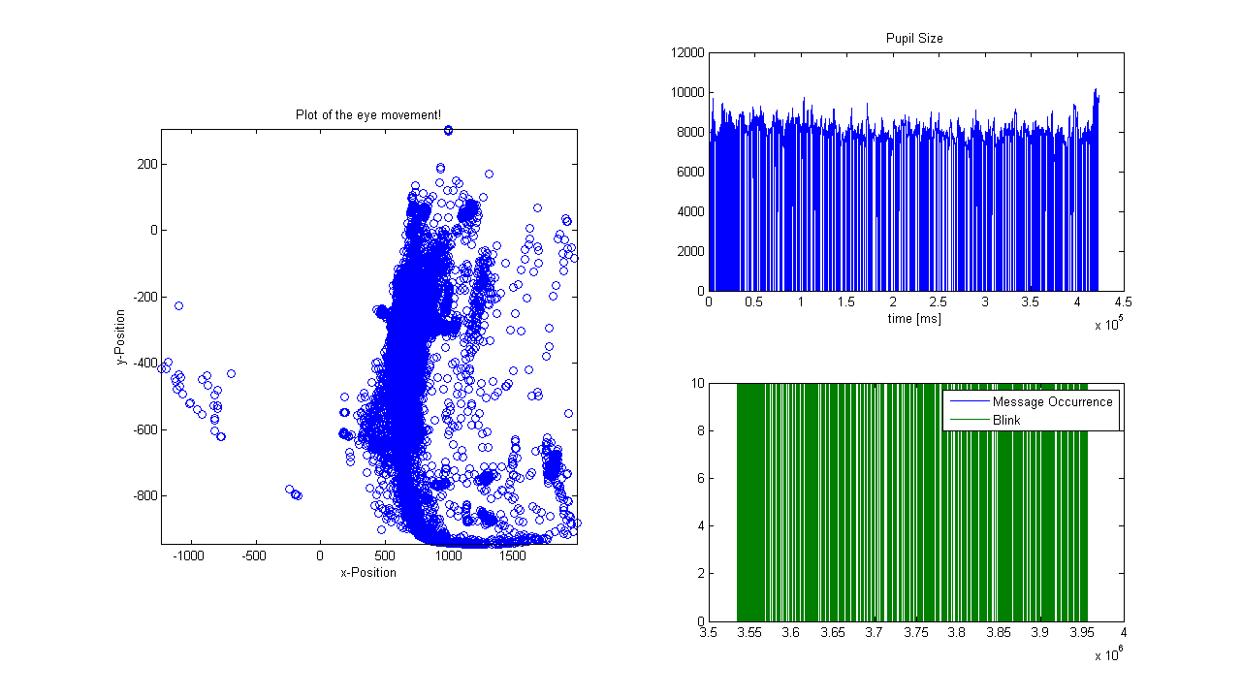
Fig. 1 Output of the Edf2Mat plot command

Last 2000 Elements |  | In order to plot eye movement only in a specified time range, the Matlab builitin plot command could be used as following:
figure();
plot(edf1.Samples.posX(end - 2000:end), edf1.Samples.posY(end - 2000:end), 'o');
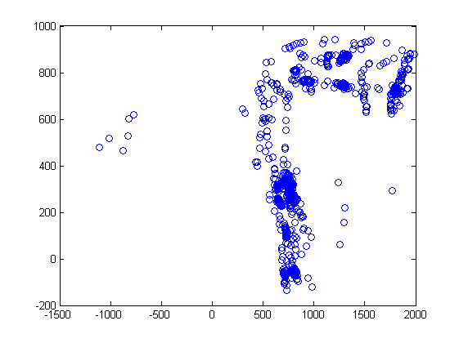
Fig. 2 Only plot a certain time frame of eye movement

Plot the pupil size |  | To simply plot the pupil size for a given time window, the pupil size array can be accessed as stated in the next line.
figure();
plot(edf1.Samples.pa(2, end - 500:end));
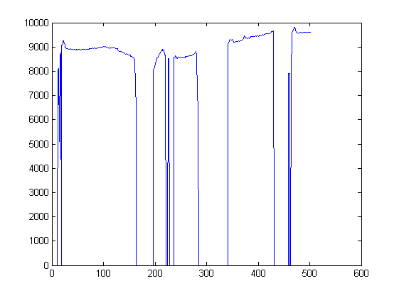
Fig. 3 The progress / development of the pupil size for a given time frame

Acknowledgment
Many thanks to Stefan Schmid to point out typos.

Bibliography
Kovach, C. (2011, 01 12). SR Research. Retrieved from SR Research Support: https://www.sr-support.com/showthread.php?255-Import-of-EDF-file-into-Matlab&p=6781#post6781

