Software Requirements Specification
for
<Brew Day!>
Version 1.0 approved
Prepared by <Yidong CHEN,
Shihan XU,
Zeyu WANG,
Ning DING>

<Babbage>
<March 4th 2019>
Table of Contents
Table of Contents ii
Revision History ii
1. Introduction 1
1.1 Purpose 1
1.2 Document Conventions 1
1.3 Intended Audience and Reading Suggestions 1
1.4 Project Scope 1
1.5 References 1
2. Overall Description 2
2.1 Product Perspective 2
2.2 Product Features 2
2.3 User Classes and Characteristics 2
2.4 Operating Environment 2
2.5 Design and Implementation Constraints 2
2.6 User Documentation 2
2.7 Assumptions and Dependencies 3
3. System Features 3
3.1 System Feature 1 3
3.2 System Feature 2 (and so on) 4
4. External Interface Requirements 4
4.1 User Interfaces 4
4.2 Hardware Interfaces 4
4.3 Software Interfaces 4
4.4 Communications Interfaces 4
5. Other Nonfunctional Requirements 5
5.1 Performance Requirements 5
5.2 Safety Requirements 5
5.3 Security Requirements 5
5.4 Software Quality Attributes 5
6. Other Requirements 5
Appendix A: Glossary 5
Appendix B: Analysis Models 6
Appendix C: Issues List 6

Revision History
Name | Date | Reason For Changes | Version
Yidong CHEN,  Shihan XU,  Zeyu WANG,  Ning DING | March 4th 2019 | Initial version | 1.0

Introduction (Yidong CHEN)

Purpose
The purpose of this documentation is to describe the software designed in the project “Brew Day” in the following sections: introduction, overall description, system features, external interface requirements and other nonfunctional requirements. This documentation intends to enable the audience of various background to understand the basic functions of the software.

Document Conventions
Bold-font: denote sections and their subtitles (There will be more if needed)

Intended Audience and Reading Suggestions
The intended audience for this document includes users, developers, testers and documentation writers.
If you are users, we recommend you to only read section one, two and three.
If you are developers or testers, we recommend you to read all the sections except section one.
If you are documentation writers, we recommend you to read all the sections.

Project Scope
This desktop-based application allows users to create, store and modify recipes, and delete them if they wish to. Besides, the application keeps track of available ingredients and give a recommended recipe which uses as much weight of the available ingredients as possible.

References
The project specification document “Brew Day”.

Overall Description (Shihan XU)

Product Perspective
Brew Day! is a complete new, self- contained software. It is independent with other software and system. It has no relationship with any larger system.

Product Features
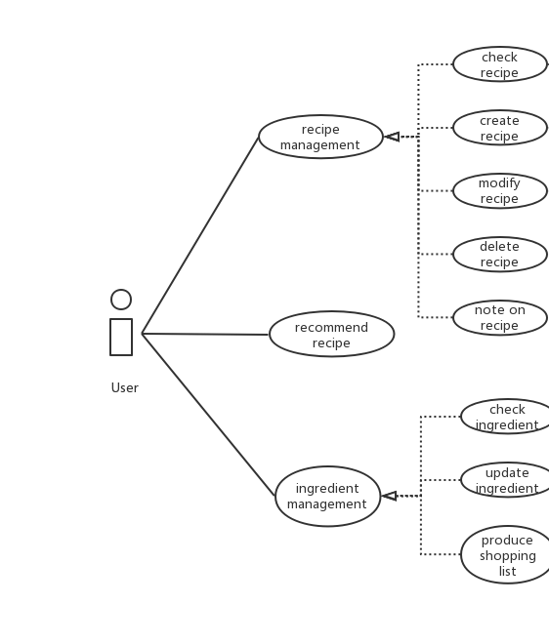
The main features are recipe management, ingredient management and recommend recipe, and they can be divided into small features. The relationship among different features are as followed:
Scenario for feature “note on recipe”:
1. User opens user interface for checking recipe
2. The system shows all the recipes
3. User chooses one recipe to make notes on
4. User inputs notes in the appearing box

User Classes and Characteristics
Our software aims at home brewing lovers. The users can be divided into two categories: users with high education levels or professional brewing skills, who like more complex recipe and have high demand for the quality of beer; users with low education level or poor brewing skills, who want simple recipes. All of our users have basic computer skills.

Operating Environment
Our software will operate on Windows system.

Design and Implementation Constraints
N/A.

User Documentation
User manual for user to use this software: the type can be either system-provided tutorial or independent documents.

Assumptions and Dependencies
Users have desktops with Windows installed already. We also assume that users have read or write spreadsheet software (for importing large number of recipes or exporting shopping lists), software that can management large amount of recipe information installed.

System Features
<This template illustrates organizing the functional requirements for the product by system features, the major services provided by the product. You may prefer to organize this section by use case, mode of operation, user class, object class, functional hierarchy, or combinations of these, whatever makes the most logical sense for your product.>

System Feature 1
<Don’t really say “System Feature 1.” State the feature name in just a few words.>
3.1.1 Description and Priority
<Provide a short description of the feature and indicate whether it is of High, Medium, or Low priority. You could also include specific priority component ratings, such as benefit, penalty, cost, and risk (each rated on a relative scale from a low of 1 to a high of 9).>
3.1.2 Stimulus/Response Sequences
<List the sequences of user actions and system responses that stimulate the behavior defined for this feature. These will correspond to the dialog elements associated with use cases.>
3.1.3 Functional Requirements
<Itemize the detailed functional requirements associated with this feature. These are the software capabilities that must be present in order for the user to carry out the services provided by the feature, or to execute the use case. Include how the product should respond to anticipated error conditions or invalid inputs. Requirements should be concise, complete, unambiguous, verifiable, and necessary. Use “TBD” as a placeholder to indicate when necessary information is not yet available.>

<Each requirement should be uniquely identified with a sequence number or a meaningful tag of some kind.>

REQ-1:
REQ-2:

System Feature 2 (and so on)

External Interface Requirements (Zeyu WANG)

User Interfaces
<Describe the logical characteristics of each interface between the software product and the users. This may include sample screen images, any GUI standards or product family style guides that are to be followed, screen layout constraints, standard buttons and functions (e.g., help) that will appear on every screen, keyboard shortcuts, error message display standards, and so on. Define the software components for which a user interface is needed. Details of the user interface design should be documented in a separate user interface specification.>

Hardware Interfaces
The printer can be connected to the software. The user can print their recipe through connecting to the printer.

Software Interfaces
Use Java (or C, C++) as the main programming language to create this software, use data management software to manage the data about recipe and ingredients, the data will interact via an application program.

Communications Interfaces
N/A.

Other Nonfunctional Requirements (Ning DING)

Performance Requirements
For real-time requirement, every search action in this software should be finished within 1 second.

Safety Requirements
This software does not need to check whether the user will cause health problems because of recipe products, the users should be responsible for the safety or recipes themselves.

Security Requirements
N/A.

Software Quality Attributes
This software should guarantee usability, it should be easy to use, and user manual should be provided if necessary. The software should assure 2000MTTF for robustness. Reusability and maintainability should also be considered, which means the software should be easy to update and add new requirements in the future.

Other Requirements (Ning DING)
TBD
Appendix A: Glossary
TBD
Appendix B: Analysis Models
TBD
Appendix C: Issues List
TBD

