Software Requirements Specification
for
Brew Day!
Version 1.3 approved
Prepared by Yidong CHEN,
Shihan XU,
Zeyu WANG,
Ning DING

Babbage
March 4th 2019
Table of Contents
Table of Contents ii
Revision History ii
1. Introduction (Yidong CHEN) 1
1.1 Purpose 1
1.2 Document Conventions 1
1.3 Intended Audience and Reading Suggestions 1
1.4 Project Scope 1
1.5 References 1
2. Overall Description (Shihan XU) 1
2.1 Product Perspective 1
2.2 Product Features 2
2.3 User Classes and Characteristics 2
2.4 Operating Environment 3
2.5 Design and Implementation Constraints 3
2.6 User Documentation 3
2.7 Assumptions and Dependencies 3
3. System Features 3
3.1 Recommend Recipe (Shihan XU & Ning DING) 3
3.2 Maintain Recipes (Zeyu WANG & Yidong CHEN) 5
3.3 Maintain Ingredients (Shihan XU & Ning DING) 6
3.4 Maintain Equipment (Shihan XU & Ning DING) 6
3.5 Write Note (Zeyu WANG & Yidong CHEN) 7
4. External Interface Requirements (Zeyu WANG) 8
User Interfaces 9
4.1 9
4.2 Hardware Interfaces 12
4.3 Software Interfaces 12
4.4 Communications Interfaces 12
5. Other Nonfunctional Requirements (Ning DING) 12
5.1 Performance Requirements 12
5.2 Safety Requirements 12
5.3 Security Requirements 12
5.4 Software Quality Attributes 12
6. Other Requirements (Ning DING) 12
Appendix A: Glossary 13
Appendix B: Analysis Models 13
Appendix C: Issues List 13

Revision History
Name | Date | Reason For Changes | Version
Yidong CHEN,  Shihan XU,  Zeyu WANG,  Ning DING | March 4th 2019 | Initial version | 1.0
Yidong CHEN,  Shihan XU,  Zeyu WANG,  Ning DING | March 12th 2019 | Add system features and user interfaces | 1.1
Yidong CHEN,  Shihan XU,  Zeyu WANG,  Ning DING | March, 18th 2019 | Add more system features and corresponding user interfaces | 1.2
Yidong CHEN,  Shihan XU,  Zeyu WANG,  Ning DING | March 25th 2019 | Add Appendix B | 1.3

Introduction (Yidong CHEN)

Purpose
The purpose of this documentation is to describe the software designed in the project “Brew Day” in the following sections: introduction, overall description, system features, external interface requirements and other nonfunctional requirements. This documentation intends to enable the audience of various background to understand the basic functions of the software.

Document Conventions
Bold-font: denote sections and their subtitles (There will be more if needed)

Intended Audience and Reading Suggestions
The intended audience for this document includes users, developers, testers and documentation writers.
If you are users, we recommend you to only read section one, two and three.
If you are developers or testers, we recommend you to read all the sections except section one.
If you are documentation writers, we recommend you to read all the sections.

Project Scope
This desktop-based application allows users to create, store and modify recipes, and delete them if they wish to. Besides, the application keeps track of available ingredients and give a recommended recipe which uses as much weight of the available ingredients as possible.

References
The project specification document “Brew Day”.

Overall Description (Shihan XU)

Product Perspective
Brew Day! is a complete new, self- contained software. It is independent with other software and system. It has no relationship with any larger system.

Product Features
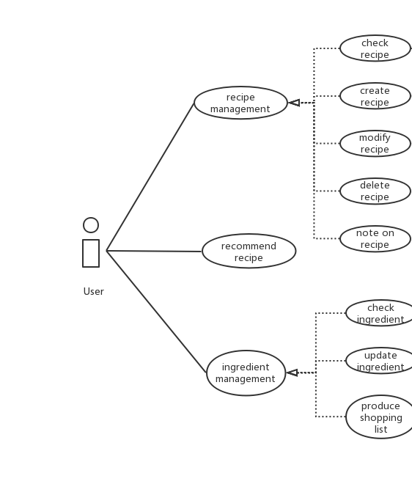
The main features are recipe management, ingredient management and recommend recipe, and they can be divided into small features. The relationship among different features are as followed:
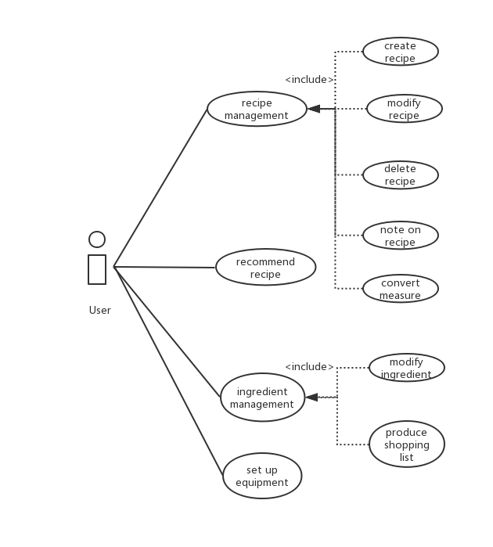
Scenario for feature “note on recipe”:
1. User opens user interface for checking recipe
2. The system shows all the recipes
3. User chooses one recipe to make notes on
4. User inputs notes in the appearing box

User Classes and Characteristics
Our software aims at home brewing lovers. The users can be divided into two categories: users with high education levels or professional brewing skills, who like more complex recipe and have high demand for the quality of beer; users with low education level or poor brewing skills, who want simple recipes. All of our users have basic computer skills.

Operating Environment
Our software will operate on Windows system.

Design and Implementation Constraints
N/A.

User Documentation
User manual for user to use this software: the type can be either system-provided tutorial or independent documents.

Assumptions and Dependencies
Users have desktops with Windows installed already. We also assume that users have read or write spreadsheet software (for importing large number of recipes or exporting shopping lists), software that can management large amount of recipe information installed.

System Features

Recommend Recipe (Shihan XU & Ning DING)
This software can recommend the recipe which maximize the available ingredients to the user, and list the missing ingredients if any.
3.1.1 Description and Priority
The system recommends to the user with the recipes which maximize the use of available ingredients, list with related notes. If the remained ingredients cannot satisfy any recipe, list the recipes according to the number of missing ingredients from small to large with related notes and corresponding shopping list. This feature has High priority.

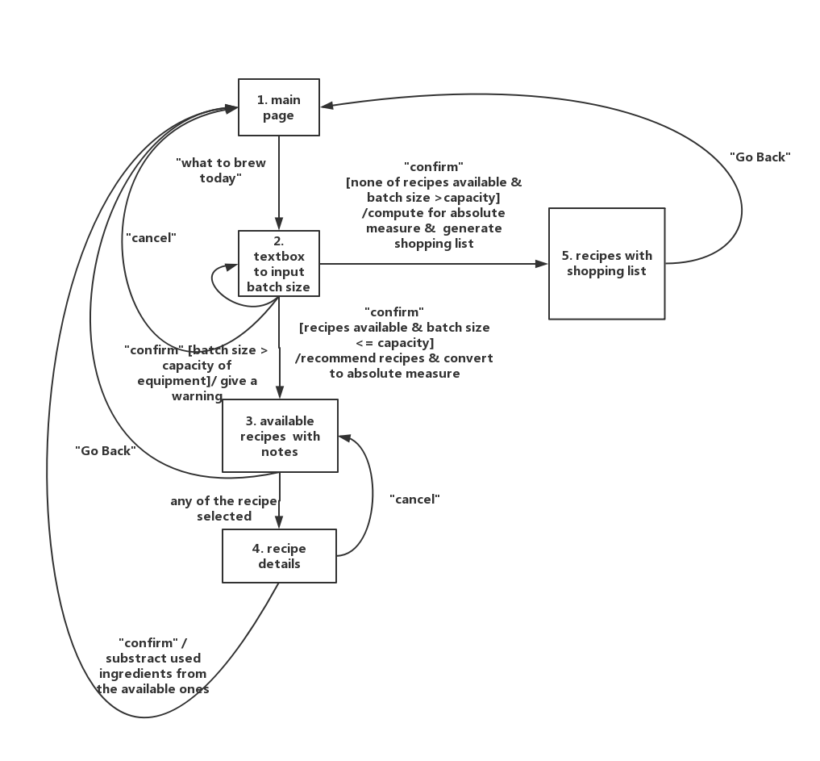
3.1.2 Stimulus/Response Sequences

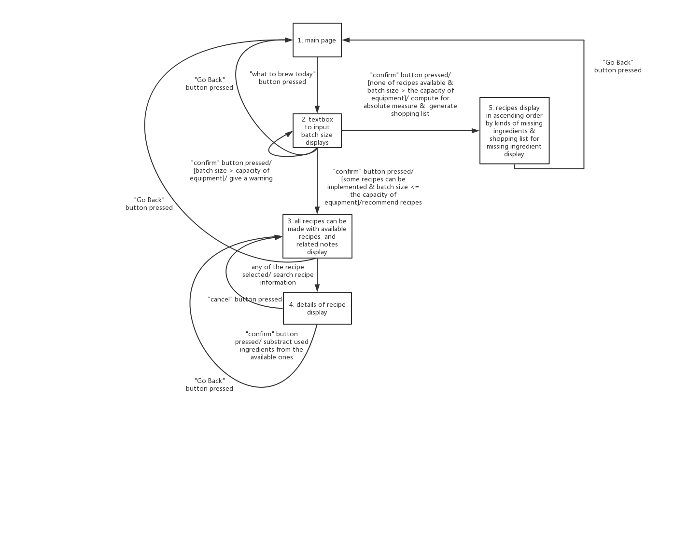
3.1.3 Functional Requirements

REQ-1: Before recommending recipe, user specify the batch of this term, if the quantity specified is larger than the equipment capability, a warning will be shown then require another time quantity input.
REQ-2: For the current ingredients is enough for any recipe, count the absolute measure according to the quantity input by user for every recipe, then display all available recipes and corresponding notes.
REQ-3: If the current ingredients are enough for current recipe, the user can click recipe to see details, then click confirm to make beer which based on that recipe. If confirm is clicked, the corresponding absolute measure of every ingredients will be subtracted in the ingredient. If cancel clicked, it will go back to the last step.
REQ-4: If none of the recipe can be implemented according to current ingredients, list the recipes according to the number of missing ingredients in ascending order, and corresponding shopping list.

Maintain Recipes (Zeyu WANG & Yidong CHEN)
This software provides users to maintain recipes.

    - Description and Priority
- The system recommends to the user with the recipes which maximize the use of available ingredients, list with related notes. If the remained ingredients cannot satisfy any recipe, list the recipes according to the number of missing ingredients from small to large with related notes and corresponding shopping list. This feature has High priority.

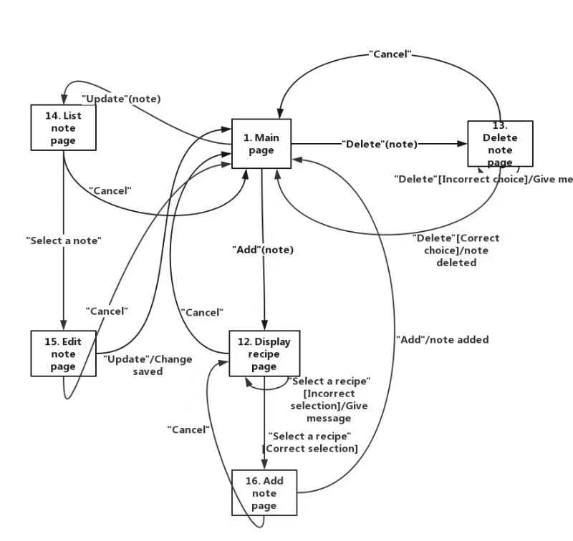
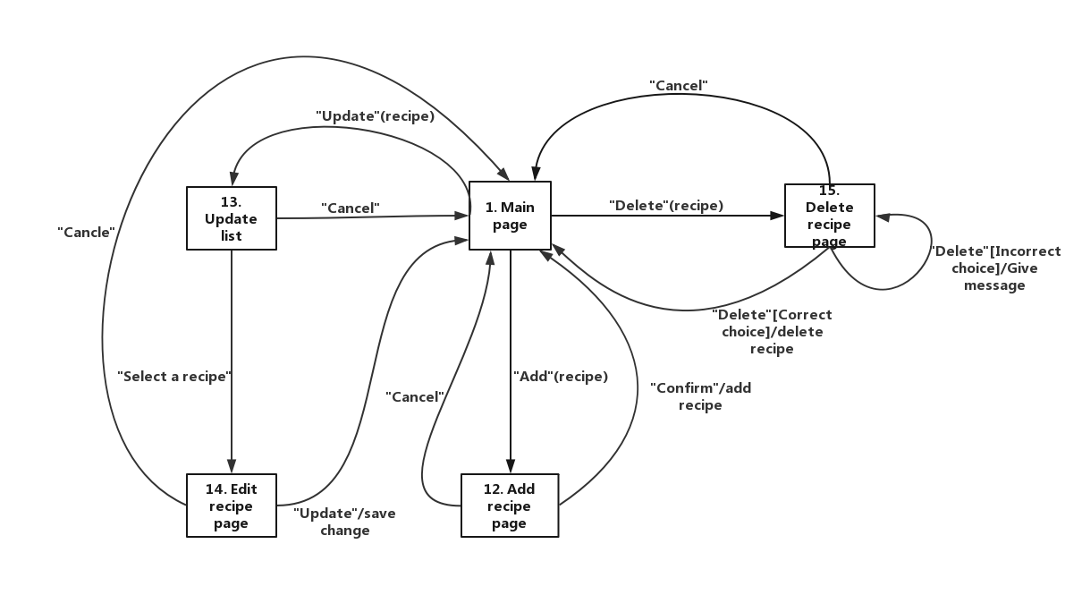
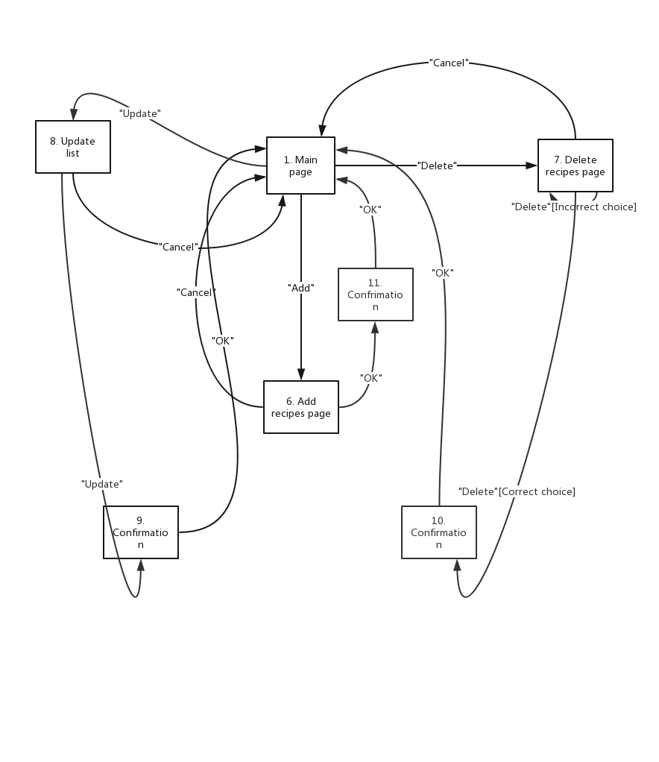
    - Stimulus/Response Sequences

    - Functional Requirements
REQ-1: Before recommending recipe, user specify the batch of this term, if the quantity specified is larger than the equipment capability, a warning will be shown then require another time quantity input.

Maintain Ingredients (Shihan XU & Ning DING)
    - Description and Priority
- The system records all the name and quantity of the ingredient. The user can change the quantity of the ingredient if he/ she buys some new ingredient or uses some. Moreover, the user can also add complete new ingredient to the system with the quantity. This feature has High priority.

    - Stimulus/Response Sequences

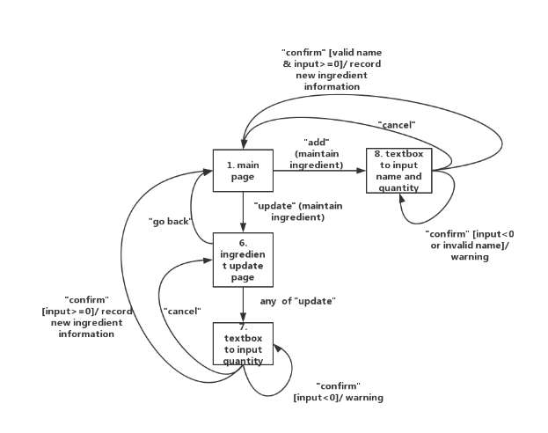
    - Functional Requirements
REQ-1: When the user want to add a new ingredient, the input quantity cannot be negative and this ingredient cannot exist before, otherwise a warning will be shown.
REQ-2: When the use want to update the quantity of the ingredient, the input quantity cannot be negative.

Maintain Equipment (Shihan XU & Ning DING)
    - Description and Priority
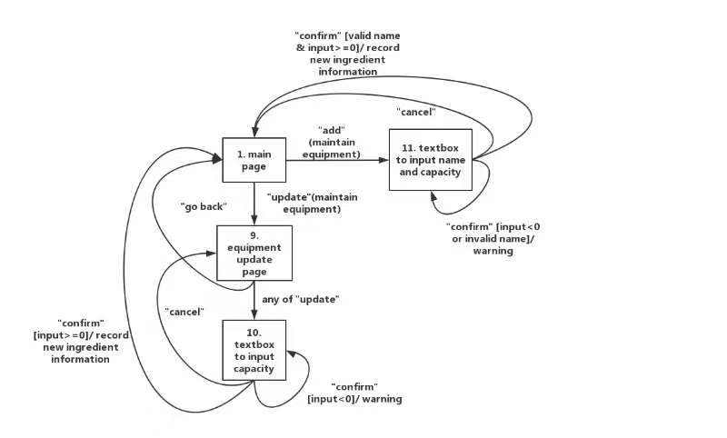
The system records all the name and capacity of the equipment. The user can change the capacity of the equipment if necessary. Moreover, the user can also add complete new equipment to the system with the capacity. This feature has High priority.

    - Stimulus/Response Sequences
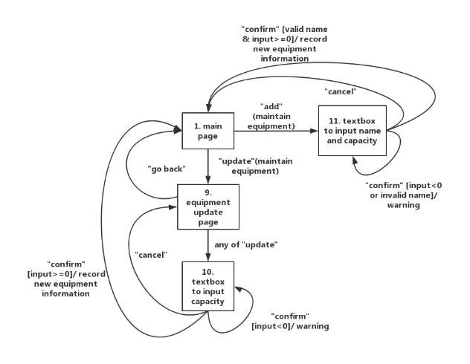
    - Functional Requirements
REQ-1: When the user wants to add a new equipment, the input capacity cannot be negative and this equipment cannot exist before, otherwise a warning will be shown.
REQ-2: When the use wants to update the capacity of the equipment, the input capacity cannot be negative.

Write Note (Zeyu WANG & Yidong CHEN)
    - Description and Priority
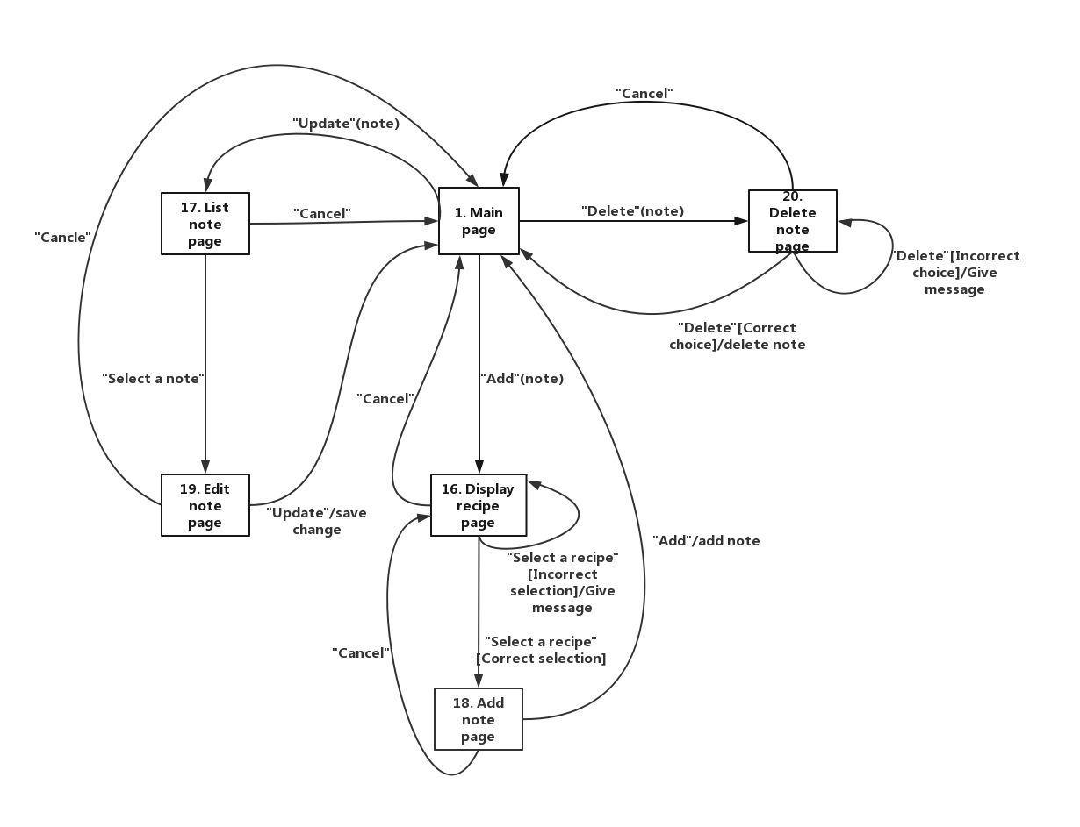
The system allows users to create, modify and delete their notes on a recipe on their own will. This feature also has middle priority.
    - Stimulus/Response Sequences

    - Functional Requirements
REQ-1: On the “Display recipe page”, if the user does not select any recipe and click “select”, a warning will pop up saying “Please select a recipe you want to add notes on!”
REQ-2: On the “List note page”, if the user does not select any note and click “select”, a warning will pop up saying “Please select a note you want to edit on!”
REQ-3: On the “Delete note page”, if the user does not select any recipe and click “delete”, a warning will pop up saying “Please select a recipe you want to delete!”.

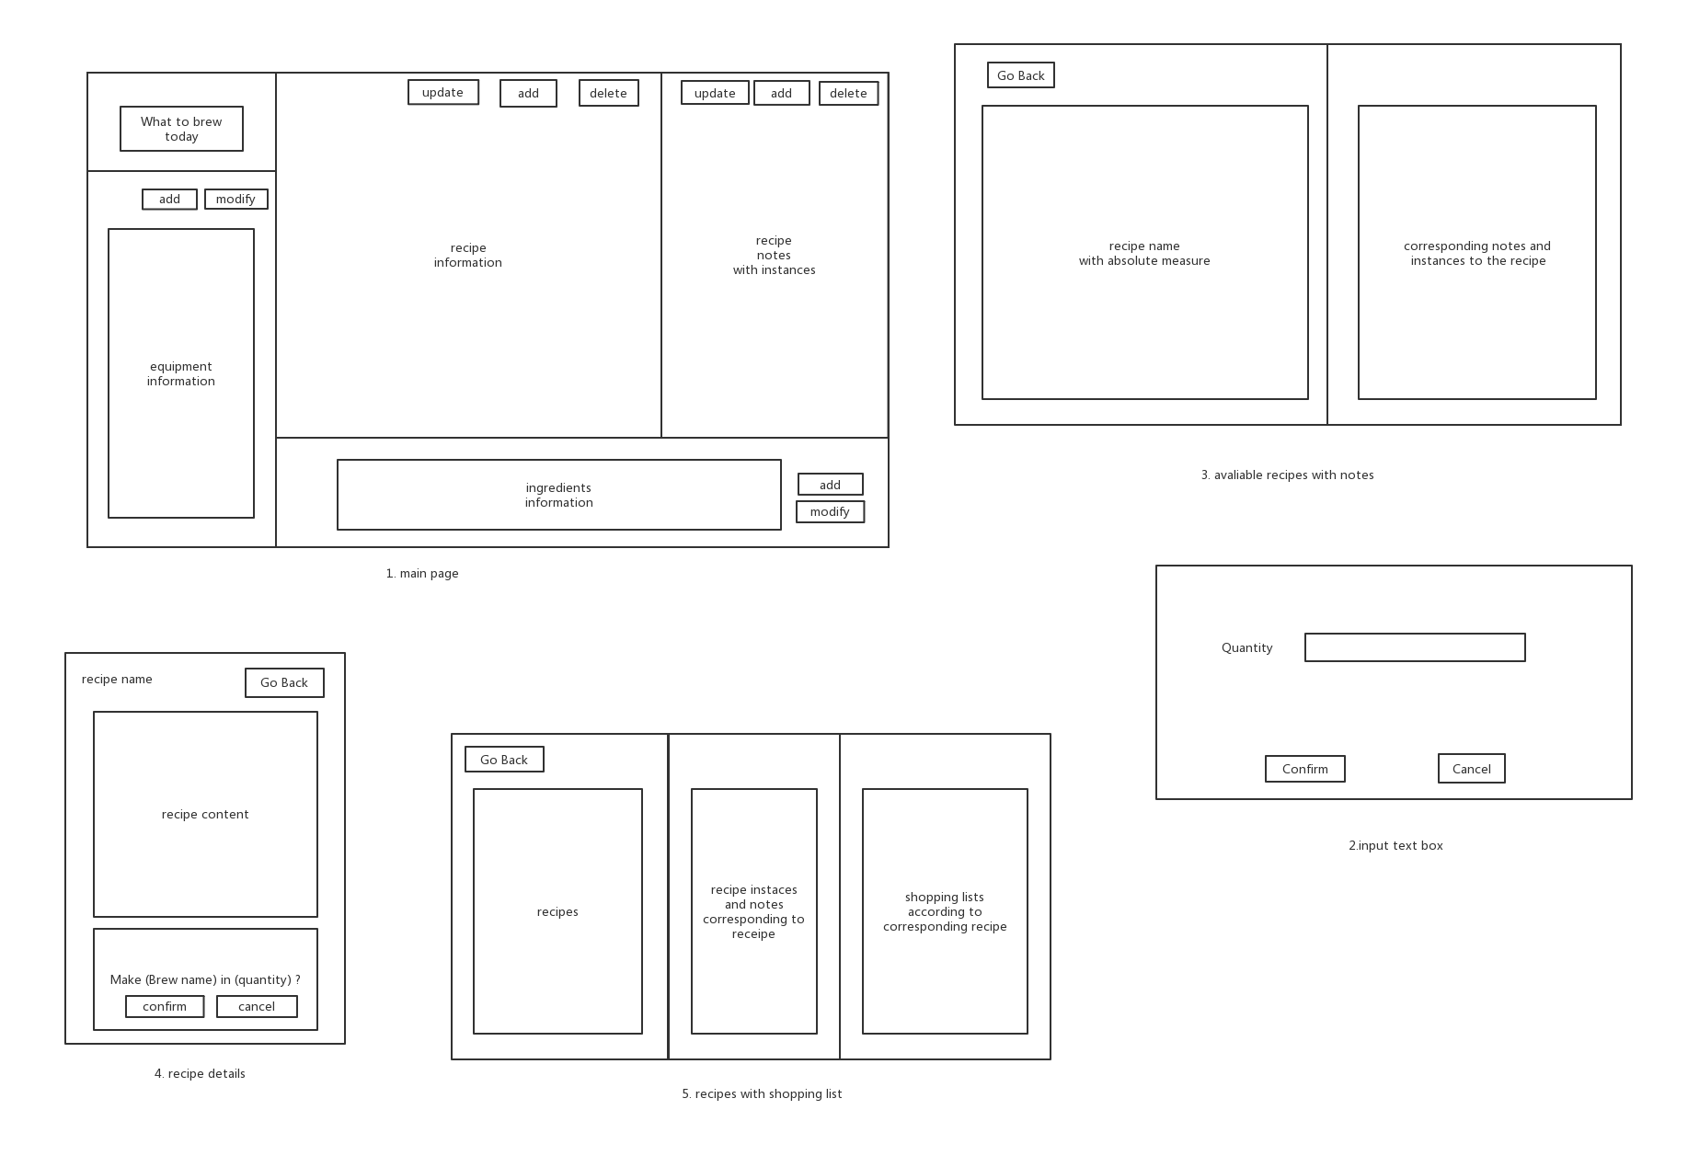
External Interface Requirements (Zeyu WANG)

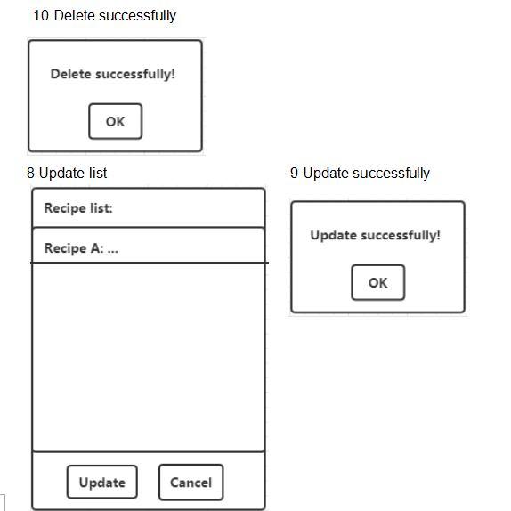
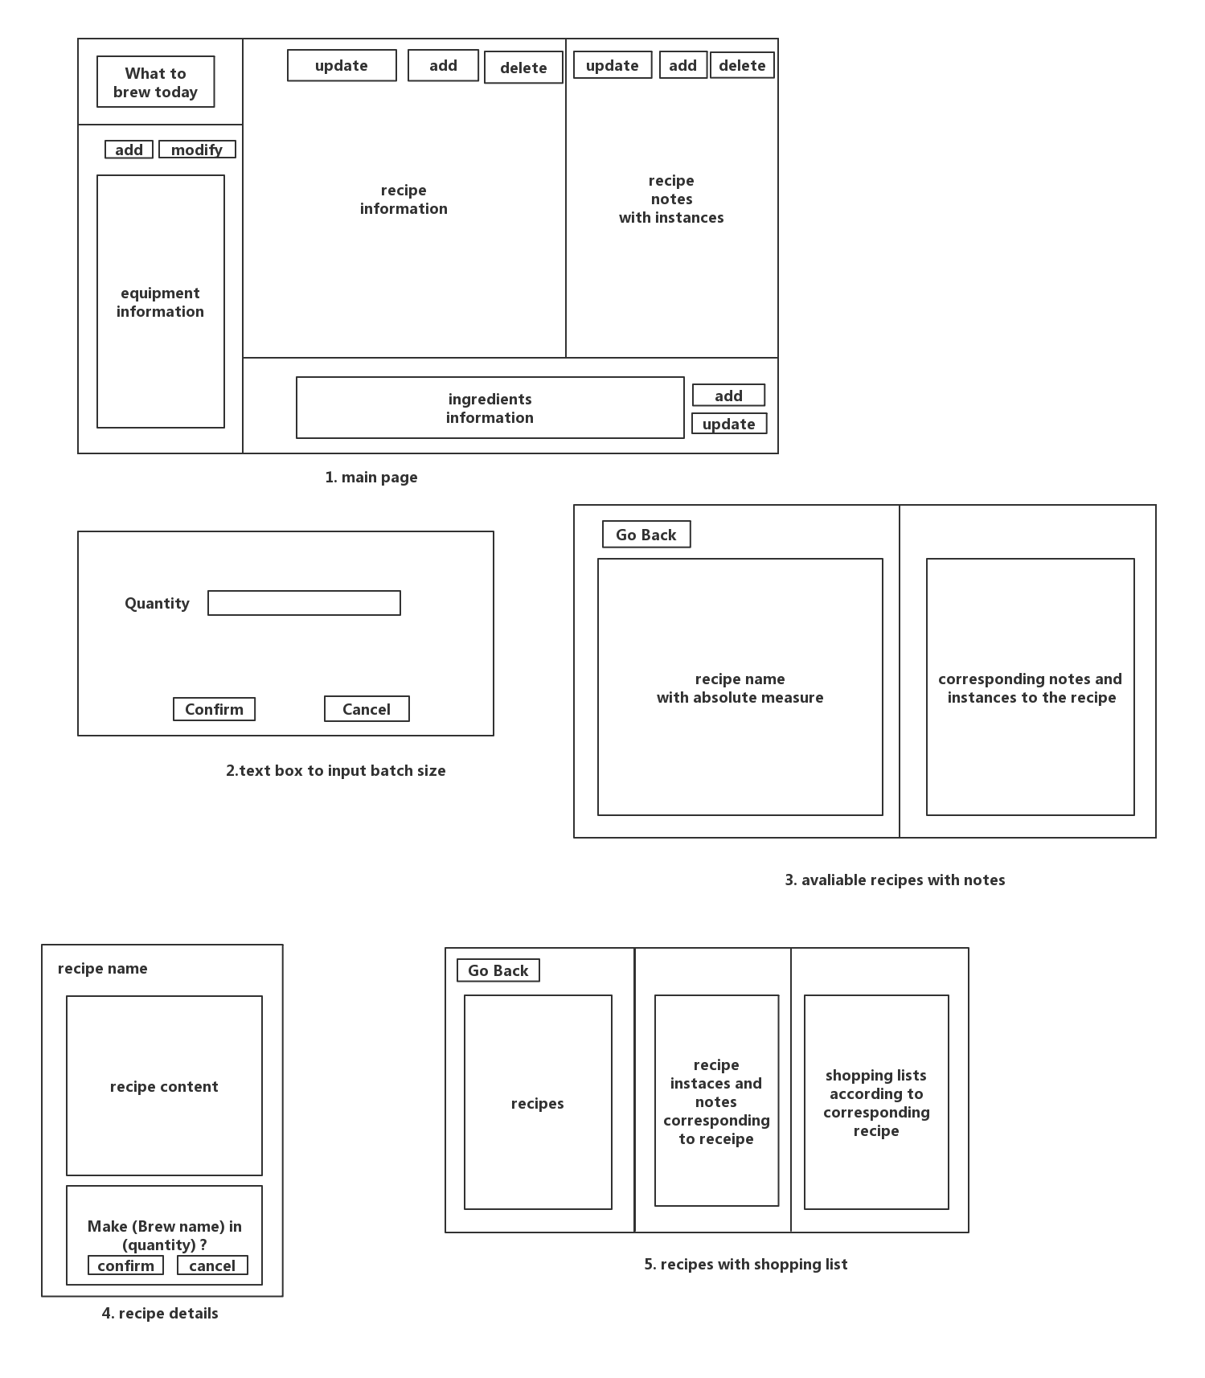
User Interfaces

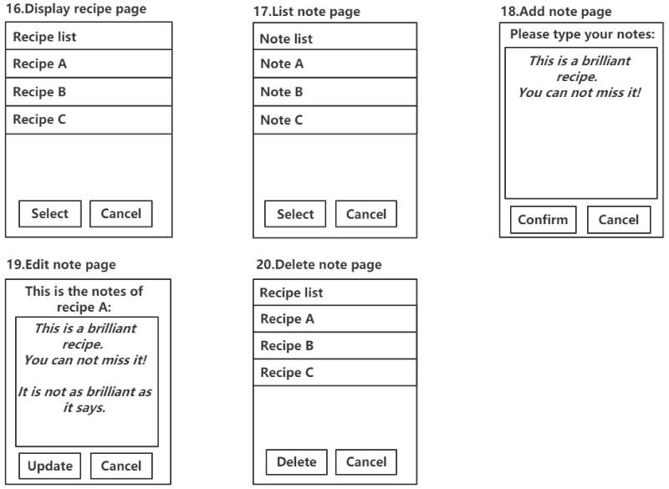
Hardware Interfaces
The printer can be connected to the software. The user can print their recipe through connecting to the printer.

Software Interfaces
This software will communicate with recipe database, ingredient database and note database to obtain, modify and store the recipes, ingredients and notes.

Communications Interfaces
N/A.

Other Nonfunctional Requirements (Ning DING)

Performance Requirements
For real-time requirement, every search action in this software should be finished within 1 second.

Safety Requirements
This software does not need to check whether the user will cause health problems because of recipe products, the users should be responsible for the safety or recipes themselves.

Security Requirements
N/A.

Software Quality Attributes
This software should guarantee usability, it should be easy to use, and user manual should be provided if necessary. The software should assure 2000MTTF for robustness. Reusability and maintainability should also be considered, which means the software should be easy to update and add new requirements in the future.

Other Requirements
TBD
Appendix A: Glossary
TBD
Appendix B: Analysis Models

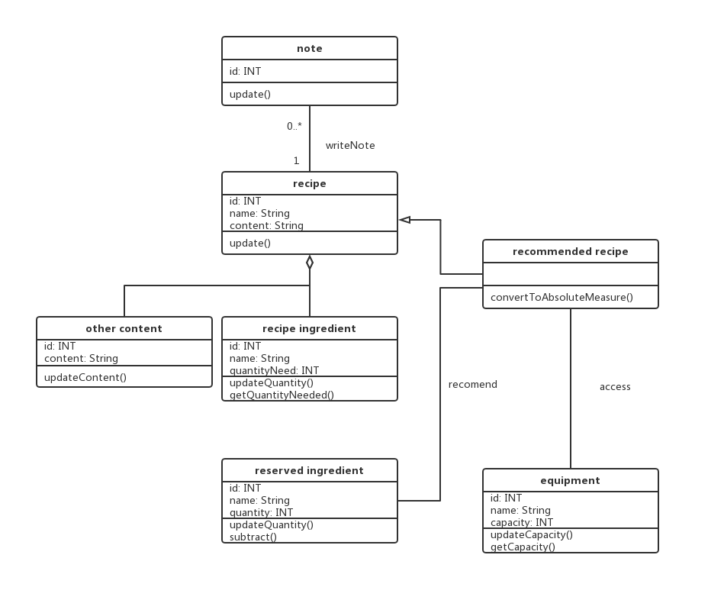
Appendix C: Issues List
TBD

