DEPARTMENT OF COMPUTER SYSTEMS ENGINEERING

DSP PROJECT REPORT

TITLE OF PROJECT

SIMULATION OF FREQUENCY HOPPING SPREAD SPECTRUM IN MATLAB

Submitted by:

ABSTRACT:

In this project I have done simulation of frequency hopping spread spectrum in matlab. I have demonstrated how a frequency hoped signal will look like and all the necessary steps that are required to make a signal hopping from frequency to frequency.
In a FHSS(FREQUENCY HOPPING SPREAD SPECTRUM) system, a transmitter "hops" between available frequencies according to a specified algorithm, which can be either random or preplanned. The transmitter operates in synchronization with a receiver, which remains tuned to the same center frequency as the transmitter. A short burst of data is transmitted on a narrowband. Then, the transmitter tunes to another frequency and transmits again. The receiver thus is capable of hopping its frequency over a given bandwidth several times a second, transmitting on one frequency for a certain period of time, then hopping to another frequency and transmitting again. Frequency hopping requires a much wider bandwidth than is needed to transmit the same information using only one carrier frequency. In short Frequency-hopping spread spectrum (FHSS) is a method of transmitting radio signals by rapidly switching a carrier among many frequency channels, using a pseudorandom sequence known to both transmitter and receiver.

METHODOLOGY:

As far as my project is concerned it is a simulation of how a signal will look like when we apply this technique of FHSS to it.
First of all I generated random bits in MATLAB by using the rand function. These will form the binary data. I took two empty arrays for the signal to be transmitted and the carrier.
I also put some conditions using simple ‘for’ loops to form a nice digital signal to transmit.
I took the cosine signal as a carrier, as cosine is one of the most widely used signal for simulation purposes and we also know that any signal can be made from it so that’s why I choose this signal as my carrier.
Now the modulation turn has come, I used BPSK scheme as my modulation scheme to modulate the binary data. I choose BPSK because it is really simple and its BER is very low as compared to the other modulation schemes.
I used point by point multiplication and multiplied the carrier with the digital signal generated.
After this I prepared six new carrier frequencies, although any number of frequencies can be used but for simulation purposes I thought six are enough. I than randomly assigned different frequencies to the signal to spread the spectrum of the signal and finally used point by point multiplication between the modulated signal and the spread signal to form a signal that hops from frequency to frequency and thus successfully demonstrated how a frequency hopped signal look like and the steps required to form it.
Finally I also took the fast fourier transform to know about the frequency content of the signal.

BLOCK DIAGRAM:

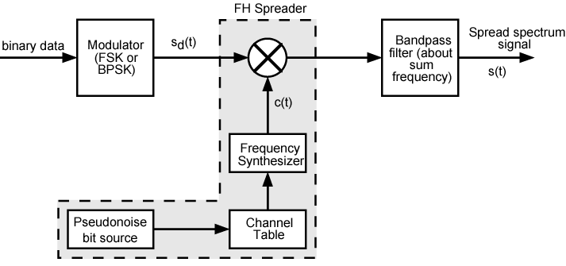

RESULTS AND DISCUSSION:

As this project was a mere simulation and not an actual implementation of frequency hopping which lies beyond the scope of a mini project. So there are no strong results to discuss but I showed and demonstrated how a simple spread spectrum signal will look like and than finally how a frequency hopping spread spectrum signal will look like. I also demonstrated in this project all the necessary steps to form a frequency hopped signal.
It is also evident from the figures below (which are infact my results)that the spectrum of the signal is significantly spread and it is transmitted with a large numbers of frequencies.
It can be seen in the BPSK modulated signal that there are no significant or large number of frequencies involved to transmit the signal. Than in the spread version of that same signal a6 different frequencies are used to transmit the signal and than finally in the frequency hopped version of the signal a large number of frequencies are involved to transmit the signal and it can be seen as well that the frequency hops are of random nature.
This was actually what the project was about that what a signal will look like when its hopping from frequency to frequency. Also it is proved that frequency hoped signals are very difficult to catch because the random hopping pattern in the last figure is known only to transmitter and receiver and without knowing about this pattern the message cannot be retrieved in full, even if some one does get lucky he/she will knock out only a few bits of the message signal.

A few figures are as follows:

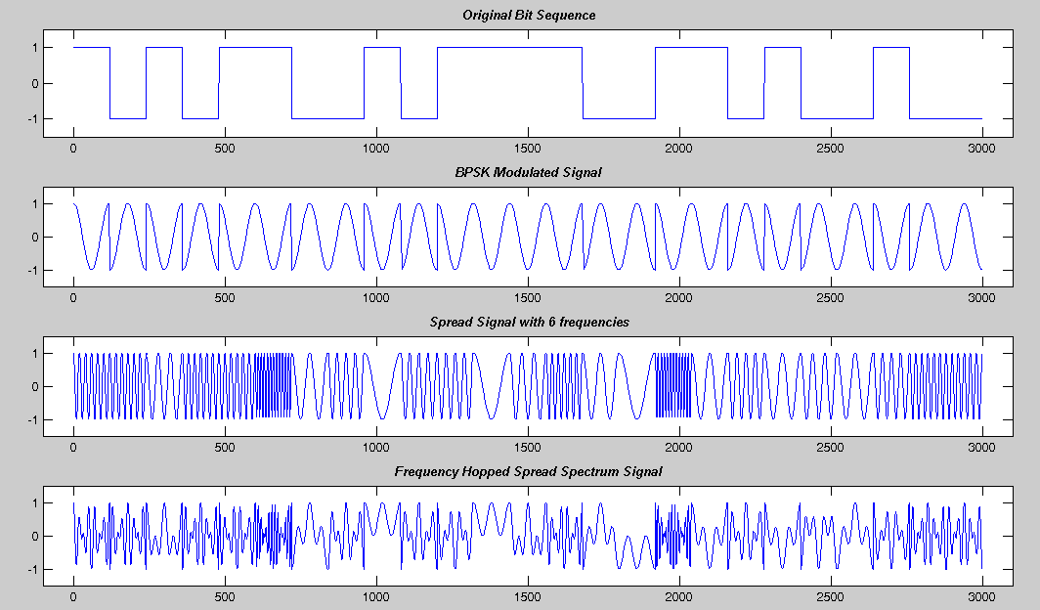

CONCLUSION:

As we know that this age in which we live now is the age of information technology and gone are the days when wars were won with sole muscle power. In todays age wars are fought and will be fought at the electronic frontiers. This is the age of electronic war fare and we all know that to win any war the safe exchange of information and valuable data is very much important. For that purpose this technique which I have simulated will play a great role and is a really great method for safe exchange of information. It is almost impossible to get hold of information sent using this technique if the seed is not known.(seed is used to generate random numbers, only receiver and transmitter knows about it).
The results of my simulation very much support this claim of mine as it is clearly seen that the signal is spread in a huge number of frequencies which are difficult to get hold of. Even if some eaves dropper manages to get hold of the information in a few frequencies, it wont make any sense to him/her. Finally I would also like to say that the spread-spectrum function must be kept out of the hands of unauthorized people or entities as they would use it for there illegal activities and will go unnoticed.

CODE:

%%%%%%%%%%%%%%%%%%%%%%
% Frequency Hopping Spread Spectrum
%%%%%%%%%%%%%%%%%%%%%%

% Generation of bit pattern
s=round(rand(1,25)); % Generating 25 bits
signal=[]; % empty array for signal
carrier=[]; % empty array for carrier
t=[0:2*pi/119:2*pi]; % Creating 60 samples for one cosine
for k=1:25 % making the digital signal or data signal
if s(1,k)==0
sig=-ones(1,120); % 120 minus ones for bit 0
else
sig=ones(1,120); % 120 ones for bit 1
end
c=cos(t); % cos(t) is my carrier
carrier=[carrier c];% concatenation
signal=[signal sig];
end
subplot(4,1,1); %simple ploting
plot(signal);
axis([-100 3100 -1.5 1.5]);
title('\bf\it Original Bit Sequence');

% BPSK Modulation of the signal
bpsk_sig=signal.*carrier; % Modulating the signal by using point by point multiplication
subplot(4,1,2);
plot(bpsk_sig)
axis([-100 3100 -1.5 1.5]);
title('\bf\it BPSK Modulated Signal');

% Preparation of 6 new carrier frequencies
t1=[0:2*pi/9:2*pi];
t2=[0:2*pi/19:2*pi];
t3=[0:2*pi/29:2*pi];
t4=[0:2*pi/39:2*pi];
t5=[0:2*pi/59:2*pi];
t6=[0:2*pi/119:2*pi];
c1=cos(t1);
c1=[c1 c1 c1 c1 c1 c1 c1 c1 c1 c1 c1 c1];
c2=cos(t2);
c2=[c2 c2 c2 c2 c2 c2];
c3=cos(t3);
c3=[c3 c3 c3 c3];
c4=cos(t4);
c4=[c4 c4 c4];
c5=cos(t5);
c5=[c5 c5];
c6=cos(t6);

% Random frequency hops to form a spread signal
spread_signal=[];
for n=1:25
c=randint(1,1,[1 6]);
switch(c)
case(1)
spread_signal=[spread_signal c1];
case(2)
spread_signal=[spread_signal c2];
case(3)
spread_signal=[spread_signal c3];
case(4)
spread_signal=[spread_signal c4];
case(5)
spread_signal=[spread_signal c5];
case(6)
spread_signal=[spread_signal c6];
end
end
subplot(4,1,3)
plot([1:3000],spread_signal);
axis([-100 3100 -1.5 1.5]);
title('\bf\it Spread Signal with 6 frequencies');

% Spreading BPSK Signal into wider band with more frequencies
freq_hopped_sig=bpsk_sig.*spread_signal;
subplot(4,1,4)
plot([1:3000],freq_hopped_sig);
axis([-100 3100 -1.5 1.5]);
title('\bf\it Frequency Hopped Spread Spectrum Signal');

% Expressing the FFTs to know about the frequency content of the signal
figure,subplot(2,1,1)
plot([1:3000],freq_hopped_sig);
axis([-100 3100 -1.5 1.5]);
title('\bf\it Frequency Hopped Spread Spectrum signal and its FFT');
subplot(2,1,2);
plot([1:3000],abs(fft(freq_hopped_sig)));

REFERENCES:

- DATA AND COMPUTER COMMUNICATIONS, 7TH EDITION(WILLIAM STALLINGS)
- "STRATEGIES_FOR_ADAPTIVE_FREQUENCY_HOPPING_IN_THE_UNLICENSED_BANDS". IEEE Wireless Communications.
- discussion forums on different dsp related websites

