1、下面是SELECT语句的逻辑执行顺序：

1. FROM
2. ON
3. JOIN
4. WHERE
5. GROUP BY
6. WITH CUBE or WITH ROLLUP
7. HAVING
8. SELECT
9. DISTINCT
10. ORDER BY
11. TOP

2、报废与报废申请中（经过处理）并且用途为办公

SELECT u.work_no,u.name,a.asset_no, a.cumputer_name,a.cpu,a.memory,a.storage,a.mac,a.create_time,a.update_time,a.memo,o.org_name,

case a.status

when '5' then '報廢'

when '3' then '報廢申請中'

end as status

,

case a.purpose

when '1' then '辦公'

end as purpose

from t_user u,t_org o,t_asset a

where a.user_id=u.uuid and a.dept_id=o.uuid and a.status IN(3,5) and a.purpose=1 order by u.work_no

3、postgresql查询出的数据导出到csv文件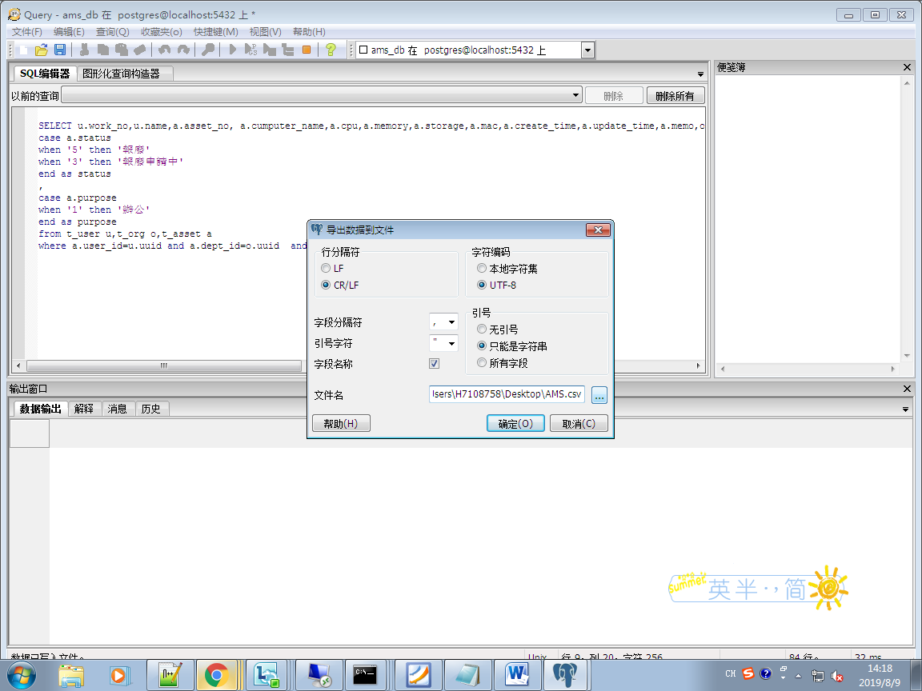

4、pgadmin 将查询数据导出到csv文件

copy (SELECT u.work_no,u.name,a.asset_no, a.cumputer_name,a.cpu,a.memory,a.storage,a.mac,a.create_time,a.update_time,a.memo,o.org_name,

case a.status

when '5' then '報廢'

when '3' then '報廢申請中'

end as status

,

case a.purpose

when '1' then '辦公'

end as purpose

from t_user u,t_org o,t_asset a

where a.user_id=u.uuid and a.dept_id=o.uuid and a.status IN(3,5) and a.purpose=1 order by u.work_no) to 'd:/skytf.test_2.csv' with csv header;