Pestaña 1

Abstract 1
1. Processing 1
2. Exploration of data 3
3. Model specification and variable selection 4
4. Model selection 6
5. Model diagnosis 11
6. Model interpretation 13
7. Conclusión 17

Abstract
The Ames, Iowa housing dataset represents the value of the sale conditions of 3000 homes with 81 variables across different categories encompassing both qualitative and quantitative variables. The objective of the assignment is to craft a regression model incorporating the techniques from the course to predict the target variable, SalePrice. The benchmark set to evaluate the model’s efficacy was to reduce the root mean squared error and assess this score through a five fold cross validation. The methodology employed was data processing and exploration to remove problematic variables and smooth the variables that are kept. Additionally, a robust variable selection to address any threats to the model’s assumption of normality by evaluating skewness and applying logarithmic transformations. The main model was selected by comparing 5 different model types and comparing Akaike Information Criterion (AIC) and RMSE and selecting the most appropriate model with a score of 0.095.

Processing
To begin the data processing, the ID’s are removed from the testing set and we check the missing values
missing_data
variable n_miss pct_miss
<chr> <int> <num>
1 LotFrontage 259 17.7
2 GarageYrBlt 81 5.55
3 MasVnrType 8 0.548
4 MasVnrArea 8 0.548
5 Electrical 1 0.0685

Several categorical variables contain missing values that do not correspond to unobserved data, but rather to the absence of a specific feature(basement, garage, fence). For these variables, missing values were recorded as an explicit category labeled “no”, allowing the model to distinguish between the absence and quality levels in a consistent way.
After recoding, the pattern of remaining missing values was inspected using graphical and numerical summaries. Only a small number of variables still presented missing values, which were handled in subsequent imputation steps. Nominal categorical variables were converted to factors without imposing any ordering. For ordinal variables, factor levels were explicitly ordered according to their semantic meaning, quality ratings from poor to excellent. This ensures that the model correctly interprets the ordinal nature of these predictors rather than treating them as unordered categories.
For variables where the absence of a feature carries meaningful information, the “no” level was explicitly included as the reference category. Moreover, the temporal variables such as house age and construction were transformed into age-based variables by computing the age of the house and the age since last renovation at the time of sale. This transformation improves interpretability and allows the model to capture depreciation effects more directly than raw calendar years.

Variables with extremely low effective variability or redundancy with other predictors were removed. Condition 2 was removed because it is a non-missing variable for only a small fraction of observations and largely overlaps in meaning with Condition1, making it difficult to reliably estimate its marginal effect. Exterior2nd coincides with Exterior1st for the vast majority of houses (approximately 86%), and therefore provides little additional information while increasing model complexity through sparse categorical levels. MiscFeature was also excluded, as it takes a non-“no” value in fewer than 4% of observations, resulting in highly unstable parameter estimates under a linear modeling framework. These variables were removed to improve model stability and parsimony. We acknowledge that this choice may discard information from rare cases, but the trade-off is acceptable given the sample size and the objectives of the analysis.

Concerning the remaining missing values, they were imputed using a random forest based imputation method (missForest)_{[1]}, which accounts for nonlinear relationships and interactions among variables. This approach allows for a more data driven imputation compared to simple mean or mode substitution, while preserving multivariate structure.
Basement-related variables were processed separately to ensure internal consistency.
Categorical basement variables were recoded with a “no” level to represent houses without a basement, while numeric basement variables, areas and bathroom counts, were set to zero in these cases. Additionally, a binary indicator variable HasBasement was created based on whether the total basement area is zero. This variable explicitly captures the presence or absence of a basement, allowing the model to distinguish between extensive and intensive effects.

Exploration of data
Initial data diagnostics
An initial diagnostic analysis was conducted to assess data quality and identify potential issues prior to modeling. Automated diagnostic tools were used to summarize variable types, missing values, and potential inconsistencies. Both numerical and categorical variables were examined using summary statistics and visual inspections to ensure that the preprocessing steps resulted in a coherent dataset. Interactive exploration tools, the esquisse and explore packages, were employed to inspect variable distributions but were omitted from the final script.

Correlation structure and multicollinearity
To assess linear dependence among predictors, a correlation matrix was computed for all numerical variables. Ordinal quality variables were temporarily converted to numeric form to allow their inclusion in the correlation analysis. The resulting matrix was visualized using a heatmap with annotated correlation coefficients. This analysis revealed several pairs of variables with strong linear dependence, including garage capacity versus garage area, basement area versus first-floor area, and age-related variables.

Based on these diagnostics, the following variable pairs were identified as unsuitable for inclusion together in the same linear model:
GarageCars / GarageArea, TotalBsmtSF / 1stFlrSF, GarageQual / GarageCond, and Age / AgeRemod.

Outlier detection and influence assessment
Potential outliers were investigated using both automated detection procedures and graphical diagnostics. Observations noted as extreme values in one or more variables were visually examined by plotting each candidate variable against the response variable, SalePrice, with observation identifiers annotated.

This exploratory analysis allowed the identification of a small set of candidate observations that may exert disproportionate influence on model estimation. Final decisions regarding the treatment of these observations were deferred to model comparison stages, where models with and without selected candidates can be evaluated.

Distributional shape and skewness
The distribution of SalePrice was examined using histograms and kernel density estimates. The original scale exhibited strong right skewness, while the logarithmic transformation resulted in a substantially more symmetric distribution.

Skewness coefficients were computed for all numerical predictors. Variables with absolute skewness exceeding 0.5 were flagged as candidates for transformation. This analysis motivated the use of logarithmic transformations for selected variables in later modeling stages.
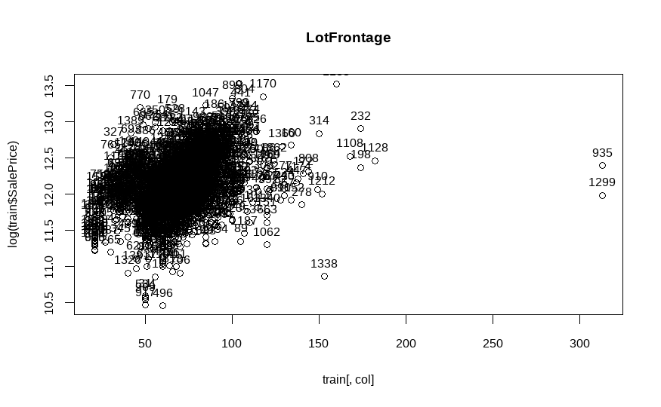

Additional considerations
Several additional transformations were explored based on distributional properties and sparsity patterns observed during the analysis. These included combining multiple porch-related area variables into a single aggregate measure, constructing indicators for the presence of rarely observed features, such as the presence of a pool, and aggregating bathroom counts.

Variables dominated by a single level or containing an overwhelming proportion of zeros were evaluated. In cases where such variables provided limited explanatory power and posed interpretability challenges, they were considered for removal or simplification. These exploratory steps informed, but did not automatically determine, the final model specification.

Model specification and variable selection
Models without log-transformation of predictors
Response transformation and baseline model as a first modeling strategy, SalePrice was log-transformed to reduce right skewness and stabilize variance, while all predictors were kept on their original scale. A multiple linear regression model including all available predictors and no interaction terms was fitted as a baseline specification. This model serves as a reference point to evaluate the effect of predictor transformations introduced in subsequent stages.

Stepwise variable selection was based on the AIC: stepwise selection，as it provided the most satisfactory balance between model fit and complexity.

Multicollinearity was assessed using variance inflation factors computed from the full model. Several groups of highly correlated predictors were identified. In particular, pairs such as garage capacity versus garage area. For this model specification, these correlated terms were retained in order to preserve the full set of structural information.

Although the model without predictor transformations provides a useful benchmark, several numerical predictors exhibit substantial skewness. This can lead to leverage effects and reduced efficiency of coefficient estimates, motivating the consideration of transformations for selected predictors.
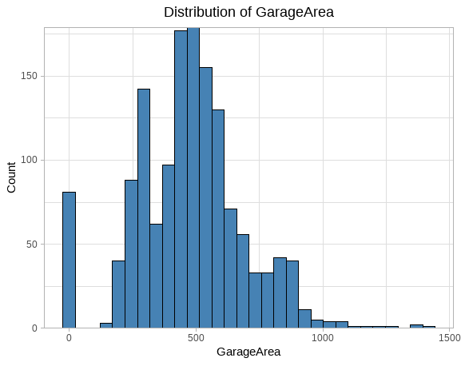
Models with log-transformation of skewed predictors
To address distributional asymmetries among predictors, skewness coefficients were computed for all numerical variables. Predictors with absolute skewness exceeding 0.5 were flagged as substantially skewed. This threshold provides a transparent and reproducible criterion for selecting variables to be transformed.

For the identified skewed predictors, a logarithmic transformation of the form log(x + 1) was applied. This transformation reduces skewness while allowing for zero-valued observations. The effect of the transformation was verified visually using before-and-after distribution plots for representative variables.
A multiple linear regression model was fitted using the log-transformed response variable and the transformed predictors. Additionally several predictors that represent the same housing characteristic such as, GarageCars and GarageArea, that were highly correlated were pruned. Thus the resulting model was examined for further multicollinearity to ensure that the transformations did not reintroduce numerical instability.

Compared to the model using untransformed predictors, the specification with log-transformed predictors exhibited improved distributional properties and reduced leverage effects for highly skewed variables. This suggests that transforming selected predictors enhances the suitability of the linear regression framework for this dataset.
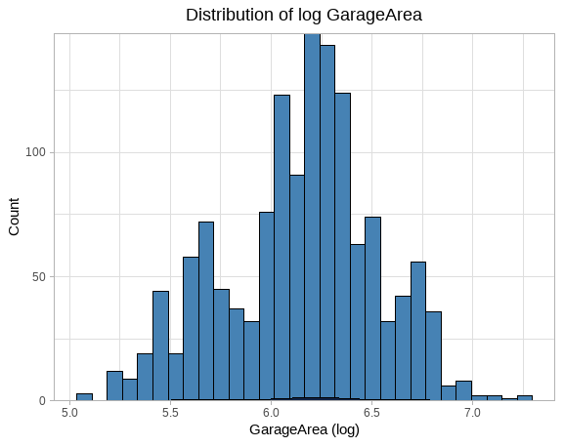

Model selection
Model 1: Full linear model (baseline)

full_model = lm(data=train_set, formula = logSalePrice ~ .)

The first model includes all available predictors without transformations or interaction terms. This specification serves as a baseline against which subsequent modeling decisions are evaluated.
While this model provides a comprehensive starting point, it is expected to suffer from multicollinearity and inefficiencies due to highly skewed predictors.

Performance:
AIC | AICc | BIC | R2 | R2 (adj.) | RMSE | Sigma
---------------------------------------------------------------
-2100.0 | -2032.7 | -1016.3 | 0.934 | 0.924 | 0.102 | 0.110

Model 2: Log-transformed predictors and reduced multicollinearity

model_log = lm(data=train_set,
formula = logSalePrice ~.-GarageCond-AgeRemod-X1stFlrSF-GarageCars
-LotArea+log(LotArea)-MasVnrArea+log(MasVnrArea+1)-LotFrontage+log(LotFrontage)-WoodDeckSF+log(WoodDeckSF+1)-TotalPorch+ log(TotalPorch+1) -BsmtFinSF1+ log(BsmtFinSF1+1) -TotalBsmtSF+ log(TotalBsmtSF+1) -BsmtUnfSF+ log(BsmtUnfSF+1)-X2ndFlrSF+ log(X2ndFlrSF+1) -GrLivArea+ log(GrLivArea+1) )

Model 2 introduces two key refinements. First, logarithmic transformations are applied to a subset of numerical predictors identified as highly skewed during exploratory analysis. A log(x + 1) transformation is used to accommodate zero values. Secondly, based on the exploratory analysis and the following plot , we can conclude that predictors exhibiting strong multicollinearity are removed in order to improve numerical stability and interpretability. This satisfies linear regression assumptions while maintaining a relatively rich set of predictors.

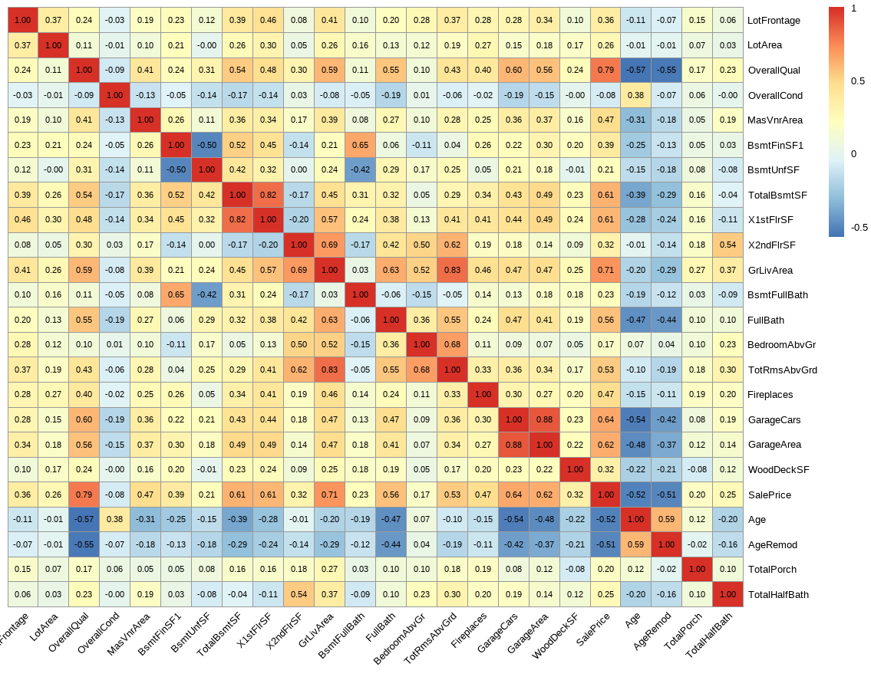

Performance:
AIC | AICc | BIC | R2 | R2 (adj.) | RMSE | Sigma
---------------------------------------------------------------
-2156.5 | -2094.0 | -1109.8 | 0.936 | 0.926 | 0.101 | 0.109

Model 3: Interaction terms and outlier removal

model_interaction = lm(data=train_set, logSalePrice~.-GarageCond-AgeRemod-X1stFlrSF-GarageCars
-LotArea+log(LotArea)-MasVnrArea+log(MasVnrArea+1)-LotFrontage+log(LotFrontage)-WoodDeckSF+log(WoodDeckSF+1)-TotalPorch+ log(TotalPorch+1) -BsmtFinSF1+ log(BsmtFinSF1+1) -TotalBsmtSF+ log(TotalBsmtSF+1) -BsmtUnfSF+ log(BsmtUnfSF+1)-X2ndFlrSF+ log(X2ndFlrSF+1) -GrLivArea+ log(GrLivArea+1) + HasBasement:TotalBsmtSF + HasPorch:TotalPorch )

In our regression diagnostics some observations may not appear extreme in terms of physical dimensions and exhibit severe statistical contradictions in the relationship between the core predictor, OverallQual, and SalePrice. As illustrated in the plot, observations 1299, 524, 1183, and 692 possess top-tier construction quality (grades 9 and 10), yet their sale prices are exceptionally low and fall below many houses with quality grades of only 6 or 7. This "high quality, low price" contradiction renders them highly disruptive outliers. Retaining these points would force the linear regression model to suppress the coefficient for OverallQual in an attempt to minimize residuals, leading to a systematic underestimation of the vast majority of houses that follow standard market logic. By removing these high-leverage outliers in Model 3, we eliminate anomalous noise, allowing the model to more accurately capture the true market principle that quality drives value, thereby significantly enhancing both the robustness and predictive accuracy of the model on unseen data.

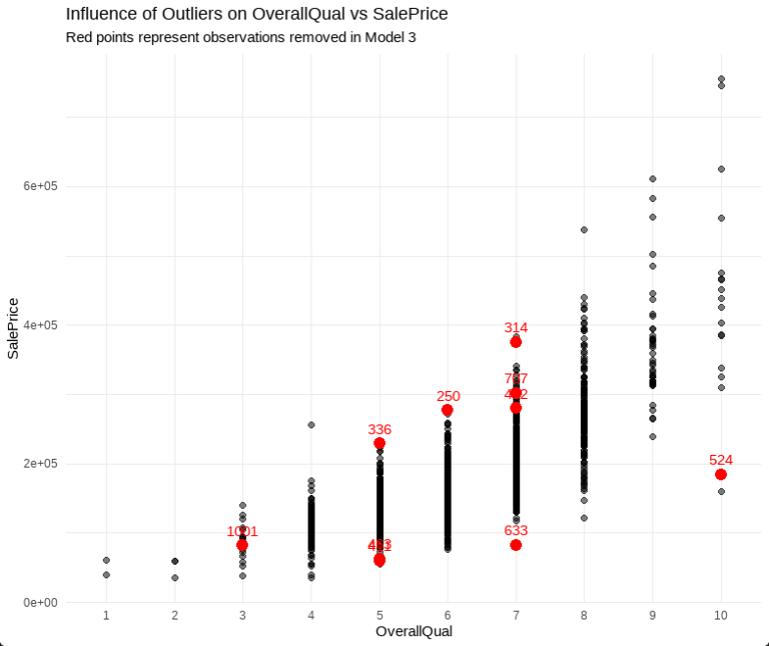

In the third model, interaction terms are introduced to capture conditional effects that cannot be represented by additive predictors alone. In particular, interactions between basement presence and basement area, as well as porch presence and total porch area, are included to distinguish between extensive and intensive margins. Additionally, a small number of observations identified as extreme or influential during exploratory diagnostics are removed. These observations exhibit unusually large living areas or leverage and may disproportionately affect coefficient estimates.This model explores whether allowing for interaction effects and reducing the influence of extreme observations leads to improved model performance.

Performance:
AIC | AICc | BIC | R2 | R2 (adj.) | RMSE | Sigma
---------------------------------------------------------------
-2398.9 | -2335.8 | -1353.7 | 0.946 | 0.938 | 0.092 | 0.099
Model 4: Parsimonious model with significant predictors

model_rem = lm(data=train_set, formula = logSalePrice ~ MSSubClass + MSZoning + LotShape + LandContour + LotConfig +
Neighborhood + Condition1 + BldgType + HouseStyle + OverallQual +
OverallCond + RoofStyle + RoofMatl + Exterior1st + MasVnrType +
ExterQual + ExterCond + Foundation + BsmtQual +
BsmtExposure + BsmtFinType1 + Heating + HeatingQC + CentralAir +
BsmtFullBath + FullBath+ BedroomAbvGr + KitchenQual + Fireplaces + GarageType + GarageArea + log(Age + 1) + HasPorch + TotalHalfBath +
log(LotArea) + log(WoodDeckSF + 1) +
log(TotalPorch + 1) + log(BsmtFinSF1 + 1) +
log(TotalBsmtSF + 1) + log(X2ndFlrSF + 1) +
log(GrLivArea + 1))

The fourth model further simplifies the specification by removing predictors and interaction terms that were not statistically significant in the previous model. The goal is to obtain a more parsimonious model that retains explanatory power while improving interpretability.
This specification represents a compromise between model complexity and statistical efficiency, focusing on predictors with robust and interpretable effects.

Performance:

AIC | AICc | BIC | R2 | R2 (adj.) | RMSE | Sigma
---------------------------------------------------------------
-2377.4 | -2331.9 | -1480.0 | 0.943 | 0.936 | 0.095 | 0.101

Model 5: Robustness check with full sample

model_rem_out = lm(data=train_set, formula = logSalePrice ~ MSSubClass + MSZoning + LotShape + LandContour + LotConfig +
Neighborhood + Condition1 + BldgType + HouseStyle + OverallQual +
OverallCond + RoofStyle + RoofMatl + Exterior1st + MasVnrType +
ExterQual + ExterCond + Foundation + BsmtQual +
BsmtExposure + BsmtFinType1 + Heating + HeatingQC + CentralAir +
BsmtFullBath + FullBath+ BedroomAbvGr + KitchenQual + Fireplaces + GarageType + GarageArea + log(Age + 1) + HasPorch + TotalHalfBath +
log(LotArea) + log(WoodDeckSF + 1) +
log(TotalPorch + 1) + log(BsmtFinSF1 + 1) +
log(TotalBsmtSF + 1) + log(X2ndFlrSF + 1) +
log(GrLivArea + 1))

The fifth model uses the same set of predictors as Model 4, but reintroduces all observations, including those previously excluded as potential outliers. This specification serves as a robustness check, allowing assessment of whether the reduced model remains stable when fitted to the complete dataset.

Performance:
AIC | AICc | BIC | R2 | R2 (adj.) | RMSE | Sigma
---------------------------------------------------------------
-2149.9 | -2103.7 | -1240.7 | 0.933 | 0.925 | 0.103 | 0.110

Model comparison and performance

Model performance was evaluated using standard goodness of fit and predictive metrics, including information criteria and root mean squared error (RMSE). While certain refinements lead to improvements in performance, increased model complexity does not consistently translate into better results.

Final model choice
Model 4 : Parsimonious model with significant predictors
Models 1, 2 and 5 showed larger values of RMSE relative to the other models. Model 3 showed the lowest value overall, but this was not very different from the value obtained for Model 4. We therefore decided to select the fourth model, as a simpler model is generally preferred.

Model diagnosis
Diagnostics
Diagnostic plots are presented for the final model:
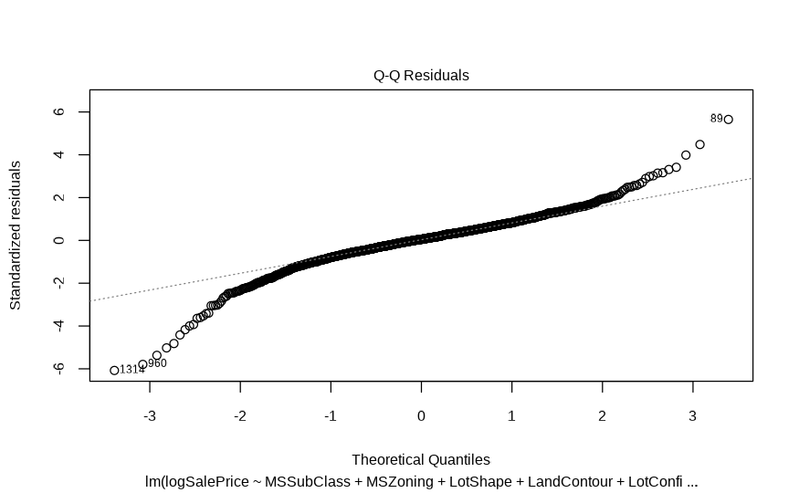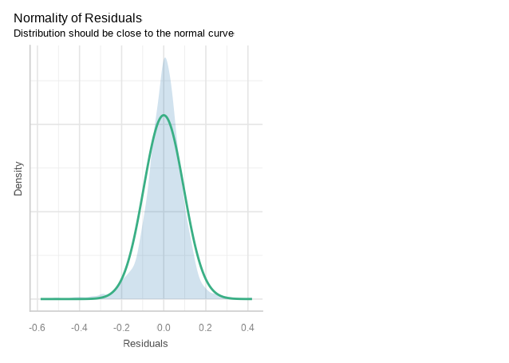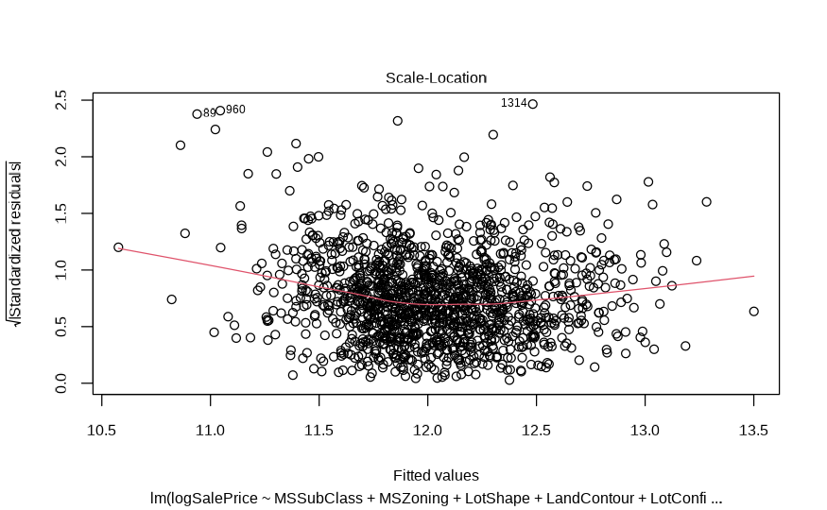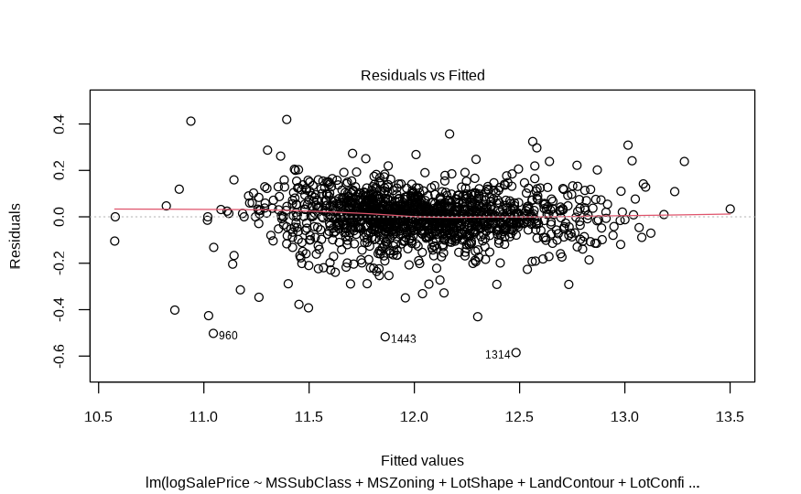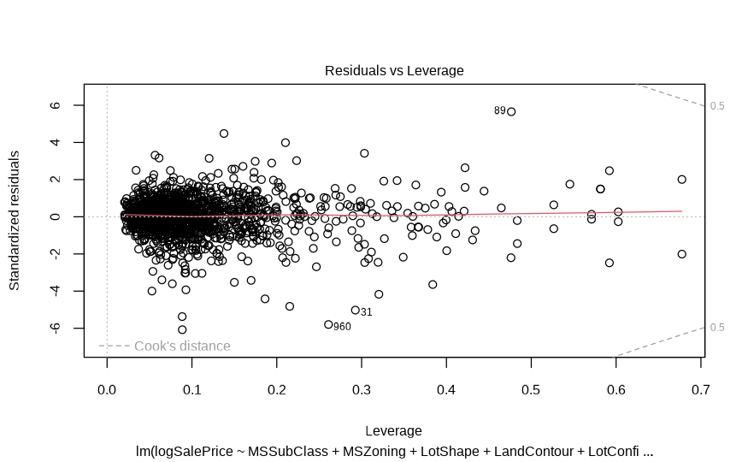

From the analysis of the plots we can conclude:
- The linearity assumption is fulfilled.
- While residuals do appear to be normally distributed, there also seem to be heavy tails on their distribution.
- The homogeneity of variance assumption also appears to be fulfilled although not perfectly.
- There does not appear to be any influential observations affecting the model.
In summary, while the assumptions are not perfectly fulfilled in some instances, the model appears to be acceptable. Since our main goal is prediction rather than description, we conclude that our model will be useful and do not change our previous decision.

Predictive power of the model
In order to obtain a measure of the predictive power of the model, K-fold cross validation is applied. The results are the following:

RMSE  <dbl> | Rsquared  <dbl> | MAE  <dbl> | MAESD  <dbl>
0.1660854 | 0.8370818 | 0.09062971 | 0.008262423
As expected, while the results with cross validation are worse than those obtained with the whole training set, the model appears to remain good, with a low RMSE and a relatively high R².

Model interpretation
We look at the ANOVA table to evaluate the variables that contribute the most to explain the variability in price.

Analysis of Variance Table

Response: logSalePrice
Df Sum Sq Mean Sq F value Pr(>F)
MSSubClass 14 77.653 5.5466 545.8714 < 2.2e-16 ***
MSZoning 4 11.864 2.9661 291.9095 < 2.2e-16 ***
LotShape 3 3.529 1.1763 115.7612 < 2.2e-16 ***
LandContour 3 1.572 0.5240 51.5720 < 2.2e-16 ***
LotConfig 4 0.424 0.1060 10.4342 2.559e-08 ***
Neighborhood 24 57.589 2.3995 236.1518 < 2.2e-16 ***
Condition1 3 0.909 0.3030 29.8207 < 2.2e-16 ***
BldgType 3 0.189 0.0631 6.2134 0.0003447 ***
HouseStyle 7 0.661 0.0945 9.2970 2.870e-11 ***
OverallQual 9 31.055 3.4505 339.5846 < 2.2e-16 ***
OverallCond 8 1.548 0.1935 19.0387 < 2.2e-16 ***
RoofStyle 5 0.449 0.0897 8.8328 2.967e-08 ***
RoofMatl 6 0.228 0.0381 3.7455 0.0010627 **
Exterior1st 13 1.862 0.1432 14.0939 < 2.2e-16 ***
MasVnrType 3 1.185 0.3951 38.8870 < 2.2e-16 ***
ExterQual 3 0.715 0.2384 23.4601 8.767e-15 ***
ExterCond 4 0.360 0.0900 8.8595 4.681e-07 ***
Foundation 5 1.036 0.2072 20.3928 < 2.2e-16 ***
BsmtQual 4 1.551 0.3878 38.1647 < 2.2e-16 ***
BsmtExposure 4 1.430 0.3574 35.1718 < 2.2e-16 ***
BsmtFinType1 5 1.382 0.2765 27.2081 < 2.2e-16 ***
Heating 5 0.788 0.1575 15.5034 7.870e-15 ***
HeatingQC 4 0.646 0.1615 15.8948 1.050e-12 ***
CentralAir 1 0.705 0.7054 69.4216 < 2.2e-16 ***
BsmtFullBath 1 0.398 0.3979 39.1583 5.320e-10 ***
FullBath 1 2.930 2.9302 288.3731 < 2.2e-16 ***
BedroomAbvGr 1 0.411 0.4113 40.4829 2.756e-10 ***
KitchenQual 3 0.622 0.2073 20.4021 6.450e-13 ***
Fireplaces 1 1.634 1.6342 160.8294 < 2.2e-16 ***
GarageType 6 0.986 0.1644 16.1789 < 2.2e-16 ***
GarageArea 1 2.203 2.2026 216.7730 < 2.2e-16 ***
HasPorch 1 0.223 0.2228 21.9268 3.134e-06 ***
TotalHalfBath 1 0.568 0.5682 55.9184 1.397e-13 ***
log(Age + 1) 1 0.260 0.2599 25.5823 4.856e-07 ***
log(LotArea) 1 1.062 1.0618 104.4965 < 2.2e-16 ***
log(WoodDeckSF + 1) 1 0.051 0.0509 5.0104 0.0253674 *
log(TotalPorch + 1) 1 0.219 0.2190 21.5559 3.790e-06 ***
log(BsmtFinSF1 + 1) 1 0.126 0.1260 12.4021 0.0004439 ***
log(TotalBsmtSF + 1) 1 1.744 1.7445 171.6853 < 2.2e-16 ***
log(X2ndFlrSF + 1) 1 0.335 0.3348 32.9489 1.180e-08 ***
log(GrLivArea + 1) 1 2.033 2.0327 200.0530 < 2.2e-16 ***
Residuals 1280 13.006 0.0102
---
Signif. codes: 0 ‘***’ 0.001 ‘**’ 0.01 ‘*’ 0.05 ‘.’ 0.1 ‘ ’ 1

We found out that the most important variable in our model was MSSubClass (that is, the type of dwelling involved in the sale). Other important variables included OverallQual (rating of the overall material and finish of the house), Neighborhood (physical locations within the city) and MSZoning (general zoning classification). In summary, according to our model, it appears that the type and conditions of the building, as well as its geographical location are the most important factors determining the sale price of the properties.

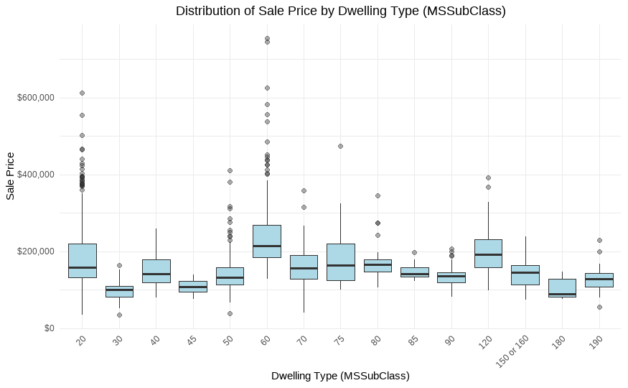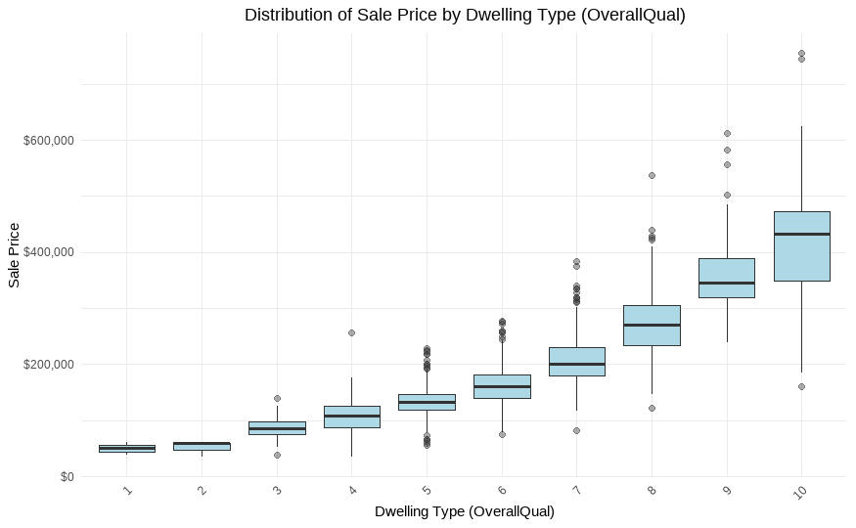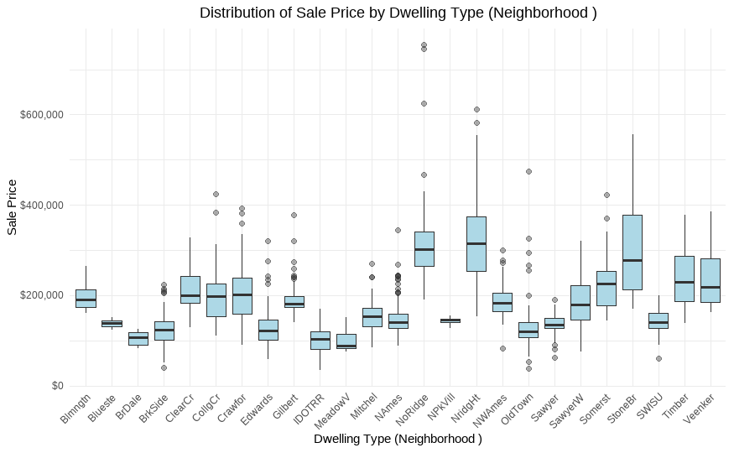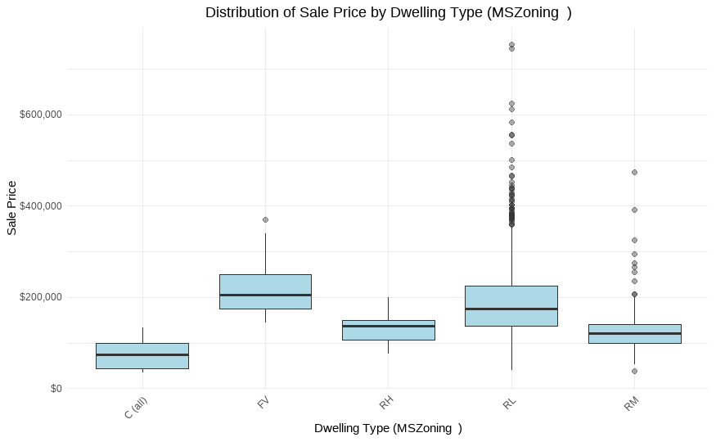

We take the 10 most expensive and the 10 cheapest houses and analyze its main characteristics. Among our findings, we can mention:
- All the expensive houses were either 2-story from 1946 or newer or 1 story from 1946 or newer. The cheapest houses belonged to more mixed categories.
- All the expensive houses were in l Low Density Residential zones, while the cheapest were mostly in Commercial areas or Medium Density Residential zones.
- The mean overall quality of the expensive houses (9.3) was clearly superior to that of the cheapest houses (3.4). Meanwhile, the overall condition does not seem to differ very much.
- The 10 highest value homes and the ten lowest had no overlap in their physical neighborhood.
- All the expensive houses had a basement of good or excellent quality, while the cheapest ones had a basement in average condition or no basement at all
- All the expensive houses had Central air conditioning, compared to only one of the ten cheapest houses
- All the expensive houses had fireplaces while none of the cheapest had one.
- All the cheapest houses had at most 2 baths, while the most expensive ones had 2, 3 or 4.
- Only 3 of the cheapest houses had a garage.
- All the expensive houses had a porch.

Conclusión
The objective was to design and implement a robust predictive model of homes in Ames Iowa and to accomplish this a sequence of five models was fitted, progressing from a comprehensive baseline specification to more refined and parsimonious alternatives. From the top five models, Model 4 was selected to be the optimal model for its interpretability and its stability. This decision is reflected in the fact that Model 3 possessed a marginally smaller RMSE but was rejected for its complexity of predictors The final model achieved a 5 fold cross-validation RMSE of ~0.10 (log scale) which explains approximately 94% of the adjusted R² in the training data.
The analysis showcases the data methodological importance of data preprocessing for an appropriate model. All the models relied on the distinction between missing data and the absence of a housing characteristic. Furthermore, the data processing revealed that housing prices follow a logarithmic scale, since the predictors revealed that increasing area for a home influenced price more strongly for homes that began small, as presented in Model 2.
Concerning the final model, the strongest predictors are OverallQual, MSSubClass, and, GrLivArea. However, the diagnostic plots revealed heavy tails in the residuals and so struggles to predict homes that are massive outliers like homes that are large tracts of land or ultra wealthy homes. This could be resolved through machine learning techniques to capture the sharp differences in values at the edges of the data such as random forests and XG Boost to better account for the variance within physical neighborhoods.
Ultimately the linear model composed of 41 predictors provided the best predictive fit and by comparing the foundational property attributes such as what it is and where it is, we can best predict the overall value of the asset.

Sources

[1] Kathan, Maurie. “Imputing Null Values with Regression.” Medium, 13 Dec. 2018, https://medium.com/@maurie.kathan/imputing-null-values-with-regression-60067ceef0d8. Accessed 08 Dec. 2025.

