**StyleSheet for PTF Archived Logs**

**Table of Contents**

1. Overview………………………………………………………………………………………………………….. 1
2. Pre-requisites……………………………………………………………………………………………..……. 1
3. Description…………………………………………………………………………………………………….... 2
4. Enhancements……………………………………………………………………………………………….… 7
5. ***Overview***

ToolsStyleSheet is a StyelSheet developed by QEO team. In PTF, logs are archived in XML Format which is not readable. The StyleSheet developed is used to render XML file in a more user friendly and to improve the readability. The StyleSheet works only on **Internet Explorer Browser** as of now.

1. ***Pre-requisites***

Active X and Scripts should be enabled in IE Options. If ActiveX and JavaScript are not enabled, you will get a Security Popup as below. You need to click on the Popup and select Allow Blocked Content.

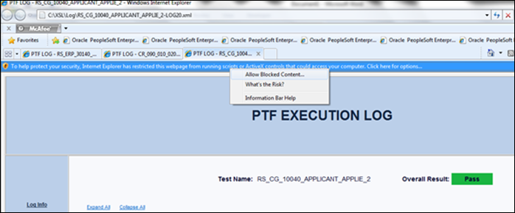

1. ***Description*:**  The following describes the features of StyleSheet.
   * **Screen Shot of StyelSheet** when XML is opened on the Browser

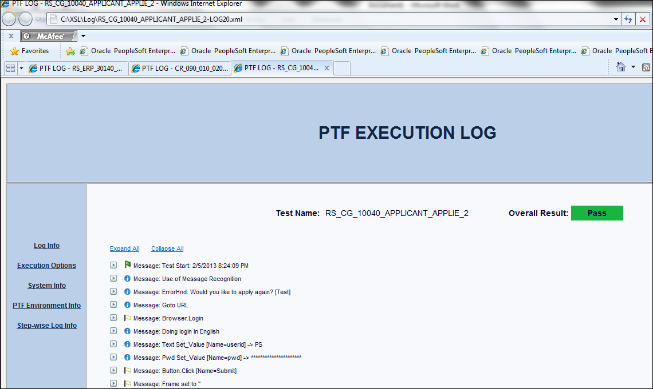

* When clicked on **Log Info**, It displays the Log Information for the particular Test Name as shown below.

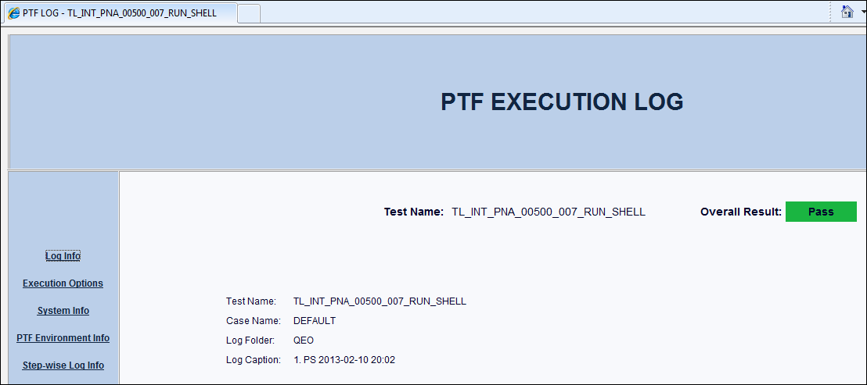

* When clicked on **Execution Options**, it displays the Execution Option Information which was selected in PTF at the time of execution. When clicked on “Click here to open Application”, the URL which is displayed in Appl URL will be opened on a new window.

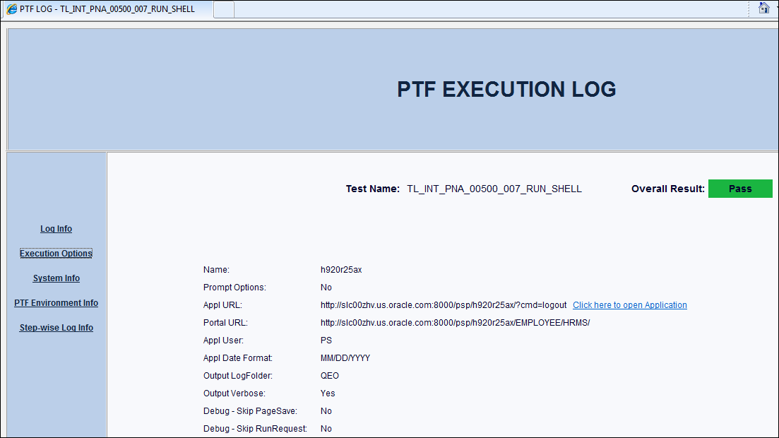

* When clicked on **System Info**, it displays the System details as shown below

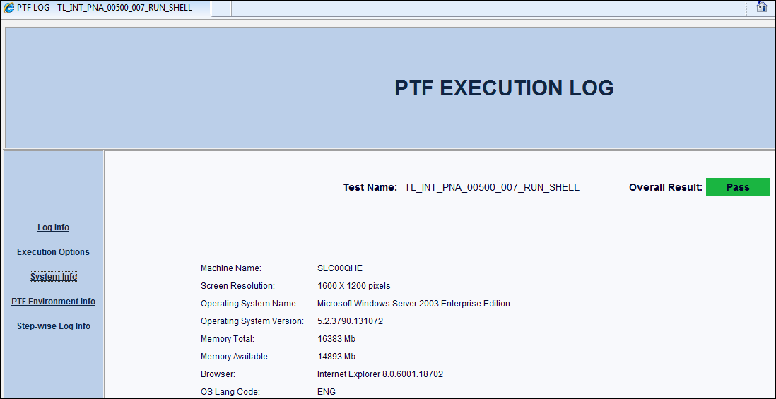

* When clicked on **PTF Environment Info**, PTF Connection details will be displayed.

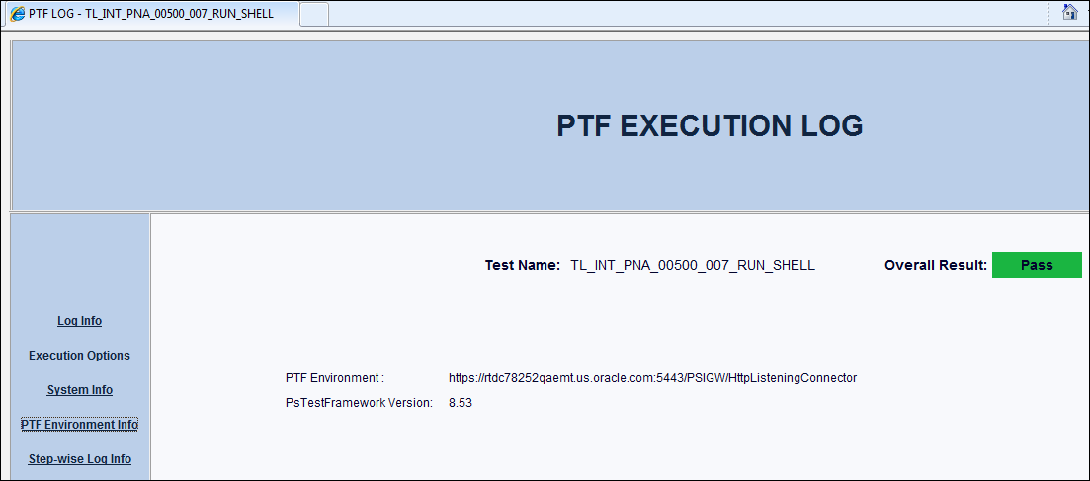

* When **Step-wise Log Info** is clicked, Step-wise Log information is displayed as shown below. This is the same which is displayed as default when the XML is opened on the Browser.

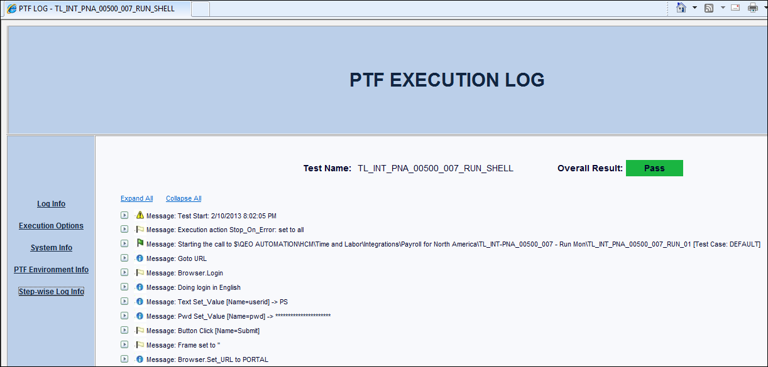

* When clicked on **Expand All**, all the rows are expanded. Each row contains details about Message, Expression, Details, Called Test and Command ID. **Collapse All**, collapses all the rows.

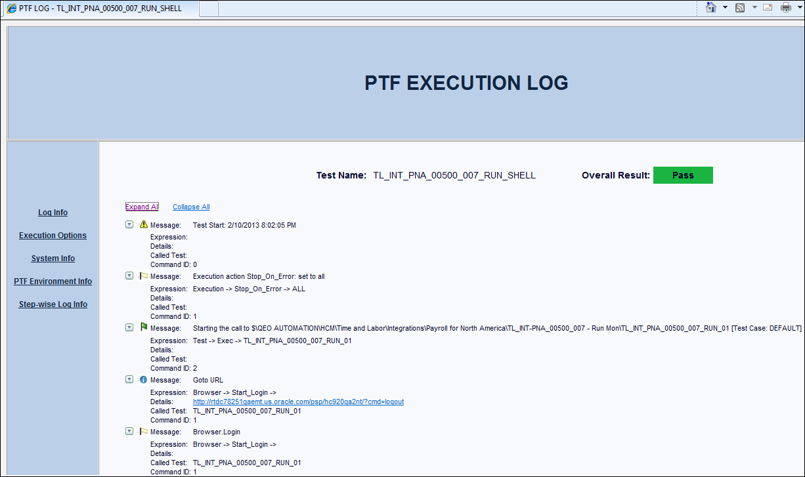

* In **Message node** wherever **Goto URL** is displayed, the Details node will be displayed as a link. On clicking, the Application opens in a new window.

The same way, when clicked on the link with Expression node as Page->Prompt, it takes directly to the Component as shown below.

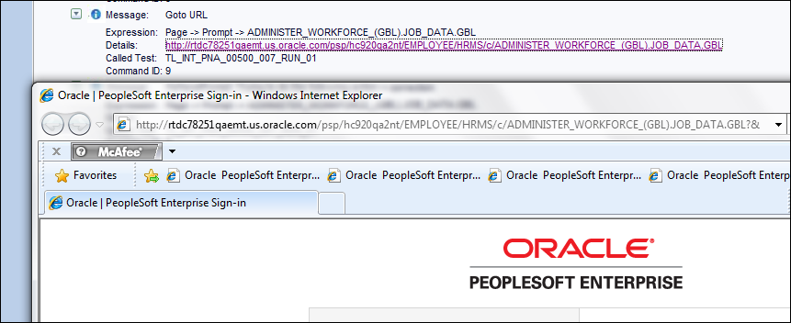

* The **Command ID** displayed is same as the PTF Script ID (highlighted in yellow), helps in indentifying which row in the script has been executed.

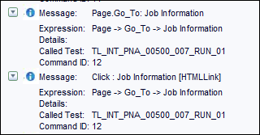

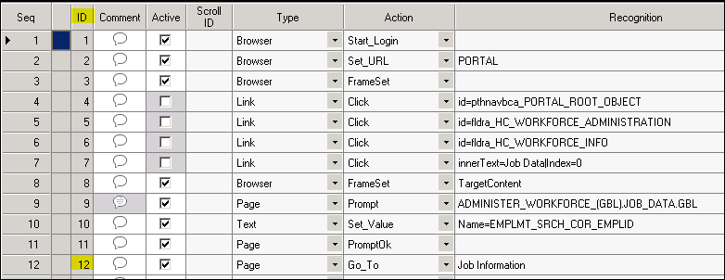

* In **Message node** wherever **Screenshot** link is displayed, on clicking, Image will be displayed on a new window. If the Image is not displayed, then you can open the Image seperately which is in the same folder where the XML resides, an Image with Filename - Test Name suffixed with Line No. (Line No. is displayed in the Log(highlighted in yellow))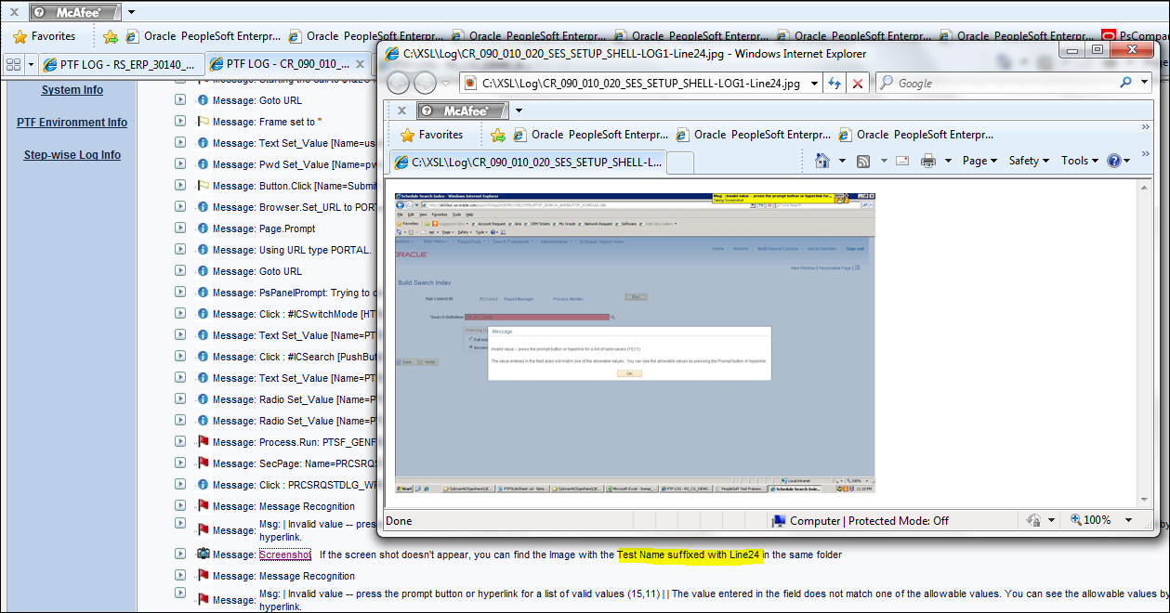

***Enhancements:***

1. Firefox compatibility
2. Step-wise log to be displayed as Tree-view structure.