**PTF Log Parser**

可以解决的问题：

* 追踪PSTO上每次运行脚本的结果，帮助分析自动化脚本的趋势，方便QA查询某一个testrun中失败case的log
* 友好简单的交互界面，可以按需求查找和展示report
* Trace每个产品的report

1. Structure/Workflow(PSTO report)

Report Analysis：Elasticsearch + Kibana

【Elasticsearch：基于restful的搜索服务器，分布式文本搜索引擎，通过http使用json进行数据搜索】

【Kibana：实现数据分析的可视化平台，配合ES使用】

Step 1: Collect Logs from \\slcnas463.us.oracle.com\enterprise\QEShare\PTF Log Archive (Copy and paste to master server)

Step 2: Transfer all the xml logs to HTML (Save in the same folder)

Step 3: Read xml logs and insert logs into Elasticsearch.

Step 4: Lookup the report in Kibana.

1. Setup(EK)
   1. Install Java
   2. Install [Elasticsearch](https://www.elastic.co/products/elasticsearch) (5.6.1), Kibana (5.6.1) and Elasticsearch-head addon for Chrome
   3. Modify config\elasticsearch.yml

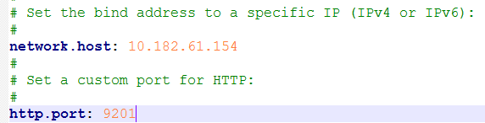

Config\ kibana.

and 

* 1. Run bin\elasticsearch.bat and bin\kibana.bat on Windows

1. Setup(Python)
   1. Install Curl for windows
   2. Install Python2.7.X
   3. Install Elasticsearch-py, libxml2, xmltodict,
2. **Flask**/Django

Upload html report and screenshot to web server.

1. MongoDB: save the ALM case mapper.

Installation: <https://www.cnblogs.com/hongwest/p/7298257.html>

Launch: net start MongoDB

MongoDB\bin>mongo

>exit

Install NoSQLBooster for MongoDB

1. Code Refer

xmltohtml:

1. modify the root of png and put png images to webserver

(\\psbldfs\dfs\enterprise\PTF\Logs)

1. file name of html need to keep the same with xml so that the screenshot can be found.
2. 【ongoing】Authority

M1： plugin（eg：X-pack，Shield）

M2： agent

1. 【Solved】PTF setting（SQL insert）



1. 【Solved】PSTO的log抽取问题：每条case运行的结果只要有pass，就算pass。全部fail的时候，取最后一次log作为参考。即在第二层目录中（单个case的目录），遍历所有的xml，其中字段scriptFinalResult为pass的，直接取当前xml，如果全部都不是pass，取最新的xml。

WebServer

Elasticsearch

PTF logs