MetaLab MS identification Quick Summary

Suggestions to [imetalabca@gmail.com](mailto:imetalabca@gmail.com)

Report generated @2020-02-05 11:24:11

Table of Contents

# Intro

**This report provides some overall description of the database search.**  **Users can use this to quickly check the overal quality of the experiment**

# Take-home figures

* **Peptide Sequences Identified in total:**

|  |  |
| --- | --- |
| * Pep | * tide Sequences Identified |
| * values | * 17060 |

* **Avearge ms/ms identification rate(%):**

|  |  |
| --- | --- |
| * MS/ | * MS Identified [%] |
| * values | * 42.72 |

* **No meta information provided**

# MSMS id rate

Why you should pay attention to MSMS Id rate?

1. MS ID rate is a good repretation of the MS run quality. Raw files from Q-Exactive series should have roughly around 50% ms ID rate (Percentage of MSMS spectra identified as peptided, at a 1% FDR) for humane cell culture digest, and at least 20% for metaproteomics samples according to experience.
2. MS ID rate should also be well-reproduced across samples and groupings.

* Check the raw files if they have obnormally low ID rate, usually with abnormal LC/basepeak profile or low MS intensity.
* A decreasing MS ID treand along sample running order indicates a performance drop of the MS: your MS might need to be cleaned. If the performance drops a lot, more than 20% within running time for the whole project, without scramble of the sample run-order, the data might not be usable, unless very careflly caliburated.

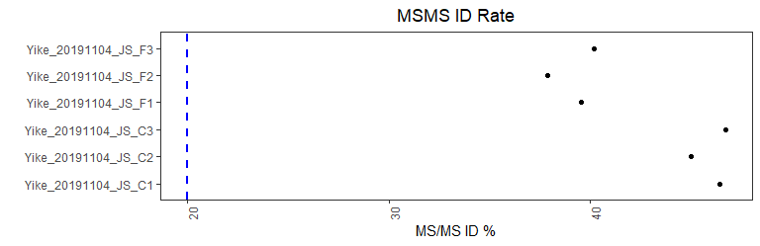

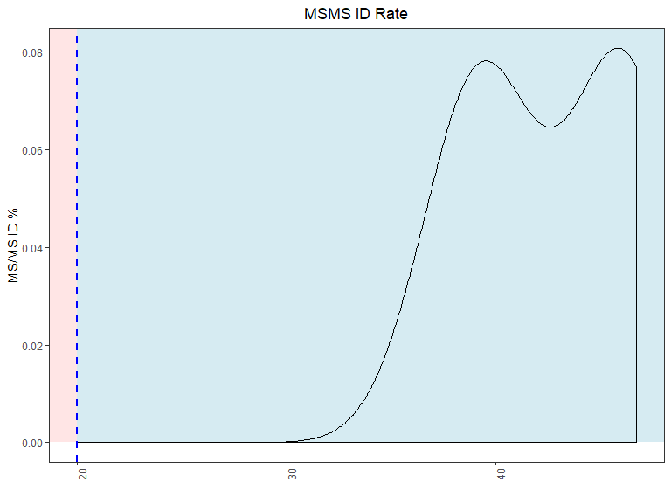

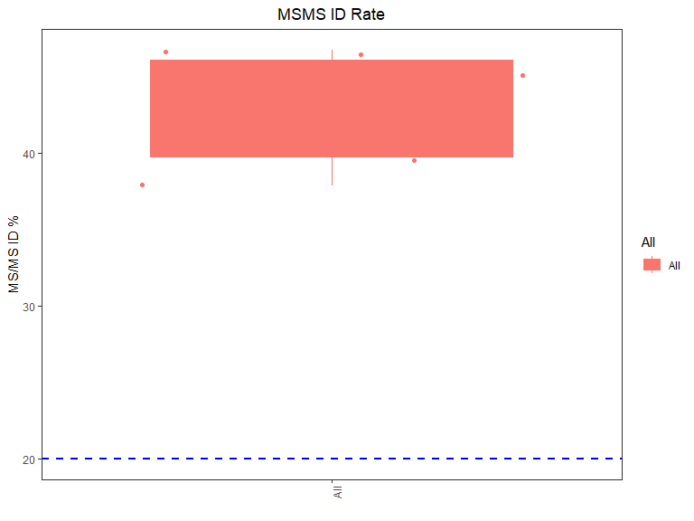

# Peptide Sequence

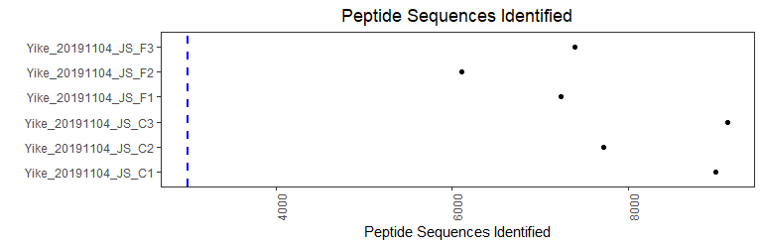

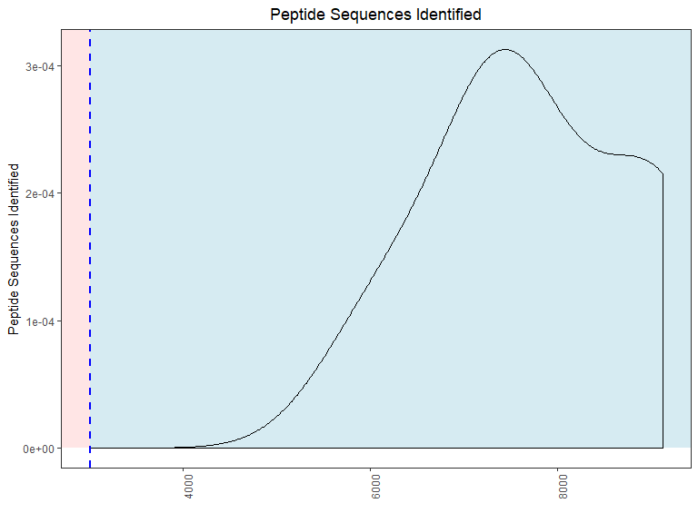

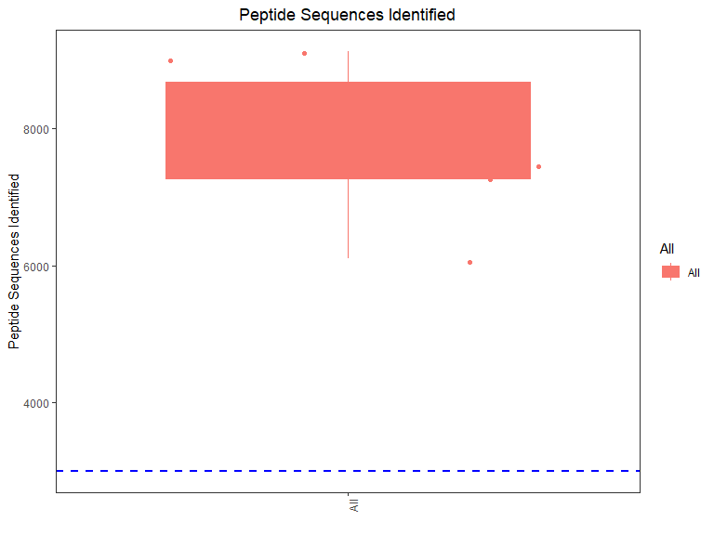

# Overall Performance

**check the overall performance for all raw files:**

|  |  |
| --- | --- |
|  | values |
| MS | 69031 |
| MS/MS | 109492 |
| MS/MS Submitted | 125177 |
| MS/MS Submitted (SIL) | 93807 |
| MS/MS Submitted (PEAK) | 31370 |
| MS/MS Identified | 53477 |
| MS/MS Identified (SIL) | 50627 |
| MS/MS Identified (PEAK) | 2850 |
| MS/MS Identified [%] | 42.72 |
| MS/MS Identified (SIL) [%] | 53.97 |
| MS/MS Identified (PEAK) [%] | 9.09 |
| Peptide Sequences Identified | 17060 |
| Peaks | 6708310 |
| Isotope Patterns | 570002 |
| Isotope Patterns Sequenced | 86162 |
| Isotope Patterns Sequenced (z>1) | 85279 |
| Isotope Patterns Sequenced [%] | 15.12 |
| Isotope Patterns Sequenced (z>1) [%] | 17.32 |
| Isotope Patterns Repeatedly Sequenced | 7200 |
| Isotope Patterns Repeatedly Sequenced [%] | 8.36 |
| Av. Absolute Mass Deviation [ppm] | 0.67125 |
| Mass Standard Deviation [ppm] | 0.94887 |
| Av. Absolute Mass Deviation [mDa] | 0.43051 |
| Mass Standard Deviation [mDa] | 0.63358 |