Câu 1

create function lab5_1(@masp nvarchar(20))

returns nvarchar(20)

as

begin

declare @ten nvarchar(20)

set @ten = (select hsx.tenhang from Hangsx hsx

inner join Sanpham sp

on hsx.mahangsx = sp.mahangsx

where sp.masp = @masp)

return @ten

end

select dbo.lab5_1('SP02')

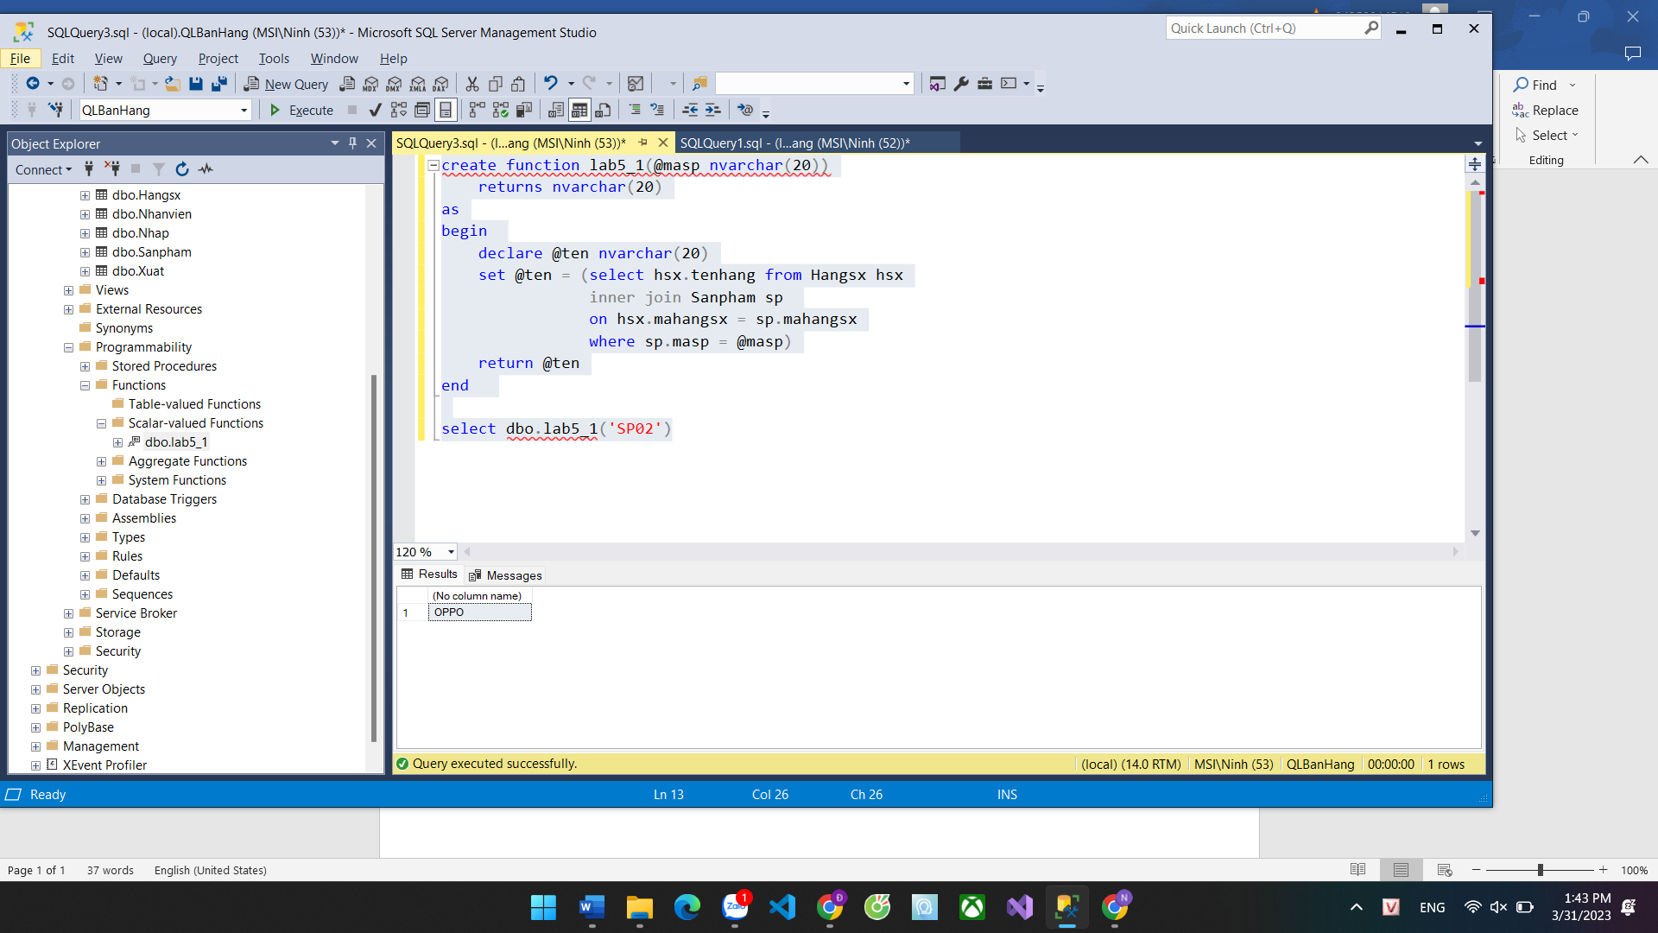

Câu 2

create function lab5_2(@x nvarchar(20), @y nvarchar(20))

returns int

as

begin

declare @sum int

set @sum = (select SUM(dongiaN) from Nhap

where YEAR(ngaynhap) >= @x --x

AND YEAR(ngaynhap) <= @y)

return @sum

end

select dbo.lab5_2('2019', '2019')

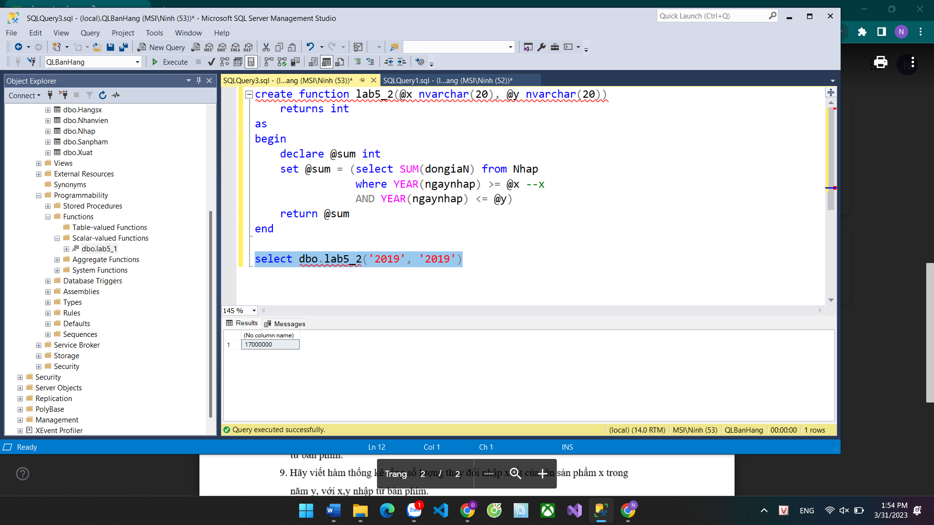

Câu 4

create function lab5_4(@x nvarchar(20), @y nvarchar(20))

returns int

as

begin

declare @sum int

set @sum = (select SUM(dongiaN) from Nhap

where ngaynhap >= @x

AND ngaynhap <= @y)

return @sum

end

select dbo.lab5_4('2020-05-17', '2020-07-04')

