Câu 1

create function lab6_1(@tenhsx nvarchar(30))

returns @Bang table(

masp nchar(10) PRIMARY KEY,

mahangsx nchar(10),

tensp nvarchar(20),

soluong INT,

mausac nvarchar(20),

giaban money,

donvitinh nchar(10),

mota nvarchar(max)

)

as

begin

insert into @Bang select Sanpham.* from Sanpham

inner join Hangsx

on Hangsx.mahangsx = Sanpham.mahangsx

where Hangsx.tenhang = @tenhsx

return

end

select * from lab6_1('OPPO')

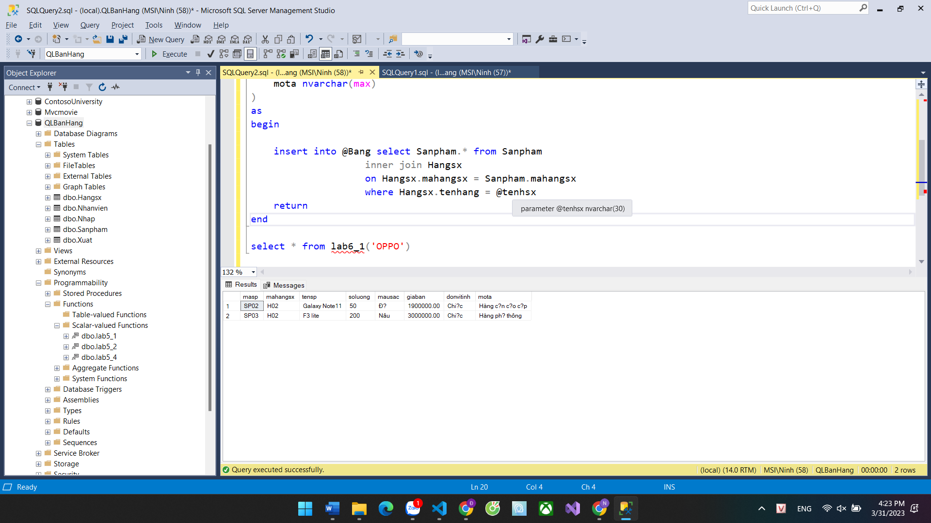

Câu 2

create function lab6_2(@x nvarchar(30), @y nvarchar(30))

returns @Bang table(

masp nchar(10) PRIMARY KEY,

mahangsx nchar(10),

tensp nvarchar(20),

soluong INT,

mausac nvarchar(20),

giaban money,

donvitinh nchar(10),

mota nvarchar(max),

tenhang nvarchar(20),

diachi nvarchar(30),

sodt nvarchar(20),

email nvarchar(30)

)

as

begin

insert into @Bang select Sanpham.*, Hangsx.tenhang, Hangsx.diachi, Hangsx.sodt, Hangsx.email from Sanpham

inner join Nhap on Sanpham.masp = Nhap.masp

inner join Hangsx on Sanpham.mahangsx = Hangsx.mahangsx

where Nhap.ngaynhap >= @x

and Nhap.ngaynhap <= @y

return

end

select * from lab6_2('2020-05-17', '2020-07-04')

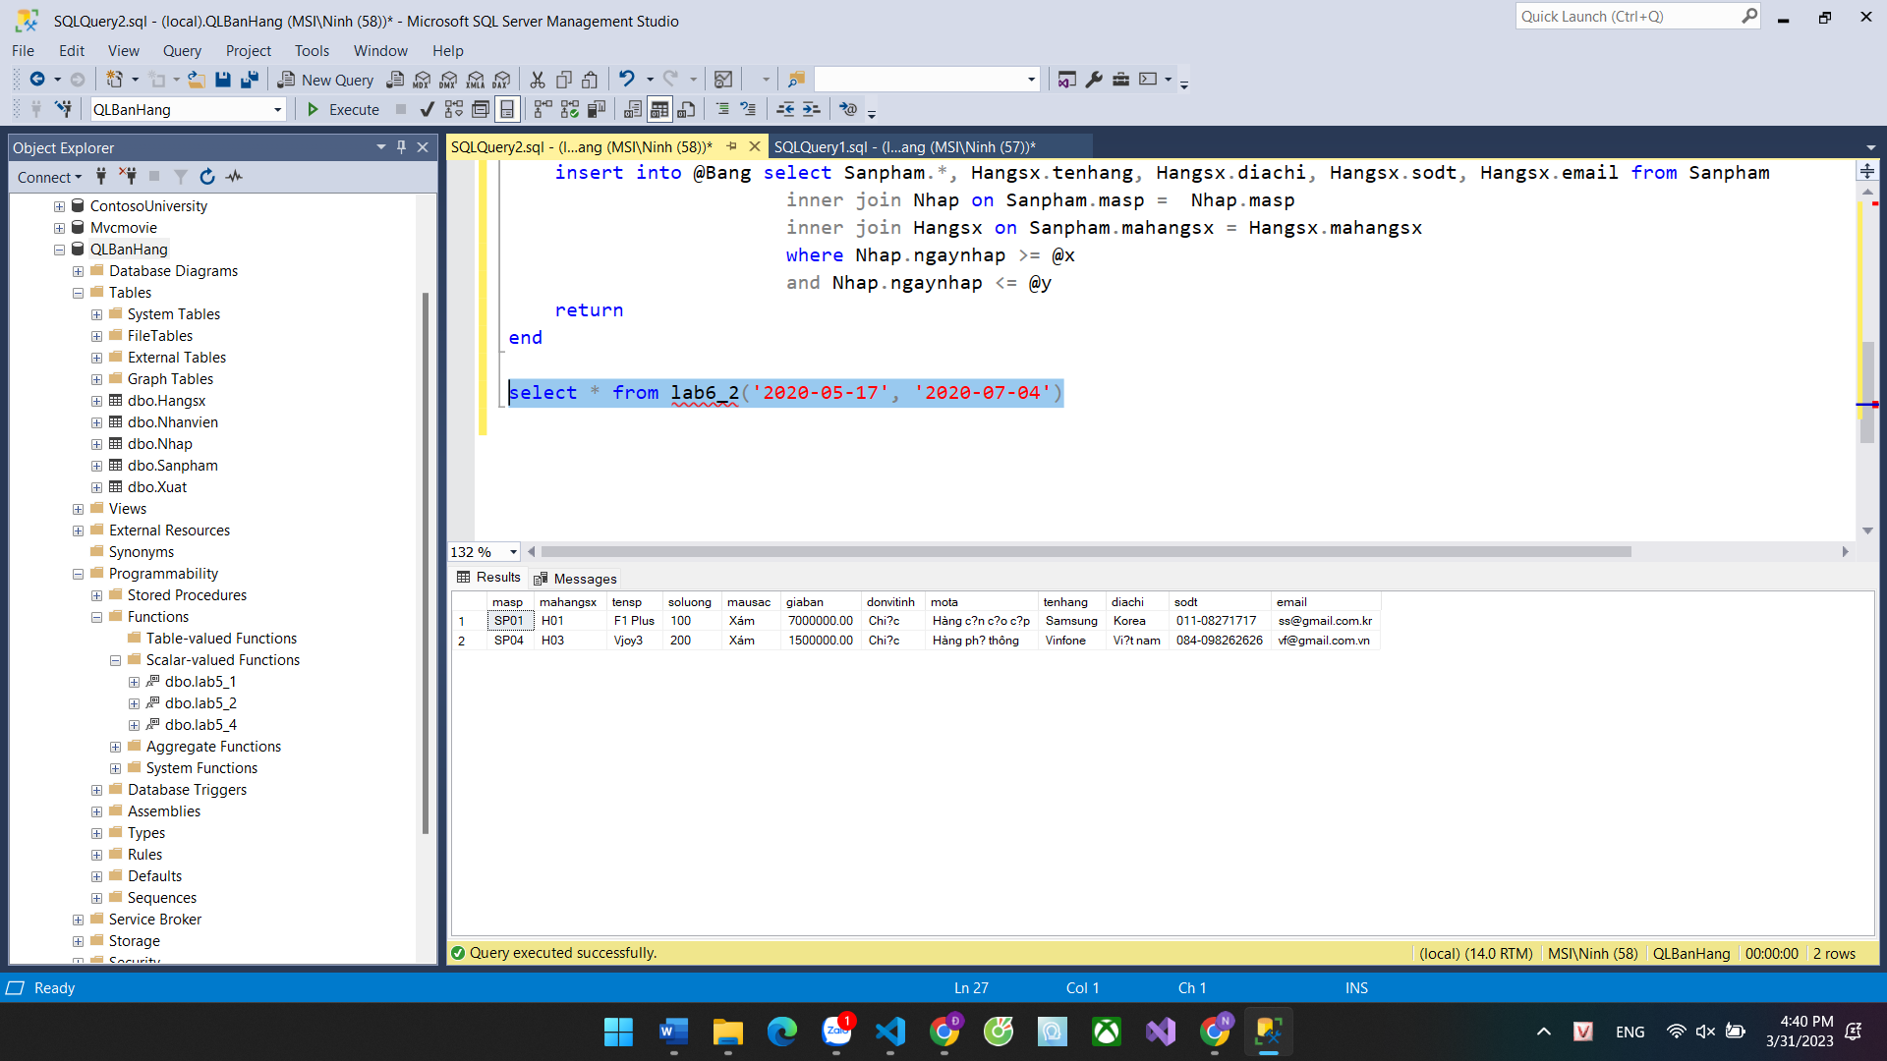

Câu 3

CREATE FUNCTION lab6_3(@tenhangsx NVARCHAR(50), @luachon INT)

RETURNS @sanpham TABLE (

masp INT,

mahangsx INT,

tensp NVARCHAR(50),

soluong INT,

mausac NVARCHAR(20),

giaban FLOAT,

donvitinh NVARCHAR(10),

mota NVARCHAR(MAX)

)

AS

BEGIN

IF @luachon = 0

BEGIN

INSERT INTO @sanpham

SELECT masp, mahangsx, tensp, soluong, mausac, giaban, donvitinh, mota

FROM Sanpham

WHERE mahangsx = (SELECT mahangsx FROM Hangsx WHERE tenhang = @tenhangsx) AND soluong = 0

END

ELSE

BEGIN

INSERT INTO @sanpham

SELECT masp, mahangsx, tensp, soluong, mausac, giaban, donvitinh, mota

FROM Sanpham

WHERE mahangsx = (SELECT mahangsx FROM Hangsx WHERE tenhang = @tenhangsx) AND soluong > 0

END

RETURN

END

select * from lab6_3('OPPO', 0)

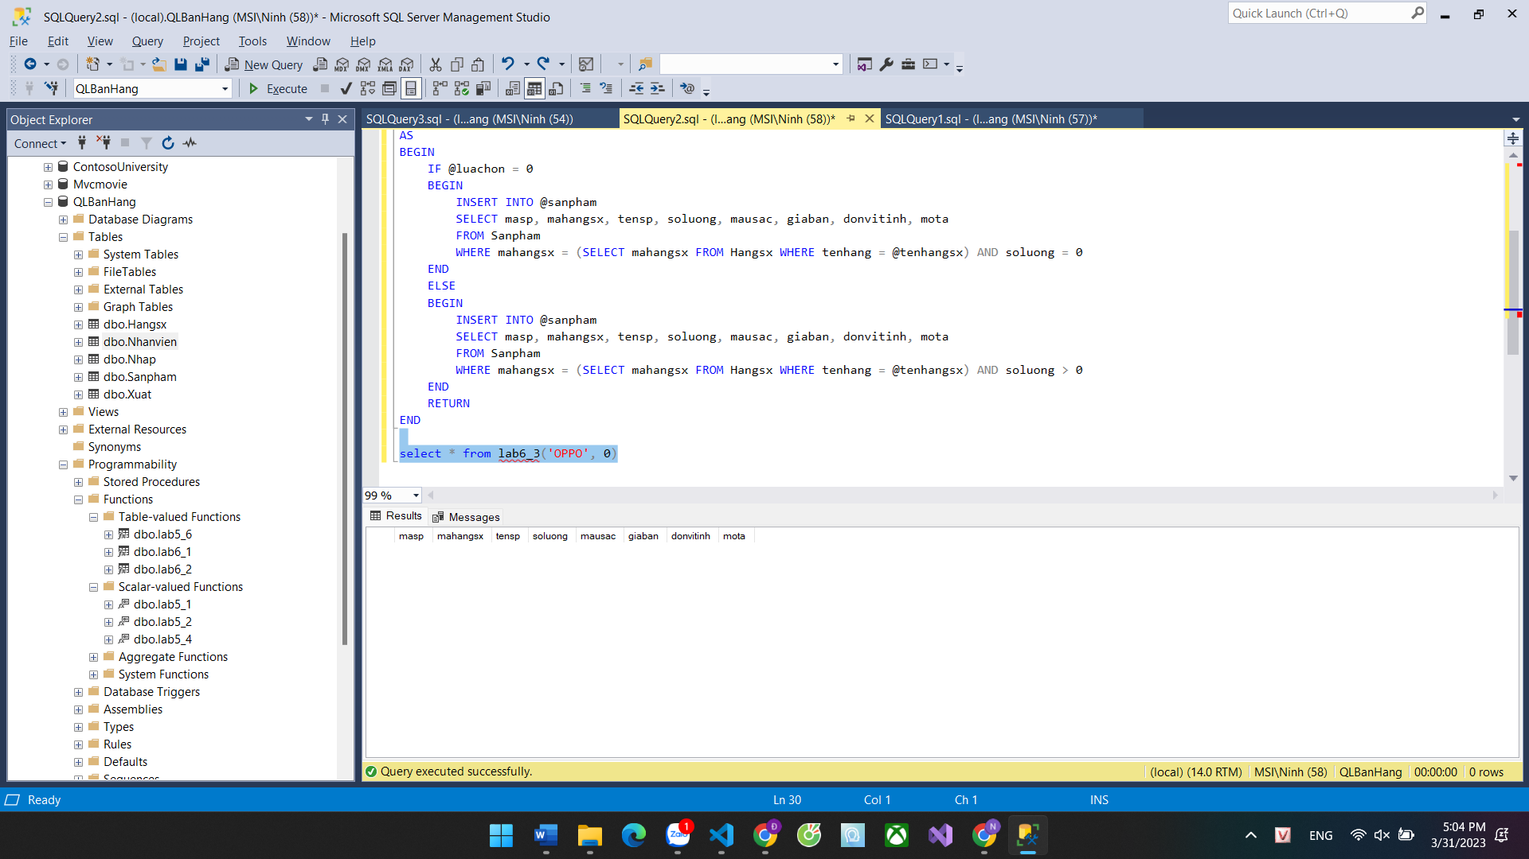

Câu 4

CREATE FUNCTION lab6_4(@tenphong NVARCHAR(50))

RETURNS @nhanvien TABLE (

manv INT,

tennv NVARCHAR(50),

gioitinh NVARCHAR(10),

diachi NVARCHAR(100),

sodt NVARCHAR(20),

email NVARCHAR(50),

phong NVARCHAR(50)

)

AS

BEGIN

INSERT INTO @nhanvien

SELECT manv, tennv, gioitinh, diachi, sodt, email, phong

FROM Nhanvien

WHERE phong = @tenphong

RETURN

END

select * from lab6_4('Kế toán')

--- câu 5---

CREATE FUNCTION DanhSachHangSXTheoDiaChi(@diaChi NVARCHAR(50))

RETURNS @hangSX TABLE (

mahangsx INT,

tenhang NVARCHAR(50),

diachi NVARCHAR(50),

sodt NVARCHAR(20),

email NVARCHAR(50)

)

AS

BEGIN

INSERT INTO @hangSX

SELECT mahangsx, tenhang, diachi, sodt, email

FROM Hangsx

WHERE diachi LIKE '%' + @diaChi + '%'

RETURN

END

---câu 6---

CREATE FUNCTION DanhSachSanPhamVaHangSXDaXuat(@namX INT, @namY INT)

RETURNS @sanPhamHangSX TABLE (

masp INT,

tensp NVARCHAR(50),

tenhang NVARCHAR(50),

ngayxuat DATE,

soluongX INT

)

AS

BEGIN

INSERT INTO @sanPhamHangSX

SELECT Sanpham.masp, Sanpham.tensp, Hangsx.tenhang, Xuat.ngayxuat, Xuat.soluongX

FROM Sanpham

JOIN Hangsx ON Sanpham.mahangsx = Hangsx.mahangsx

JOIN Xuat ON Sanpham.masp = Xuat.masp

WHERE YEAR(Xuat.ngayxuat) BETWEEN @namX AND @namY

RETURN

END

**--Câu 7—-**

CREATE FUNCTION dbo.DanhSachSanPhamTheoHangSXVaLuaChon

(

@mahangsx INT,

@luaChon INT

)

RETURNS TABLE

AS

RETURN

(

SELECT

sp.masp,

sp.tensp,

sp.soluong,

sp.giaban,

sp.donvitinh,

sp.mota

FROM

Sanpham sp

JOIN Hangsx hs ON sp.mahangsx = hs.mahangsx

LEFT JOIN Nhap n ON sp.masp = n.masp

LEFT JOIN Xuat x ON sp.masp = x.masp

WHERE

hs.mahangsx = @mahangsx

AND (@luaChon = 0 AND n.masp IS NOT NULL OR @luaChon = 1 AND x.masp IS NOT NULL)

)

**--Câu 8—**

CREATE FUNCTION dbo.DanhSachNhanVienDaNhapHang

(

@ngayNhap DATE

)

RETURNS TABLE

AS

RETURN

(

SELECT

nv.manv,

nv.tennv,

nv.gioitinh,

nv.diachi,

nv.sodt,

nv.email,

nv.phong

FROM

Nhanvien nv

JOIN Nhap n ON nv.manv = n.manv

WHERE

n.ngaynhap = @ngayNhap

)

**--Câu 9—**

CREATE FUNCTION GetProductsByPriceAndManufacturer

(

@minPrice FLOAT,

@maxPrice FLOAT,

@manufacturer VARCHAR(50)

)

RETURNS @products TABLE

(

masp VARCHAR(10),

mahangsx VARCHAR(10),

tensp NVARCHAR(50),

soluong INT,

mausac NVARCHAR(50),

giaban FLOAT,

donvitinh NVARCHAR(20),

mota NVARCHAR(MAX)

)

AS

BEGIN

INSERT INTO @products

SELECT s.masp, s.mahangsx, s.tensp, s.soluong, s.mausac, s.giaban, s.donvitinh, s.mota

FROM Sanpham s

INNER JOIN Hangsx h ON s.mahangsx = h.mahangsx

WHERE s.giaban >= @minPrice AND s.giaban <= @maxPrice AND h.tenhang = @manufacturer

RETURN

END

**--Câu 10--**