Basic Security Concepts

CIA Triad
Confidentiality – Is data accessible to those who only need to know?
- Personal Data (Name, CC information, intellectual property, health records)
Confidentiality Implementation Examples
- Encryption of hard drives, flash drives
- Encrypting data in motion (VPN)
- Access Control (Locks, too!)
- Acceptable User Policy (AUP)
- Security Awareness Policy
- Enhanced Access Control
Integrity – Is data information accurate? (Not modified)
- Maintaining valid uncorrupted, and accurate information.
  - Data is not altered
  - Data is valid
  - Data is accurate
Integrity Implementation Examples
- Hashing
- Configuration Management
- Digital Signing
- Threat Assessment and Monitoring
- Vulnerability Assessment and Management
- Asset Protection Policy
Availability – Do we have access to the data whenever it is needed?
Availability Implementation Examples
- Backups
- Load Balancing
- Failover
- RAID (Redundant Array of Disks)
- Geographically distant

Who is in control?
Confidentiality
- User
- IT administrator
- Network administrator
- Human resources
- Senior management
Integrity
- User
- IT administrator
- Network administrator
- Human resources
- Senior management
Availability
- IT administrator
- Network administrator
- Third party vendor (Such as telecommunication company)
Weakest link in security plan?
- Users/people because of below:
  - Simple passwords (password123)
  - Recycled Passwords (password spray)
  - Sharing passwords (even inadvertently)
  - Inherently Trusting (you’ve won $1 mil)
  - Tailgating, allowing physical access
  - Bypass security measures (screensaver)

Risk Management

Concepts
Event – A measurable occurrence that has an impact on the business.
Incident – Any event that violates or threatens to violate your security policy.
Control – Includes both safeguards and countermeasures.
Safeguard – Addresses gaps or weaknesses in controls that could lead to a realized threat.
Countermeasure – A targeted control, provide specific protection, put in place in response to some event or attack.
Risk Assessment – A process used to identify, assess, prioritize, and address risks on the basis of threats and vulnerabilities, before they lead to an incident. (Before something happens)
- Risks are quantified based on importance or impact severity, and then prioritized.

Risk Assessment Process
Identify threats and vulnerabilities Identify likelihood that a risk will occur Identify asset values Determine the impact of risk Determine the usefulness of a safeguard or control
Threat – Something (generally bad) that might happen.
Vulnerability – Any exposure that could allow a threat to be realized.
Risk – The likelihood that a particular threat will be realized against a specific vulnerability.
Impact – The amount of harm a threat exploiting a vulnerability can cause.

Risk Assessment Approaches
Quantitative – Attempts to describe risk in financial terms and put a dollar value on each risk.
- Financial Data Objective
Qualitative – Ranks risk based on the probability of occurrence and impact on business operations.
- Scenario-oriented Subjective

Quantitative Risk Assessment
Probability – Likelihood that a threat agent will exploit a vulnerability.
Impact – Negative result if a risk occurs
Risk Level = Probability x Impact
Probability or Likelihood – Examples below
- Malfunction of a badge reader in employee entrance, will seldom happen
- Employees calling in sick will certainly happen
Impact – Examples below
- Workstation that fails to boot up will have a minor impact on productivity.
- Production system breaking down will have a major impact.

Risk Assessment Analysis
There are always tradeoffs, such as:
Cost - Are the costs of a control justified by the reduction of the risk?
Operational Impact – Does the control have an adverse effect on system performance?
- Convenience vs. Security Tradeoff
Feasibility – Is the control technically feasible? Will the control be feasible for end-users?
- Ex. Scanning CSULB student IDs before entering class.
Detective – Controls identify that a threat has landed in your system. An intrusion detection system (IDS) is an example of a detective control.
Preventive – Controls stop threats from exploiting a vulnerability. An example would be an intrusion prevention system (IPS).
Corrective – Controls reduce the effects of a threat. Forensics and incident response are examples.
Deterrent - Controls deter an action that could result in a violation.
- Difference between Deterrent controls and preventive controls
- Merely suggest a subject should not take some action
Preventive – Controls that prevent or do not allow the action to occur.
Compensating – Controls are designed to address a threat in place of a preferred control that is too expensive or difficult to implement.

Selecting Countermeasures
- Fix known exploitable software flaws
- Develop and enforce operational procedures and access controls (data and system)
- Provide encryption capability
- Improve physical security
- Disconnect unreliable networks
Given the previous inputs (threats and vulnerabilities), the final step is to determine the level of risk.
(Risk assessment analysis) When pairing threats and vulnerabilities, risk is determined primarily by three functions:
- Likelihood
  - What is the likelihood of a threat exploiting a vulnerability?
- Impact
  - What is the impact of the organization if that threat is achieved?
- Sufficiency of Controls
  - What is the sufficiency of the controls either to eliminate or reduce the risk?

Concepts
Total Risk – Risk that exists if no security/controls were implemented.
Total Risk = Threats x Vulnerability x Asset Value**
Residual Risk = Risk that remains after all countermeasures are implemented
Residual Risk = Total Risk – Countermeasures

Responding to Risk
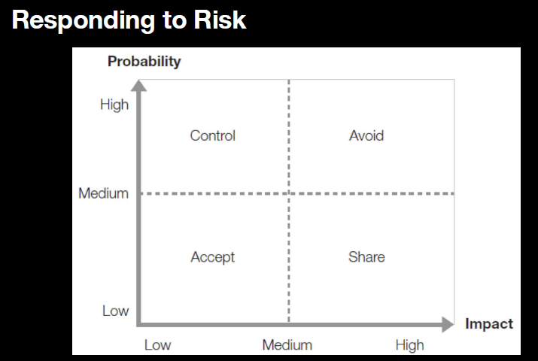

Business Continuity/Disaster Recovery
Business Continuity Plan (BCP) - Implement critical systems to functional status during major crisis (keeps business going during a disruption)
- A plan designed to help an organization continue to operate during and after a disruption.
- Covers all functions of a business (IT systems, facilities, and personnel).
- Generally, includes only mission-critical systems.
Order of Priorities
- Safety and well-being of people
- Continuity of critical business functions and operations (based on the BIA)
- Continuity of IT infrastructure components within the seven domains of an IT Infrastructure.
Disaster Recovery (DR) – Minimize the effects of disruption during major crises.
- Includes the specific steps and procedures to recover from a disruption/disaster and restore the infrastructure necessary for normal business operations.
- This is part of the Business Continuity Plan
Terms
Critical Business Function (CBF)
Maximum Acceptable Outage (MAO)
Recovery Time Objective (RTO) – Amount of time needed to recover a business process.
- Designates the amount of “real time” can pass before the disruption begins to seriously and impede the flow of normal business operations.
- How much downtime can you endure?
- RTO <= MAO/MTD
Recovery Point Objective (RPO)

Site Comparisons – Data Centers Alternatives
Hot Site - Has Environmental utilities, hardware, software, and data like original data center
Warm Site – Has environmental utilities and basic computer hardware
Cold Site - Has basic environmental utilities, but no infrastructure components
Mobile Site - Trailer with necessary environmental utilities, can operate as warm or cold site.

Complying with C.I.A
Assess Risks Business Impact Analysis Create DRP and BCP
What could happen and how can we prepare for it?
What is the maximum downtime or disruption that we are comfortable with/can sustain?
How much disruption can operations take?
How much can be put in financially?
What are the regulatory requirements?
How will the company’s reputation be affected?

Business Impact Analysis
Study that identifies the Critical Business Functions (CBF) and Maximum Acceptable Outage of a Disaster Recovery Plan.
- Studies include interviews, surveys, meetings, and so on.
- Identifies the impact to the business if one or more IT functions fails.
- Identifies the priority of different critical systems.

Cryptology

How so password checks work?
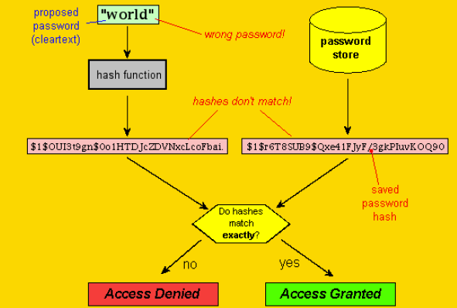
Concepts
Salt - A salt is random data that is used as an additional input to a one-way function that “hashes” a password or passphrase.
- Are closely related to the concept of nonce (Arbitrary number only used once). The primary function of salts is to defend against dictionary attacks or against its hashed equivalent, a pre-computed rainbow table attack.
- To avoid having plain-text passwords in your database, you need to store a value that has been altered in a way that will be very difficult to crack.
- The first step is to add a salt, which is a random string that is added to the password.
  - Can be prepended or appended to password and should be long to provide the best security.
- After a password is salted, it becomes hashed.
- Hashing will take the password and turn into a string of characters using an algorithm such as MD5, SHA-1, and SHA-2.
  - Hashed password can be saved in the database instead of a plain-text password.
- If two users both input the same password, the hashes stored needs to be different for the two users. The point of salt is to add “Something Unique” to each password before hashing.
- The Salt is a user-specified prefix/suffix that is added to the password before hashing.

Security Architecture
Concepts
Threat Modeling – The process of describing probable adverse effects on assets caused by specific threat sources.
- Focuses on reasonable likely threats
Attack Trees – A graph showing how individual actions by attackers can be chained together to accomplish a goal.
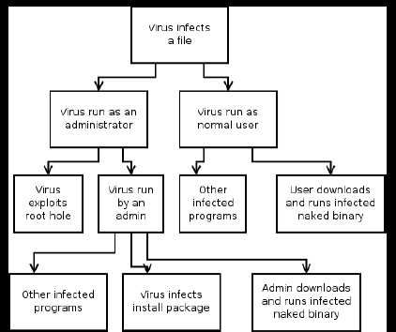
Reduction Analysis - Reduce the possible attacks in the Attack Tree
- Reduce the number of attacks to consider
- Reduce the threat posed by attacks
  - The closer to the root attack, the more the attacks in the chain are defeated.

Common Threat Modeling Frameworks
STRIDE - Developed by Microsoft in 1999 to help secure systems as they were developed
- Spoofing
- Tampering
- Repudiation
- Informational Disclosure
- Denial of Service
- Elevation of Privilege
Cyber Kill Chain – Developed by Lockheed Martin
- Reconnaissance – Select target
- Weaponization – Adapt or create malware
- Delivery – Transmit weapon to target
- Exploitation – Weapon triggers and then takes action.
- Installation – Access created, backdoor enabled
- Command and Control – Persistent access, on demand
- Actions on Objective – Goals to achieve

Secure Design Concepts
Defense in Depth – Add more layers of security to protect assets
- Endpoint protection, network protection, passwords, MFA
Zero Trust - Every entity is assumed hostile
Trust but Verify – Even if trusted, double-check
Shared Responsibility – Service provider responsible for part of security, customer another part
- Common in cloud environments
Separation of Duties – One user should not have complete control of a particular function
- Spread ownership of important duties
Principles of Least Privilege – Give the bare minimum of access that is required to complete job duties
- Limits exposure if account is compromised
Authorization Creep – Over time, users gain more privilege than needed if they move around
- Conduct periodic privilege audits to verify need
Keep it Simple – Make everything simple and check occasionally to ensure it does not get complex (Which can lead to reduced security in some areas).
Secure Defaults – Start off at a state that favors security over user friendliness
- Think of convenience vs. security tradeoff concept
Fail Security – Default manner is to behave in a predictable/non-compromising manner
- Default to highest level of security in case of a fault.

Secure Networks
TCP (Transmission Control Protocol) – Communication method between server/client. This requires confirmation.
UDP (User Datagram Protocol) – Communication method between server/client. This is stateless.
TCP and UDP are the two main protocols in the IP Suite.
Link Encryption – Encrypts all the data along a specific communication path.
- Advantages
  - All data are encrypted, including the headers
- Disadvantages
  - Key distribution and management are more complex because each hop device must receive a key.
  - Packets are decrypted at each hop
End – To – End – Encryption – Headers, addresses, routing information, trailer information are not encrypted.
- Advantages
  - Flexible use
  - Every hop does not require decryption (less points of leakage)
- Disadvantages
  - Headers/routing/addresses not protected.
- Encryption Types
  - TLS (Transport Layer Security)
    - Security Protocol that provides Confidentiality and Data Integrity
    - Uses certificates and cryptography to protect data
    - Issues
      - Downgrade attacks: Attackers allow negotiation of the type of Security Protocol to an insecure version (SSL 3.0, TLS 1.1, 1.2)
    - Noteworthy Attacks
      - 2011 Browser Exploit against SSL/TLS (B.E.A.S.T)
      - 2014 Padding Oracle on downgraded legacy encryption (P.O.O.D.L.E)
  - SSL (Secure Sockets Layer)
    - Predecessor of TLS, now considered insecure
SSL should no longer be used
TLS should be used, only 1.3 and above.

Security Architecture

DNS Attacks
Domain Generation Algorithm (DGA) – A method attackers use to help mask the actual malicious domain.
- Seems random, but predictable if you know the pattern.
DNS Tunneling – A methods used of using DNS queries to exfiltrate data (or infiltrate) into a network.
- Attack commands
DDoS (Distributed Denial of Service) – Attack on a network utilizing DNS to overwhelm network resources to take it down. Can be an amplification or reflection attack.

Secure Communications
Considerations
Some recent developments regarding communication:
- Virtual Meetings (Zoom)
  - Don’t use consumer grade tools or applications
  - Use highest available encryption for communications
  - Control access to meetings (Avoid interception)
  - Enable the waiting room (Verify before allowing)
  - Restrict sharing video screens unless needed
  - Keep software updated
  - Don’t record meetings unless business needs it
  - Know how to remove users if needed
- Messenger Platforms (Google, Teams)
- Virtual Access (VPN, Remote Desktop)
  - Remote Desktop
    - Able to connect to a single computer on demand
    - Remote Desktop Protocol (RDP) – Built into windows
    - Virtual Network Computer (VNC) – Third party program
    - Pro – Relatively easy to use
    - Con – Can be abused
    - VNC/RDP is highly recommended not to be used unless in conjunction with tightly bound Access Control List (ACL) and never over the internet
  - Virtual Desktop Infrastructure (VDI)
    - Multiple remote desktops in a centralized location
    - Citrix is an example
    - Pro – Relatively easy to maintain/control and quick isolation
    - Con – If not set up properly/securely, can be a liability
  - Secure Shell (SSH)
    - Able to remotely access systems via command line (CLI)
    - Pro – Low system overhead
    - Con – Can be abused, possible to use undetected by end user (If not observing logs)
    - As with VNC/RDP, SSH should block everyone (this is implicit deny) unless approved
- Third Party Access (Consultants/Vendors)
  - How to handle contractors/vendors in our environment?
    - Identify possible threats (threat model)
    - Limit access to job-specific (principle of least privilege)
    - Multiple layers of protection (defense in depth)
    - Force default strong security (Secure defaults)
    - If problems arise, fall back to highest level of security
    - Remember separation of duties
    - Don’t make it too complicated
    - Trust no one (everyone is hostile)
    - Keep privacy in mind (privacy by design)
    - Verify actions by third parties (trust, but verify)
    - Know who is responsible (shared responsibility)

Data Protection/Compliance
US-centric Laws/Regulations
California Consumer Privacy Act (CCPA)
- Privacy regulation protecting California-based residents
- Must be a CA resident for this to apply
Health Insurance Portability and Accountability Act (HIPAA)
- Protects health patient information from being disclosed without consent
- This is a US Federal Law
Health Information Technology for Economic and Clinical Health (HI-TECH) Act
- Aimed towards pushing providers for using electronic health records
- Better for control and portability

GDPR Details
What are important concepts of GDPR?
Protects many pieces of information
- Name
- Address
- ID Numbers
- Web Data
- Health and generic data
- Biometric data
- Racial/ethnic data
- Political opinions
- Sexual orientation
Key Ideas of GDRP for consumer
- Consent – Cannot use data without explicit permission
- Right to be Informed – Processors must tell users how data will or could be used
- Right to Restrict Processing – Can say no to processing data
- Right to be forgotten – Data must be removed/purged/deleted
- Data Breaches must be reported within 72 hours of becoming aware.

