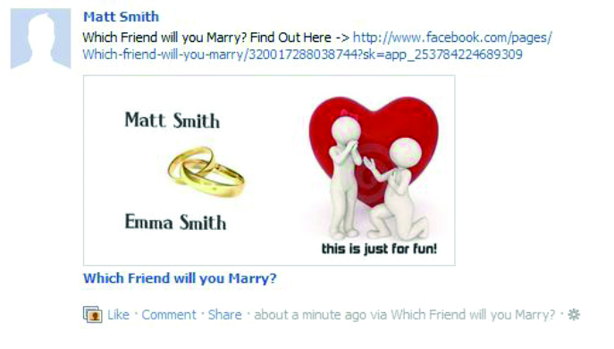

**Thanks for Purchasing!**

**Before you continue read below:**

**Although this Script is Whitehat, it can still get banned from Facebook.**

**Please read :** [**https://developers.facebook.com/docs/guides/policy/policy_checklist/english/**](https://developers.facebook.com/docs/guides/policy/policy_checklist/english/)

**I DO NOT take responsibility for Loss of or Terminated Accounts.**

**1. Create a App on Facebook Developers**

**2. Create a Page**

**3. Setup the App Settings**

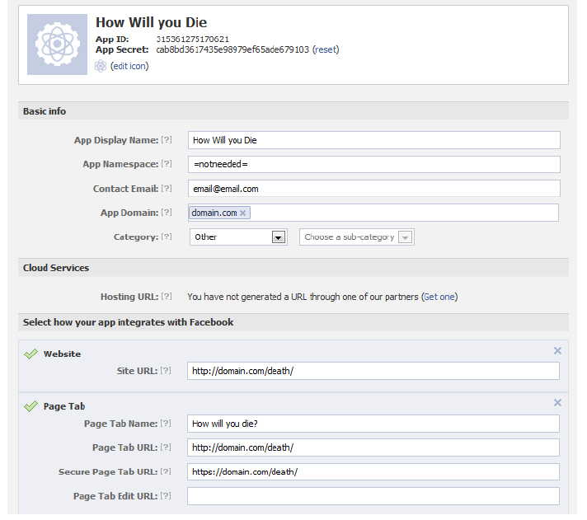

**4. Set up the URLs to where the script is hosted. App Domain is Top Level so if you hosting in a SubDomain it will still be just the domain on its own.**

**5. Open Index.php and Main.php and Put in your App ID & Secret Key aswell as the Full path to main.php on your server**

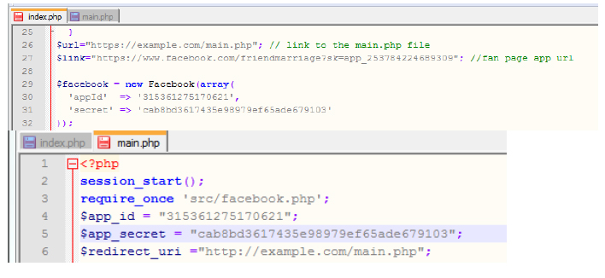

**6. Goto Advanced Settings on the app settings page.**

**7. add a link to Terms and Privacy files in advanced settings. change the text in the files as you wish.**

**8. Now open a new tab and: https://www.facebook.com/dialog/pagetab?app_id=YOUR_APP_ID&next=YOUR_URL**

**YOU_APP_ID = app ID | YOUR_URL = App Domain. (**[**http://domain.com**](http://domain.com)**)**

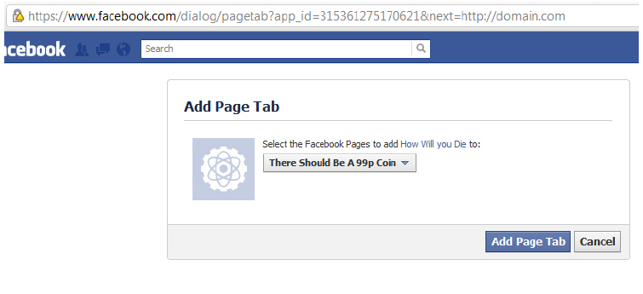

**9. Setting up Image can be a Bit complicated better to have prior knowledge of PHP GD,**

<http://www.google.co.uk/search?q=php+gd+examples>

<http://www.google.co.uk/search?q=php+gd+help>

**That should be setup and the apps Should work!**

**If you need anymore help!**

**Contact me!**