Christina Ninh

CSS 143 B

Professor Peng Du

Homework 7 Problem 3 Design

Autocomplete Goal:

Given a set of words [“hello”, “high”, “seattle”, “seatac”, “see”, “hollow”, “how”];

* When you input “h”, it’ll produce [“hello”, “high”, “hollow”, “how”]
* When you input “se”, it’ll produce [“seattle”, “see”]
* When you input “sea”, it’ll produce [“seattle”, “seatac”]
* When you input “ho”, it’ll produce [“how”]
* When you input “xyz”, it’ll produce []

Design:

Similarly to homework 6, the text search engine that can search a single word or phrase from the given texts. The autocomplete will work in a way where the first letters of the word will produce the result. Storing the set of words in a place, and using the autocomplete to figure out what words have the first letters we are looking for.

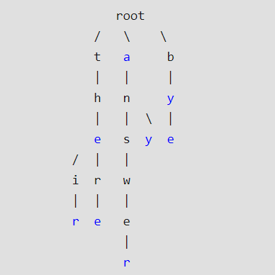

* A TrieNode would be used in this situation because it can store each character in a binary search tree, and N is the number of keys in the tree. When using a TrieNode it takes up O(M) time when searching for the key. However, the Trie has storage requirements that will take up some time.
* Every character of the input key is inserted as an individual Trie node, and that allows us to search for the word we are looking for when it individually goes through each character in the tree.
* There should be tests to test for one character, two characters, or three characters, or if the key isn’t in the set of words.