Task 1

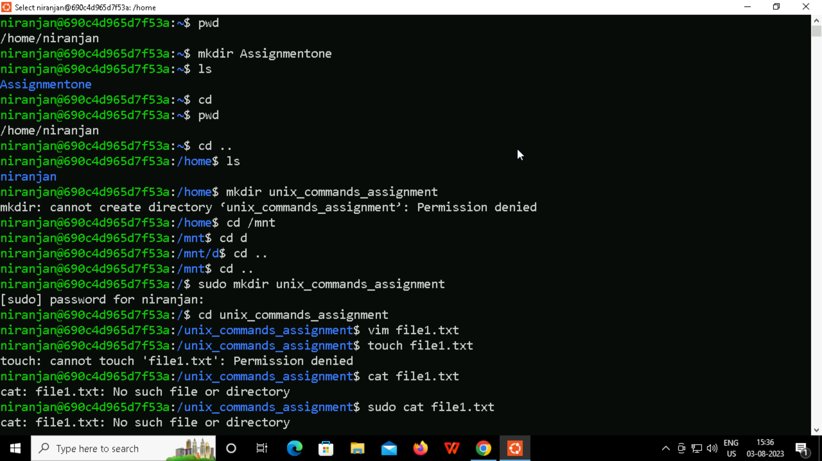

Task 2



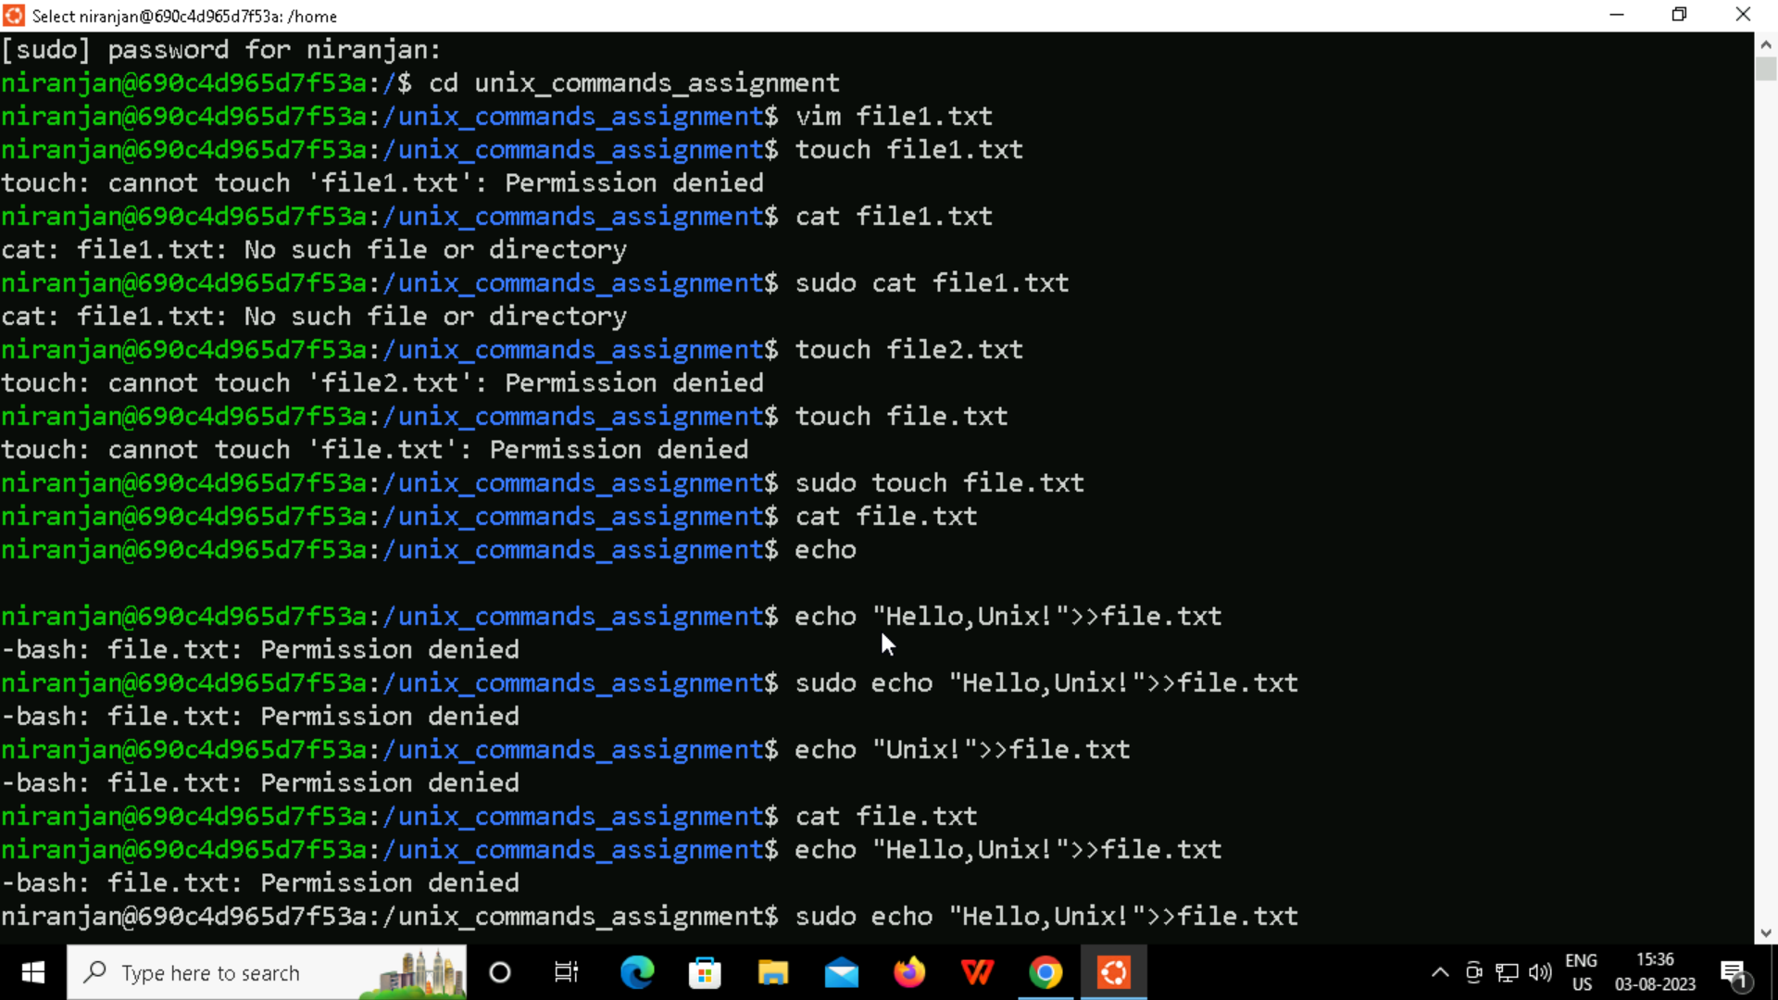

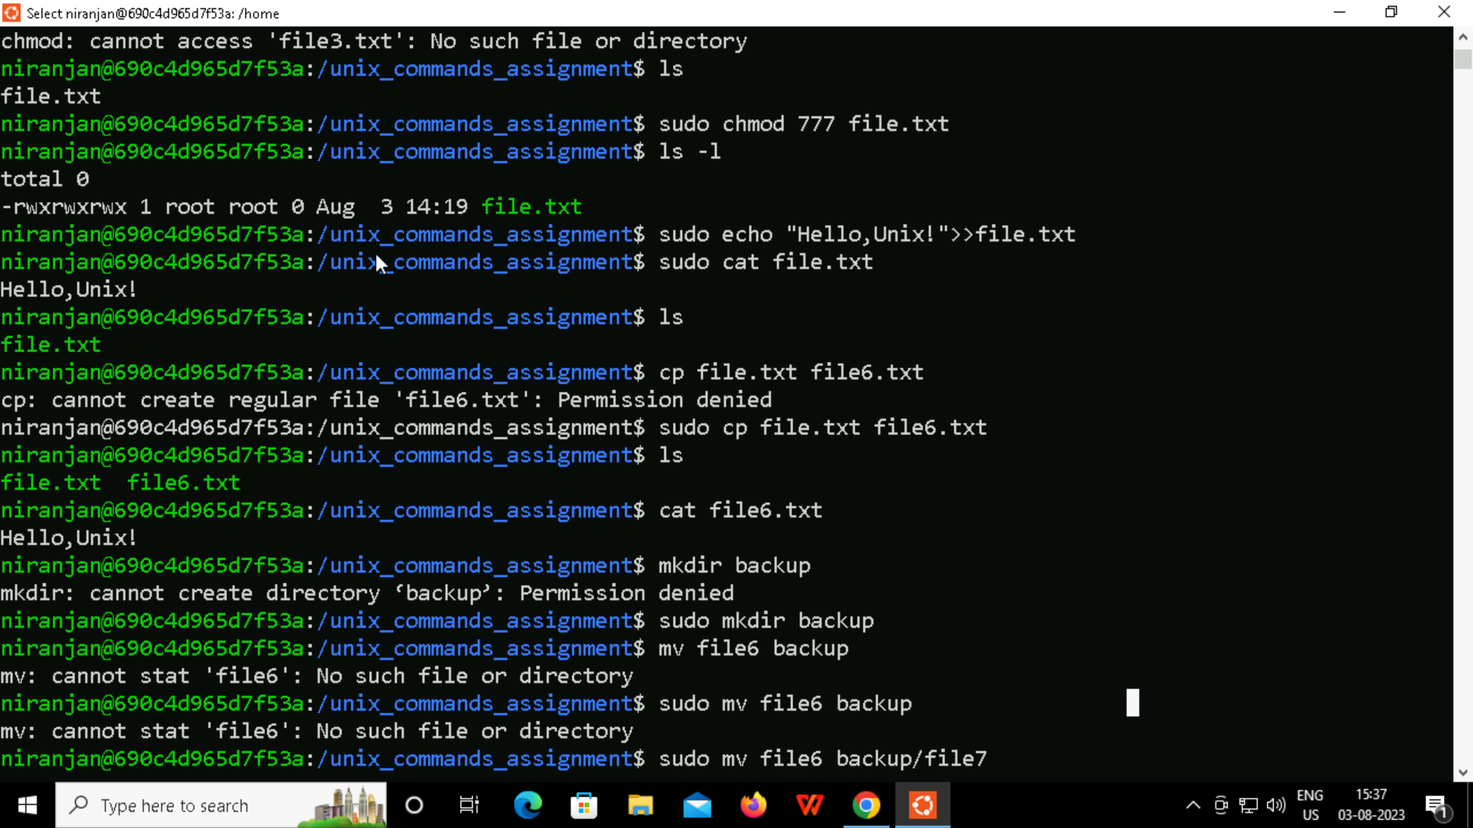



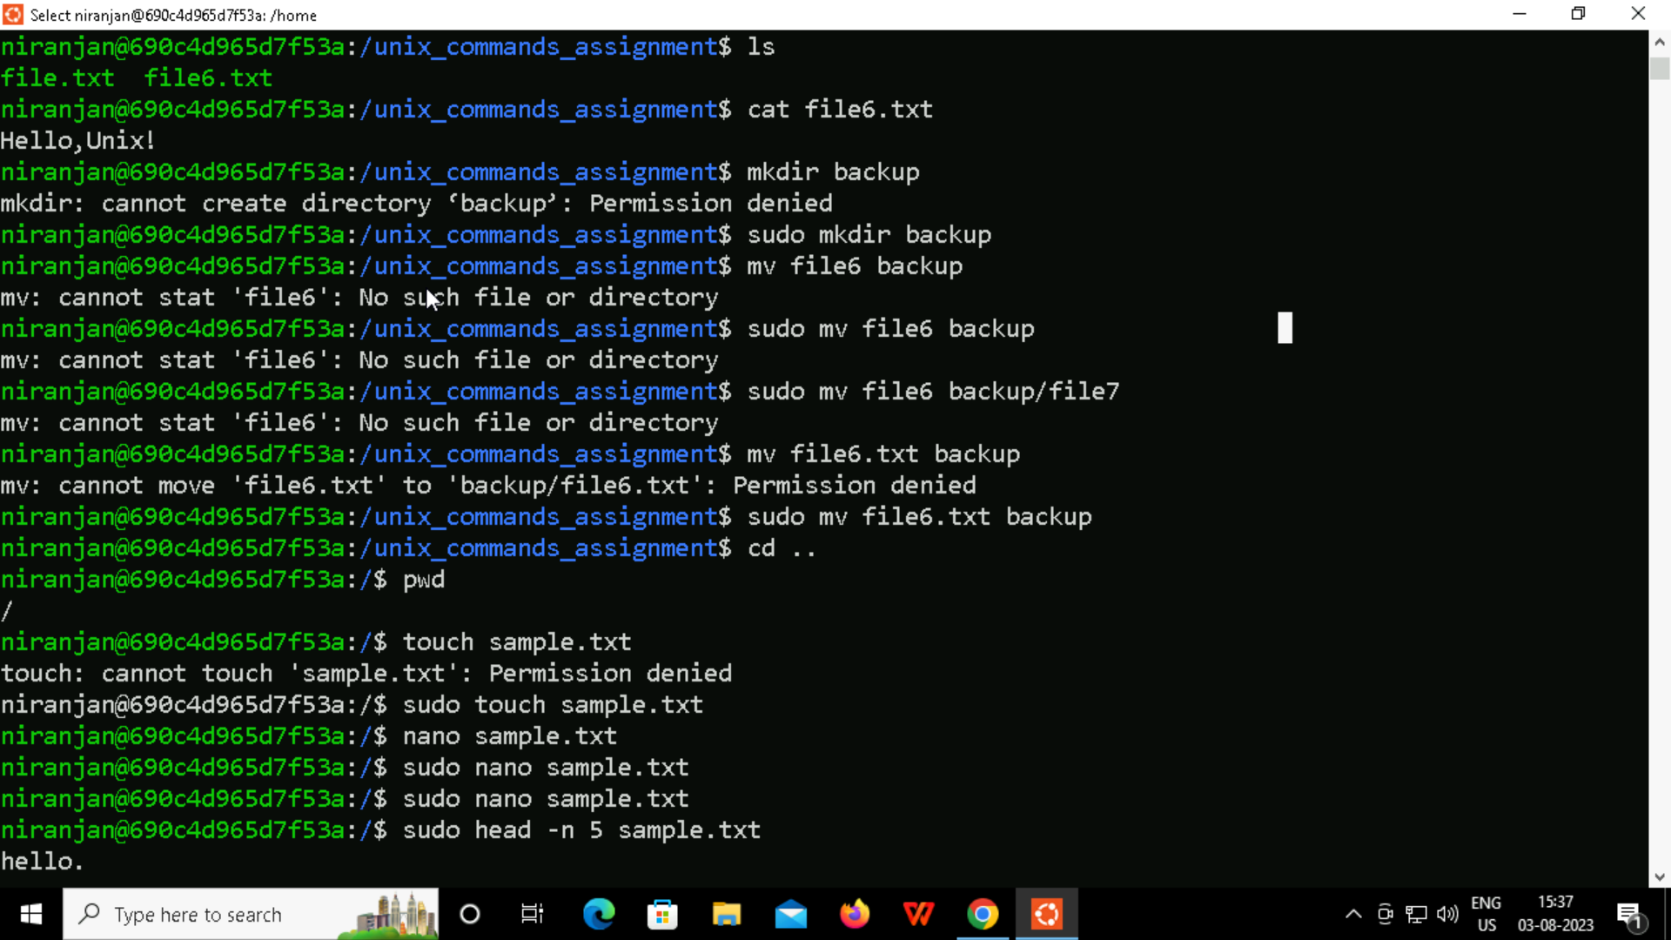

Task 3

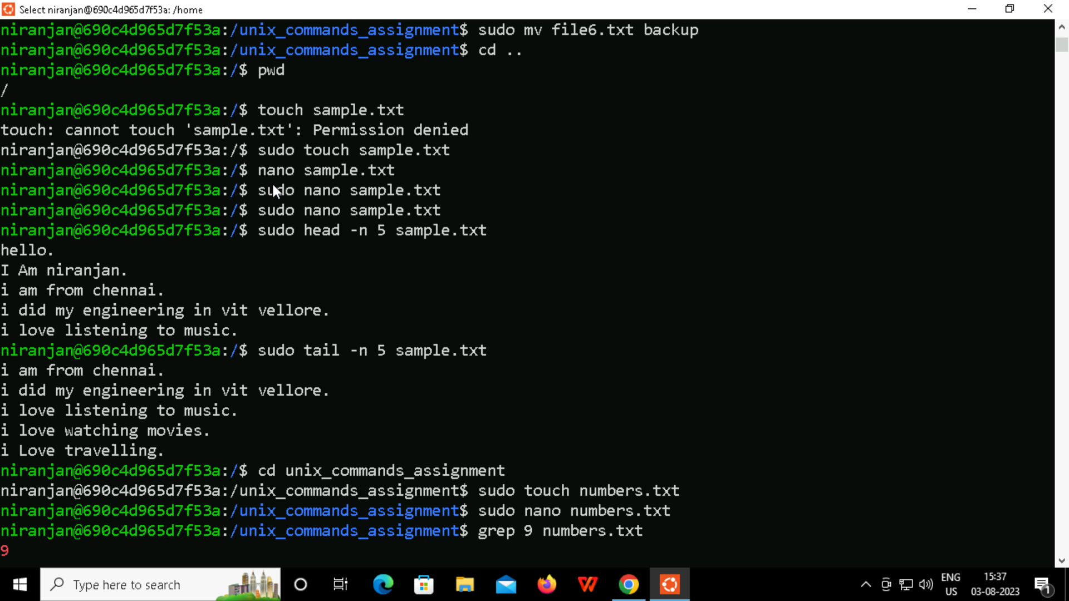

Task 4



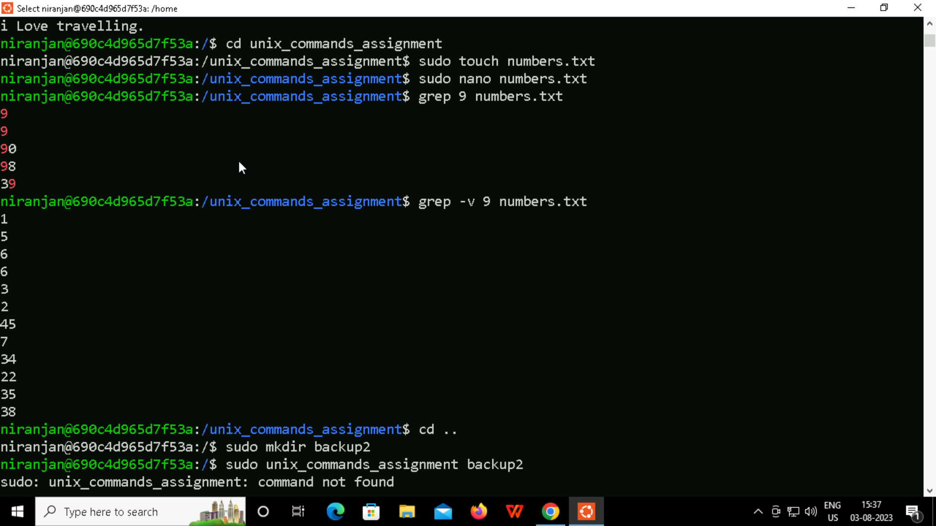

Task 5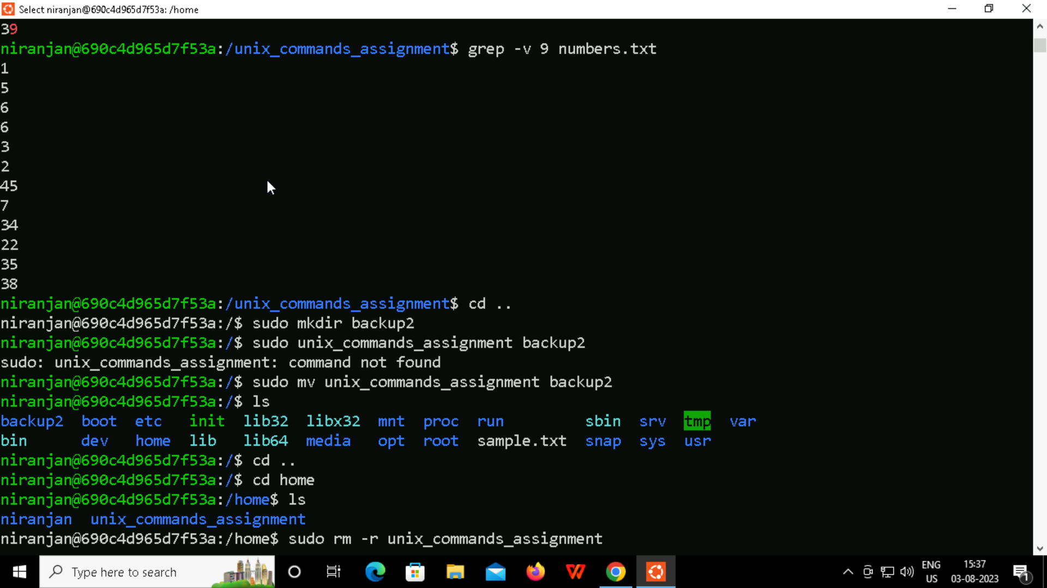

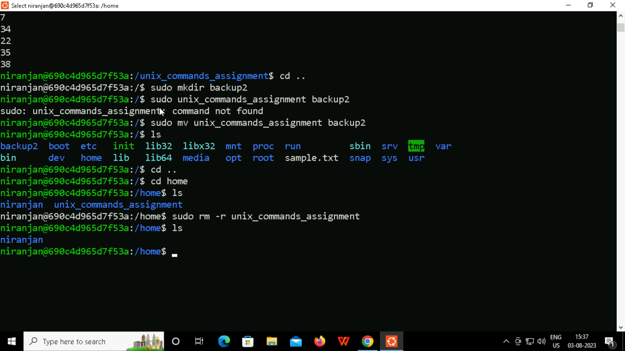

Summary:

Learnt about basic linux commands and how to create file using command and how to perform file operations like copying the content from one file to another, print the first “n” number of lines etc..

Learnt about permissions and access control.

Learnt about how to create directory and move files/delete/update/write in them.

The explanations given by the tutor were crispy and clear and to the point and was easier to understand.