* Title: Mafia Game
* Who:
  + Camille Owens: caow7208
  + Soo Park: soorin1993
  + Jake Mitchell: jakeMitchell1419
  + Alex Sheehan: ninjaalex888
  + Qi Pei: qipe3398
* Project Tracker: <https://connect.goalscape.com/#/goal/2E636749-BFF6-EEA4-EB20-296D941A3BE>
* Project Tracker Report Export: [link to report.pdf on github]

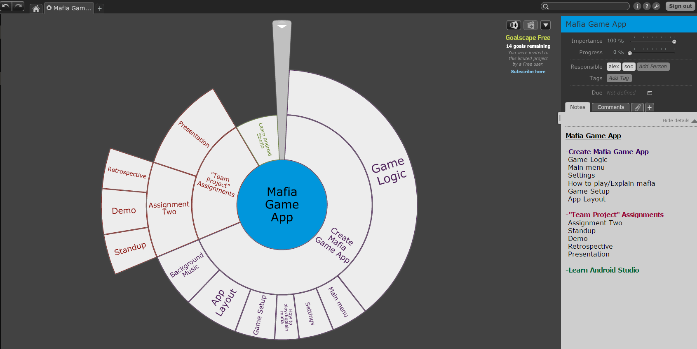

* (Optional) Video: 5 minute or less video demonstrating your project. Your audience is a potential customer or person interested in using your product.
* VCS: https://github.com/soorin1993/mafiagame
  + Project Part 5 document named ProjectTitle_Part6.pdf
* Screenshot of each member’s contributions throughout the semester from GitHub: e.g.,
* Deployment: Link to deployment environment or explain how to access/run.
* Auto-doc: The purpose is to run an auto-documenter on your code base. While Doxygen is very common (and Javadoc is used for Java), you may need (or want) to use another documenter. Make sure you choose a documenter that produces a PDF file or an HTML website.
  + - List which program you did
    - Link to GitHub where the auto-generated docs are