Analyze International Debt Statistics

Wireframe Documentation

Homepage

As per the instructions we have created the visualizations required.

This is the dashboard created for analyzing the international debt statistics.

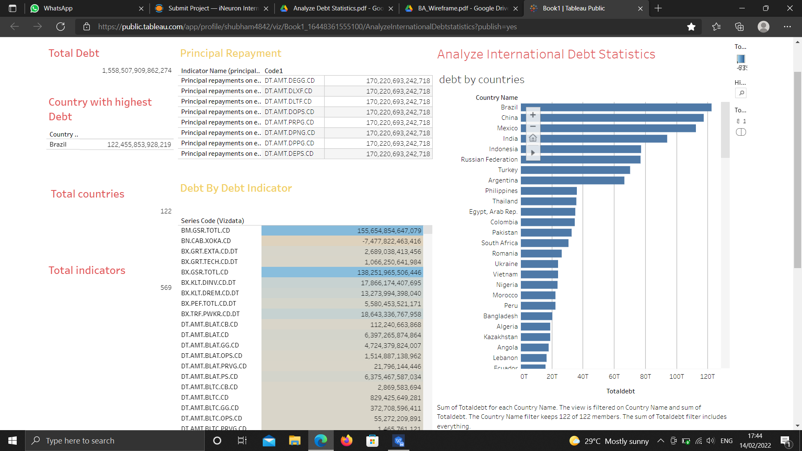

The dashboard consist of the following worksheets.

1 The total debt of world bank

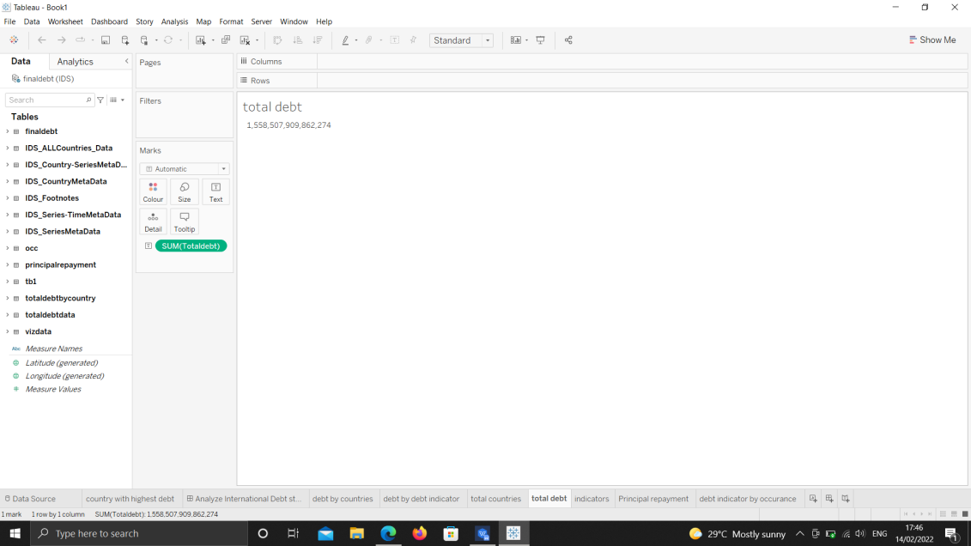

2 Total Number of Countries

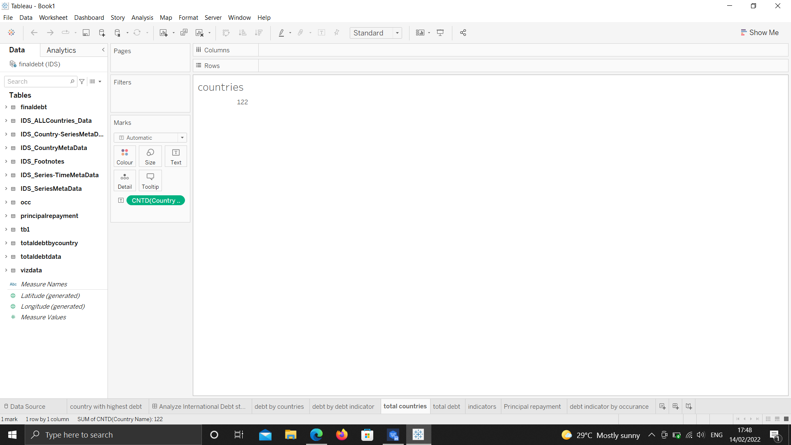

3 Total Number of debt Indicators .



4 The country with the highes debt

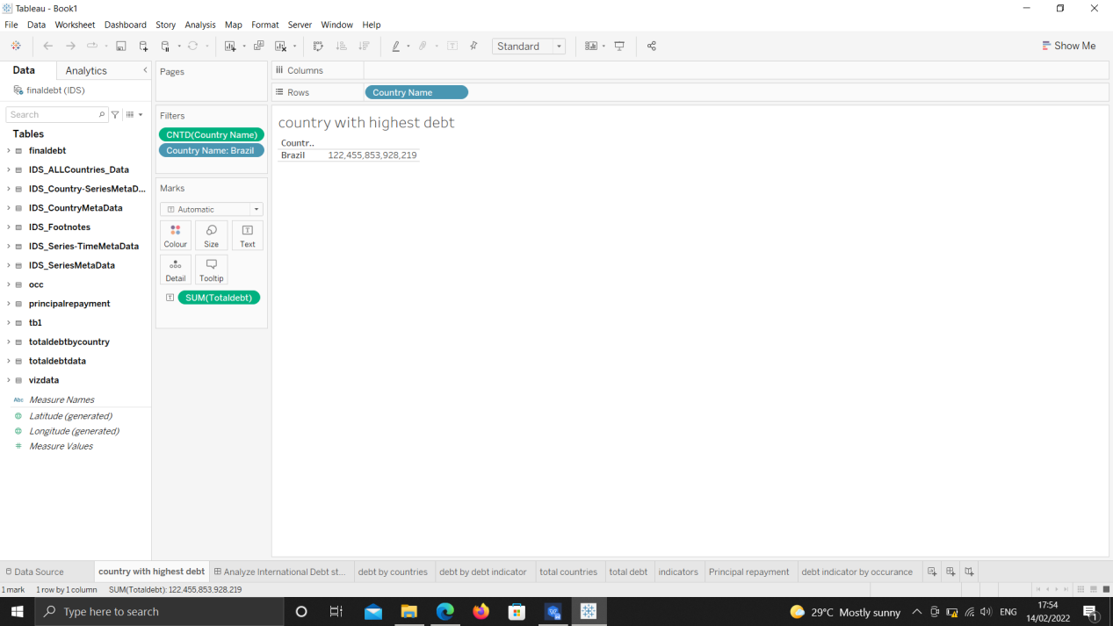

5 Total debt by countries

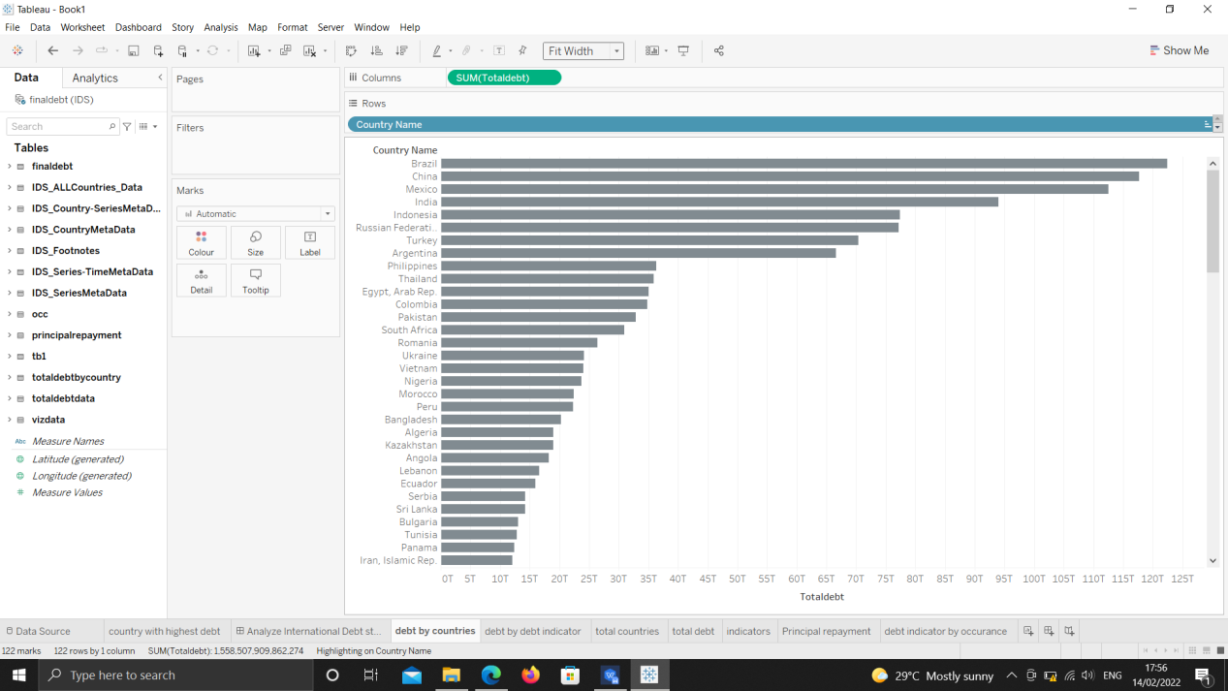

6 Average debt across the indicators.

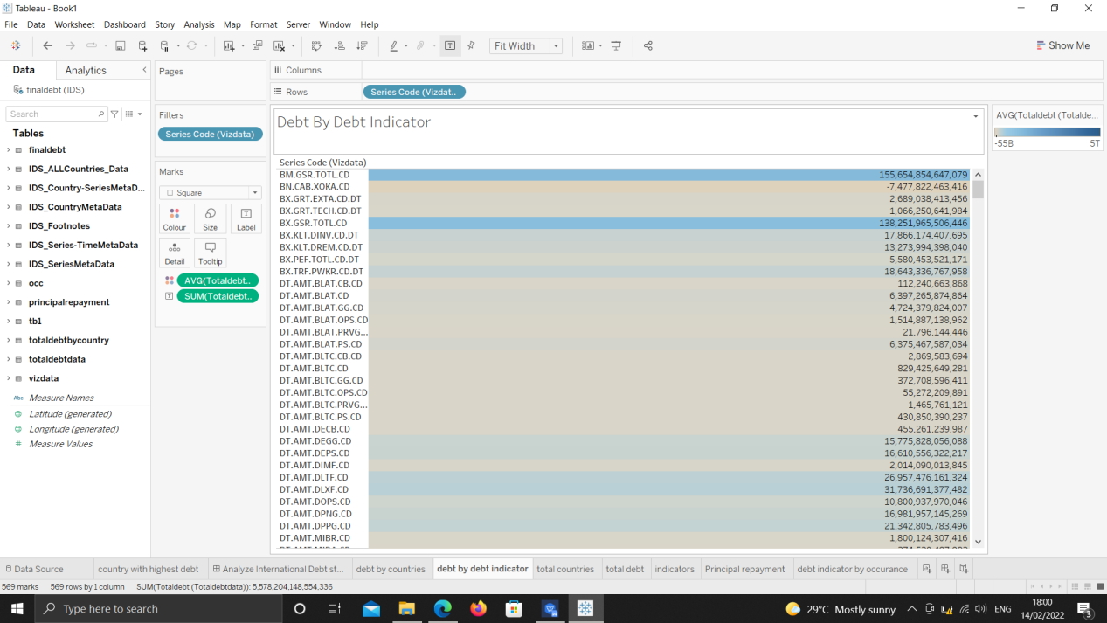

7 The Principal repayment debt indicator

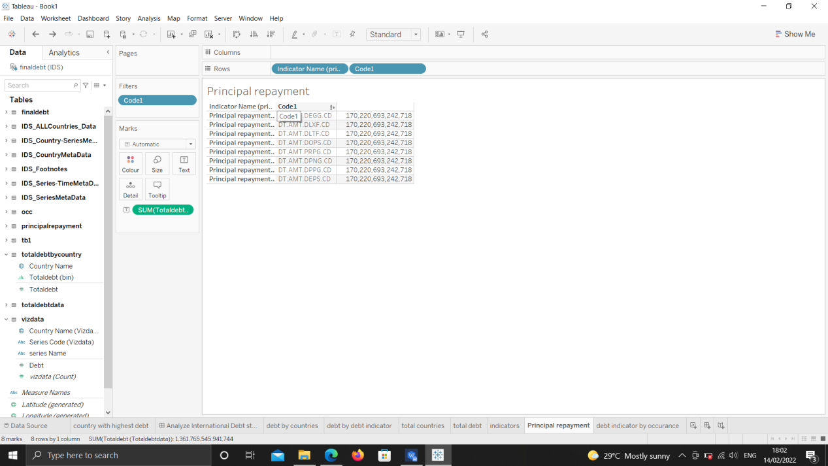

8 The number of debt indicator occurance

