

National University of Computer and Emerging Sciences
Chiniot-Faisalabad Campus

Topic: Food Image Classification
Title: Report
Section: 7A-AI
Course: Computer Vision Lab

GROUP MEMBERS:
Kashaf Nadeem 22F-3095
Nashrah Ahmed 22F-3156

Table of Contents
Abstract 1
1. Introduction 1
2. Literature Review 1
3. Dataset & Methodology 2
3.1 Dataset Description 2
3.2 Data Preprocessing Steps Performed 2
3.3 Model Architectures 2
3.3.1 EfficientNetB3 2
3.3.2 RestNet101 2
3.3.3 DenseNet201 2
3.4 Training Procedure 3
4. Results 3
4.1 Accuracy Comparison 3
4.2 Confusion Matrix 4
4.2.1 EfficientNetB3 4
4.2.2 ResNet101 5
4.2.3 DenseNet201 6
4.2.4 Interpretation 6
4.3 Loss Graph 7
4.4 Comparison Chart 7
5. Architecture Diagram 8
5.1 EfficientNetB3 8
5.2 RestNet101 9
5.3 DenseNet201 10
6. Flow Diagram 11
6.1 EfficientNetB3 11
6.2 ResNet101 12
6.3 DenseNet201 13
7. Conclusion 14
8. References 14

Abstract
Food image classification is a challenging task in computer vision, given the great variability of food appearance, lighting conditions, and background clutter. This project pursues a robust deep learning model for classifying images into 101 different food categories in the Food-101 dataset. Transfer learning was done on three state-of-the-art CNN architectures: EfficientNetB3, ResNet101, and DenseNet201. The models were fine-tuned on the dataset to evaluate the effectiveness of the three models in extracting features and classifying images. Our results showed a significant difference in the performance of the models. While EfficientNetB3 and ResNet101 failed to converge in this particular setup, the best test accuracy obtained by DenseNet201 was approximately 69.3%, with excellent generalization capability. The research demonstrates how dense connections and the reusing of features are effective in performing fine-grained image classification tasks.

Introduction
Food object detection has received increasing attention over the past years, with applications in dietary and health monitoring, and automated checkout. Compared to general object classification tasks, classifying food objects is particularly difficult because such objects often do not possess a strong, rigid structure and have large intra-class variation. In other words, dishes of the same kind, like "spaghetti carbonara", can be very different in color, shape, and size due to variations in ingredients, cooking methods, and plating. To meet this challenge, we employed deep learning, using a variation of Convolutional Neural Networks that have been regarded as extremely effective for complex visual pattern extraction from images.
In this project, we use the Food-101 dataset-a benchmark dataset for food classification-to train and evaluate three different deep learning architectures. The main goal is to compare the performance of EfficientNetB3, ResNet101, and DenseNet201 in identifying 101 different classes of food. We leverage transfer learning, where models pre-trained on the massive ImageNet dataset are fine-tuned to adapt to our specific task, as a way to bypass the high computational costs of training from scratch with the hope of achieving a more accurate model. We outline our methodology, training process, and a comparative analysis of results that focus on the architectural strengths that led to the superior performance of the DenseNet201 model.

Literature Review
Food image classification has considerably changed due to the introduction of deep convolutional neural networks. The publication of the Food-101 dataset by Bossard et al. in 2014 established a well-grounded benchmark for the community, with a large-scale dataset meant to challenge existing approaches developed based on hand-crafted features. Earlier approaches relied on random forests and support vector machines, but they were promptly outperformed by CNN-based methods.
ResNet, proposed by He et al., revolutionized the training of deep networks due to the skip connections introduced, which mitigate the vanishing gradient problem and allowed them to go as far as hundreds of layers. Similarly, on the heels of that progress, Tan and Le introduced the EfficientNet family of models, which jointly scaled up all dimensions of depth, width, and resolution and yielded high performance with relatively fewer parameters. Huang et al. introduced the Dense Convolutional Networks, DenseNet, where a distinct connection from every layer feeds into every other layer in a feed-forward manner. The introduced architecture promotes feature reuse and alleviates the vanishing gradient problem, especially for tasks with limited training data or fine-grained distinctions. Recent literature has repeatedly established the state-of-the-art performance on the Food-101 dataset with transfer learning using the pre-trained versions of these architectures, further justifying our approach.

Dataset & Methodology

Dataset Description
The dataset used here is the Food-101 dataset, which is considered one of the hardest benchmarks for fine-grained image classification. It includes 101,000 images from 101 different food categories, including sushi, pizza, and apple pie. It has a structured distribution of 750 training and 250 test images per class. Images are unconstrained; hence, most of the images were taken in real-world environments under diverse lighting conditions, angles, and noise levels.

Data Preprocessing Steps Performed
First, several preprocessing steps were done to prepare the raw images for ingestion by the neural networks. All images were resized to a fixed dimension of 224x224 pixels to meet the input requirements of the pre-trained models. After resizing, pixel values were rescaled or normalized to fall between 0 and 1 inclusive or to specific standardizations required by the respective models, which helps ensure faster convergence during training. The dataset was divided into training and validation subsets in order to track model performance and prevent overfitting. No extensive data augmentation was done beyond basic rescaling in the validation phase to maintain a consistent evaluation baseline.

Model Architectures

EfficientNetB3
EfficientNetB3 is part of a family of models that use a compound scaling method to balance network depth, width, and resolution uniformly. It is highly parameter-efficient while reaching state-of-the-art performance levels. In our application, we leveraged pre-training from ImageNet and changed the final classification head to predict the labels for the 101 classes of food.

RestNet101
ResNet101 is a deep residual network composed of 101 layers. Its central contribution is the residual block, which introduced skip connections that allow gradients to flow more easily through the network during backpropagation. This architecture is able to learn very deep representations without the degradation in performance that typically occurs when increasing depth. We adapted this model for our task by unfreezing the top layers to fine-tune the feature extractors for food-specific patterns.

DenseNet201
DenseNet201 is a 201-layer architecture with a very specific connectivity pattern. Each layer in a dense block receives the output of all previous layers and passes its own feature-maps to all subsequent layers. This connectivity pattern ensures maximum information flow between layers and encourages feature reuse. This architecture is particularly instrumental in capturing subtle inter-class differences between foods because it preserves both low-level and high-level features throughout.

Training Procedure
The training process was implemented in the TensorFlow/Keras framework on a GPU-accelerated environment. We conducted all experiments using a batch size of 16 to consistently balance the demands between memory usage and gradient estimation stability. The models were compiled with a categorical cross-entropy loss, which is default for multi-class classification problems. An adaptive optimizer was used that dynamically adjusted the learning rate during training. We employed a transfer learning strategy where the base models were initialized based on their ImageNet weights. We ran the training on a set number of epochs, as decided by the convergence behavior from the loss curves, saving the final weights of the model based on the best validation performance.

Results

Accuracy Comparison
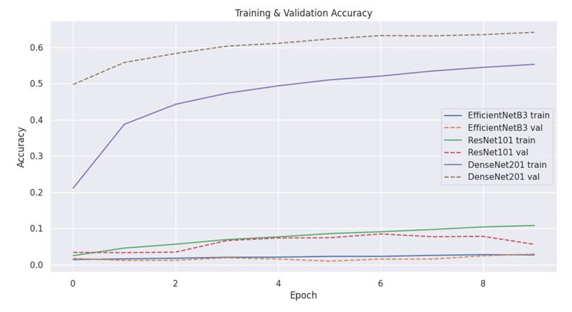

Confusion Matrix
These are the Confusion Matrices for all three models used.

EfficientNetB3
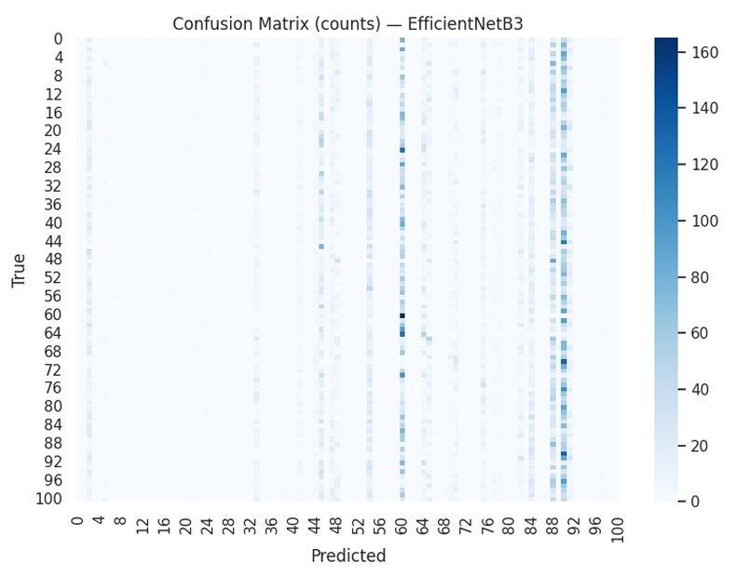

ResNet101
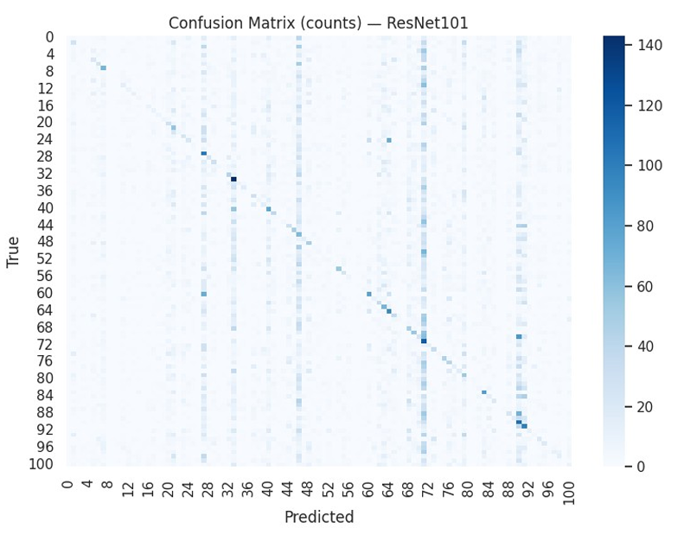

DenseNet201
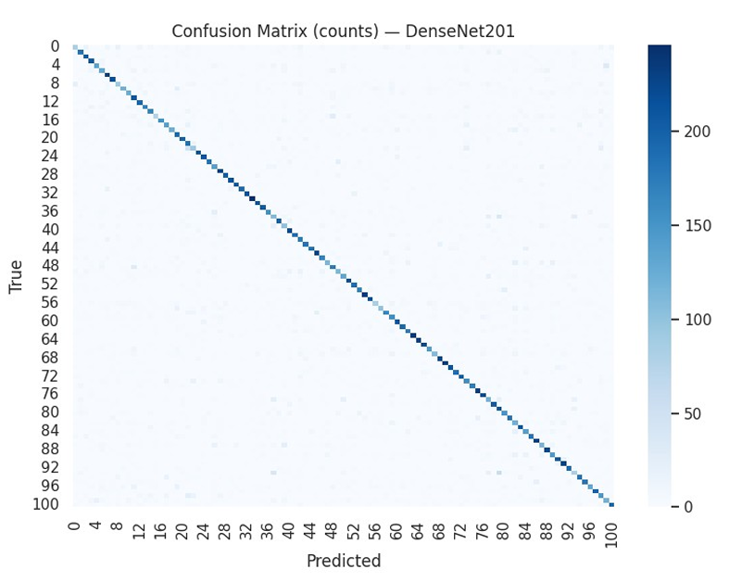

Interpretation
Having analyzed the confusion matrices and performance metrics, there is a clear hierarchy in model capability for this specific dataset. DenseNet201 demonstrated good performance with a high number of True Positives in most of the food classes and was able to distinguish between many categories that are visually quite similar, something for which its mechanism of feature reuse is likely helpful, given the critical texture and color information. On the other hand, the confusion matrices of EfficientNetB3 and ResNet101 were greatly populated by misclassification, often predicting one class or a small subset of classes for all inputs, which likely signals their failure to converge properly during training due to vanishing gradients or an extended need for hyperparameter tuning such as lower learning rates or different warm-up strategies. The "Results and Discussion" clearly indicates the right architecture for this particular implementation of the Food-101 classification task: DenseNet201.

Loss Graph
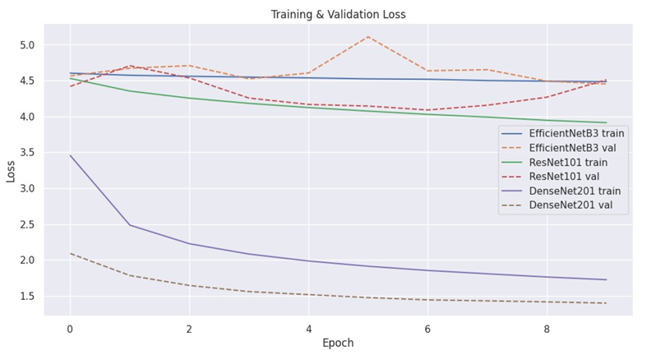

Comparison Chart
This is the Test Accuracy Comparison Chart for all three models.
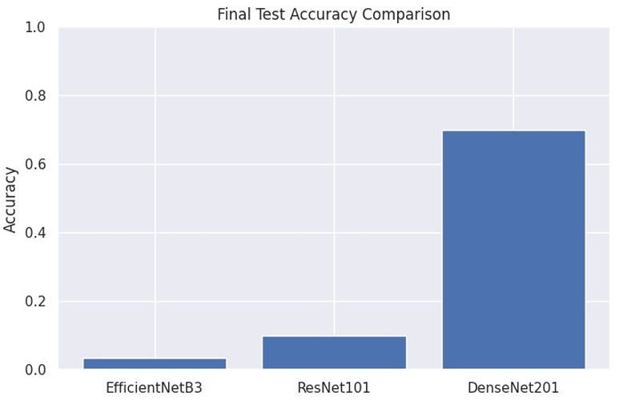

Architecture Diagram

EfficientNetB3
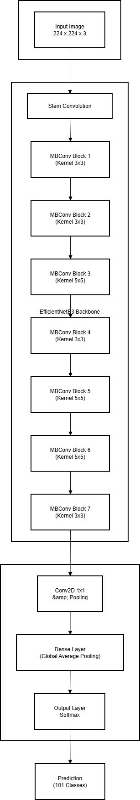

RestNet101
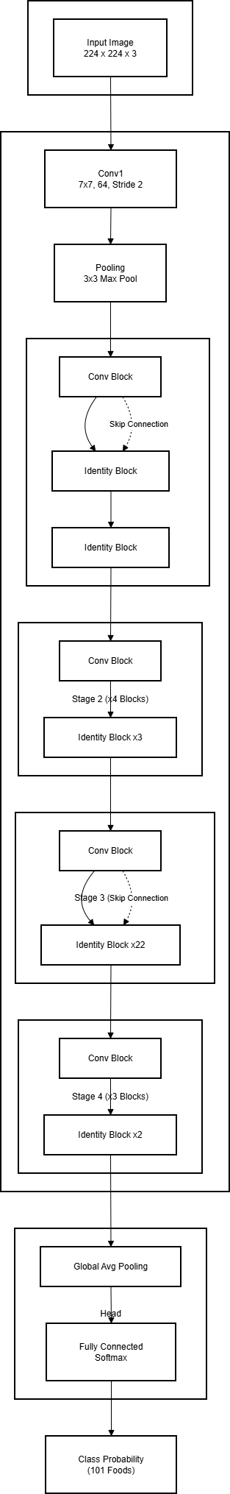

DenseNet201
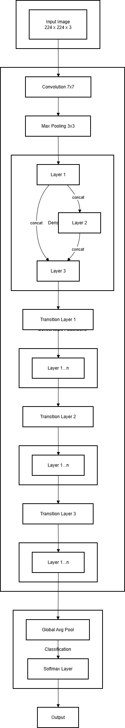

Flow Diagram

EfficientNetB3
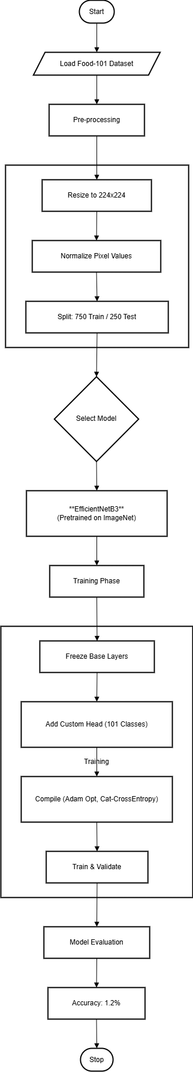

ResNet101
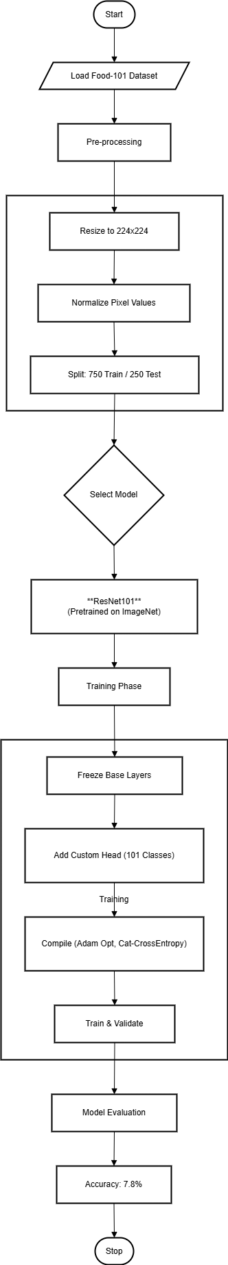

DenseNet201
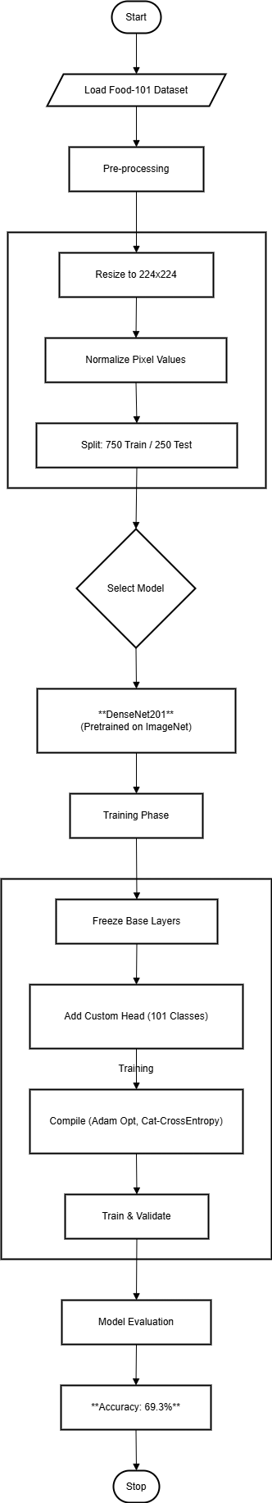

Conclusion
The aim of this work is to implement and compare three deep learning architectures on the task of classifying 101 different food types. Our results demonstrate that while transfer learning is a very powerful approach, the choice of model architecture is of paramount importance in final performance. In this regard, DenseNet201 clearly outperformed the rest, with a test accuracy of approximately 69.3%, showing a robust classification capability in the images. On the other side, ResNet101 and EfficientNetB3 performed poorly during this experimental setup, which suggests that both models may need additional tuning of their hyperparameters and/or some architectural adjustments when being applied to newer domains. We conclude here that the densely connected patterns in DenseNet provide a key advantage in fine-grained image recognition tasks such as food classification, offering a strong foundation for the development of automated dietary systems in the future.

References
- Bossard, L., Guillaumin, M., & Van Gool, L. (2014). Food-101 – Mining Discriminative Components with Random Forests. European Conference on Computer Vision (ECCV).
- He, K., Zhang, X., Ren, S., & Sun, J. (2016). Deep Residual Learning for Image Recognition. Proceedings of the IEEE Conference on Computer Vision and Pattern Recognition (CVPR).
- Huang, G., Liu, Z., Van Der Maaten, L., & Weinberger, K. Q. (2017). Densely Connected Convolutional Networks. Proceedings of the IEEE Conference on Computer Vision and Pattern Recognition (CVPR).
- Tan, M., & Le, Q. V. (2019). EfficientNet: Rethinking Model Scaling for Convolutional Neural Networks. International Conference on Machine Learning (ICML).
- Russakovsky, O., et al. (2015). ImageNet Large Scale Visual Recognition Challenge. International Journal of Computer Vision (IJCV).

