LAB 3

CREATE DATABASE company_db;
Result :create database

Connect:

\c company_db

Create Tables:

CREATE TABLE departments (

dept_id SERIAL PRIMARY KEY,

dept_name VARCHAR(100)

);



Result: already created
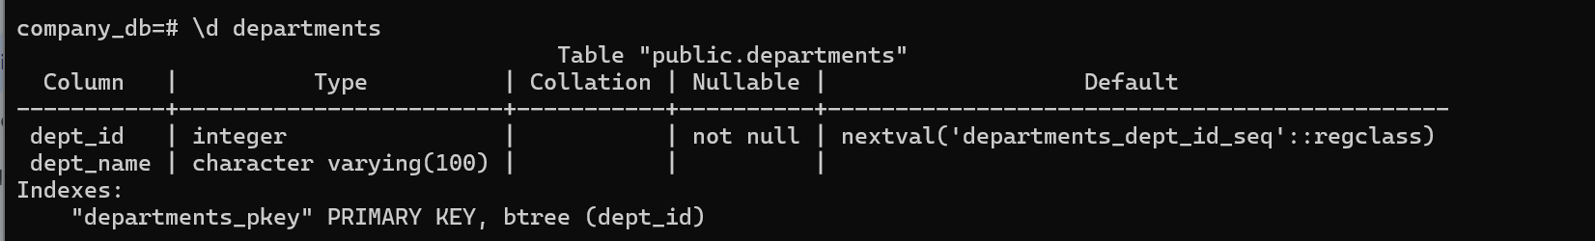

CREATE TABLE employees (

emp_id SERIAL PRIMARY KEY,

emp_name VARCHAR(100),

salary NUMERIC,

dept_id INT

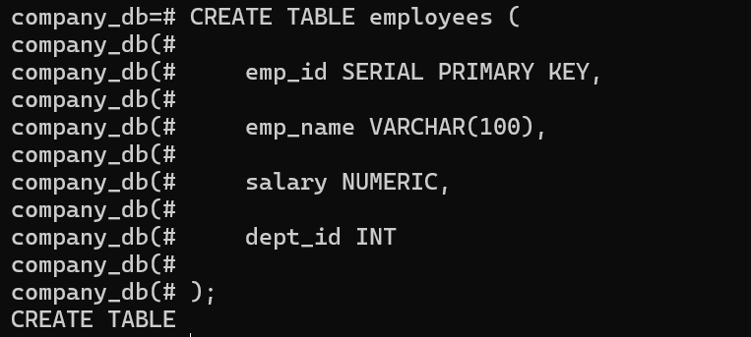
);

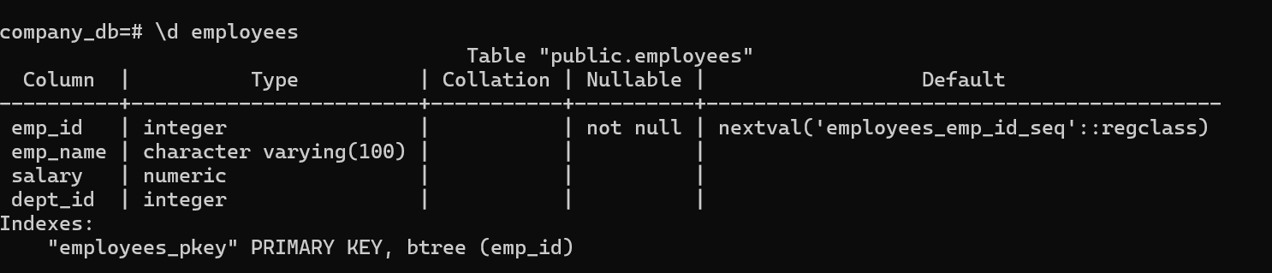
Result: already created table

CREATE TABLE projects (

project_id SERIAL PRIMARY KEY,

project_name VARCHAR(100),

dept_id INT


);

Result: already create table
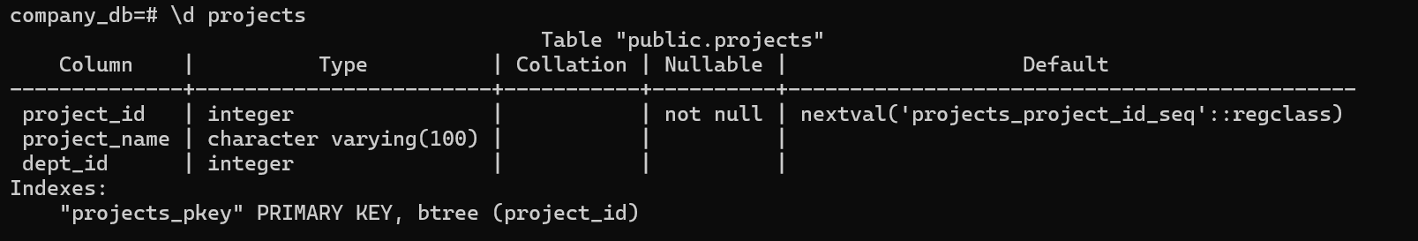

CREATE TABLE employee_projects (

emp_id INT,

project_id INT

);


Result:already created table


INSERT INTO departments (dept_name)


VALUES ('IT'), ('HR'), ('Finance'), ('Marketing');

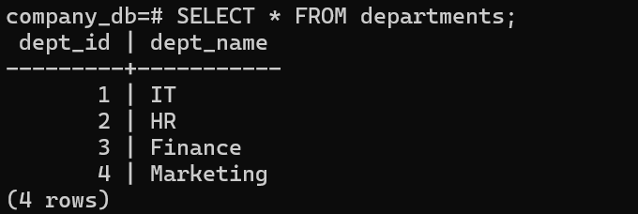
Result: already insert

INSERT INTO employees (emp_name, salary, dept_id)

VALUES
('Karl', 50000, 1),
('Ana', 45000, 2),
('John', 60000, 1),
('Lisa', 55000, 3),
('Mark', 40000, 4);

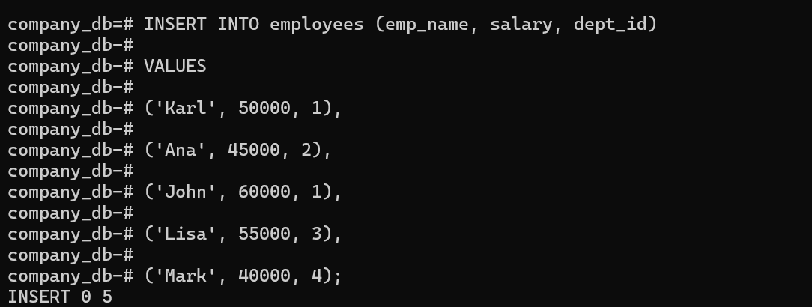

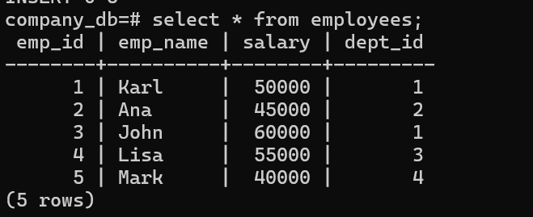
Result: already insert

INSERT INTO projects (project_name, dept_id)

VALUES

('System Upgrade', 1),

('Recruitment Drive', 2),

('Budget Planning', 3),

('Ad Campaign', 4);

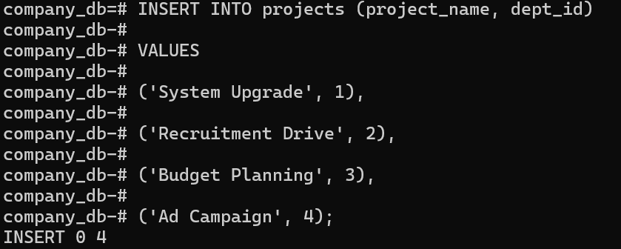

Result:already insert
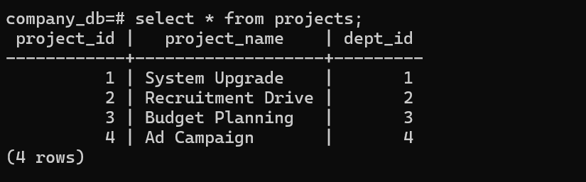

INSERT INTO employee_projects

VALUES

(1,1),(1,2),(2,2),(3,1),(4,3),(5,4);


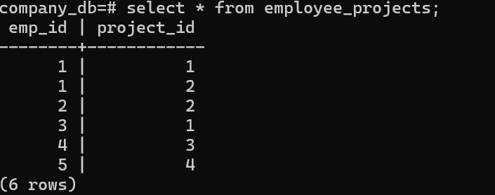
Result: already insert.

PART 2: COMPLEX SQL
QUERIES

Task 1: Multi-table JOIN

Show:

- Employee
Name
- Department
Name
- Project
Name
Solution:

SELECT
e.emp_name AS "Employee Name",
d.dept_name AS "Department Name",
p.project_name AS "Project Name"
FROM employees e
JOIN departments d ON e.dept_id = d.dept_id
JOIN projects p ON d.dept_id = p.dept_id;

Result:
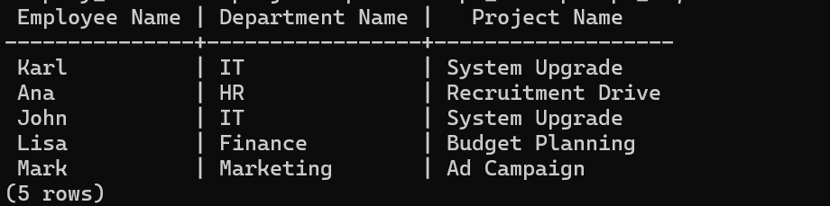
your employees and projects tables both use dept_id to link back to the departments table. Here is the SQL query to get that result:

Task 2: Aggregation + JOIN

Show total employees
per department

SELECT
d.dept_name AS "Department",
COUNT(e.emp_id) AS "Total Employees"
FROM departments d
LEFT JOIN employees e ON d.dept_id = e.dept_id
GROUP BY d.dept_name
ORDER BY "Total Employees" DESC;

Result:
To find the total number of employees in each department, you need to use the COUNT function paired with a GROUP BY clause. This tells SQL to look at the employees table, put people into "buckets" based on their dept_id, and then count how many people are in each bucket.
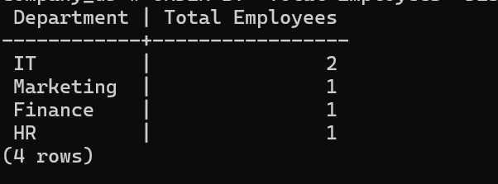

Task 3: Advanced Query

Show:

- Department
- Average
Salary
- Total
Projects handled

SELECT
d.dept_name AS "Department",
ROUND(AVG(e.salary), 2) AS "Average Salary",
COUNT(DISTINCT p.project_id) AS "Total Projects Handled"
FROM departments d
LEFT JOIN employees e ON d.dept_id = e.dept_id
LEFT JOIN projects p ON d.dept_id = p.dept_id
GROUP BY d.dept_name;

Result:
To solve Task 3, we need to calculate two different metrics at the same time: a math average (AVG) and a count (COUNT). We will link all three of your tables—departments, employees, and projects
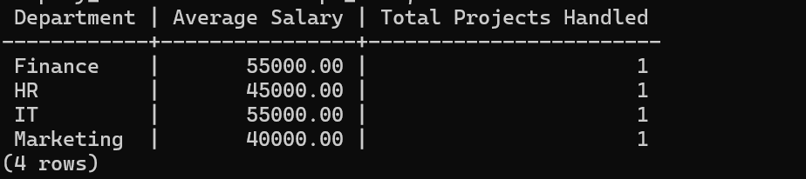

Task 4: CONCAT + Filtering

Show:

- "Employee
- Department"

SELECT
e.emp_name || ' - ' || d.dept_name AS "Employee - Department"
FROM employees e
JOIN departments d ON e.dept_id = d.dept_id
ORDER BY d.dept_name ASC, e.emp_name ASC;

Result: you need to combine the employee name and department name into a single string using the concatenation operator (||).
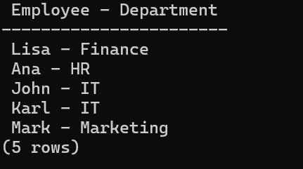
Since you are used to the school_db syntax (where you combined first and last names), the logic here is very similar, but you are pulling columns from two different tables.

PART 3: DML OPERATIONS

Task:

Insert
new employee
Update
salary of one employee
Delete
one employee

-- Insert

INSERT INTO employees (emp_name, salary, dept_id)

VALUES ('NewEmployee', 48000, 1);

Result: already insert employee
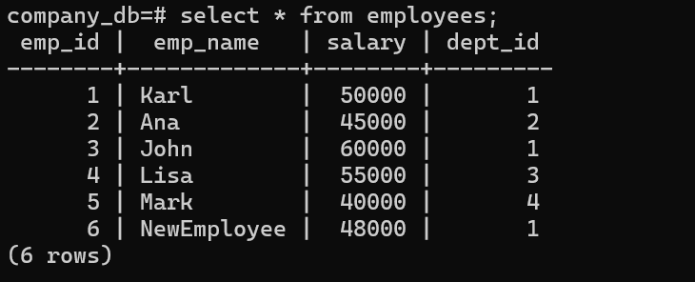

-- Update

UPDATE employees

SET salary = 70000

WHERE emp_name = 'Karl';

Result : already update
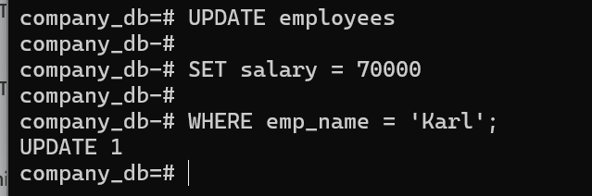

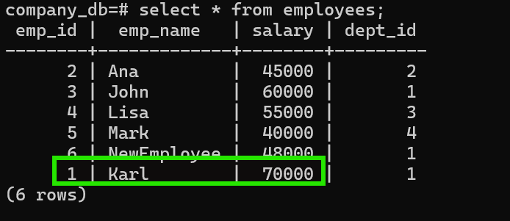

-- Delete

DELETE FROM employees

WHERE emp_name = 'Mark';

Result: mark already deleted from employees.
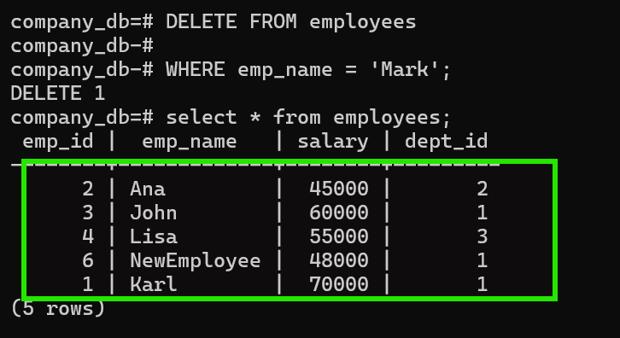

PART 4: LOGICAL BACKUP
& RESTORE

Step 1: Backup

pg_dump -U postgres -d company_db -f company_backup.sql


Result:already backup
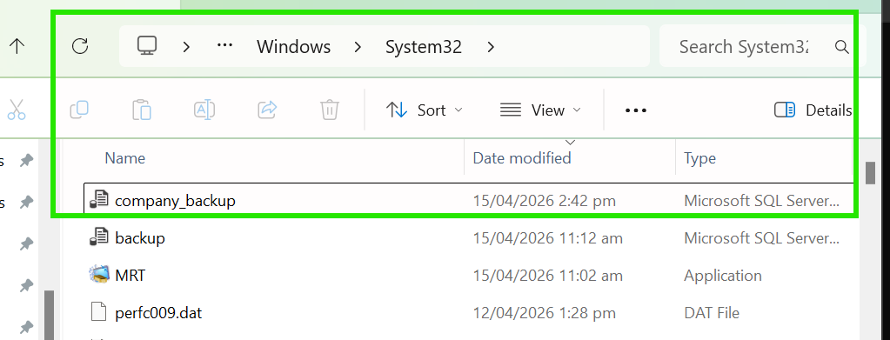

\

Step 2: Drop Database

DROP DATABASE company_db;

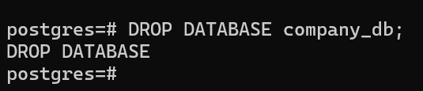
Result:already drop/delete database

Step 3: Recreate

CREATE DATABASE company_db;


Result:already create database

Step 4: Restore

psql -U postgres -d company_db -f company_backup.sql

Step 5: Verify

\dt

SELECT * FROM employees;
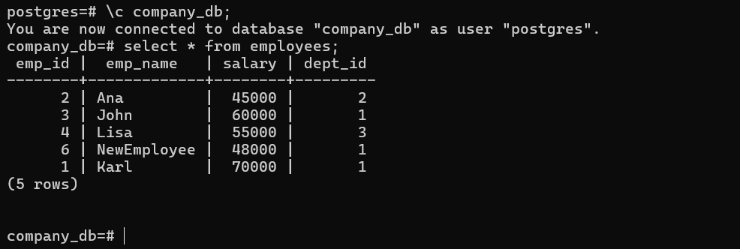

\

PART 5: PHYSICAL BACKUP

Task:

Run:

pg_basebackup -U postgres -D C:\backup_lab3 -Fp -Xs -P

Result: already physical backup


PART 6: VACUUM &
MAINTENANCE

VACUUM ANALYZE employees;

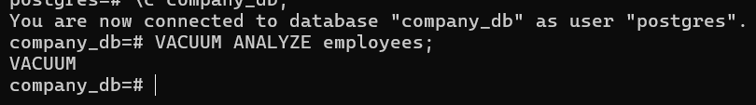
Result:

PART 7:

Task:

Show:

- Employee
Name
- Department
- Total
Projects
- Rank
by Salary
Result:
SELECT
e.emp_name AS "Employee Name",
d.dept_name AS "Department",
COUNT(p.project_id) AS "Total Projects",
DENSE_RANK() OVER(ORDER BY e.salary DESC) AS "Salary Rank"
FROM employees e
JOIN departments d ON e.dept_id = d.dept_id
LEFT JOIN projects p ON d.dept_id = p.dept_id
GROUP BY e.emp_id, e.emp_name, d.dept_name, e.salary;

