psql -U postgres
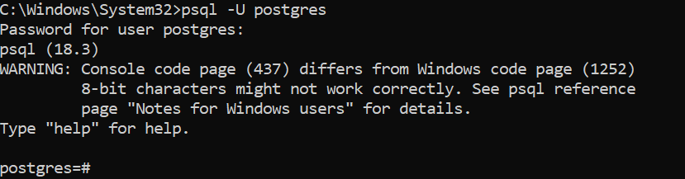

Connect to your database:
\c school_db

CREATE TABLE students (
student_id SERIAL PRIMARY KEY,
first_name VARCHAR(50),
last_name VARCHAR(50),
age INT
);
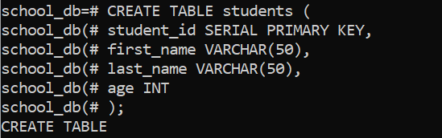

CREATE TABLE enrollments (
enrollment_id SERIAL PRIMARY KEY,
student_id INT,
course_id INT,
enrollment_date DATE,
FOREIGN KEY (student_id) REFERENCES students(student_id),
FOREIGN KEY (course_id) REFERENCES courses(course_id)
);
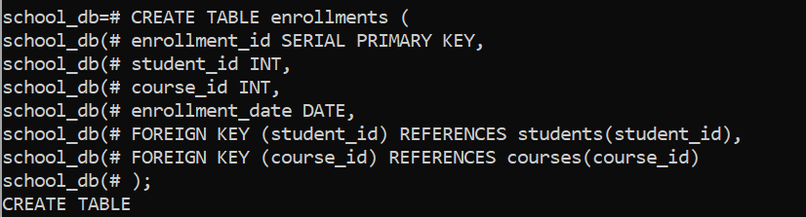

INSERT INTO students (first_name, last_name, age)
VALUES
('Karl', 'Saycon', 25),
('Ana', 'Reyes', 21),
('John', 'Dela Cruz', 23);
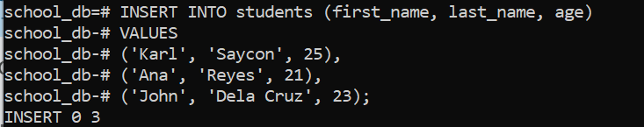

INSERT INTO enrollments (student_id, course_id, enrollment_date)
VALUES
(1, 1, '2024-01-10'),
(1, 2, '2024-01-15'),
(2, 2, '2024-02-01'),
(3, 3, '2024-02-10');
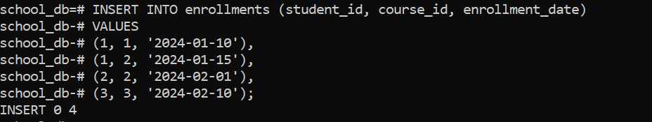

SELECT
s.first_name,
s.last_name,
c.course_name
FROM students s
JOIN enrollments e ON s.student_id = e.student_id
JOIN courses c ON e.course_id = c.course_id;
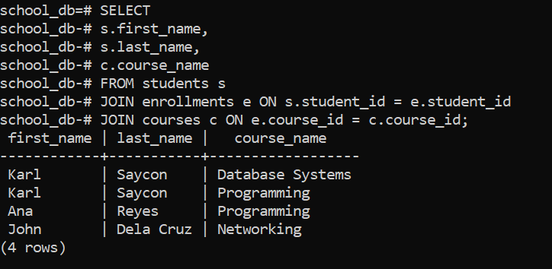

SELECT
CONCAT(s.first_name, ' ', s.last_name) AS full_name,
c.course_name,
c.department
FROM students s
JOIN enrollments e ON s.student_id = e.student_id
JOIN courses c ON e.course_id = c.course_id
WHERE c.department = 'IT Department';
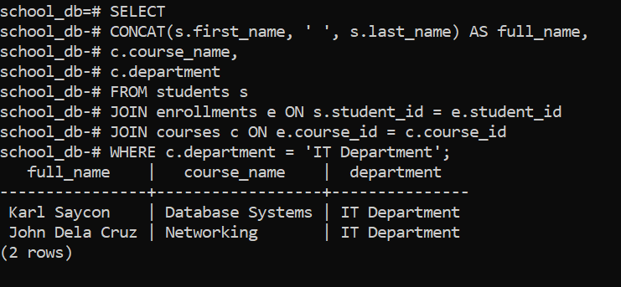

Create a query that:
- Displays full name
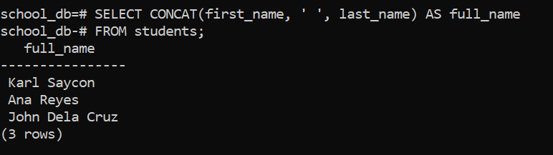

Shows course + department
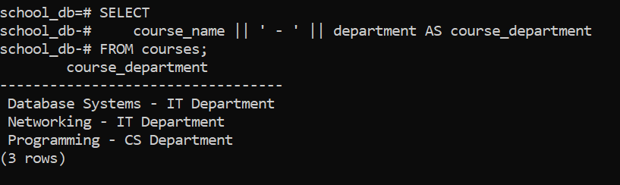

Shows enrollment date
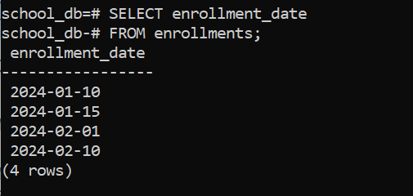

Filters students age > 21
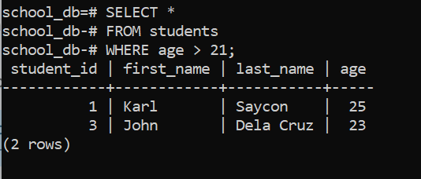

Sort by enrollment_date DESC
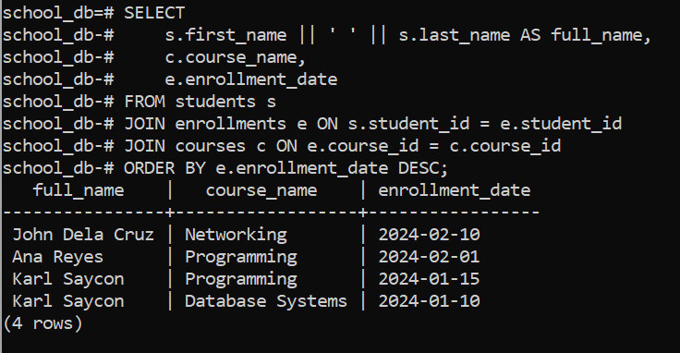

SELECT
CONCAT(s.first_name, ' ', s.last_name) AS full_name,
c.course_name,
c.department,
e.enrollment_date
FROM students s
JOIN enrollments e ON s.student_id = e.student_id
JOIN courses c ON e.course_id = c.course_id
WHERE s.age > 21
ORDER BY e.enrollment_date DESC;
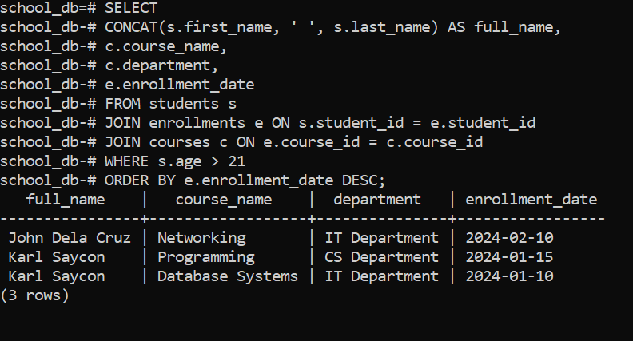

SELECT
c.course_name,
COUNT(e.student_id) AS total_students
FROM courses c
LEFT JOIN enrollments e ON c.course_id = e.course_id
GROUP BY c.course_name;
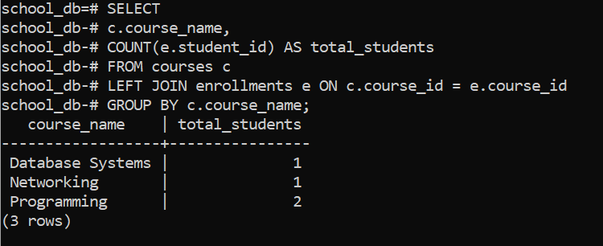

CREATE USER student_user WITH PASSWORD 'password123';

GRANT CONNECT ON DATABASE school_db TO student_user;
GRANT USAGE ON SCHEMA public TO student_user;
GRANT SELECT ON ALL TABLES IN SCHEMA public TO student_user;
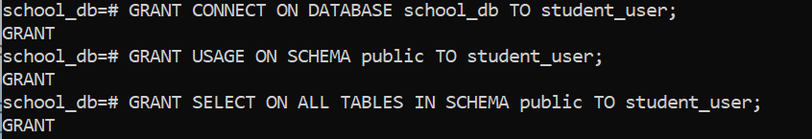

psql -U student_user -d school_db
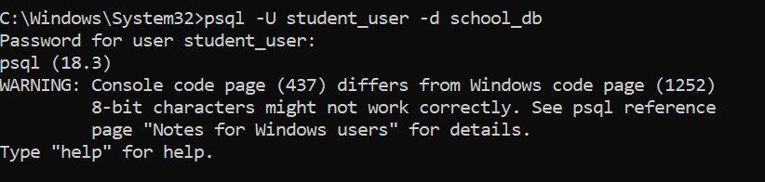

Run:
SHOW config_file;
SHOW hba_file;
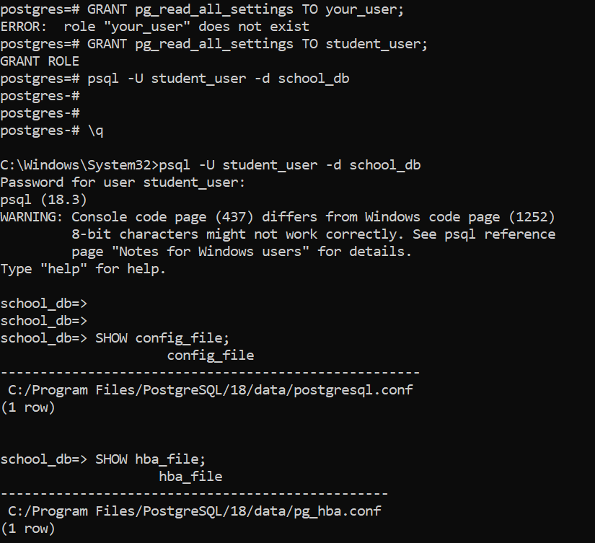

Example entry:
host school_db student_user 127.0.0.1/32 md5
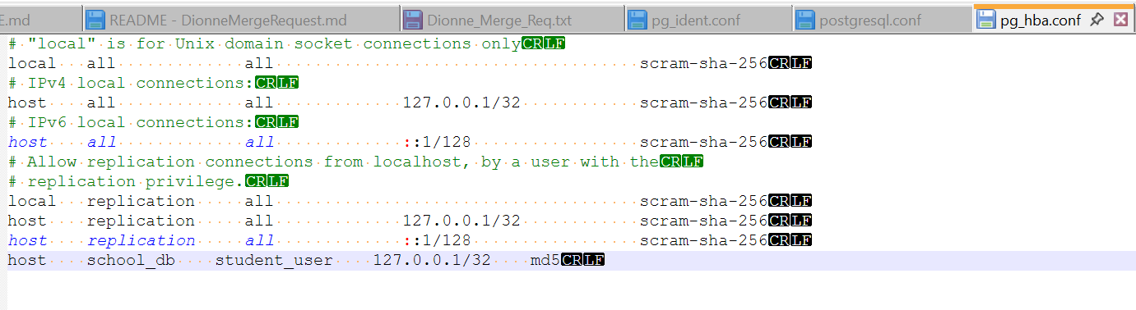

Example:
listen_addresses = '*'
port = 5432
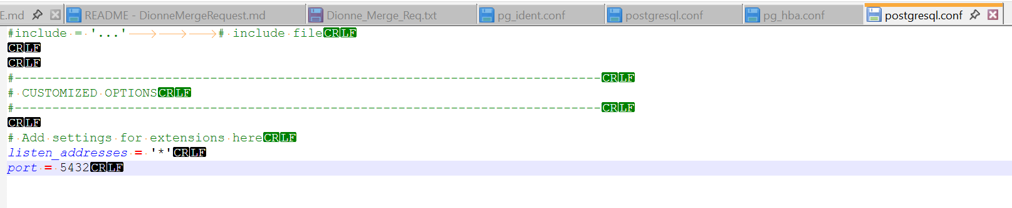

SELECT pg_reload_conf();
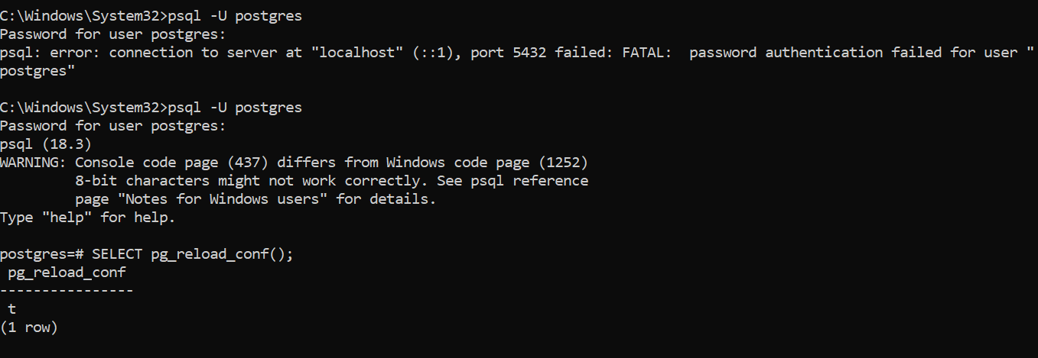

Create a query that:
- Shows FULL NAME (UPPERCASE)
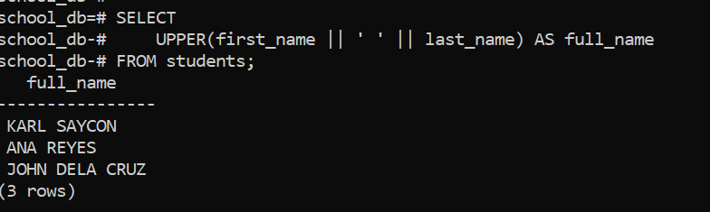

Shows COURSE + DEPARTMENT combined
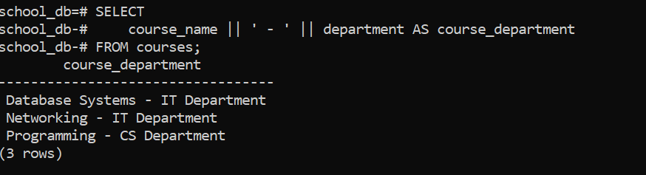

Shows number of courses per student
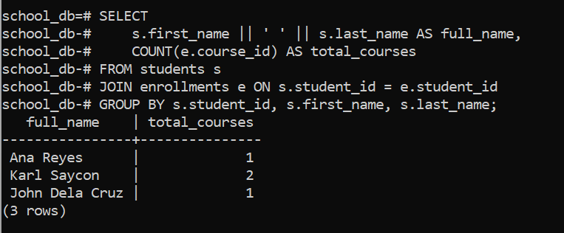

Only include students enrolled in more than 1 course
