ASSIGNMENT:
.
Expected Output:
1. Create a Word document with steps + screenshots.
2. Create SQL file and put it on the day2 folder on the github for the Part 10 Final Challenge.
3. Create branching strategy feature/ksaycon_handson_day2, commit and push changes.
4. Send pull request PR for review paste the PR link to the google classroom together with your word document.

<firstname>_<lastname>_lab2_activity.docx

psql -U postgres (Green)
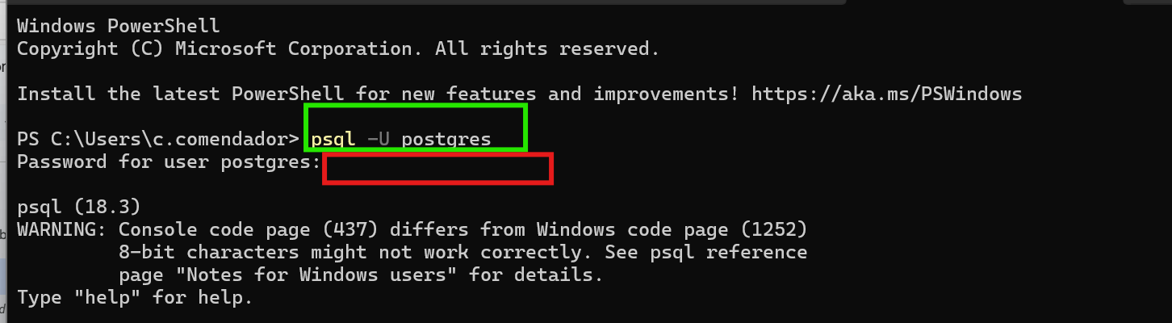
password(RED)

Connect to your database:

\c school_db(RED)
“You are now connected to database "school_db" as user "postgres". (GREEN/OUTPUT)

Create Table Students

CREATE TABLE students (
student_id SERIAL PRIMARY KEY,
first_name VARCHAR(50),
last_name VARCHAR(50),
age INT
);
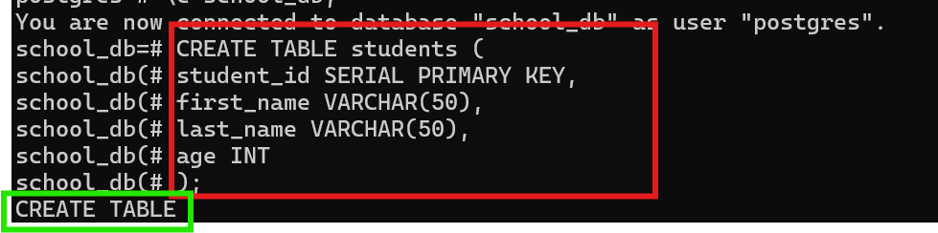
CREATE TABLE (already create)

CREATE TABLE enrollments

CREATE TABLE enrollments (
enrollment_id SERIAL PRIMARY KEY,
student_id INT,
course_id INT,
enrollment_date DATE,
FOREIGN KEY (student_id) REFERENCES students(student_id),
FOREIGN KEY (course_id) REFERENCES courses(course_id)
);
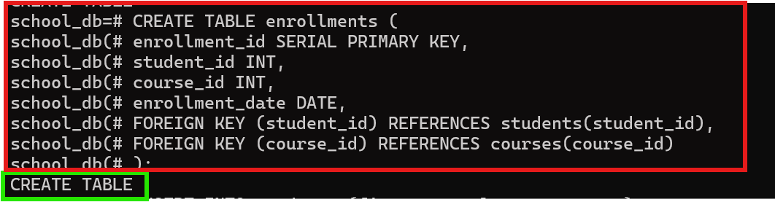
CREATE TABLE (already create)

INSERT INTO students

INSERT INTO students (first_name, last_name, age)
VALUES
('Karl', 'Saycon', 25),
('Ana', 'Reyes', 21),
('John', 'Dela Cruz', 23);
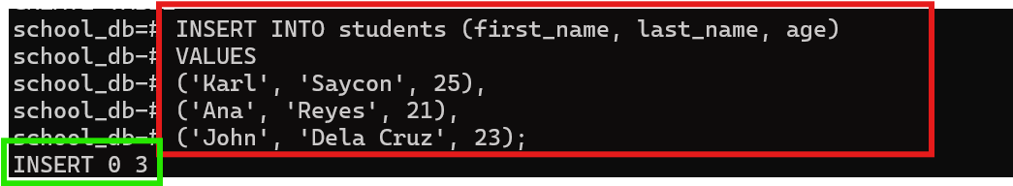
INSERT 0 3( already insert)

INSERT INTO enrollments

INSERT INTO enrollments (student_id, course_id, enrollment_date)
VALUES
(1, 1, '2024-01-10'),
(1, 2, '2024-01-15'),
(2, 2, '2024-02-01'),
(3, 3, '2024-02-10');
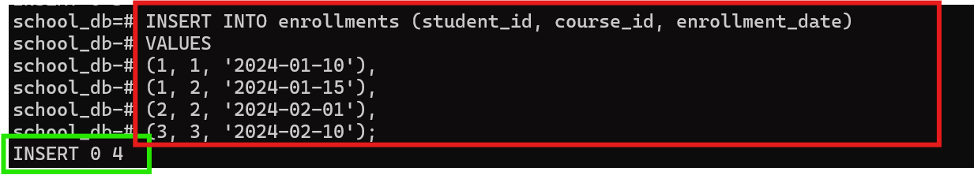
INSERT 0 4( already insert

SELECT
s.first_name,
s.last_name,
c.course_name
FROM students s
JOIN enrollments e ON s.student_id = e.student_id
JOIN courses c ON e.course_id = c.course_id;
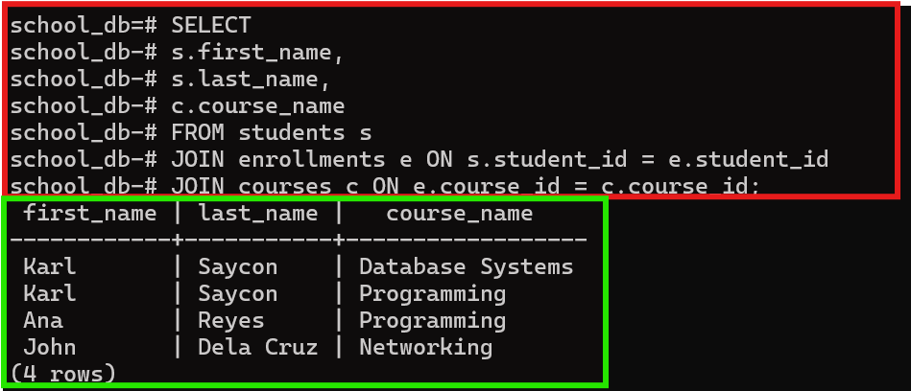
Greenbox shows output

SELECT
CONCAT(s.first_name, ' ', s.last_name) AS full_name,
c.course_name,
c.department
FROM students s
JOIN enrollments e ON s.student_id = e.student_id
JOIN courses c ON e.course_id = c.course_id
WHERE c.department = 'IT Department';
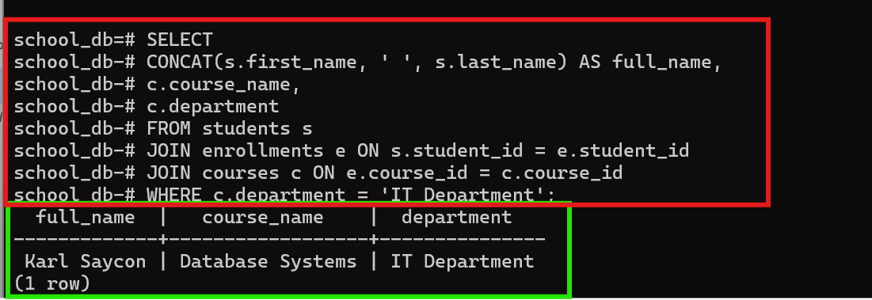
Greenbox shows output

Create a query that:

Displays full name

Red : Script
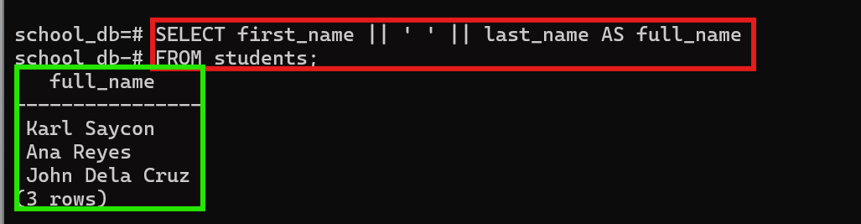
Green: output

Shows course + department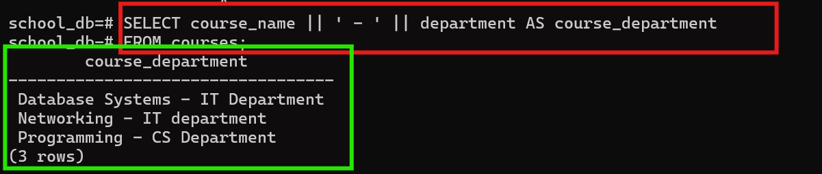

Shows course + department
Red : Script


Green: output

Shows enrollment date
Red : Script
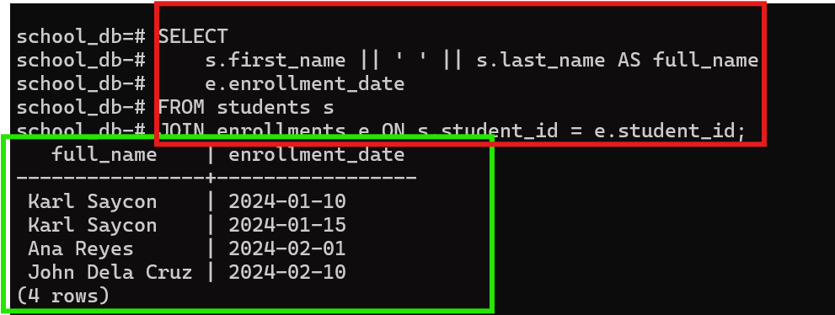
Green: output

Filters students age > 21
Red : Script
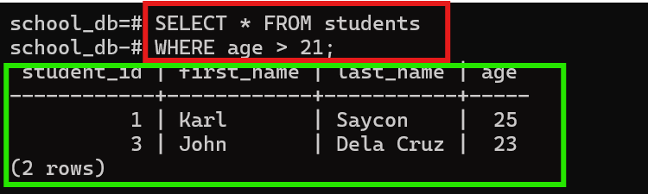
Green: output

Sort by enrollment_date DESC
Red : Script
Green: output
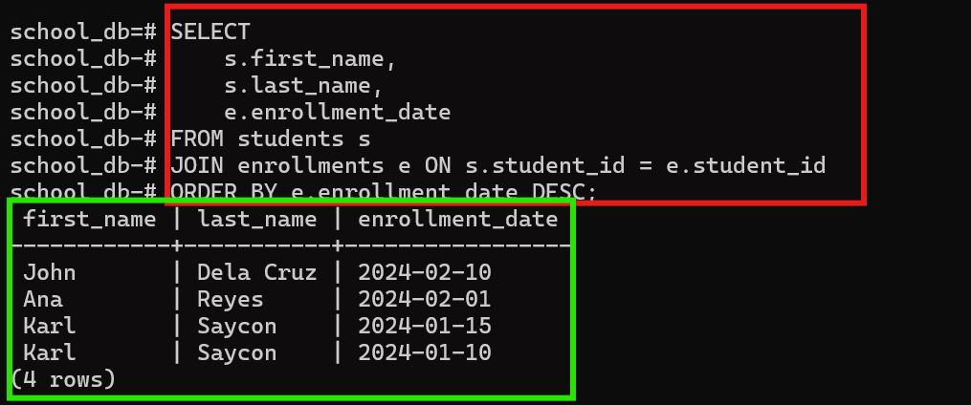

SELECT
CONCAT(s.first_name, ' ', s.last_name) AS full_name,
c.course_name,
c.department,
e.enrollment_date
FROM students s
JOIN enrollments e ON s.student_id = e.student_id
JOIN courses c ON e.course_id = c.course_id
WHERE s.age > 21
ORDER BY e.enrollment_date DESC;

Green: output
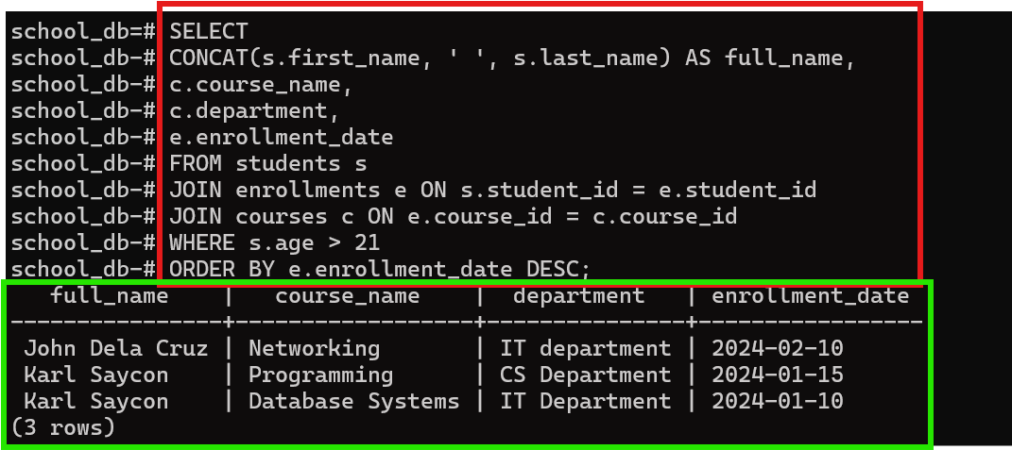

SELECT
c.course_name,
COUNT(e.student_id) AS total_students
FROM courses c
LEFT JOIN enrollments e ON c.course_id = e.course_id
GROUP BY c.course_name;
Green: output
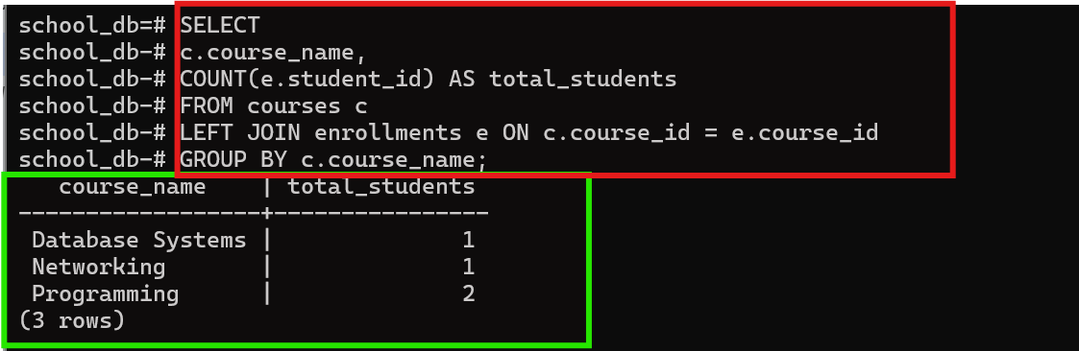

CREATE USER student_user WITH PASSWORD 'password123';

GRANT CONNECT ON DATABASE school_db TO student_user;
GRANT USAGE ON SCHEMA public TO student_user;
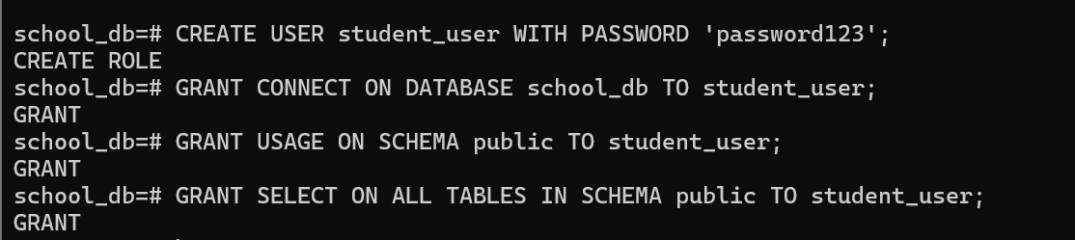
GRANT SELECT ON ALL TABLES IN SCHEMA public TO student_user;

\q

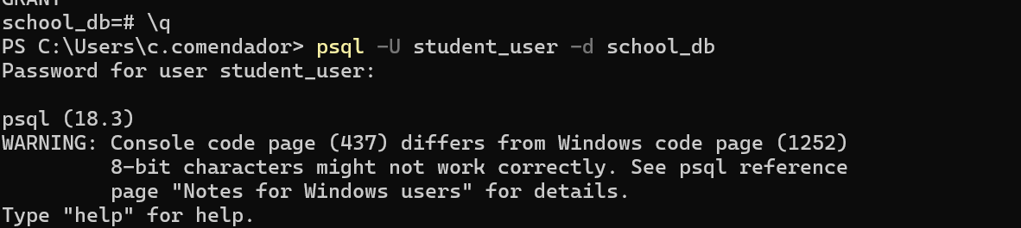
psql -U student_user -d school_db

Run:

SHOW config_file;
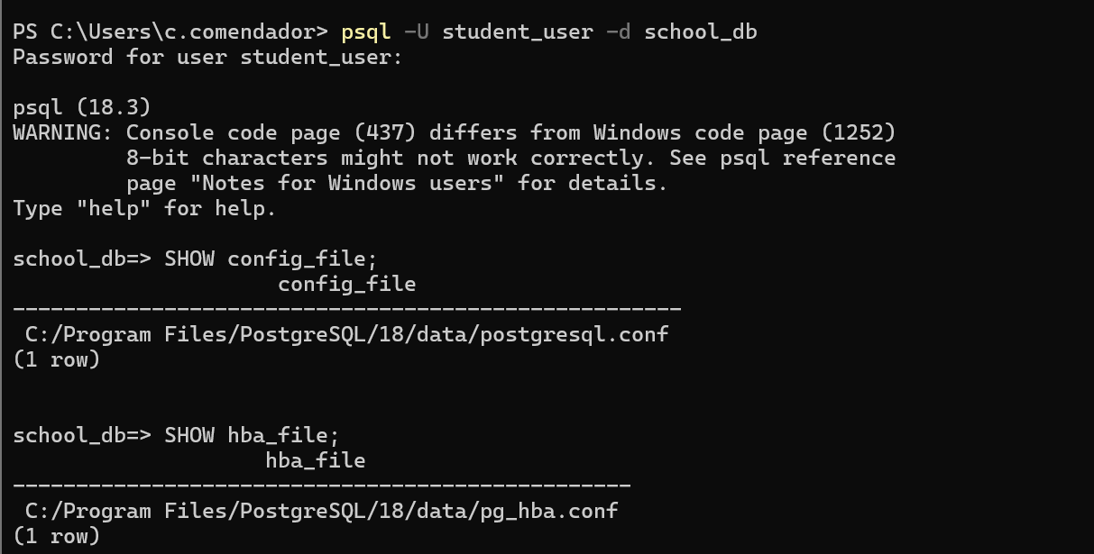
SHOW hba_file;

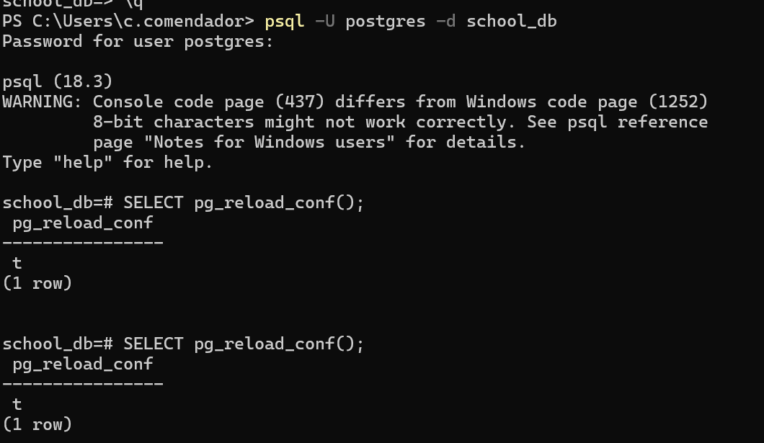
SELECT pg_reload_conf();

Create a query that:
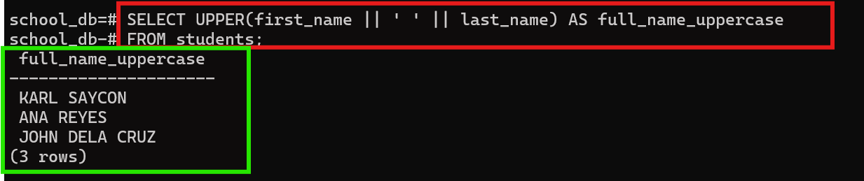
Shows FULL NAME (UPPERCASE)

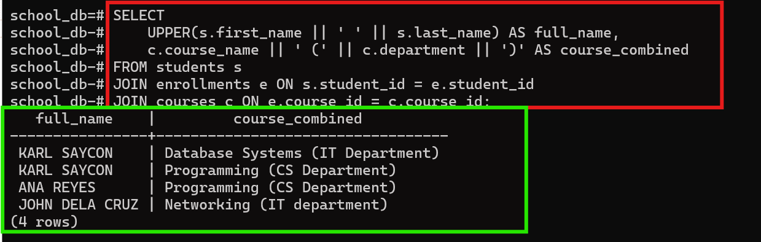
Shows COURSE + DEPARTMENT combined

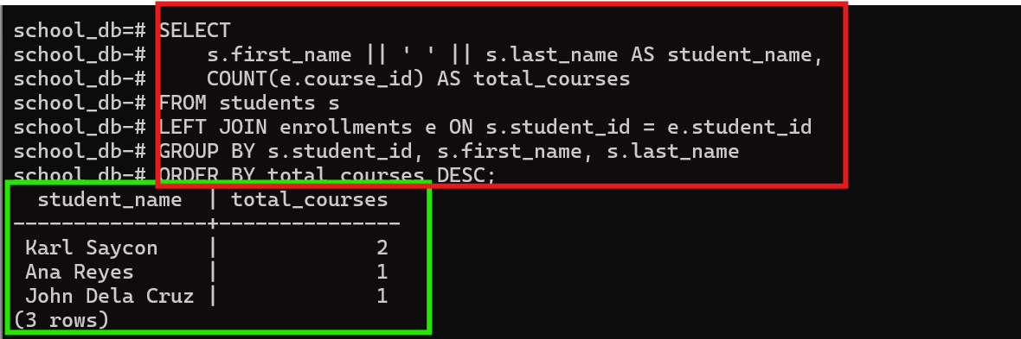
Shows number of courses per student

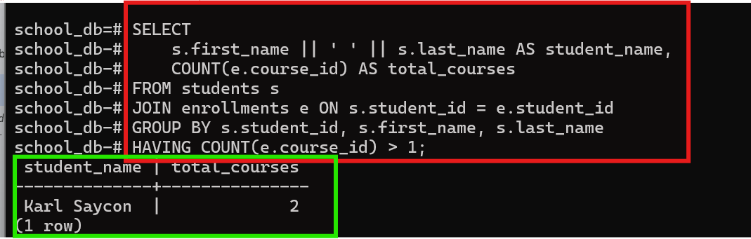
Only include students enrolled in more than 1 course

