Aljohn_alejandrino_lab3_activity

CREATE DATABASE company_db;

Connect:

\c company_db

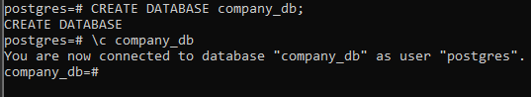

CREATE TABLE departments (

dept_id SERIAL PRIMARY KEY,

dept_name VARCHAR(100)

);

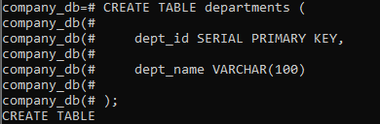

CREATE TABLE employees (

emp_id SERIAL PRIMARY KEY,

emp_name VARCHAR(100),

salary NUMERIC,

dept_id INT

);

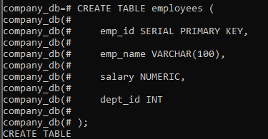

CREATE TABLE projects (

project_id SERIAL PRIMARY KEY,

project_name VARCHAR(100),

dept_id INT

);

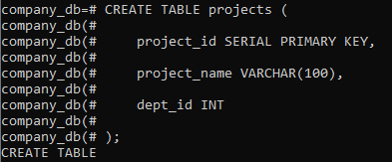

CREATE TABLE employee_projects (

emp_id INT,

project_id INT

);

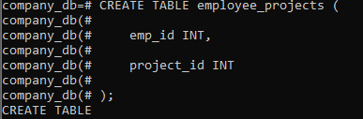

\dt

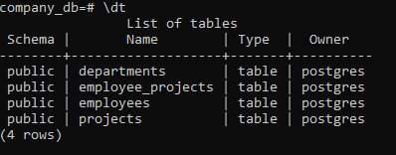

Insert Sample Data:

INSERT INTO departments (dept_name)

VALUES ('IT'), ('HR'), ('Finance'), ('Marketing');

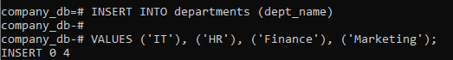

INSERT INTO employees (emp_name, salary, dept_id)

VALUES

('Karl', 50000, 1),

('Ana', 45000, 2),

('John', 60000, 1),

('Lisa', 55000, 3),

('Mark', 40000, 4);

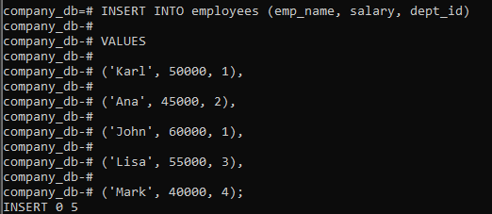

INSERT INTO projects (project_name, dept_id)

VALUES

('System Upgrade', 1),

('Recruitment Drive', 2),

('Budget Planning', 3),

('Ad Campaign', 4);

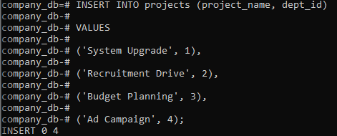

INSERT INTO employee_projects

VALUES

(1,1),(1,2),(2,2),(3,1),(4,3),(5,4);

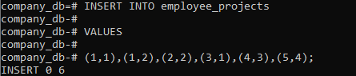

PART 2: COMPLEX SQL
QUERIES

Task 1: Multi-table JOIN

Show:

- Employee
Name
- Department
Name
- Project
Name

SELECT
e.emp_name AS Employee_Name,
d.dept_name AS Department_Name,
p.project_name AS Project_Name
FROM
employees e
JOIN
departments d ON e.dept_id = d.dept_id
JOIN
employee_projects ep ON e.emp_id = ep.emp_id
JOIN
projects p ON ep.project_id = p.project_id;

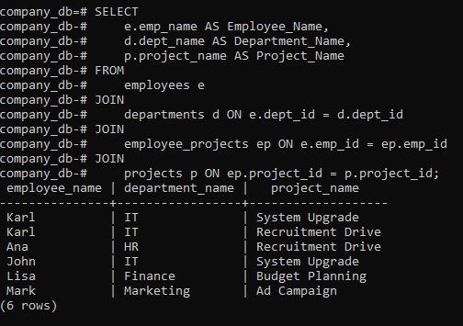

Task 2: Aggregation + JOIN

Show total employees
per department

SELECT
d.dept_name AS Department_Name,
COUNT(e.emp_id) AS Total_Employees
FROM
departments d
LEFT JOIN
employees e ON d.dept_id = e.dept_id
GROUP BY
D.dept_name;

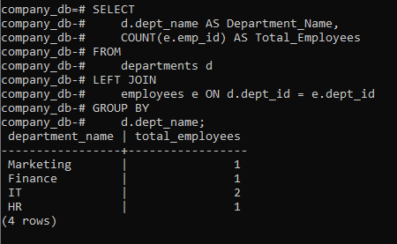

Task 3: Advanced Query

Show:

- Department
- Average
Salary
- Total
Projects handled

SELECT
d.dept_name AS Department_Name,
AVG(e.salary) AS Average_Salary,
COUNT(DISTINCT ep.project_id) AS Total_Projects_Handled
FROM
departments d
JOIN
employees e ON d.dept_id = e.dept_id
LEFT JOIN
employee_projects ep ON e.emp_id = ep.emp_id
GROUP BY
D.dept_name;

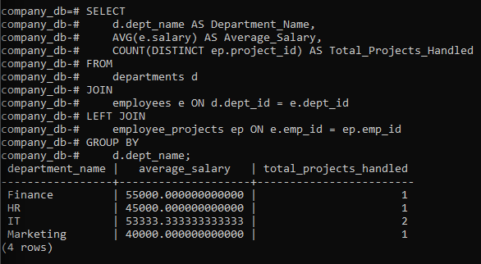

Task 4: CONCAT + Filtering

Show:

- "Employee
- Department"

SELECT
CONCAT(e.emp_name, ' - ', d.dept_name) AS "Employee - Department"
FROM
employees e
JOIN
departments d ON e.dept_id = d.dept_id;
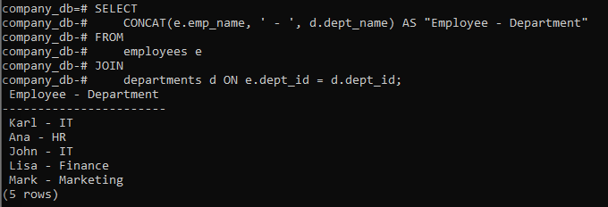

PART 3: DML OPERATIONS

Task:

Insert
new employee
Update
salary of one employee
Delete
one employee

-- Insert

INSERT INTO employees (emp_name, salary, dept_id)

VALUES ('NewEmployee', 48000, 1);

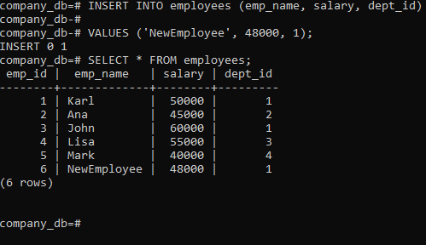

-- Update

UPDATE employees

SET salary = 70000

WHERE emp_name = 'Karl';

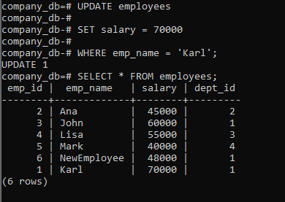

-- Delete

DELETE FROM employees

WHERE emp_name = 'Mark';

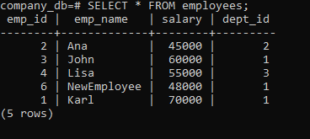

PART 4: LOGICAL BACKUP
& RESTORE

Step 1: Backup

pg_dump -U postgres -d company_db -f company_backup.sql

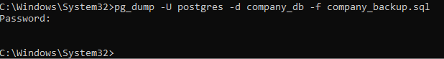

Step 2: Drop Database

DROP DATABASE company_db;

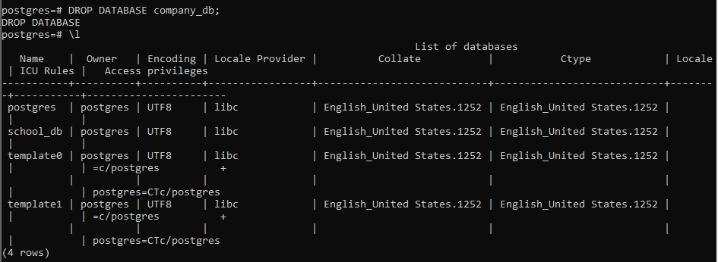

Step 3: Recreate

CREATE DATABASE company_db;

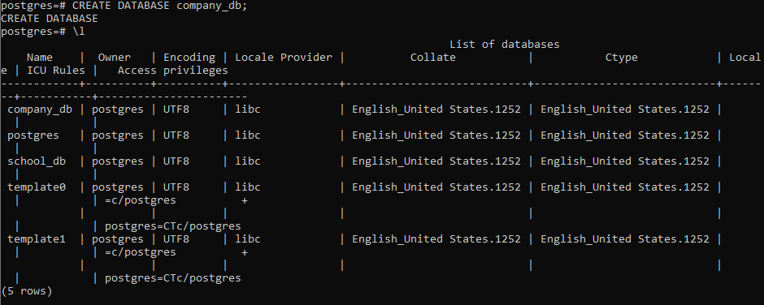

Step 4: Restore

psql -U postgres -d company_db -f company_backup.sql

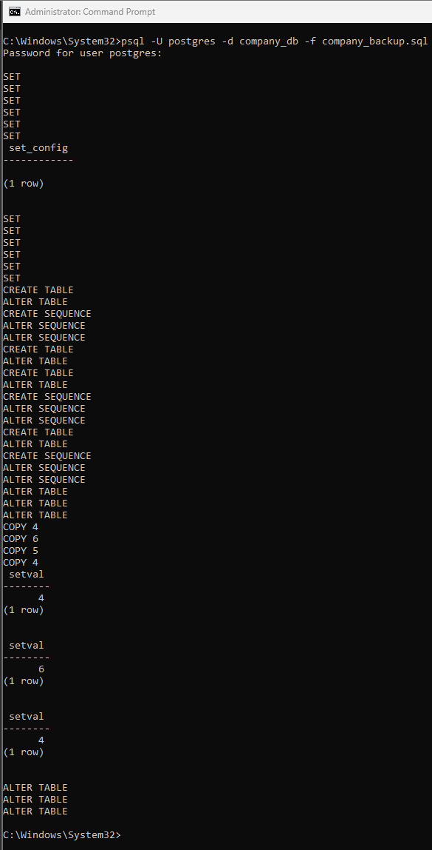

Step 5: Verify

\dt

SELECT * FROM employees;

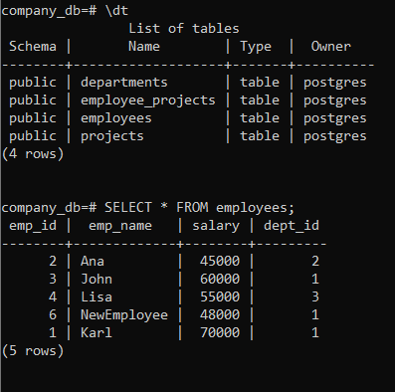

PART 5: PHYSICAL BACKUP

Task:

Run:

pg_basebackup -U postgres -D C:\backup_lab3 -Fp -Xs -P

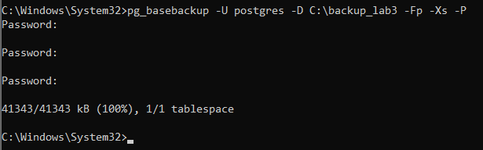



PART 6: VACUUM &
MAINTENANCE

VACUUM ANALYZE employees;

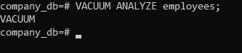

PART 7:

Task:

Show:

- Employee
Name
- Department
- Total
Projects
- Rank
by Salary
SELECT
e.emp_name AS Employee_Name,
d.dept_name AS Department,
COUNT(DISTINCT ep.project_id) AS Total_Projects,
RANK() OVER (ORDER BY e.salary DESC) AS Salary_Rank
FROM
employees e
JOIN
departments d ON e.dept_id = d.dept_id
LEFT JOIN
employee_projects ep ON e.emp_id = ep.emp_id
GROUP BY
e.emp_name, d.dept_name, e.salary
ORDER BY
Salary_Rank;
