Postgresql Training
Lab Activity 2

Summary
- Create a Word document with steps + screenshots.
- Create SQL file and put it on the day2 folder on the github for the Part 10 Final Challenge.
- Create branching strategy feature/ksaycon_handson_day2, commit and push changes.
- Objective: Send pull request PR for review paste the PR link to the google classroom together with your word document.

Step by Step
psql -U postgres
Connect to your database:
\c school_db
CREATE TABLE students (student_id SERIAL PRIMARY KEY,first_name VARCHAR(50), last_name VARCHAR(50), age INT);
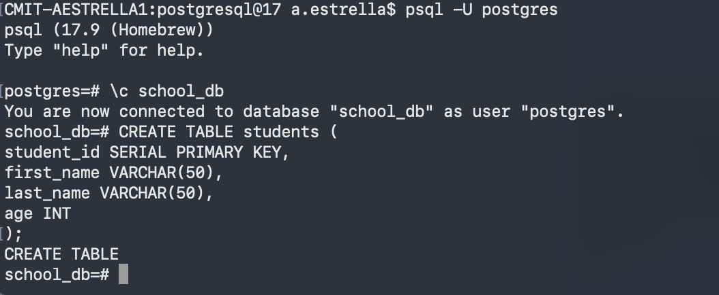

CREATE TABLE enrollments (enrollment_id SERIAL PRIMARY KEY, student_id INT, course_id INT, enrollment_date DATE, FOREIGN KEY (student_id) REFERENCES students(student_id), FOREIGN KEY (course_id) REFERENCES courses(course_id) );

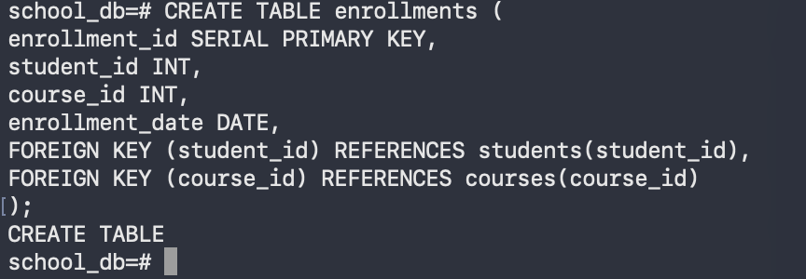

INSERT INTO students (first_name, last_name, age)VALUES ('Karl', 'Saycon', 25), ('Ana', 'Reyes', 21), ('John', 'Dela Cruz', 23);
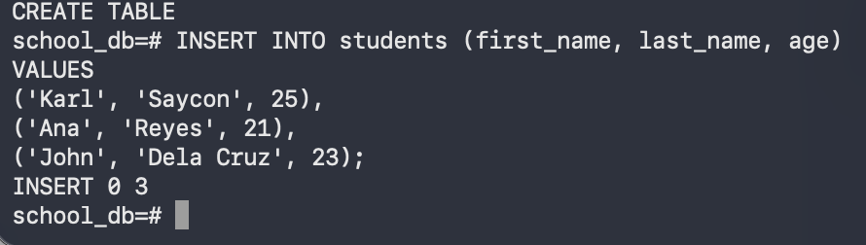

INSERT INTO enrollments (student_id, course_id, enrollment_date) VALUES (1, 1, '2024-01-10'), (1, 2, '2024-01-15'), (2, 2, '2024-02-01'), (3, 3, '2024-02-10');
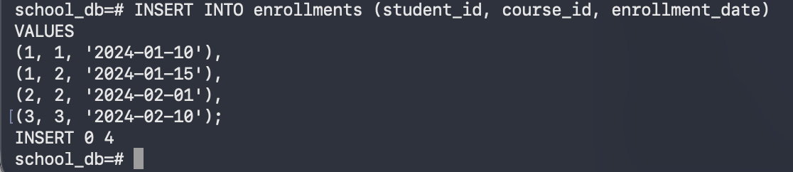

SELECT s.first_name, s.last_name, c.course_name FROM students s JOIN enrollments e ON s.student_id = e.student_id JOIN courses c ON e.course_id = c.course_id;

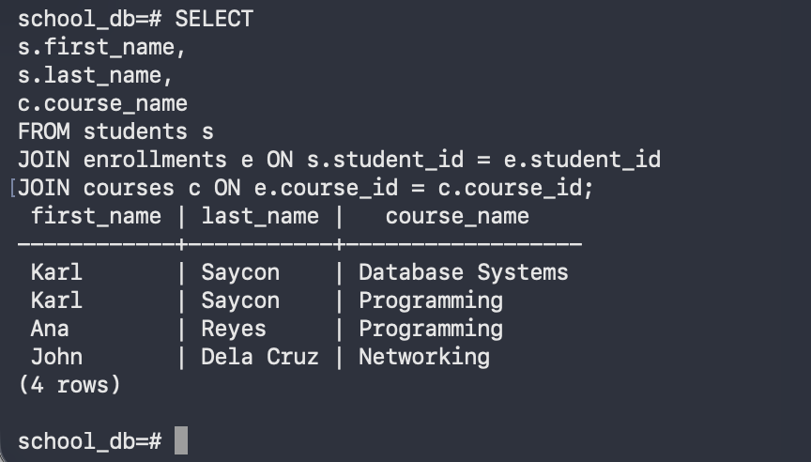
SELECT CONCAT(s.first_name, ' ', s.last_name) AS full_name, c.course_name, c.department FROM students s JOIN enrollments e ON s.student_id = e.student_id JOIN courses c ON e.course_id = c.course_id WHERE c.department = 'IT Department';
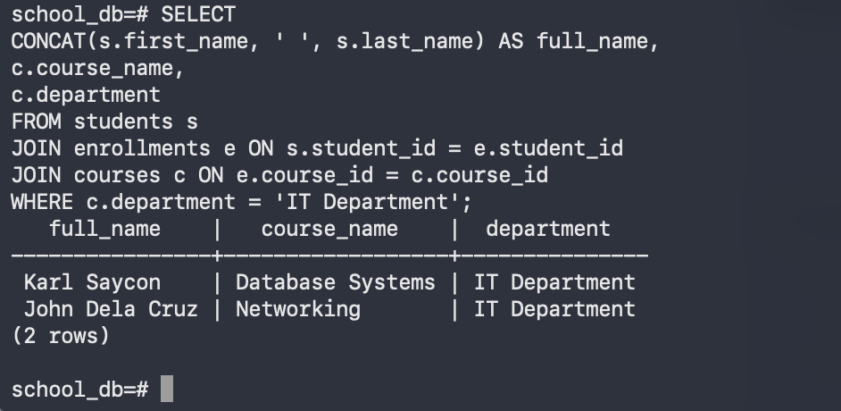

Create a query that: Displays full name, Shows course + department, Shows enrollment date Filters students age > 21, Sort by enrollment_date DESC
SELECT CONCAT(s.first_name, ' ', s.last_name) AS full_name, c.course_name, c.department, e.enrollment_date FROM students s JOIN enrollments e ON s.student_id = e.student_id JOIN courses c ON e.course_id = c.course_id WHERE s.age > 21 ORDER BY e.enrollment_date DESC;
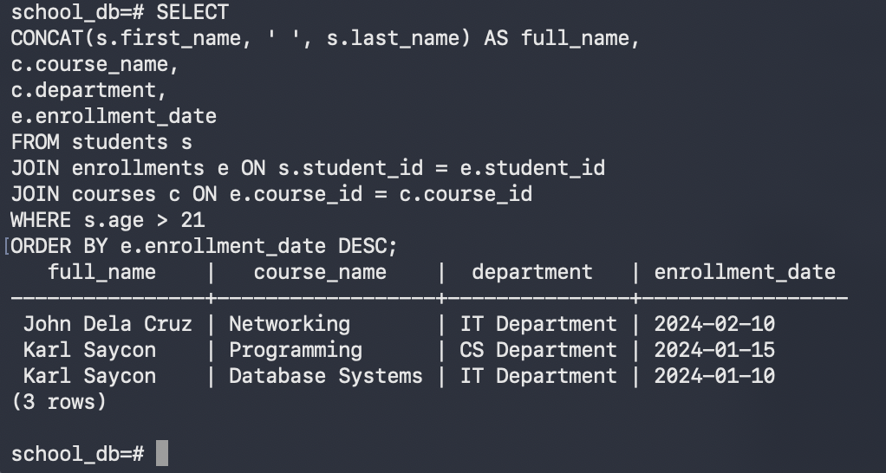

SELECT c.course_name, COUNT(e.student_id) AS total_students FROM courses c LEFT JOIN enrollments e ON c.course_id = e.course_id GROUP BY c.course_name;
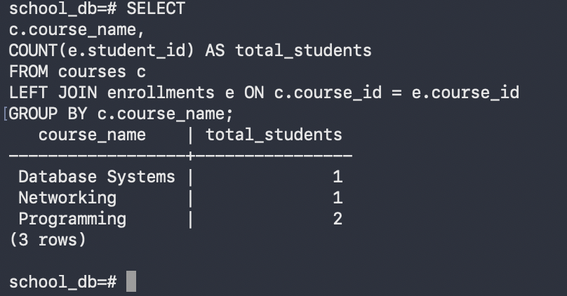

CREATE USER student_user WITH PASSWORD 'password123';

GRANT CONNECT ON DATABASE school_db TO student_user;
GRANT USAGE ON SCHEMA public TO student_user;
GRANT SELECT ON ALL TABLES IN SCHEMA public TO student_user;
psql -U student_user -d school_db
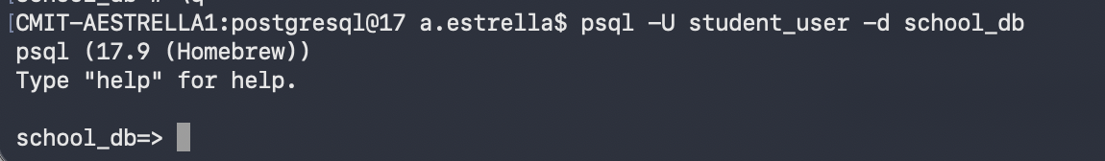

SHOW config_file;
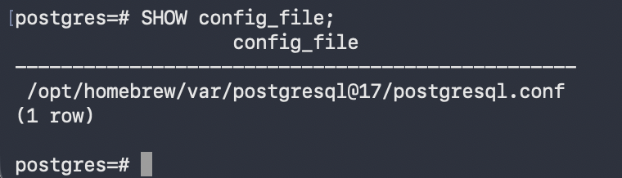
SHOW hba_file;
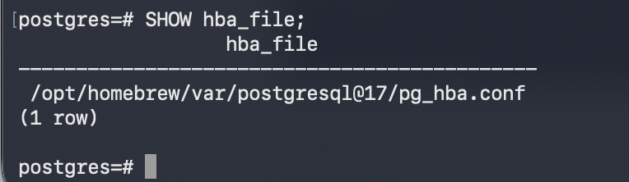
Example postgresql.conf
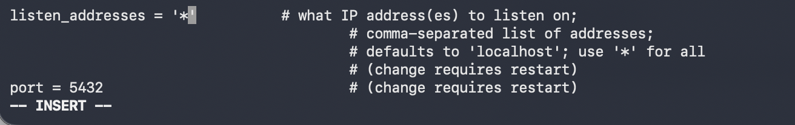

Example hba.conf
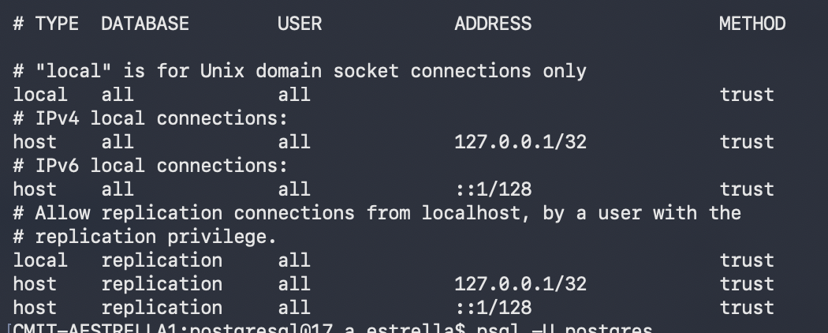

SELECT pg_reload_conf();
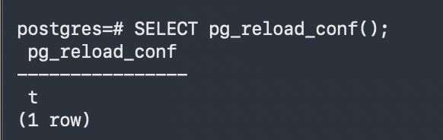

SELECT
UPPER(CONCAT(s.first_name, ' ', s.last_name)) AS full_name,
STRING_AGG(c.course_name || ' - ' || c.department, ', ') AS courses_and_departments,
COUNT(e.enrollment_id) AS number_of_courses
FROM students s
JOIN enrollments e ON s.student_id = e.student_id
JOIN courses c ON e.course_id = c.course_id
GROUP BY s.student_id, s.first_name, s.last_name
HAVING COUNT(e.enrollment_id) > 1;

