Nadya Postolaki
In Class 12

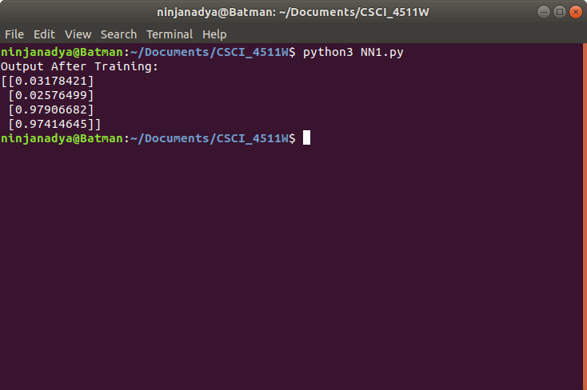

Figure 1. Output after running NN1.py file

The 4 given points are classified as an array as so:

# input data. Each row is a sample, columns correspond to input nodes.
X = np.array([ [0,0,1],
[0,1,1],
[1,0,1],
[1,1,1] ])

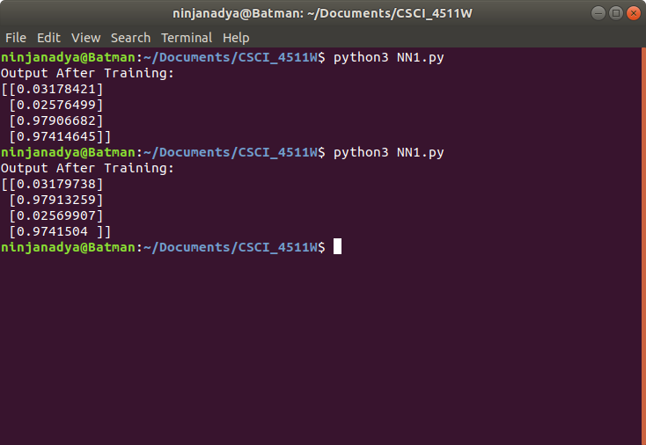

Figure 2: Output after changing y = np.array

The first element of the array is very similar to the first one before we made any changes, but just barely larger by 0.00001317, similarly the fourth element of the array seems similar, but also slightly larger. Now the second and third elements look to be swapped (of course with minor changes in the last few digits of the outputs).
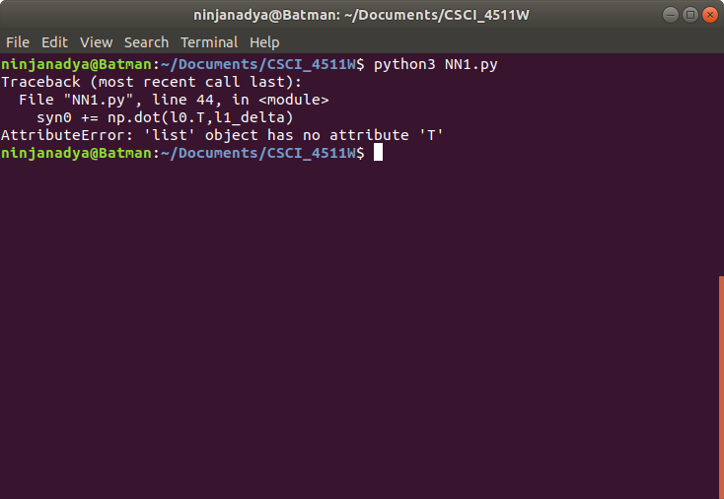

Now part 6 I had issues with and am confused where exactly I’m supposed to create a newX and where to replace the X, so this is the output, but when commenting out line 44 which is the error on the terminal above, we get this:
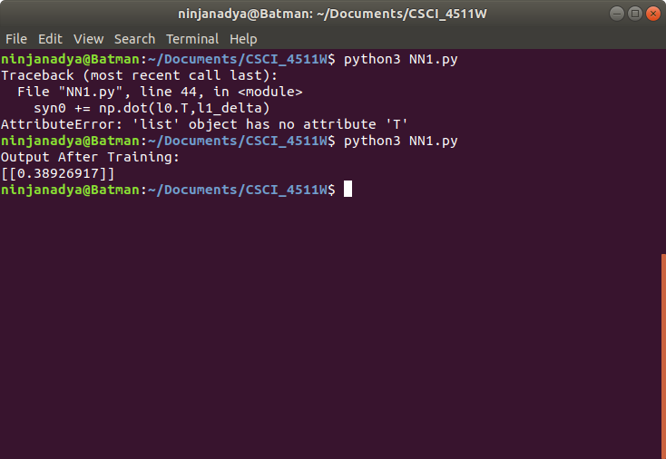

I’m unsure if this was what the result was supposed to be, but it seems as though this number is roughly the average of those in X.

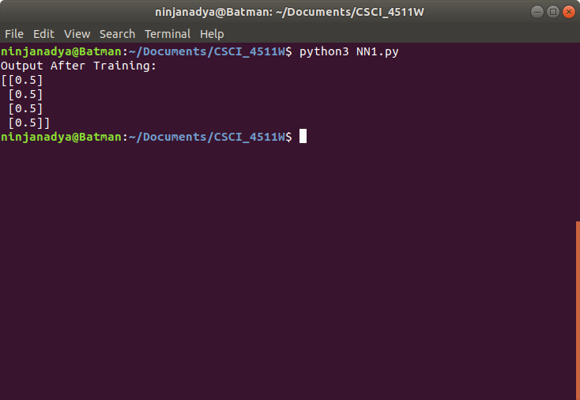

This is after changing y again in part 7.

