1)WPN to open Browser and Search the Word Java in Google Search
import org.openqa.selenium.By;
import org.openqa.selenium.WebDriver;
import org.openqa.selenium.WebElement;
import org.openqa.selenium.chrome.ChromeDriver;
public class P1searchgoogle {
public static void main(String[] args) throws InterruptedException {
System.setProperty("webdriver.chrome.driver", "C:\\browserdriver\\chromedriver.exe");
WebDriver driver = new ChromeDriver();
driver.get("https://www.google.com/");
driver.manage().window().maximize();
Thread.sleep(2000);
driver.findElement(By.name("q")).sendKeys("java");
Thread.sleep(10000);
driver.close();

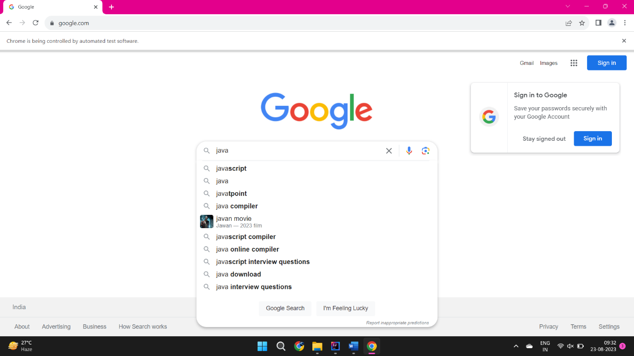

2)WPN to Search the Word Java in Google Search and list the number of dropdown options.
import org.openqa.selenium.By;
import org.openqa.selenium.WebDriver;
import org.openqa.selenium.WebElement;
import org.openqa.selenium.chrome.ChromeDriver;
import java.util.List;
public class P2searchgoogle {
public static void main(String[] args) throws InterruptedException {
System.setProperty("webdriver.chrome.driver", "C:\\browserdriver\\chromedriver.exe");
WebDriver driver = new ChromeDriver();
driver.get("https://www.google.com/");
driver.manage().window().maximize();
Thread.sleep(2000);
driver.findElement(By.name("q")).sendKeys("java");
Thread.sleep(10000);
List<WebElement> list=driver.findElements(By.xpath("//ul[@role='listbox']//li/descendant::div[@class='wM6W7d']"));
System.out.println(list.size());
driver.findElement(By.name("btnK")).click();
}
}
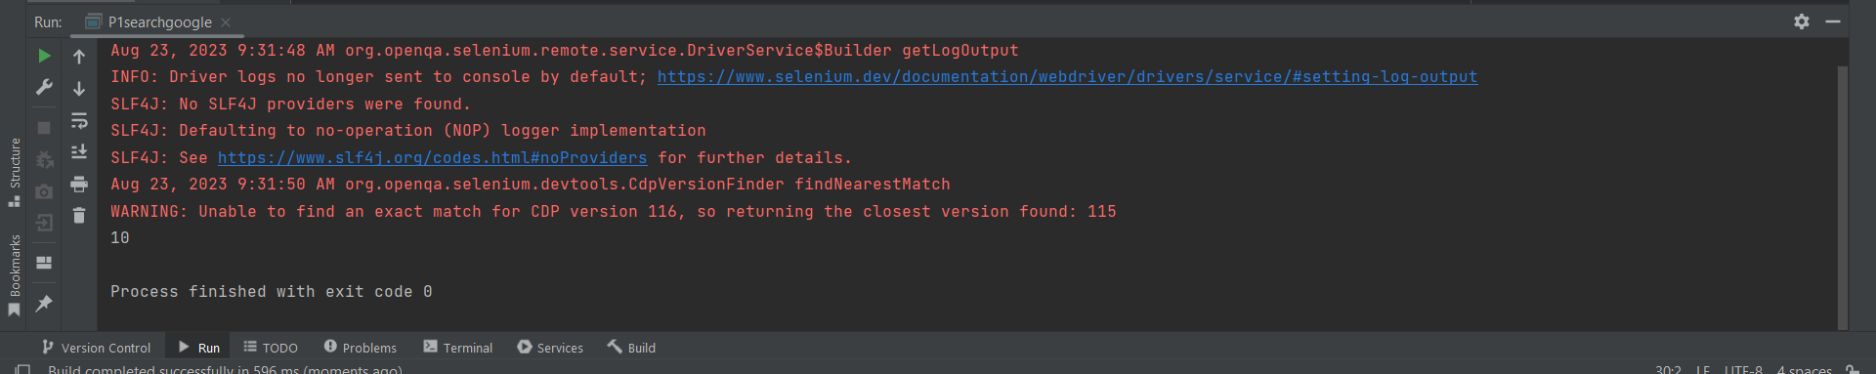

3)WPN to perform the radio Button operation.
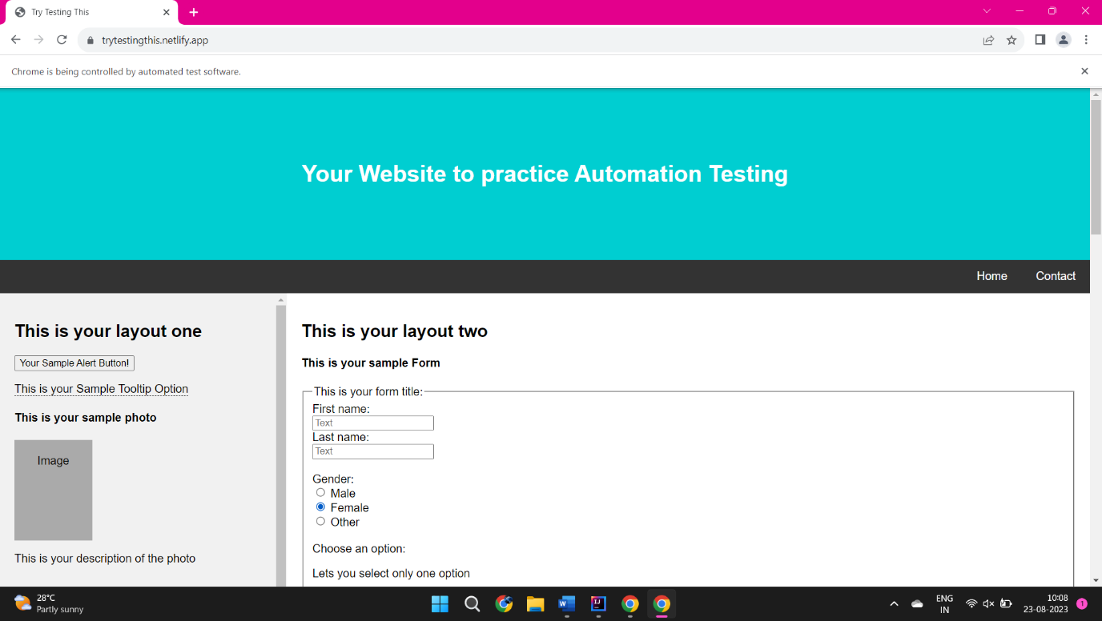
import org.openqa.selenium.By;
import org.openqa.selenium.WebDriver;
import org.openqa.selenium.WebElement;
import org.openqa.selenium.chrome.ChromeDriver;
public class P3redio {
public static void main(String[] args) throws InterruptedException {
System.setProperty("webdriver.chrome.driver", "C:\\browserdriver\\chromedriver.exe");
WebDriver driver = new ChromeDriver();
driver.get("https://trytestingthis.netlify.app/");
driver.manage().window().maximize();
WebElement RadioButton = driver.findElement(By.xpath("//label[normalize-space()='Female']"));
RadioButton.click();
Thread.sleep(1000);
WebElement Raiobutton2 = driver.findElement(By.xpath ("//input[@id='male']"));
Raiobutton2.click();
Thread.sleep(1000);
WebElement Raiobutton3 =driver.findElement(By.xpath("//label[normalize-space()='Other']"));
Raiobutton3.click();
Thread.sleep(1000);
}
}

4) WPN to perform the Checkbox operation.
import org.openqa.selenium.By;
import org.openqa.selenium.WebDriver;
import org.openqa.selenium.WebElement;
import org.openqa.selenium.chrome.ChromeDriver;
public class P4checkbox {
public static void main(String[] args) {
System.setProperty("webdriver.chrome.driver", "C:\\browserdriver\\chromedriver.exe");
WebDriver driver = new ChromeDriver();
driver.get("https://trytestingthis.netlify.app/");
driver.manage().window().maximize();
WebElement Checkbox = driver.findElement(By.xpath("//label[normalize-space()='Option 1']"));
boolean isSelected = Checkbox.isSelected();
if (isSelected == false) {
Checkbox.click();
}
}
}
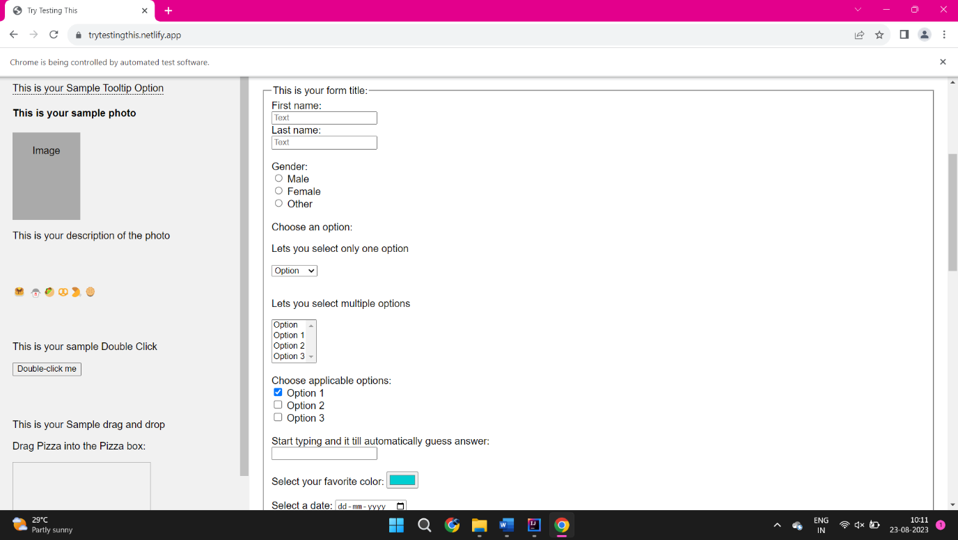

5) WPN to perform the Dropdown operation.
import org.openqa.selenium.By;
import org.openqa.selenium.WebDriver;
import org.openqa.selenium.WebElement;
import org.openqa.selenium.chrome.ChromeDriver;
import org.openqa.selenium.support.ui.Select;
public class P5dropdown {
public static void main(String[] args) throws InterruptedException {
System.setProperty("webdriver.chrome.driver", "C:\\browserdriver\\chromedriver.exe");
WebDriver driver = new ChromeDriver();
driver.get("https://trytestingthis.netlify.app/");
driver.manage().window().maximize();
WebElement select =driver.findElement(By.id("owc"));
//selecting the elements options
Select select1=new Select((select));
//selecting using value
select1.selectByValue("option 1");
Thread.sleep(1000);
//selecting using value
select1.selectByValue("option 2");
Thread.sleep(1000);
//selecting using value
select1.selectByValue("option 3");
//descleting tyhe options
select1.deselectByVisibleText("Option 3");
Thread.sleep(1000);
driver.close ();
}
}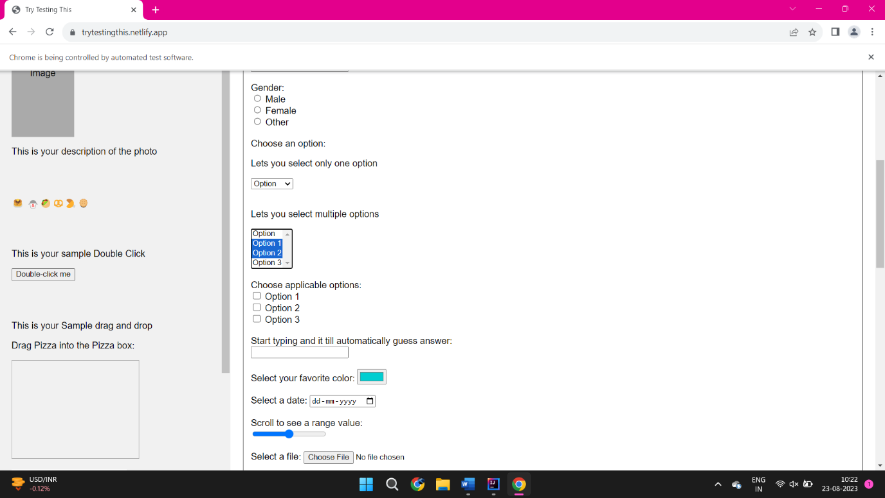
6) WPN to perform the Alert operation.
import org.openqa.selenium.Alert;
import org.openqa.selenium.By;
import org.openqa.selenium.WebDriver;
import org.openqa.selenium.chrome.ChromeDriver;
public class P6Alert {
public static void main(String[] args) throws InterruptedException {
System.setProperty("webdriver.chrome.driver", "C:\\browserdriver\\chromedriver.exe");
WebDriver driver = new ChromeDriver();
driver.get("https://demo.guru99.com/test/delete_customer.php");
driver.manage().window().maximize();
driver.findElement(By.name("cusid")).sendKeys("12345");
driver.findElement(By.name("submit")).submit();
//switching to Alert
Alert alert= driver.switchTo().alert();
//capturing alert message
String alertMessage =driver.switchTo().alert().getText();
//Disp
System.out.println(alertMessage);
Thread.sleep(1000);
//accepting alter
alert.accept();
}
}
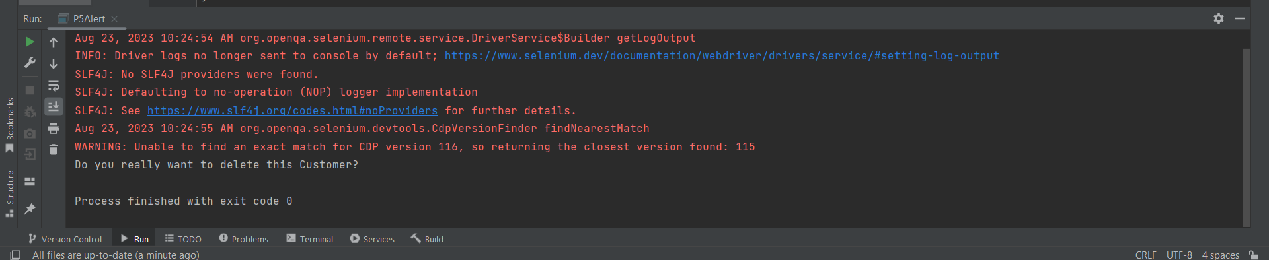

7) WPN to perform the Table operation and print the Field Name.
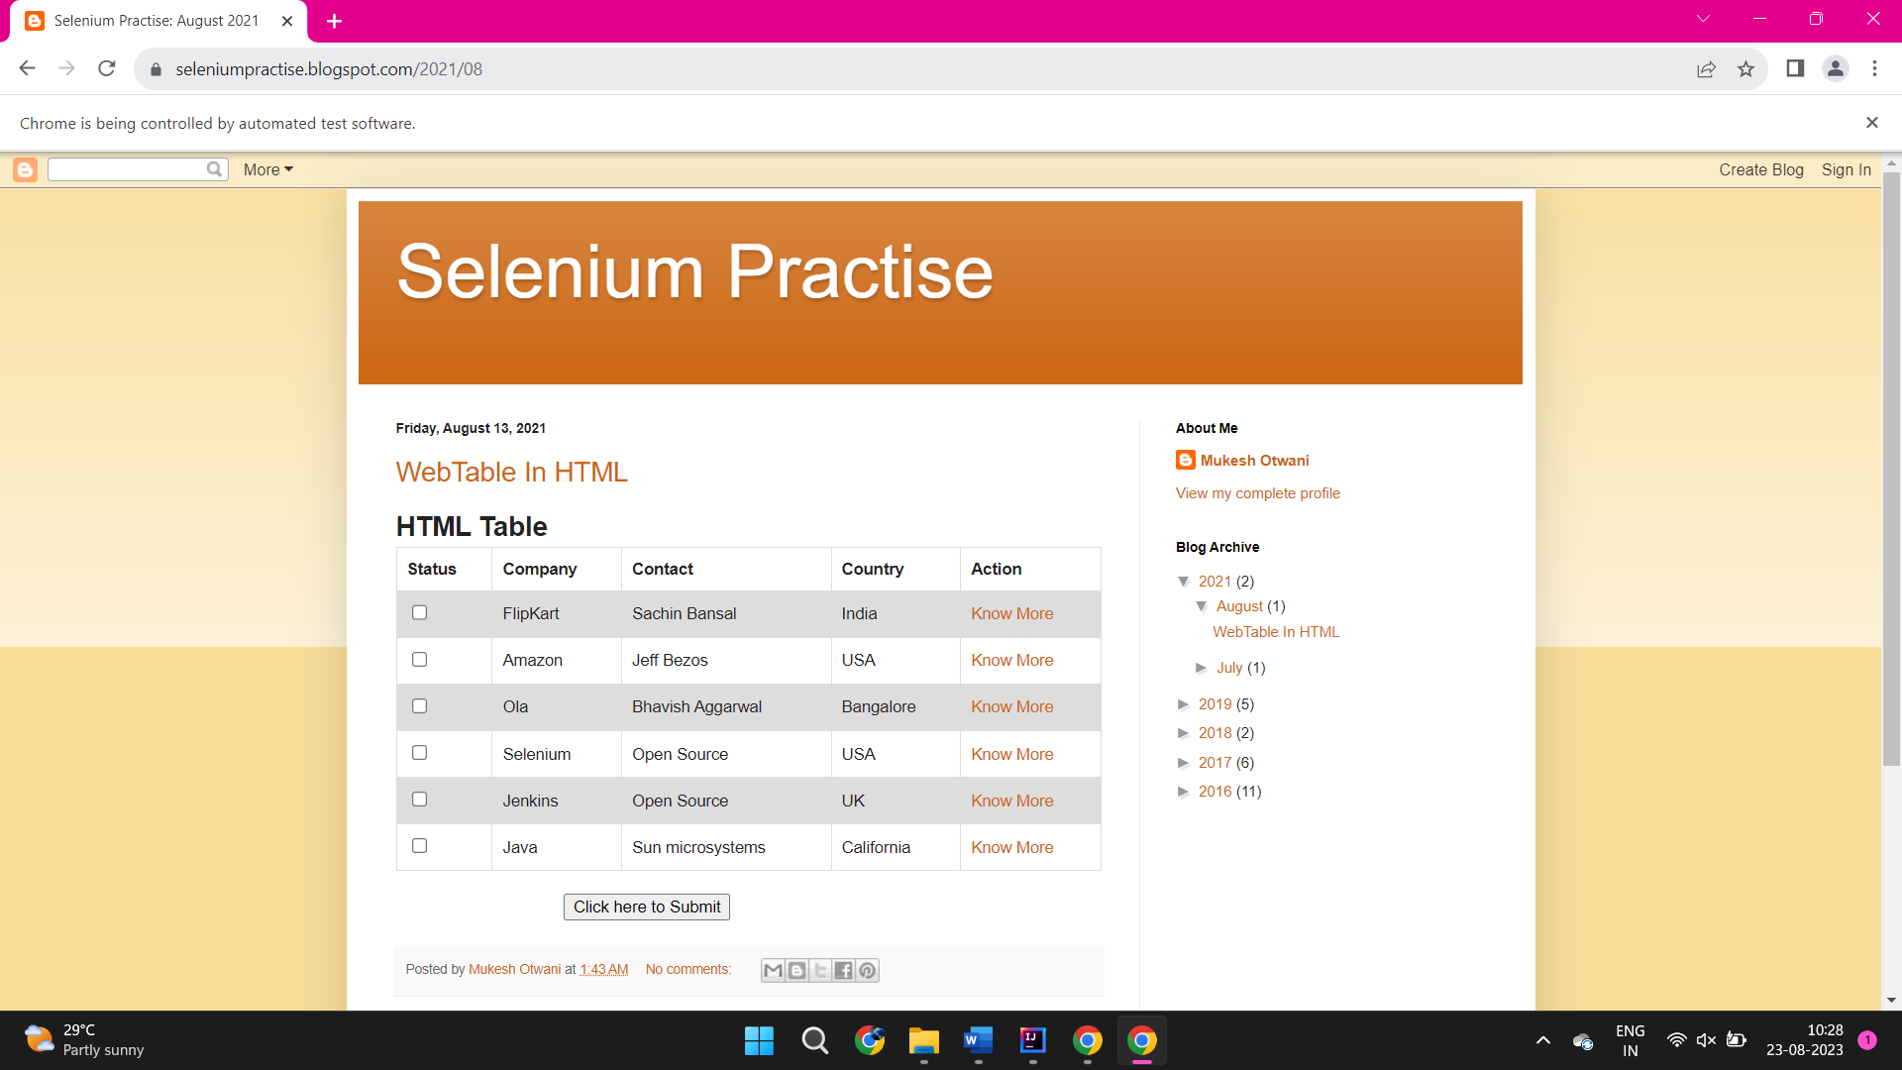
import org.openqa.selenium.By;
import org.openqa.selenium.WebDriver;
import org.openqa.selenium.WebElement;
import org.openqa.selenium.chrome.ChromeDriver;
import java.util.List;
public class P7table {
public static void main(String[] args) {
System.setProperty("webdriver.chrome.driver", "C:\\browserdriver\\chromedriver.exe");
WebDriver driver = new ChromeDriver();
driver.get("https://seleniumpractise.blogspot.com/2021/08");
driver.manage().window().maximize();
List<WebElement> list=driver.findElements(By.xpath("//table//th"));
System.out.println(list.size());
for(WebElement web:list){
String value= web.getText();
System.out.println(value);
}
}
}

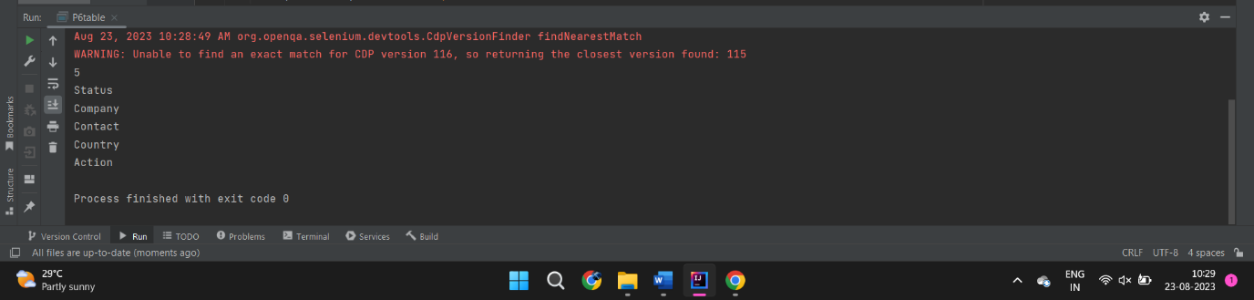
8) WPN to perform the Wait operation.
import org.openqa.selenium.WebDriver;
import org.openqa.selenium.chrome.ChromeDriver;
import java.util.concurrent.TimeUnit;
public class P8wait {
public static void main(String[] args) {
System.setProperty("webdriver.chrome.driver", "C:\\browserdriver\\chromedriver.exe");
WebDriver driver = new ChromeDriver();
driver.get("http://seleniumpractise.blogspot.com/2021/08");
driver.manage().timeouts().implicitlyWait(10, TimeUnit.SECONDS);
driver.manage().window().maximize();
driver.close();
}
}

9) WPN to perform the Validate the Login is Successful or Faild
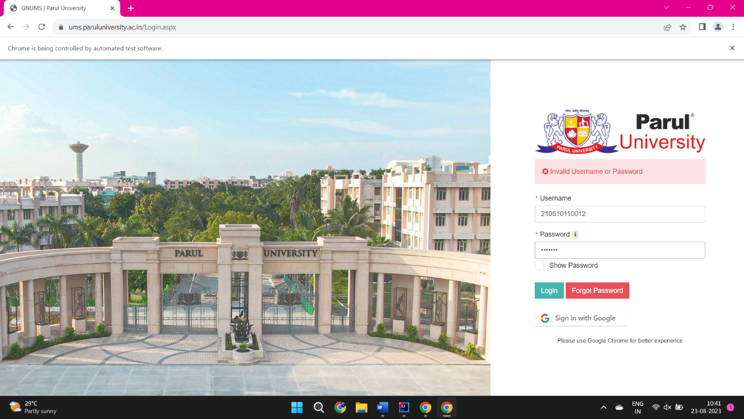
import org.openqa.selenium.By;
import org.openqa.selenium.WebDriver;
import org.openqa.selenium.WebElement;
import org.openqa.selenium.chrome.ChromeDriver;
public class P9login {
public static void main(String[] args) {
System.setProperty("webdriver.chrome.driver", "C:\\browserdriver\\chromedriver.exe");
WebDriver driver = new ChromeDriver();
driver.get("https://ums.paruluniversity.ac.in/Login.aspx");
WebElement username=driver.findElement(By.id("txtUsername"));
WebElement password=driver.findElement(By.id("txtPassword"));
WebElement login=driver.findElement(By.name("btnLogin"));
username.sendKeys("210510110012");
password.sendKeys("18092002");
login.click();
String actualUrl="https://ums.paruluniversity.ac.in/StudentPanel/StudentDashboard.aspx";
String expectedUrl= driver.getCurrentUrl(); if(actualUrl.equalsIgnoreCase(expectedUrl)) {
System.out.println("Login: passed"); } else { System.out.println("Login: Failed"); } } }
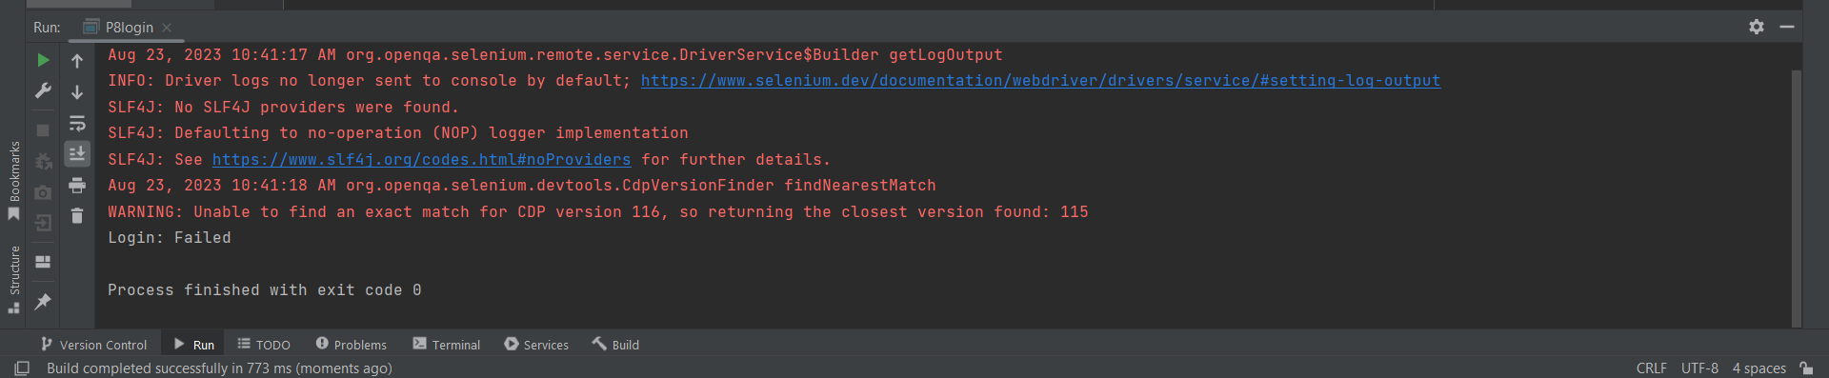

10) WPN to perform the Validate the Registration is Submit Successful or Failed
import org.openqa.selenium.By;
import org.openqa.selenium.WebDriver;
import org.openqa.selenium.WebElement;
import org.openqa.selenium.chrome.ChromeDriver;
import org.openqa.selenium.support.ui.Select;
public class P10registrationval {
public static void main(String[] args) throws InterruptedException {
System.setProperty("webdriver.chrome.driver", "C:\\browserdriver\\chromedriver.exe");
WebDriver driver = new ChromeDriver();
driver.get("https://nxtgenaiacademy.com/demo-site/");
driver.findElement(By.name("vfb-5")).sendKeys("hjgff");
driver.findElement(By.name("vfb-7")).sendKeys("hjhhhgff");
WebElement Raiobutton2 = driver.findElement(By.id("vfb-31-2"));
Raiobutton2.click();
Thread.sleep(1000);
driver.findElement(By.name("vfb-13[address]")).sendKeys("bshjbhsvgsvsfsfghsvhsvhcsvvshfvsdh");
driver.findElement(By.name("vfb-13[address-2]")).sendKeys("bshjbhsvgsvsfsfghsvhsvhcsvvshfvsdh");
driver.findElement(By.name("vfb-13[city]")).sendKeys("bsvvshfvsdh");
driver.findElement(By.name("vfb-13[state]")).sendKeys("svsfsfghsvhsv");
driver.findElement(By.name("vfb-13[zip]")).sendKeys("401202");
WebElement testDropDown = driver.findElement(By.name("vfb-13[country]"));
Select dropdown = new Select(testDropDown);
dropdown.selectByValue("Bangladesh");
driver.findElement(By.name("vfb-14")).sendKeys("hjgfgmail.com");
driver.findElement(By.name("vfb-18")).sendKeys("01/08/23");
WebElement testDropDown1 = driver.findElement(By.name("vfb-16[hour]"));
Select dropdown1 = new Select(testDropDown1);
dropdown1.selectByValue("06");
WebElement testDropDown2 = driver.findElement(By.name("vfb-16[min]"));
Select dropdown2 = new Select(testDropDown2);
dropdown2.selectByValue("20");
driver.findElement(By.name("vfb-19")).sendKeys("93745812455");
WebElement Checkbox = driver.findElement(By.name("vfb-20[]"));
boolean isSelected = Checkbox.isSelected();
if(isSelected == false){
Checkbox.click();
}
WebElement Checkbox1 = driver.findElement(By.id("vfb-20-3"));
boolean isSelected1 = Checkbox1.isSelected();
if(isSelected1 == false){
Checkbox1.click();
}
driver.findElement(By.name("vfb-23")).sendKeys("bfhavhavfhsavfhvfhavgfagsfvhavfafhavfhjahdbjhiajdkj");
driver.findElement(By.name("vfb-3")).sendKeys("44");
driver.findElement(By.name("vfb-submit")).click();
String actualUrl="https://nxtgenaiacademy.com/dynamictransaction/";
String expectedUrl= driver.getCurrentUrl(); if(actualUrl.equalsIgnoreCase(expectedUrl)) {
System.out.println("Test data submit "); } else { System.out.println("Test data failed"); } } }
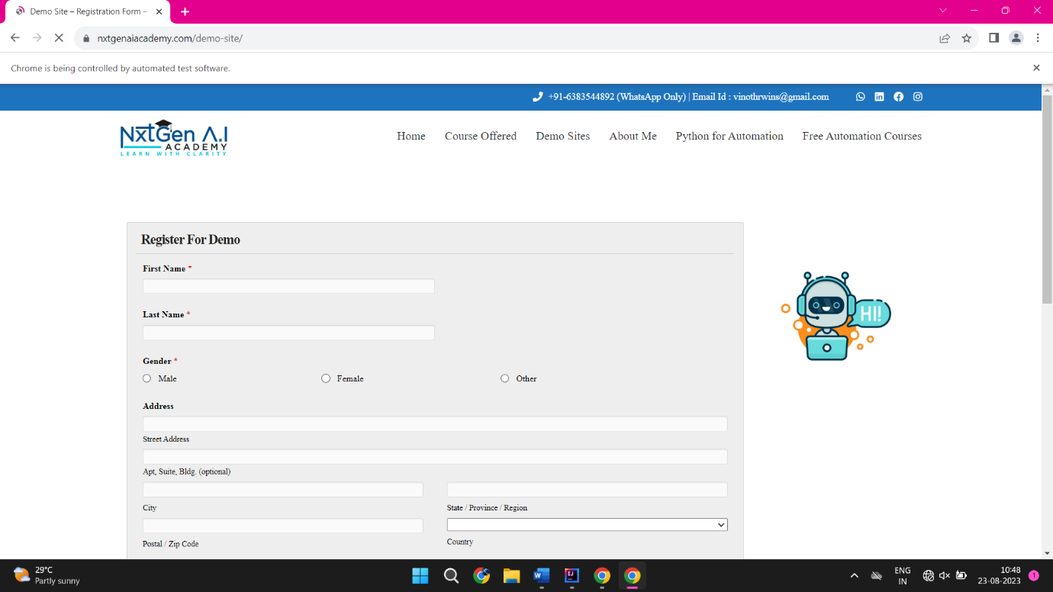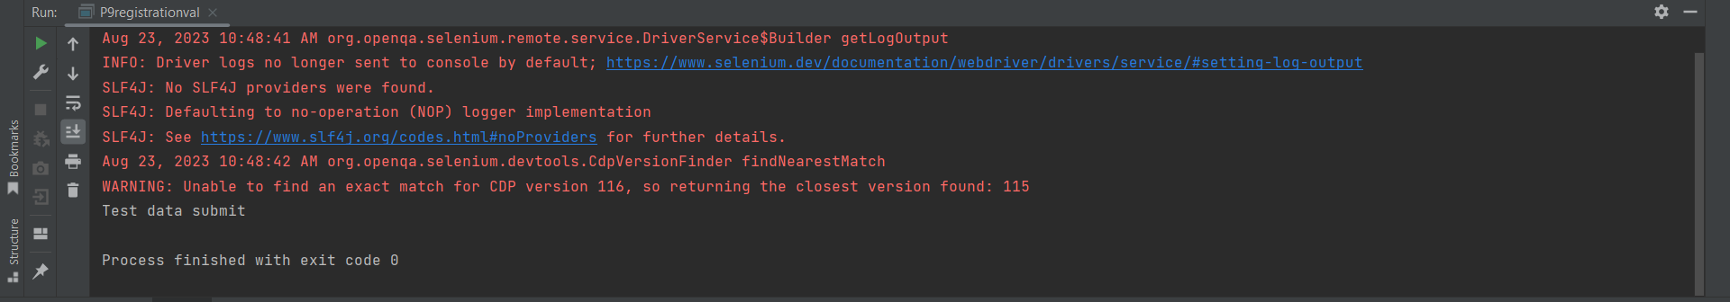

11) WPN to check the logo is present on the web page.
import org.openqa.selenium.By;
import org.openqa.selenium.WebDriver;
import org.openqa.selenium.WebElement;
import org.openqa.selenium.chrome.ChromeDriver;
public class P11logo {
public static void main(String[] args) {
System.setProperty("webdriver.chrome.driver", "C:\\browserdriver\\chromedriver.exe");
WebDriver driver = new ChromeDriver();
driver.get("https://www.google.com/");
driver.manage().window().maximize();
WebElement logoElement= driver.findElement(By.className("lnXdpd"));
if(logoElement != null){
System.out.println("Logo present");
}
else {
System.out.println("Logo is not present");
}
}
}
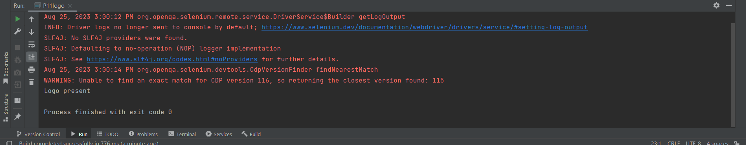

12)WPN to find numbers of links on a webpage.
import org.openqa.selenium.By;
import org.openqa.selenium.WebDriver;
import org.openqa.selenium.WebElement;
import org.openqa.selenium.chrome.ChromeDriver;
public class P12links {
public static void main(String[] args) {
System.setProperty("webdriver.chrome.driver", "C:\\browserdriver\\chromedriver.exe");
WebDriver driver = new ChromeDriver();
driver.get("https://www.google.com/");
driver.manage().window().maximize();
java.util.List<WebElement> links = driver.findElements(By.tagName("a"));
System.out.println("NUMBERS OF LINKS:- "+links.size());
driver.quit();
}
}
