WARNING for US Readers: For some meaningless reasons the hypophosphorous acid and its salts (including calcium hypophosphite) is included into DEA List I of chemicals, so its distributions is controlled and availability is limited. I'm really sorry, that this method is unavailable for US readers.
Described method does not use expensive, hazardous or hard to obtain chemicals, provides good adhesion of plated copper and has very good productivity, because all holes are processed at once. Sounds like miracle? But it is not.
Basically the method is very simple to use: just put board into activator solution, then into oven for about a half of hour, then wash it and put into galvanic bath to perform electroplating of the copper layer of necessary thickness. That't it. Of course the key is the activator solution. You need to prepare it once and then you can process several boards with it. While not in use solution can be stored for a long time without degradation of its properties.
Note, that description below does not include the electroplating step. There are several guides, recipes and detailed descriptions of the process, so I see no need to repeat them again. Especially taking into account, that most convenient one heavily depends on various conditions, availability of chemicals/materials and other things.
Lets begin with a little bit of history. This method uses ability of the some copper compounds to decompose under high temperature with the release of nano-particles of metallic copper. This allows to form a conductive layer on the processed surface and then deposit solid copper layer using regular electroplating. It was developed several years ago at the former USSR as a replacement for expensive palladium based method. After death of the USSR development of this method continued and at the beginning of the 90x group of the chemists leaded by Oleg Lomovsky obtained patent for the industrial version of the PCB through hole plating method (page is in Russian). This method was almost unknown to wide hobbyist audience until about year ago, when at VRTP.RU forum user JIN published his article (page is in Russian) about through hole plating. The article described early version of the method, which has some issues which prevented its use in industry, but most of these issues are irrelevant for home use. What is more important, the article described recipe of base activator solution suitable for repeating in home environment. In fact method described below heavily based on the same recipe. Since then method started quickly gaining popularity in Russian-speaking hobbyist communities.
As mentioned above, to use this method, we need an activator solution. Next step describes preparation of the activator solution in details.

Step 1: Preparing activator solution

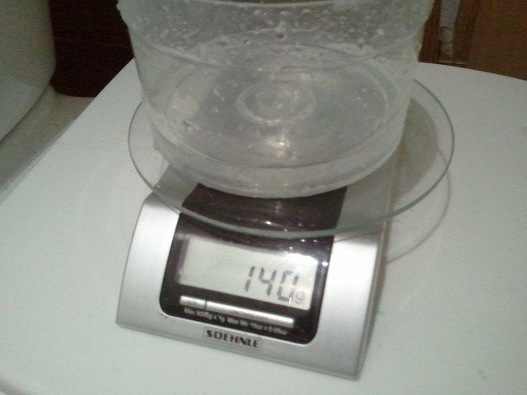
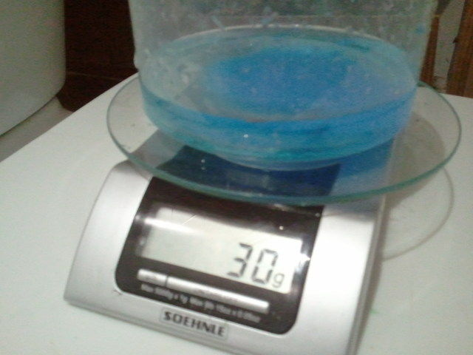
WARNING! DO NOT WORK WITH CHEMICALS WITHOUT GLOVES!
Although all ingredients are not hazardous in general, they still present danger to your skin.
Also, it is suggested to perform final steps of the solution preparation at the open air or with very good ventilation (keeping window open might be not enough). See below why.
To prepare an activator solution we will need following things:
1. Distilled water
2. Copper sulfate
3. Calcium hypophosphite (Ca(H2PO2)2)
4. Ammonium hydroxide (25%)
5. Liquid soap
All ingredients are required in small quantities (see below) and most of them are widely available. The only less accessible component is calcium hypophosphite, but in fact it is not rare nor expensive, just can't be purchased in nearest drugstore or Home Depot. Probably simplest way to obtain it is just buy online as an analytic reagent. Minimal quantities usually about 1kg, this will be enough to open your own small PCB shop :)
The activator solution is prepared as follows.
1. Take 140ml of water and dissolve 30g of copper sulfate in it. Stir until all copper sulfate is dissolved. At this point solution will get light blue color.
2. Pour into solution 22g of calcium hypophosphite and carefully stir it for 3-4 minutes. Once you pour calcium hypophosphite into solution, there will appear sediment which change solution color to white-blue. The sediment consists mostly of gypsum (calcium phosphate). Note that there is quite high amounts of sediment, so use at least 0.5 liter cans for preparing solution.
3. Filter the solution through funnel with filter paper placed into it. Again, use large funnel. Also, at the end speed of the filtering might be quite slow, so be patient. The solution should have light blue (perhaps a little dull) color.
4. Pour through the sediment another 100ml of water.
5. Remove funnel and add 40ml of 25% ammonium hydroxide. WARNING! This reagent stink! So, while you'll be doing this, try to keep nose as far from the solution as possible. Once ammonium hydroxide is dissolved in the solution, it stinks much less, so activation solution is usable indoor, although it still stink so the container with the solution should not be left open for long time. The solution quickly thicken for some time and you'll see white flakes, but they quite quickly disappear and solution obtains deep blue color. You may speedup this process by stirring the solution.
6. Add about 5-6ml of liquid soap and stir for few seconds.
7. Add about 8-10g of calcium hypophosphite. Part of it will dissolve, but part of it will remain as a sediment in the solution. Stir solution for few seconds to speedup process.
Solution is ready. It is quite stable and can be stored for a long time without loosing its properties. Use tightly closed container and store it in dry place, away from direct sunlight and out of reach of children and pets. Since solution contains copper compounds, it might be toxic if you'll drink it, so it is not recommended to do so :)
Solution requires maintenance, especially if used intensively. Maintenance is quite simple - just check from time to time if there is still calcium hypophosphite sediment at the bottom of the container where solution is stored and if necessary add few grams of calcium hypophosphite.
Once you prepared the solution you're ready for the next step.
Images provided below show activator solution at different stages of preparation.

Step 2: Preparing copper laminate

Preparation of the laminate is very important step, it actually defines quality of holes after plating, so take special attention to this step.
1. Cut laminate to size slightly larger than board size. One edge usually is used for the fixing board during electroplating, so at one side make larger margin.
2. Drill the board. All drills must be of exact necessary size, there will be no chance to drill hole of larger diameter without destroying copper in hole once hole is plated. Use tungsten carbide drill bits to get clean holes suitable for the plating.
3. Carefully inspect all holes against the light source and make sure there are no copper chips left in the holes.
4. Carefully sand copper surface with the flint paper of largest available number (i.e. with the smallest size of abrasive particles) and make sure that there are no copper borders around holes, especially at the opposite side.
5. Carefully wash the board using dishwashing detergent with soft abrasive, for example Cif or something like that.
6. Finally carefully rinse the board in water.
7. Inspect holes again and make sure they are clean.
The board is ready for the next step.
Image shows prepared board right before activation.

Step 3: Activating the board surface

This process is quite simple:
WARNING! DO NOT TOUCH BOARD DURING THIS STEP, EVEN IN GLOVES! This may cause problems with the plating.
1. Open the container with the activator and slowly put horizontally oriented board into the solution for 2-3 seconds (do not touch the bottom of the container!) and then lift it slightly above the surface of the liquid to let the activator flow down. You'll see that liquid at the board changes its color around the holes. This does mean that activator freely flows through the holes and wets them properly. Check if color is changed around all holes and if not, slowly put board back into solution and immediately lift above the surface. Usually this step need not to be repeated more than twice. If this is not so, then you have problem with the holes, so rinse the board in large amount of water, fix the problem and repeat entire step again. It is not recommended to keep board in the activator more than few seconds because this may result to problems at the further steps.
2. Once holes are wet, put board off the solution, rotate it vertically and let excessive activator flow down back to container.
3. Once most of the excessive activator flew down, close the container and distribute remaining activator as uniformly as possible by rotating board.
Once activator is distributed, board is ready for the next step.
Image shows activated board. Notice that all holes hold the activator. There is no need to remove it specially, but also no need to do anything if some hole lacks the activator film inside.

Step 4: Thermal treating

To perform this operation you'll need some kind of electric oven. The monitoring and controlling of temperature is necessary.
1. Put board into the oven and start heating. When temperature reaches 125 degrees (Celsius) hold it at this level for at least 10 minutes (12-15 minutes highly recommended).
2. Resume heating until it reaches 175 degrees and hold it at this level for at least 5 minutes (7-8 minutes highly recommended).
3. Stop heating and open oven but keep board inside until it's temperature crosses point 100 degrees.
At this point board has thin copper layer at most surfaces (including holes) covered with thick layer of remaining products of pyrolysis of the activator. All we need to do is just gently remove these products from the board as the next step.
Images shown below show the board after first and after second stage of thermal treating.

Step 5: Cleaning up the board

This step is quite simple: just gently rinse the board in the water using soft sponge and some liquid soap. WARNING: Do not use washing liquids with soft abrasives at this step! The copper layer is very thin and can be damaged. Unlikely that you'll be able to remove it completely (adhesion is quite good), but you may break electrical connection between deposited layer inside holes and laminated copper. During electroplating lack of connection results to lack of copper deposition. So, be careful at this step.
Once board is cleaned up it is ready for the electroplating.
Image shows the board seen at previous steps after about 5 minutes (out of required ~60) of electroplating (i.e. it's almost the very beginning of the process). All holes are already plated with smooth shiny copper layer.

