Autor - Michał Kuśmidrowicz 244021  
Zadanie 2 - Program na ocenę bardzo dobrą

∑ = {a, b, c, 0, 1, 2, 3}  
q0 = q0  
Q = {q0, q1, q2, q3, q4, q5, q6, q7, q8, q9, q10, q11, q12, q13, q14, q15, q16, q17, q18}  
A = {q9, q18}   
δ = Q x ∑ ∪ {ε} -> 2Q

Tablica przejść:

|  |  |  |  |  |  |  |  |  |
| --- | --- | --- | --- | --- | --- | --- | --- | --- |
|  | a | b | c | 0 | 1 | 2 | 3 | ε |
| q0 |  | - | - | - | - | - | - | {q1, q2} |
| q1 | {q1, q3} | {q1, q4} | {q1, q5} | - | - | - | - | - |
| q2 | - | - | - | {q2, q10} | {q2, q11} | {q2, q12} | {q2, q13} | - |
| q3 | q6 | - | - | - | - | - | - | - |
| q4 | - | q7 | - | - | - | - | - | - |
| q5 | - | - | q8 | - | - | - | - | - |
| q6 | q9 | - | - | - | - | - | - | - |
| q7 | - | q9 | - | - | - | - | - | - |
| q8 | - | - | q9 | - | - | - | - | - |
| q9 | q9 | q9 | q9 | - | - | - | - | - |
| q10 | - | - | - | q14 | - | - | - | - |
| q11 | - | - | - | - | q15 | - | - | - |
| q12 | - | - | - | - | - | q16 | - | - |
| q13 | - | - | - | - | - | - | q17 | - |
| q14 | - | - | - | q18 | - | - | - | - |
| q15 | - | - | - |  | q18 |  |  | - |
| q16 | - | - | - | - | - | q18 | - | - |
| q17 | - | - | - | - | - | - | q18 | - |
| q18 | - | - | - | q18 | q18 | q18 | q18 | - |

Opis atrybutów stanów końcowych:

q9 – we wprowadzonym słowie wystąpiło potrojenie liter zdefiniowanych jako symbole alfabetu  
q18 – we wprowadzonym słowie wystąpiło potrojenie cyfr zdefiniowanych jako symbole alfabetu

Model automatu:

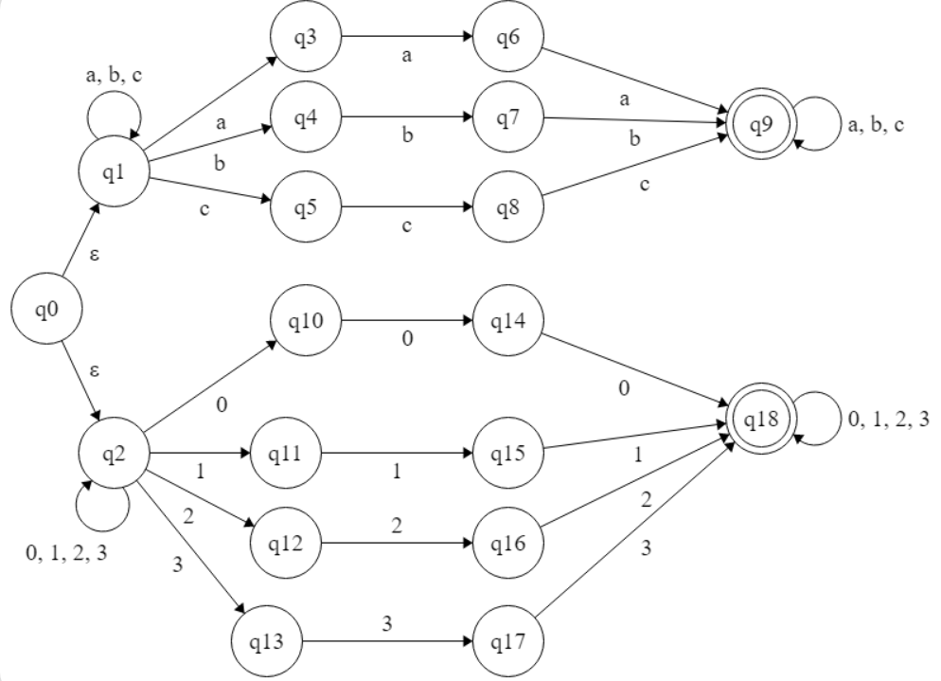

Sprawdzenie poprawności działania (wygenerowane przez zamieszczony program w języku angielskim):

**1. abbbaac**

1. Traversed path consists of the following states: q0[ε], q1[a], q1[b], q1[b], q1[b], q1[a], q1[a], q1[c], q1[]

Last state is not in accepting state - a path does not lead to the solution

2. Traversed path consists of the following states: q0[ε], q1[a], q1[b], q1[b], q1[b], q1[a], q1[a], q1[c], q5[]

Last state is not in accepting state - a path does not lead to the solution

3. Traversed path consists of the following states: q0[ε], q1[a], q1[b], q1[b], q1[b], q1[a], q1[a], q3[c]

Last state is not in accepting state - a path does not lead to the solution

4. Traversed path consists of the following states: q0[ε], q1[a], q1[b], q1[b], q1[b], q1[a], q3[a], q6[c]

Last state is not in accepting state - a path does not lead to the solution

5. Traversed path consists of the following states: q0[ε], q1[a], q1[b], q1[b], q1[b], q4[a]

Last state is not in accepting state - a path does not lead to the solution

6. Traversed path consists of the following states: q0[ε], q1[a], q1[b], q1[b], q4[b], q7[a]

Last state is not in accepting state - a path does not lead to the solution

7. Traversed path consists of the following states: q0[ε], q1[a], q1[b], q4[b], q7[b], q9[a], q9[a], q9[c], q9[]

Last state is in accepting state - a program is successfully finished

8. Traversed path consists of the following states: q0[ε], q1[a], q3[b]

Last state is not in accepting state - a path does not lead to the solution

9. Traversed path consists of the following states: q0[ε], q2[a]

Last state is not in accepting state - a path does not lead to the solution

~~~~~~~~~~~~~~~~~~~~~~~~~

**Program finished successfully** - the successful path leading to the accepting state consists of the following states: **q0[ε], q1[a], q1[b], q4[b], q7[b], q9[a], q9[a], q9[c], q9[]**

**2. 1111002123**

1. Traversed path consists of the following states: q0[ε], q1[1]

Last state is not in accepting state - a path does not lead to the solution

2. Traversed path consists of the following states: q0[ε], q2[1], q2[1], q2[1], q2[1], q2[0], q2[0], q2[2], q2[1], q2[2], q2[3], q2[]

Last state is not in accepting state - a path does not lead to the solution

3. Traversed path consists of the following states: q0[ε], q2[1], q2[1], q2[1], q2[1], q2[0], q2[0], q2[2], q2[1], q2[2], q2[3], q13[]

Last state is not in accepting state - a path does not lead to the solution

4. Traversed path consists of the following states: q0[ε], q2[1], q2[1], q2[1], q2[1], q2[0], q2[0], q2[2], q2[1], q2[2], q12[3]

Last state is not in accepting state - a path does not lead to the solution

5. Traversed path consists of the following states: q0[ε], q2[1], q2[1], q2[1], q2[1], q2[0], q2[0], q2[2], q2[1], q11[2]

Last state is not in accepting state - a path does not lead to the solution

6. Traversed path consists of the following states: q0[ε], q2[1], q2[1], q2[1], q2[1], q2[0], q2[0], q2[2], q12[1]

Last state is not in accepting state - a path does not lead to the solution

7. Traversed path consists of the following states: q0[ε], q2[1], q2[1], q2[1], q2[1], q2[0], q2[0], q10[2]

Last state is not in accepting state - a path does not lead to the solution

8. Traversed path consists of the following states: q0[ε], q2[1], q2[1], q2[1], q2[1], q2[0], q10[0], q14[2]

Last state is not in accepting state - a path does not lead to the solution

9. Traversed path consists of the following states: q0[ε], q2[1], q2[1], q2[1], q2[1], q11[0]

Last state is not in accepting state - a path does not lead to the solution

10. Traversed path consists of the following states: q0[ε], q2[1], q2[1], q2[1], q11[1], q15[0]

Last state is not in accepting state - a path does not lead to the solution

11. Traversed path consists of the following states: q0[ε], q2[1], q2[1], q11[1], q15[1], q18[0], q18[0], q18[2], q18[1], q18[2], q18[3], q18[]

Last state is in accepting state - a program is successfully finished

12. Traversed path consists of the following states: q0[ε], q2[1], q11[1], q15[1], q18[1], q18[0], q18[0], q18[2], q18[1], q18[2], q18[3], q18[]

Last state is in accepting state - a program is successfully finished

~~~~~~~~~~~~~~~~~~~~~~~~~

**Program finished successfully** - the successful path leading to the accepting state consists of the following states: **q0[ε], q2[1], q11[1], q15[1], q18[1], q18[0], q18[0], q18[2], q18[1], q18[2], q18[3], q18[]**

**3. 213312**

1. Traversed path consists of the following states: q0[ε], q1[2]

Last state is not in accepting state - a path does not lead to the solution

2. Traversed path consists of the following states: q0[ε], q2[2], q2[1], q2[3], q2[3], q2[1], q2[2], q2[]

Last state is not in accepting state - a path does not lead to the solution

3. Traversed path consists of the following states: q0[ε], q2[2], q2[1], q2[3], q2[3], q2[1], q2[2], q12[]

Last state is not in accepting state - a path does not lead to the solution

4. Traversed path consists of the following states: q0[ε], q2[2], q2[1], q2[3], q2[3], q2[1], q11[2]

Last state is not in accepting state - a path does not lead to the solution

5. Traversed path consists of the following states: q0[ε], q2[2], q2[1], q2[3], q2[3], q13[1]

Last state is not in accepting state - a path does not lead to the solution

6. Traversed path consists of the following states: q0[ε], q2[2], q2[1], q2[3], q13[3], q17[1]

Last state is not in accepting state - a path does not lead to the solution

7. Traversed path consists of the following states: q0[ε], q2[2], q2[1], q11[3]

Last state is not in accepting state - a path does not lead to the solution

8. Traversed path consists of the following states: q0[ε], q2[2], q12[1]

Last state is not in accepting state - a path does not lead to the solution

~~~~~~~~~~~~~~~~~~~~~~~~~

**Program did not finish successfully** - there is no successful path leading to the accepting state

**4. abcaaac**

1. Traversed path consists of the following states: q0[ε], q1[a], q1[b], q1[c], q1[a], q1[a], q1[a], q1[c], q1[]

Last state is not in accepting state - a path does not lead to the solution

2. Traversed path consists of the following states: q0[ε], q1[a], q1[b], q1[c], q1[a], q1[a], q1[a], q1[c], q5[]

Last state is not in accepting state - a path does not lead to the solution

3. Traversed path consists of the following states: q0[ε], q1[a], q1[b], q1[c], q1[a], q1[a], q1[a], q3[c]

Last state is not in accepting state - a path does not lead to the solution

4. Traversed path consists of the following states: q0[ε], q1[a], q1[b], q1[c], q1[a], q1[a], q3[a], q6[c]

Last state is not in accepting state - a path does not lead to the solution

5. Traversed path consists of the following states: q0[ε], q1[a], q1[b], q1[c], q1[a], q3[a], q6[a], q9[c], q9[]

Last state is in accepting state - a program is successfully finished

6. Traversed path consists of the following states: q0[ε], q1[a], q1[b], q1[c], q5[a]

Last state is not in accepting state - a path does not lead to the solution

7. Traversed path consists of the following states: q0[ε], q1[a], q1[b], q4[c]

Last state is not in accepting state - a path does not lead to the solution

8. Traversed path consists of the following states: q0[ε], q1[a], q3[b]

Last state is not in accepting state - a path does not lead to the solution

9. Traversed path consists of the following states: q0[ε], q2[a]

Last state is not in accepting state - a path does not lead to the solution

~~~~~~~~~~~~~~~~~~~~~~~~~

**Program finished successfully** - the successful path leading to the accepting state consists of the following states: **q0[ε], q1[a], q1[b], q1[c], q1[a], q3[a], q6[a], q9[c], q9[]**

**5. 1300002**

1. Traversed path consists of the following states: q0[ε], q1[1]

Last state is not in accepting state - a path does not lead to the solution

2. Traversed path consists of the following states: q0[ε], q2[1], q2[3], q2[0], q2[0], q2[0], q2[0], q2[2], q2[]

Last state is not in accepting state - a path does not lead to the solution

3. Traversed path consists of the following states: q0[ε], q2[1], q2[3], q2[0], q2[0], q2[0], q2[0], q2[2], q12[]

Last state is not in accepting state - a path does not lead to the solution

4. Traversed path consists of the following states: q0[ε], q2[1], q2[3], q2[0], q2[0], q2[0], q2[0], q10[2]

Last state is not in accepting state - a path does not lead to the solution

5. Traversed path consists of the following states: q0[ε], q2[1], q2[3], q2[0], q2[0], q2[0], q10[0], q14[2]

Last state is not in accepting state - a path does not lead to the solution

6. Traversed path consists of the following states: q0[ε], q2[1], q2[3], q2[0], q2[0], q10[0], q14[0], q18[2], q18[]

Last state is in accepting state - a program is successfully finished

7. Traversed path consists of the following states: q0[ε], q2[1], q2[3], q2[0], q10[0], q14[0], q18[0], q18[2], q18[]

Last state is in accepting state - a program is successfully finished

8. Traversed path consists of the following states: q0[ε], q2[1], q2[3], q13[0]

Last state is not in accepting state - a path does not lead to the solution

9. Traversed path consists of the following states: q0[ε], q2[1], q11[3]

Last state is not in accepting state - a path does not lead to the solution

~~~~~~~~~~~~~~~~~~~~~~~~~

**Program finished successfully** - the successful path leading to the accepting state consists of the following states: **q0[ε], q2[1], q2[3], q2[0], q10[0], q14[0], q18[0], q18[2], q18[]**

**6. abcabcc**

1. Traversed path consists of the following states: q0[ε], q1[a], q1[b], q1[c], q1[a], q1[b], q1[c], q1[c], q1[]

Last state is not in accepting state - a path does not lead to the solution

2. Traversed path consists of the following states: q0[ε], q1[a], q1[b], q1[c], q1[a], q1[b], q1[c], q1[c], q5[]

Last state is not in accepting state - a path does not lead to the solution

3. Traversed path consists of the following states: q0[ε], q1[a], q1[b], q1[c], q1[a], q1[b], q1[c], q5[c], q8[]

Last state is not in accepting state - a path does not lead to the solution

4. Traversed path consists of the following states: q0[ε], q1[a], q1[b], q1[c], q1[a], q1[b], q4[c]

Last state is not in accepting state - a path does not lead to the solution

5. Traversed path consists of the following states: q0[ε], q1[a], q1[b], q1[c], q1[a], q3[b]

Last state is not in accepting state - a path does not lead to the solution

6. Traversed path consists of the following states: q0[ε], q1[a], q1[b], q1[c], q5[a]

Last state is not in accepting state - a path does not lead to the solution

7. Traversed path consists of the following states: q0[ε], q1[a], q1[b], q4[c]

Last state is not in accepting state - a path does not lead to the solution

8. Traversed path consists of the following states: q0[ε], q1[a], q3[b]

Last state is not in accepting state - a path does not lead to the solution

9. Traversed path consists of the following states: q0[ε], q2[a]

Last state is not in accepting state - a path does not lead to the solution

~~~~~~~~~~~~~~~~~~~~~~~~~

**Program did not finish successfully** - there is no successful path leading to the accepting state