A
SOFTWARE REQUIREMENT SPECIFICATION
ON
BLOOD BANK SYSTEM (BBS)
UNDER
NON - SYLLABUS PROJECT

Submitted To: Submitted By:
Dr. Vishnu Soni NEHA YADAV (PIET24CS113)
Assistant Professor NIRMAL YOGI (PIET24CS117)
DEPARTMENT OF COMPUTER ENGINEERING
POORNIMA INSTITUTE OF ENGINEERING & TECHNOLOGY, JAIPUR
Academic Year (2025-26)

BLOOD BANK SYSTEM (BBS) - PROJECT DOCUMENTATION

Chapter 1: Introduction of Project
1.1 Objective of Project
The main objective of the Blood Bank Management System (BBMS) is to automate and streamline the process of managing blood donation requests, approval workflows, and blood inventory tracking. This web-based system reduces manual effort, ensures real-time updates, and maintains accuracy in blood stock records.
The system provides a user-friendly interface for clients (donors/recipients) and administrators to efficiently manage blood donation requests and inventory.

1.2 Types of Users
- Clients (Donors/Recipients):
    - Can submit blood donation/request forms with personal details and health certificates.
    - Can select their blood group from a predefined list.
    - Receive confirmation after submission.
- Admin (Blood Bank Staff):
    - Can view and manage all incoming donor requests. o Can approve or reject donation requests.
    - Can monitor and update blood inventory (add/remove units per blood group).
    - Can log out securely.

1.3 Dependency
- Frontend Technologies: HTML, CSS, JavaScript
- Styling Framework: Custom CSS (with gradient background and responsive design)
- Data Storage: Local Storage (browser-based temporary storage)
- Development Environment: Visual Studio Code with Live Server
- Execution Platform: Any modern web browser (Google Chrome, Edge, Firefox, Safari)

1.4 Methodology Used (Waterfall Model)
The Waterfall Model is used for system development, following a sequential process:
- Requirement Gathering and Analysis
- System Design
- Implementation (Coding)
- Testing
- Deployment
- Maintenance

Chapter 2: Requirement Analysis
2.1 Functional Requirements
- Role-based access: Client and Admin login selection.
- Client request submission with name, blood group, and health certificate upload.
- Admin panel to view all donor requests with status (Pending/Approved/Rejected).
- Approve/Reject functionality for donation requests.
- Real-time blood inventory management (view, add, remove units per blood group).
- Logout feature for secure session termination.
- Data persistence using Local Storage.

2.2 Non-Functional Requirements
- Usability: Intuitive interface with clear buttons and visual feedback.
- Performance: Instant response for all actions (< 500ms).
- Reliability: Works offline after initial load using Local Storage.
- Portability: Fully compatible with modern desktop and mobile browsers.
- Scalability: Can be extended with backend (Node.js, PHP, Firebase) and database integration.
- Security: Role-based access; file upload validation (demo purposes).

2.3 Technology Used
- Frontend: HTML5, CSS3, Vanilla JavaScript
- Storage: LocalStorage API
- Tools: Visual Studio Code, Live Server Extension
- Hosting (Optional): GitHub Pages, Netlify, Vercel

2.4 Hardware Configuration
- Processor: Intel Core i3 or equivalent (or higher)
- RAM: Minimum 4 GB
- Storage: 500 MB free space
- Operating System: Windows / macOS / Linux
- Internet: Required only for hosting or initial load (offline-capable after)

2.5 Graphical User Interface The interface includes:
- Login Page: Role selection (Client / Admin) with attractive red-white theme.
- Client Portal: Form to enter name, select blood group, upload health certificate.
- Admin Dashboard:
    - View donor requests in tabular format.
    - Approve/Reject buttons (visible only for pending requests).
    - Manage blood inventory with + Add and - Remove buttons.
- Responsive Design: Mobile-friendly layout using flexible containers.
- Visual Feedback: Success messages, color-coded status (Green:
Approved, Orange: Pending, Red: Rejected).

Chapter 3: Design

3.1 Data Flow Diagram (DFD 1):
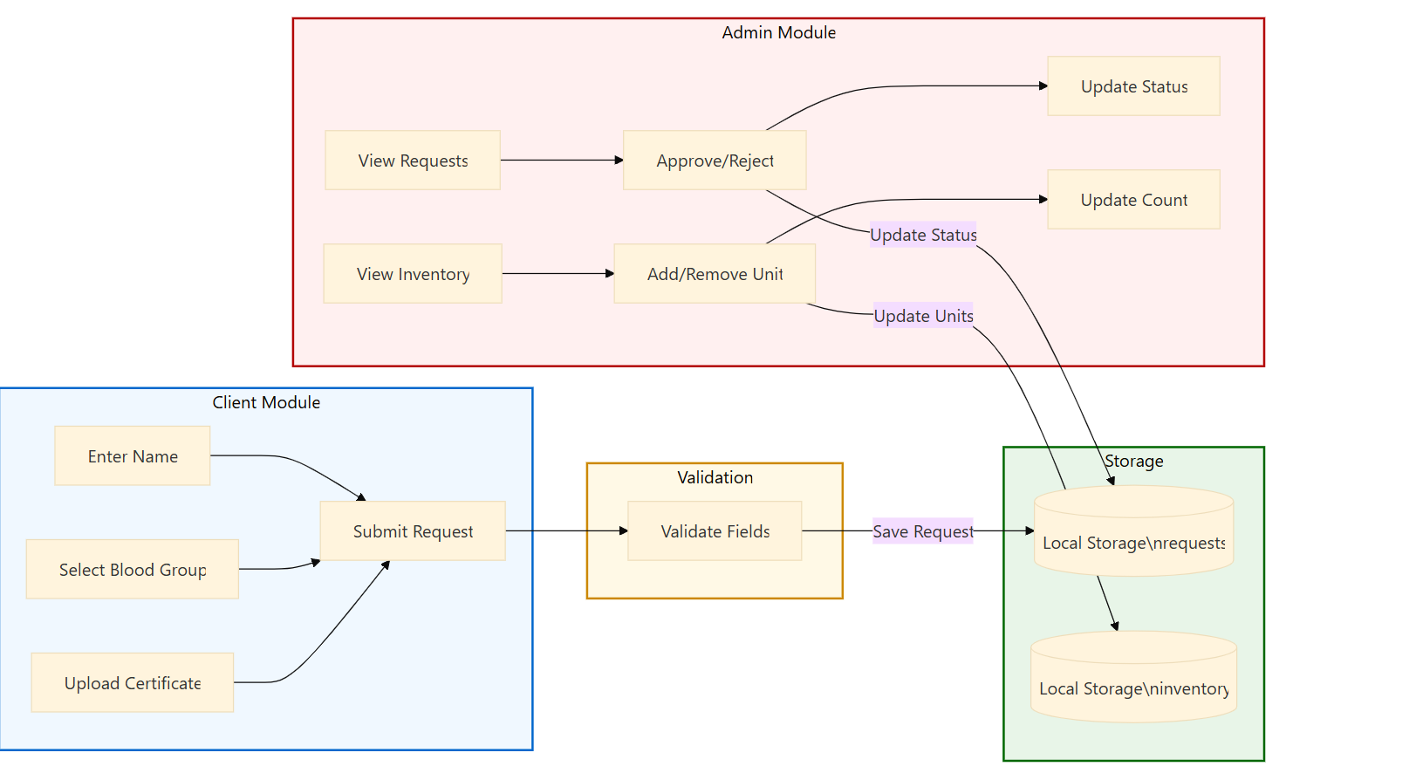

1. Data Flow Diagram (DFD 0) : 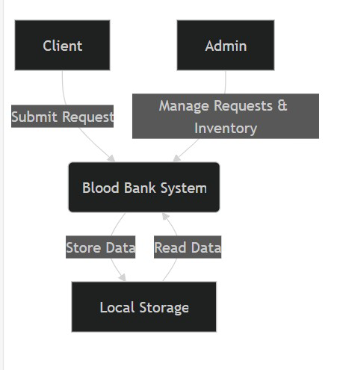

3.2 UML (Use Case Diagram)
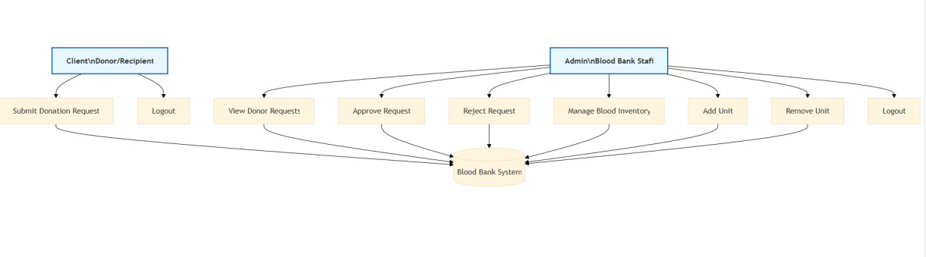

Chapter 4: Conclusion
The Blood Bank Management System (BBMS) efficiently digitizes blood donation request handling and inventory management through a lightweight, browser-based web application.
It eliminates paper-based processes, reduces errors, and enables instant tracking of blood units. The system demonstrates practical use of frontend web technologies and client-side persistence to build functional real-world applications.
Future Enhancements:
- Integrate backend (Node.js + MongoDB / PHP + MySQL)
- Add user authentication (email/password)
- Email/SMS notifications on approval
- Generate PDF reports
- Search and filter donor history
- Automated low-stock alerts

Chapter 5: References

- W3Schools – HTML, CSS, JavaScript Tutorials
- Mozilla Developer Network (MDN) – LocalStorage API Documentation
- FreeCodeCamp – JavaScript DOM Manipulation Guide
- Stack Overflow – Dynamic Table Rendering in JS
- Blood Bank Operational Guidelines – Indian Red Cross Society

Chapter 6: Snapshots of Project



