Practical No: 05
Aim : Understanding, Reading and Analyzing Routing Table of a network.
Steps :
1.Open Cisco Packet Tracer and Get 9 PC’s , 3 Switches , 3 Routers
2. Use Copper Straight-Through cable to connect: PCs ↔ Switches Switches ↔ Routers (FastEthernet interfaces) and Use Serial DCE Cable to connect Routers to each other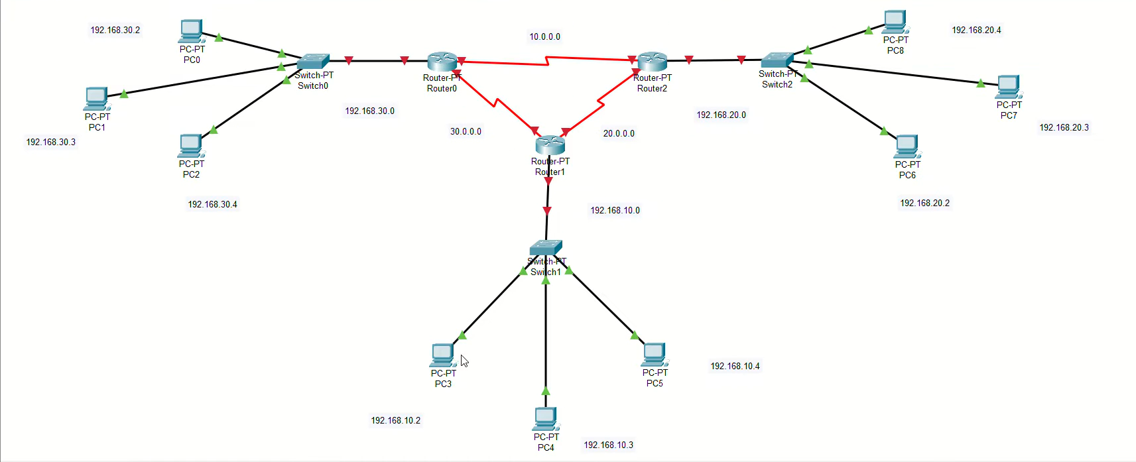
3. Assign IP Addresses :
Go to each PC → Desktop → IP Configuration :
This Above Steps Look like the below :
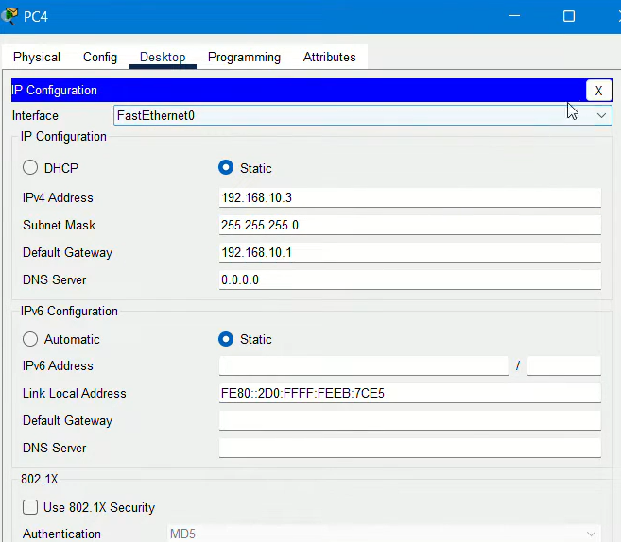
(Like wise all of the Others)

4. For Routers , Click on RoutersConfiginterfacefastEthernets/Serial ipConfigration(all 3 Routers) amd Turn On Prt status
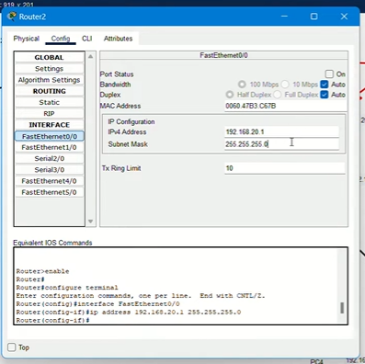

5. Now , Its times to set an Ip to RIP ALL ROUTERS
RouterconfigRIPat the place of network enter some others ips of gatewaysadd
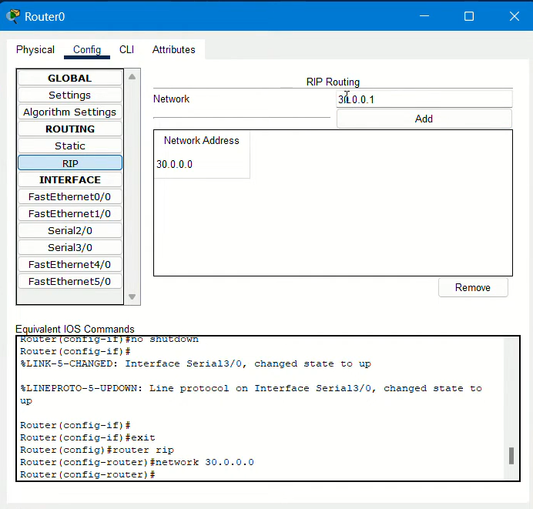
If your message is trasmitterd Correctly then Your Message is TRanmited Sucessfully and that message is shown below
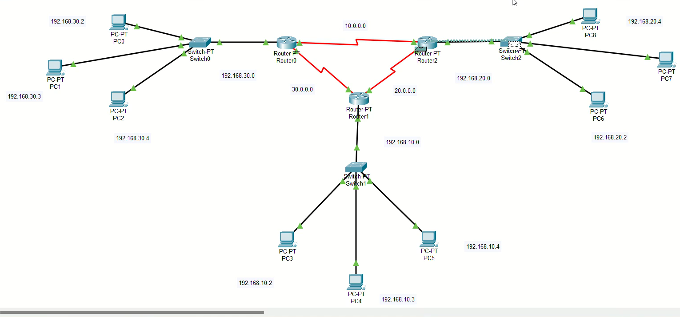
If Not the Try it gain or wait 30-40 seconds

Practical No.12
Aim: Network IP and basic network command and network configuration Commands,Simulation of Four Node Point to Point Network
Ping , ipconfig , hostname , getmac , arp , nslookup , nbtstat , net , netstat , taskkill , tracert , and route.
1.Ping :
1. ping www.google.com
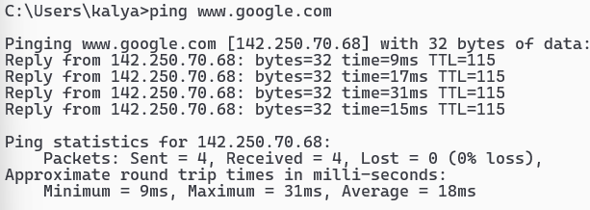
2. ping /?
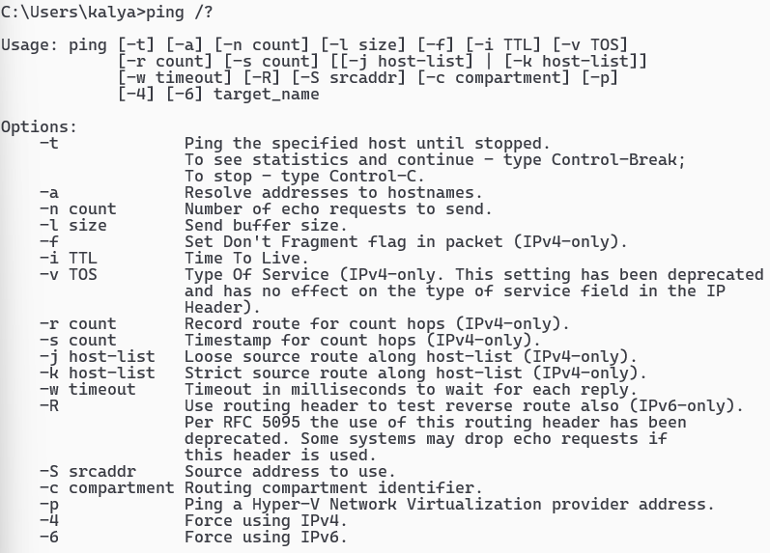
3. ping -4 www.google.com
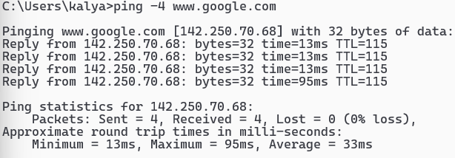

2.ipconfig : 3.hostname :
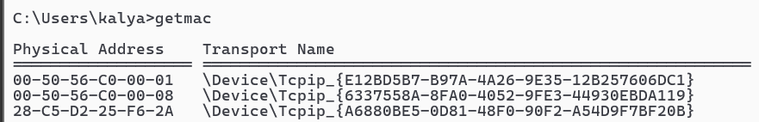

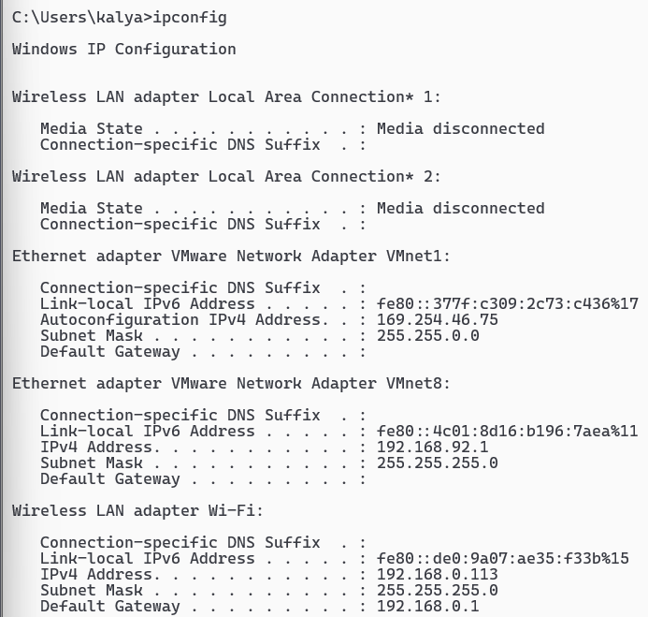
4. getmac

5. arp -a
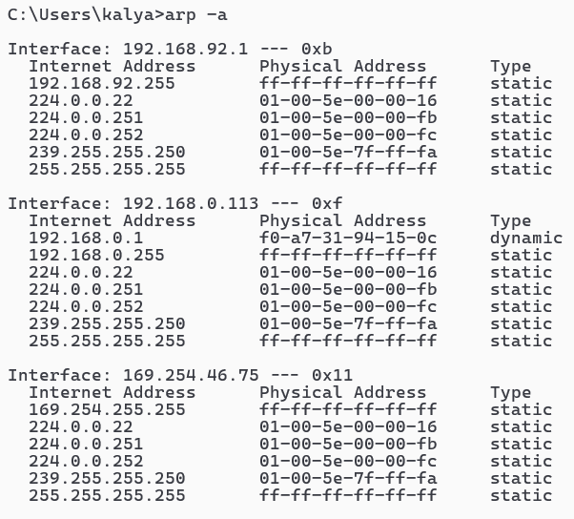
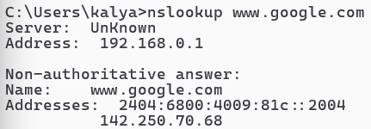
6. nslookup www.google.com

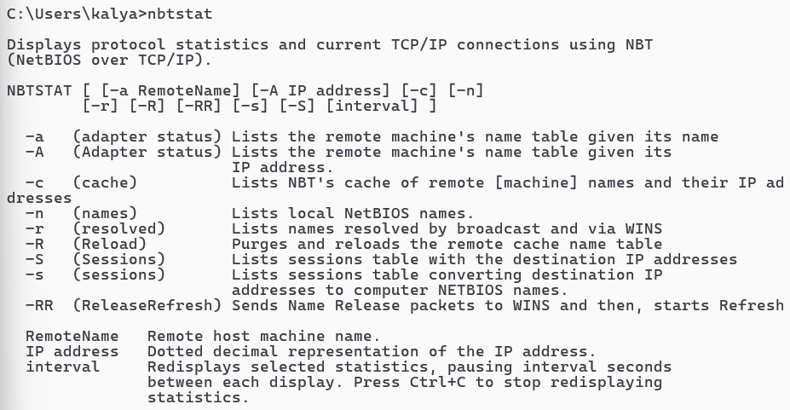
7.nbtstat 8.nbtstat -n :
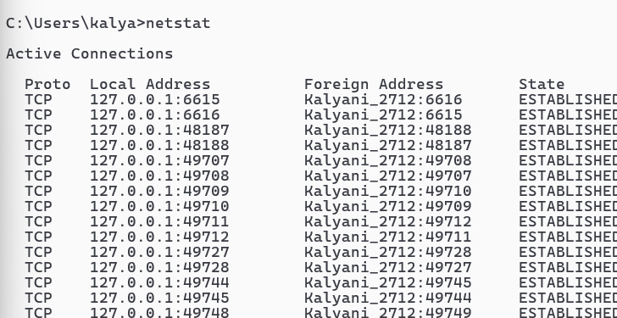
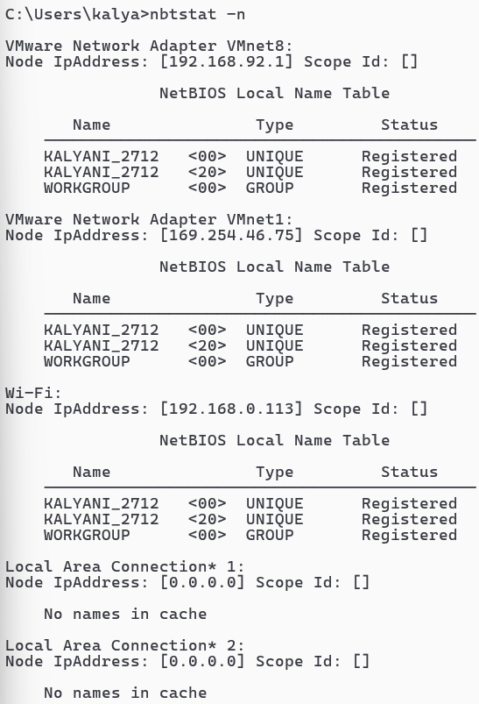

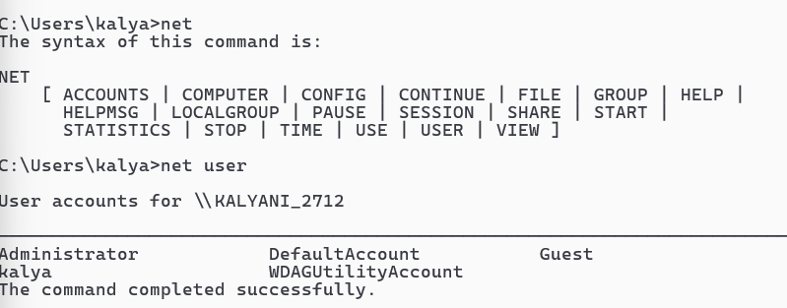
10. net and net user :

11. taskkill :
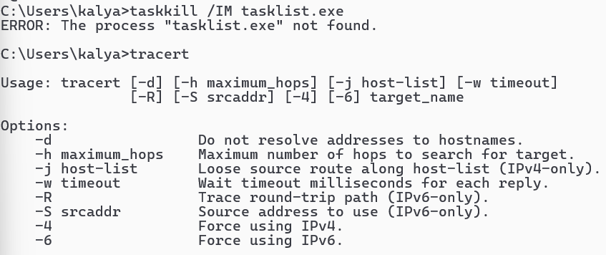
12. route print
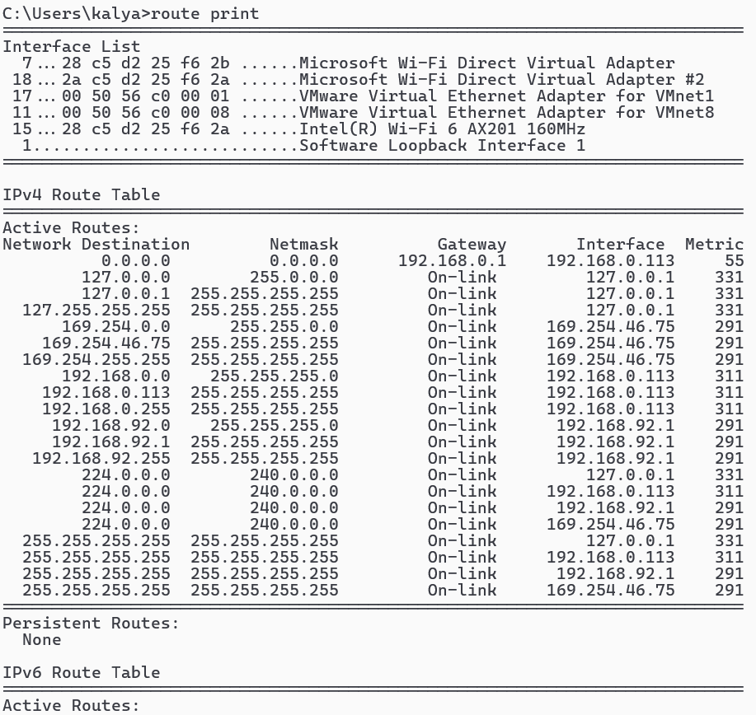

Practical No.09
Aim: Simulate Mobile Adhoc Network with Directional Antenna.
Steps :
- Open Cisco packet Tracer
- Now Take Devices like : fan , Motion detector sensor ,smartphone(SMARTPHONE-PT),Home Gateway0(DLC 100) and Create the Network :
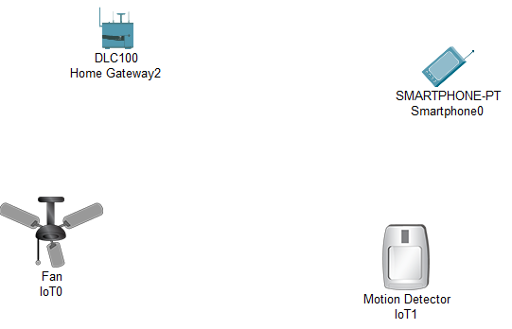
(DLC 100 will create a auto network with fan and motion detector)
3.Now Click on Fan -Config Global, select Home gateway
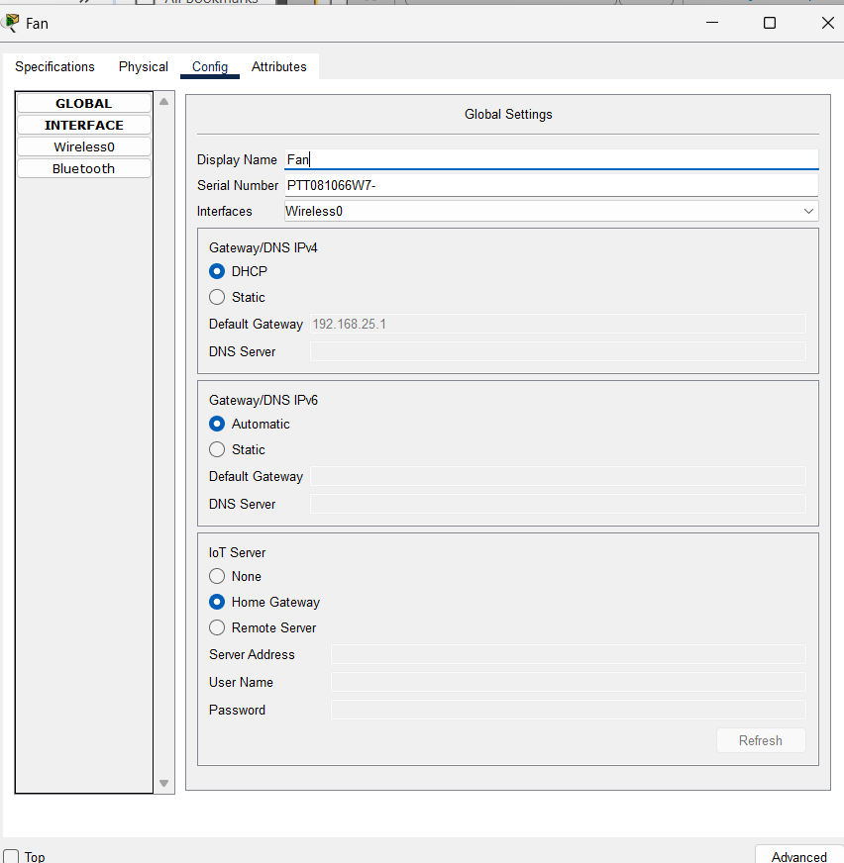
- Click on AdvancedI/O Configselect Network Adapter (PT-IOT-NM-1W)
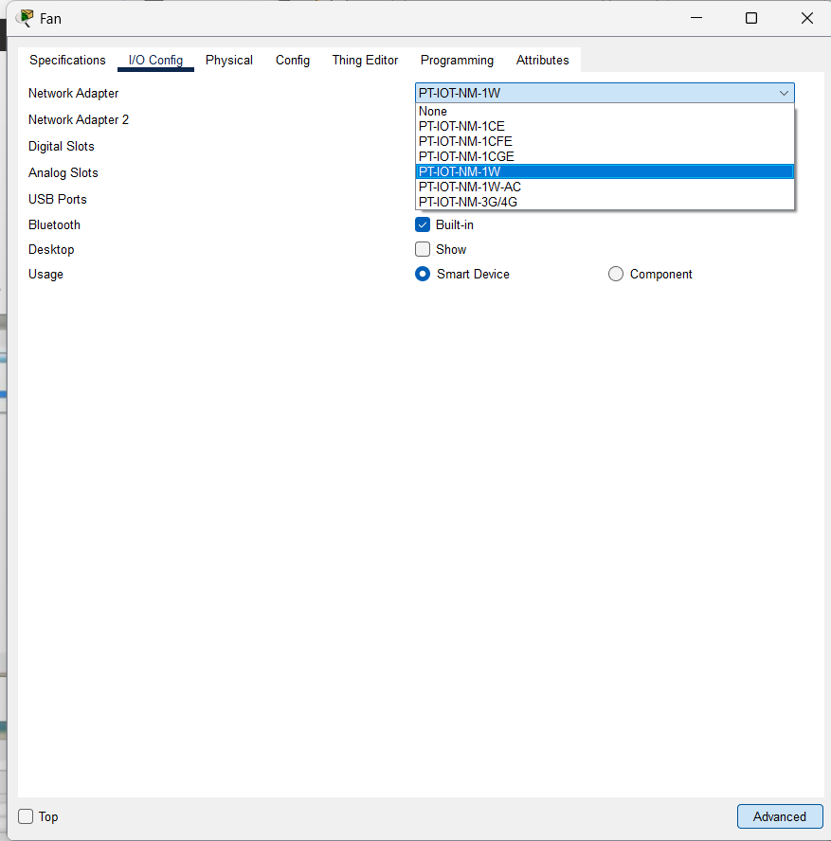
4.Click on Motion Detector (sensor) ConfigGlobalselect Home Gateway Advanced I/O Configselect Network Adapter(PT-IOT-NM-1W) and Tick off the Built-in
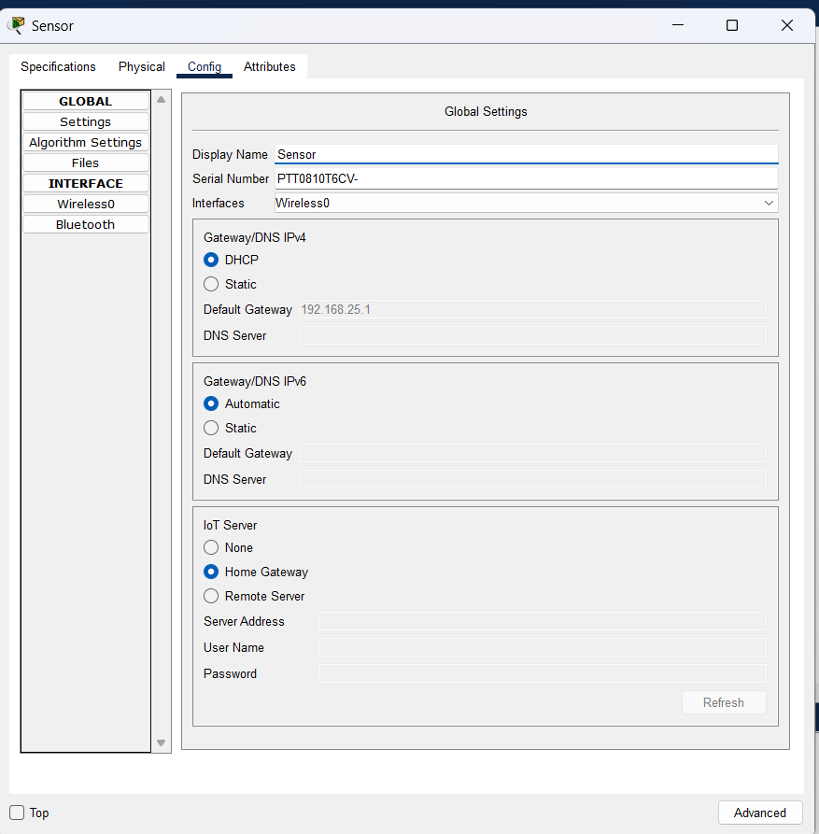

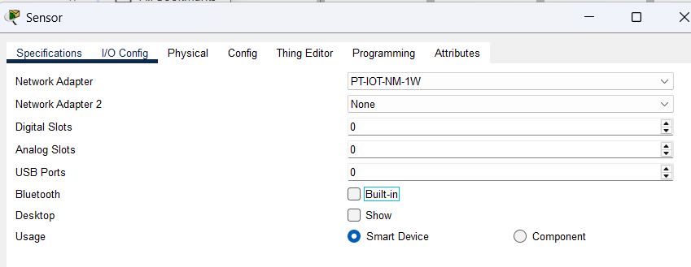

5. Click on HomeGateway ConfigWireless Change SSID to HomeGateway
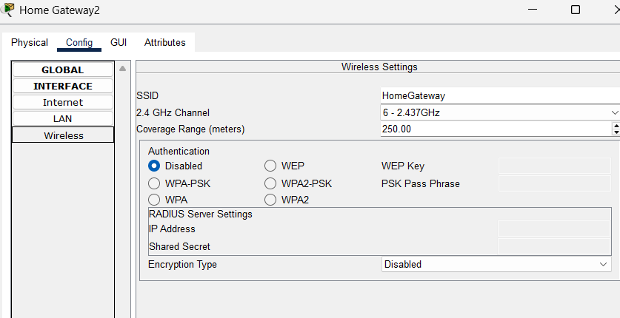
6. Select Smartphone Config Wireless0 SSID(HomeGateway)—Same as above gateway in Homegateway :
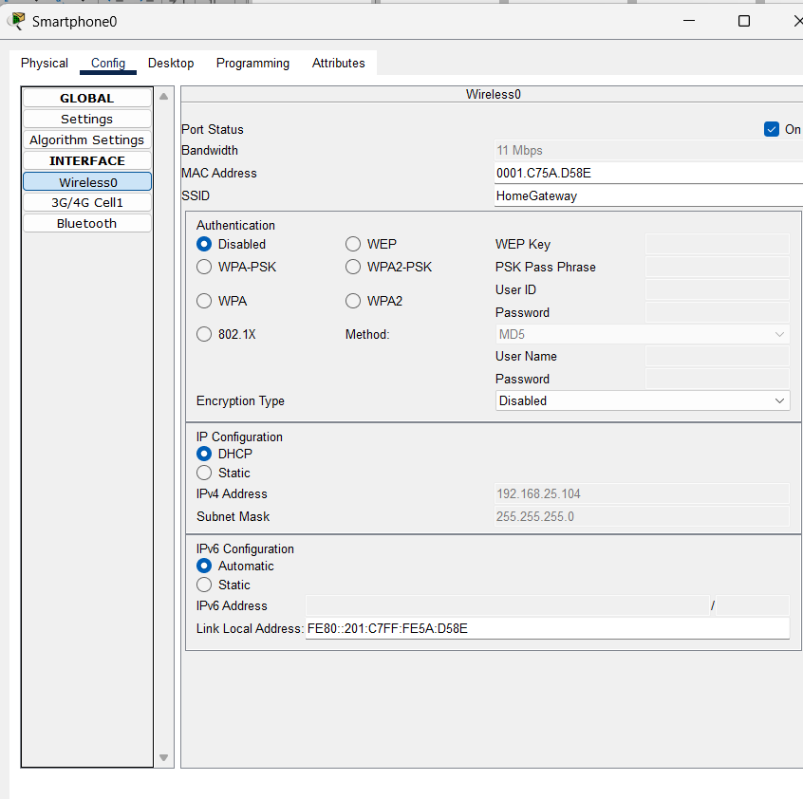
7.Now Open Web Browser in Smartphone :
Smartphonedesktopweb Browser and type ip address= 192.168.25.1 of the HomeGateway:
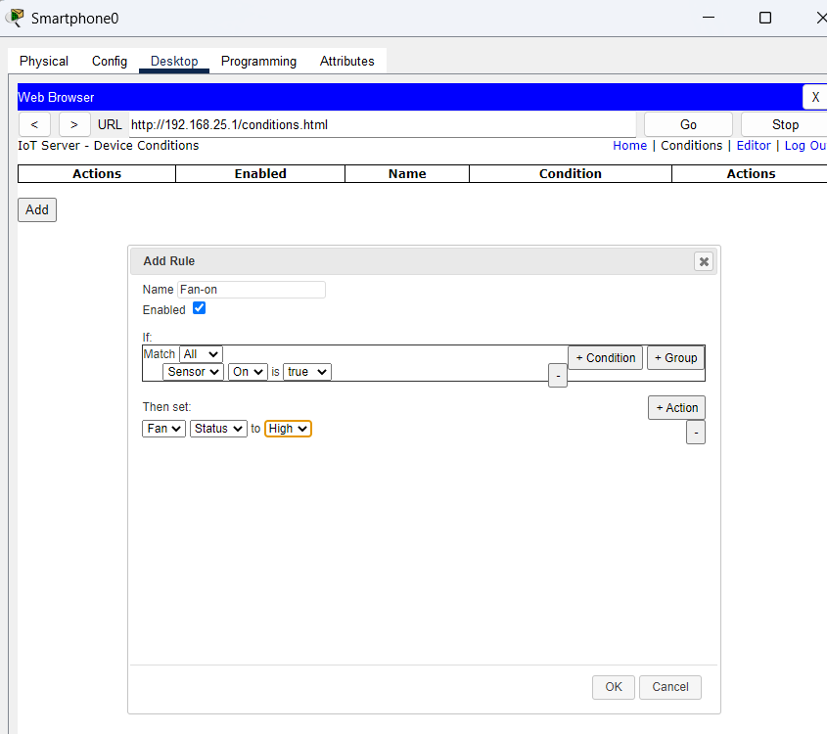
After Entering ,Enter UserNme:admin and password=admin after logging click on ConditionsaddConditionsfan on and off press Go
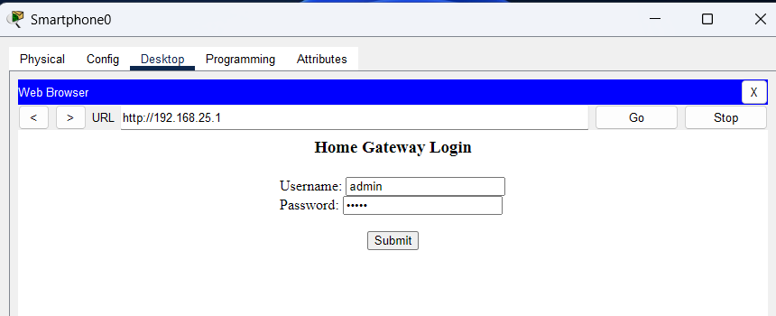
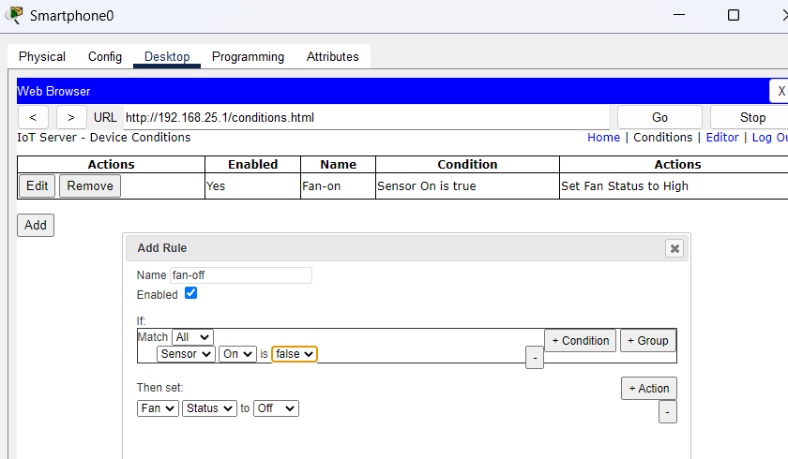

For , Turning on the fan press Alt key with leftclick mouse over the Sensor
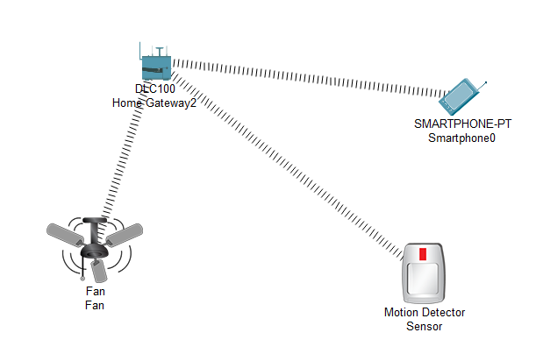
Practical No.10
Aim: Create a mobile network using Cell Tower, Central Office Server, Web browser and Web Server. Simulate connection between them.
Steps :
1.Open Cisco Packet Tracer and by using Devices(smartphone , wireless router WRT 300N , Hub-pt ,1841 router , cell tower , Central-office-server ) and Create A Network
2. Connect Cell tower and central office server with co-axial cable and routers,hub and centralod=ffice server using Copper Straight through wire.
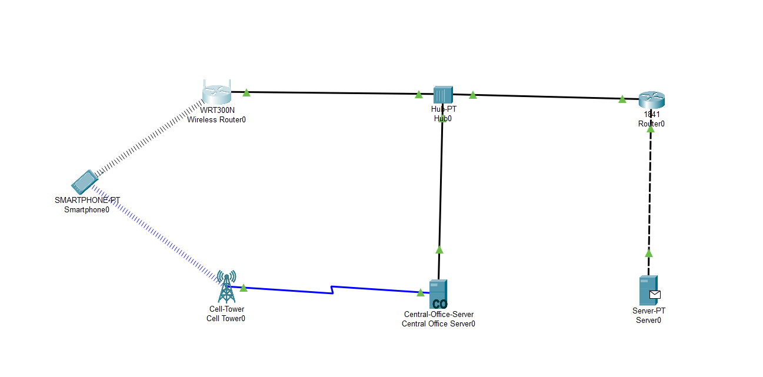
3.click on wireless Router WRT 300N config internetselect static set Ip addtress and Default gateway :
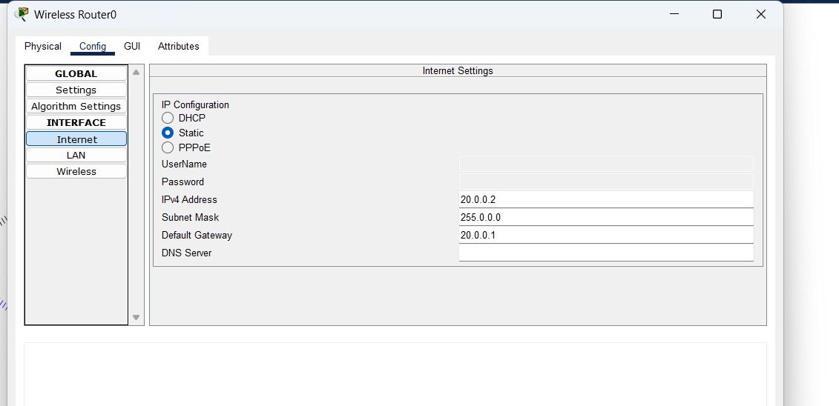
4. Next, Click on the Router 1841 , ConfigInterfaceFastTnternet0/0port status OnIpAddress Setting
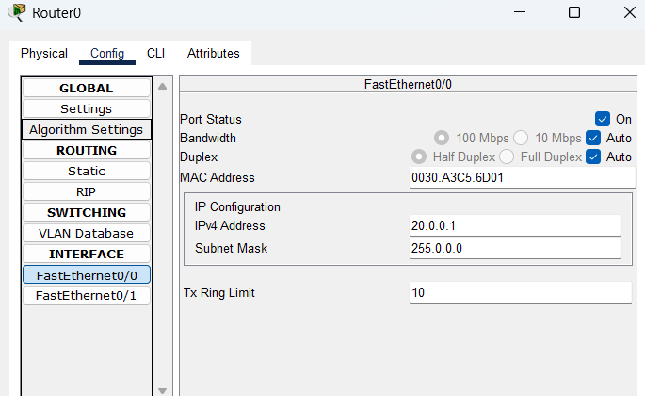
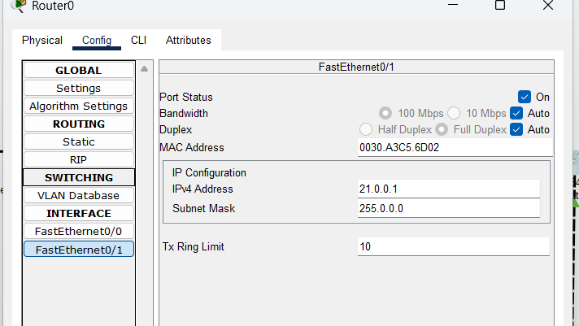

- goto server > config > global setting
set static then default gateway= 21.0.0.1
then goto fastethernet set static and ip address= 21.0.0.2 and ON
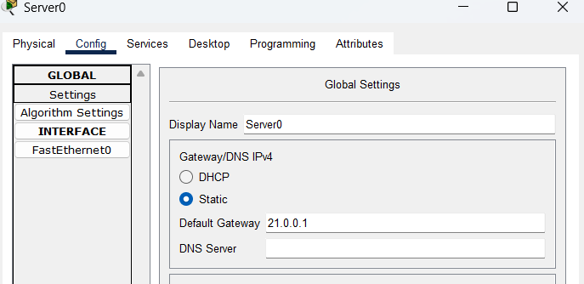

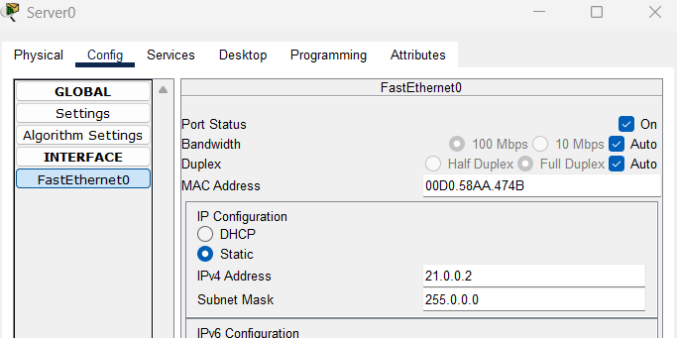
5. Now Next, Click on the SmartPhone .and Ping router 1841 :
SmartphoneDesktopCommand PromptPing 20.0.0.1

