Go To This URL : <https://business.facebook.com/commerce>

1. Go To Data Source Menu
2. On Data Feed Section, Click on Add New Feed

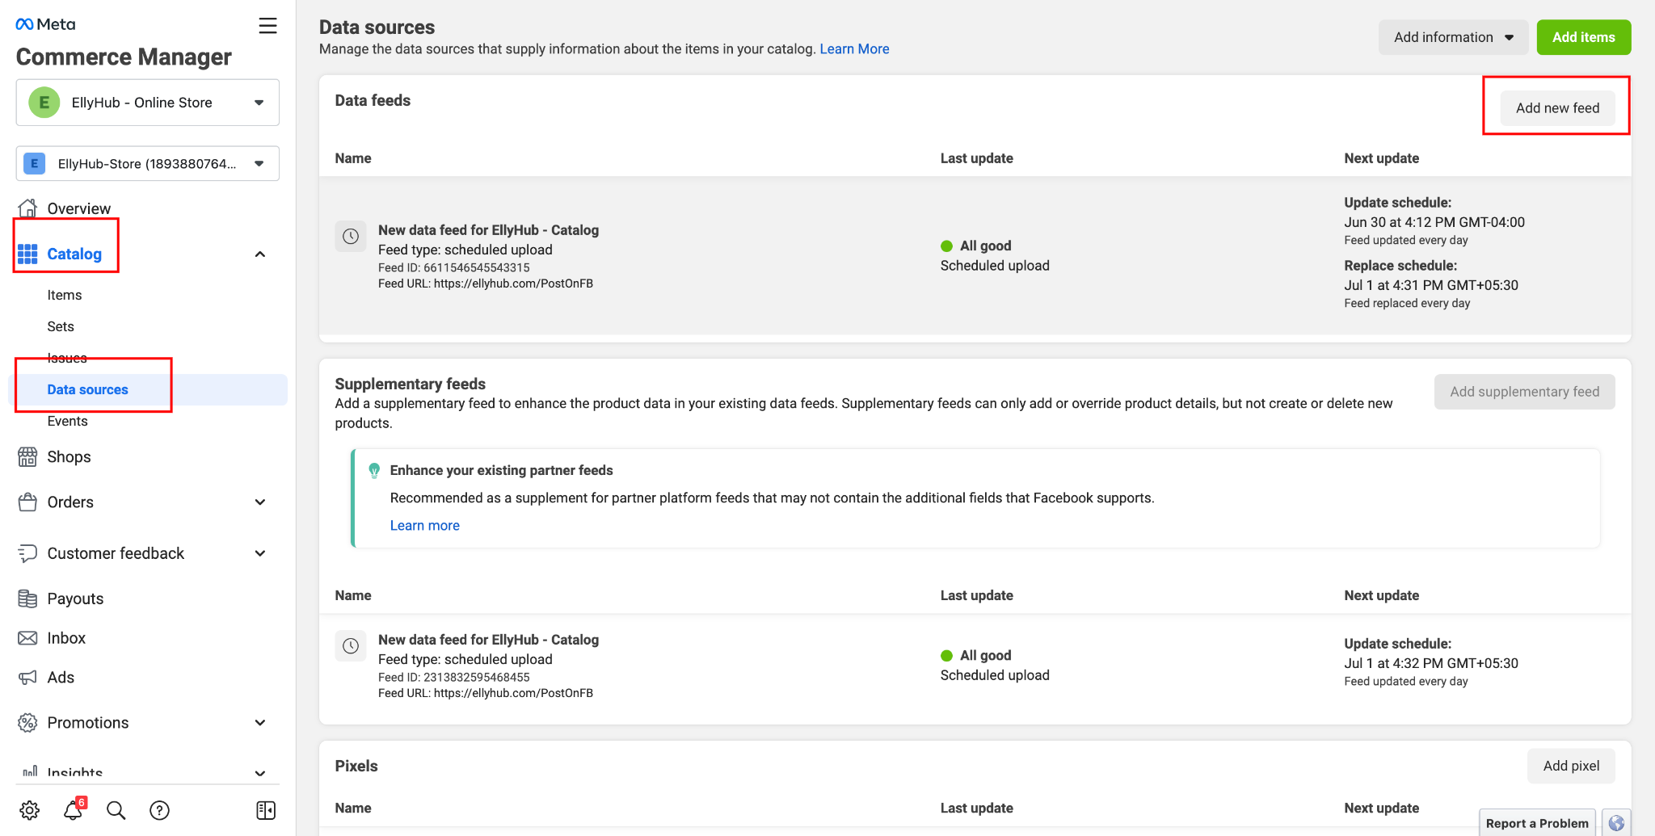

1. Choose Yes option for “Are you ready to upload your spreadsheet or file?”
2. Click on Next Button

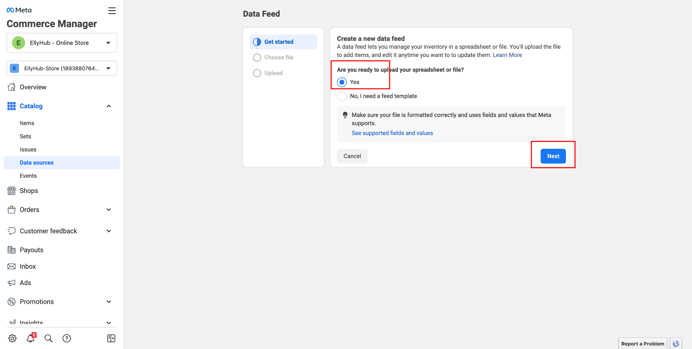

1. Choose “USE A URL” option
2. Enter the URL provided by us
3. Click on Next

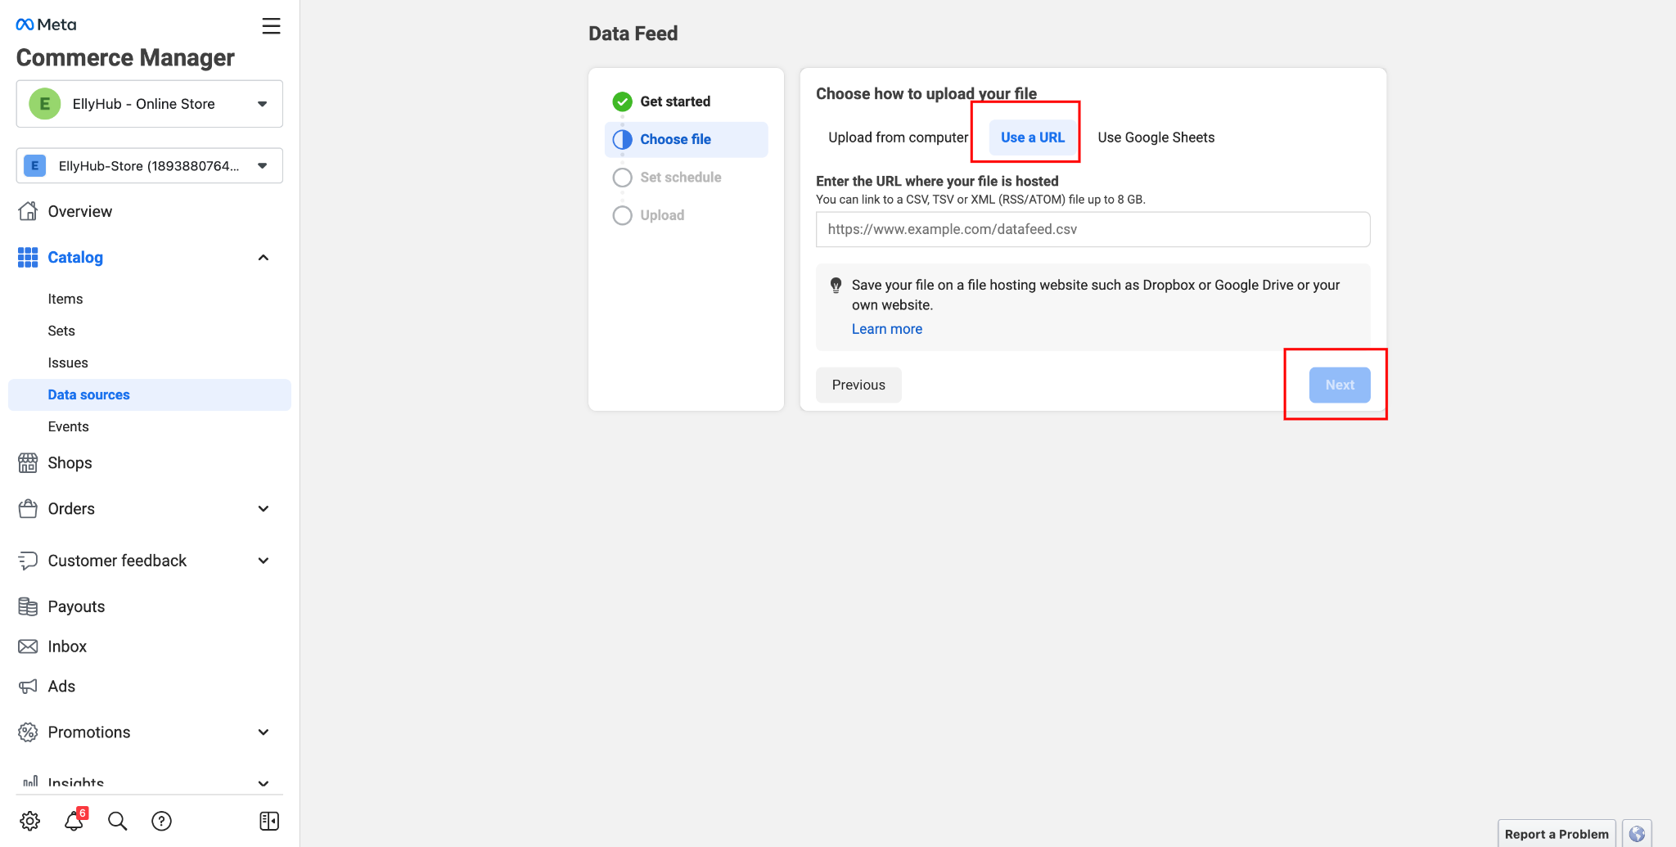

1. Choose the design update frequency, according to your product update cycle.
2. Click on Next Button

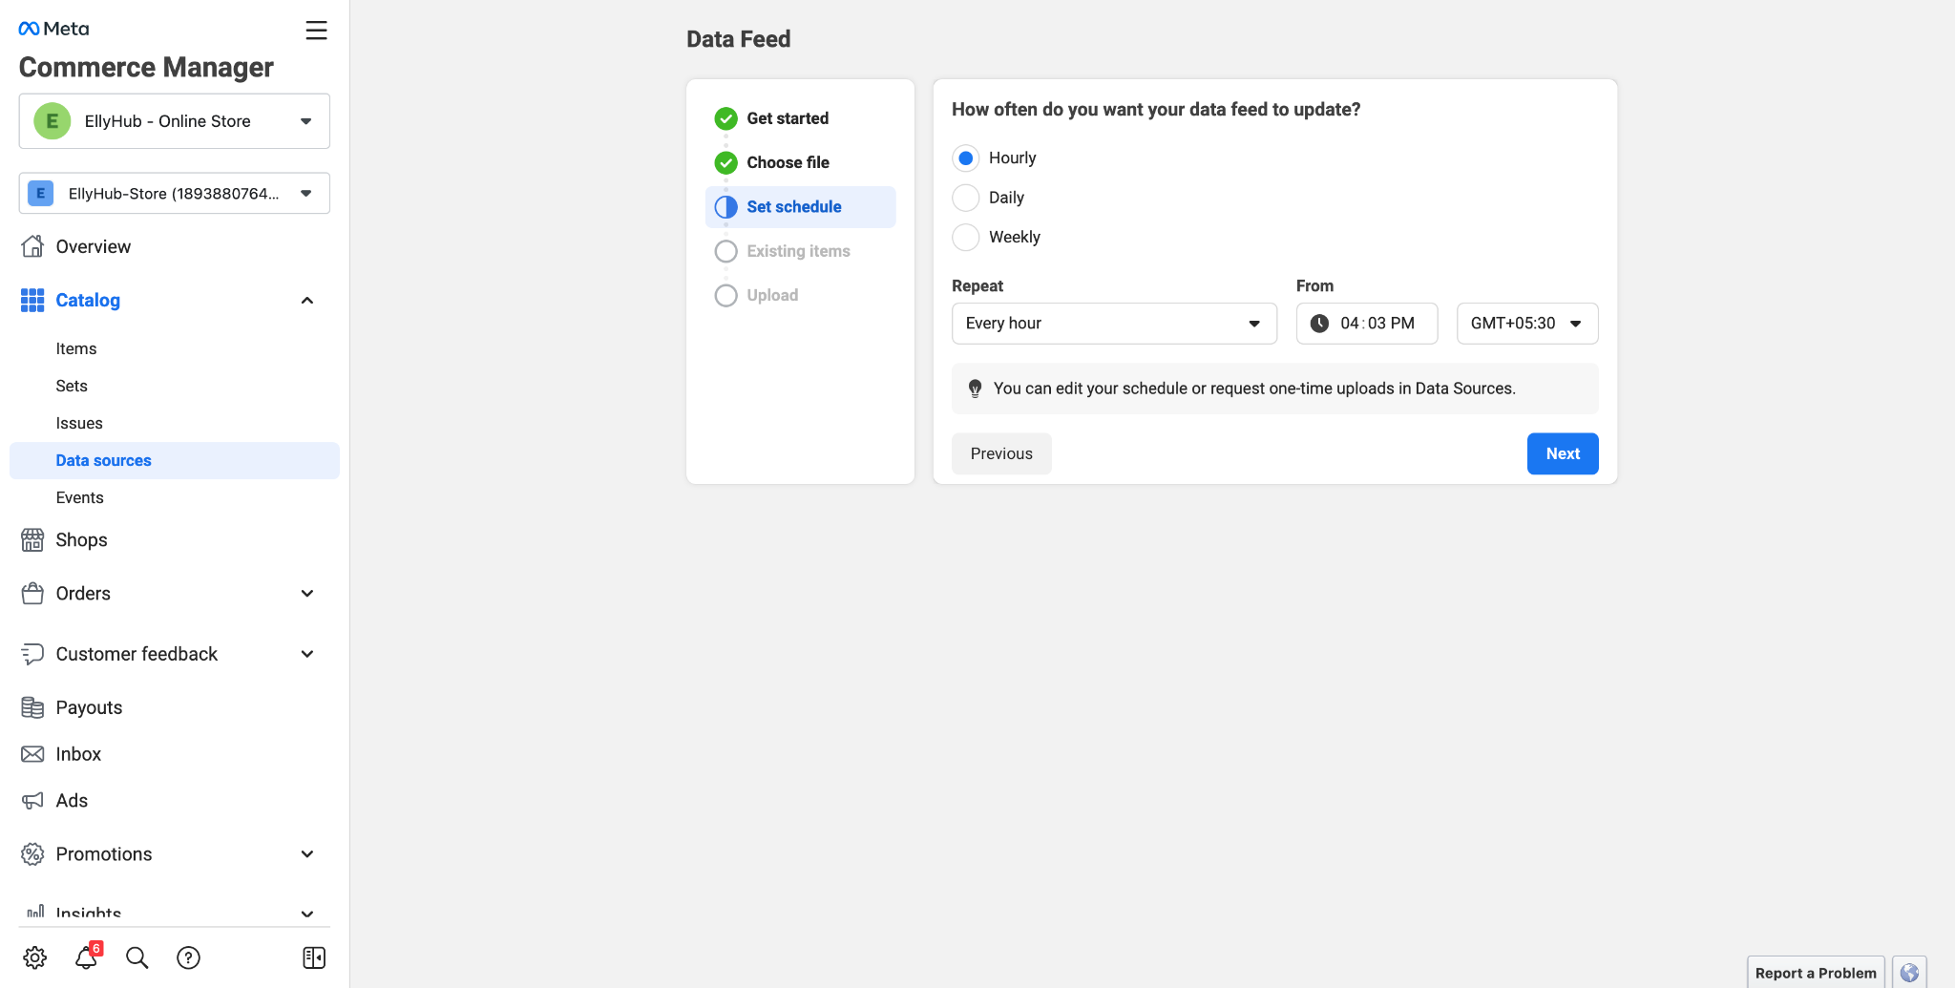

1. Choose how you want to import product
   1. Update existing data feed – It will update the product data, if you delete any product from admin, it will not deleted in FB
   2. Replace existing data feed - It will update the product data, if you delete any product from admin, it will also deleted from FB

