***Design opportunities from contextual user research***

**TABLE OF CONTENT**

**I. Introduction**

1.1. Package WP2 and D2.1

1.2. Research aim and questions

1.3. Scope of the research

1.4. Outline of the report

**II. Background**

… (Literature review from desk research)

**III. Method**

3.1. Data recollection

3.2. Sample definition ( table with participants)

3.3. Analysis and techniques

3.4. Ethics

**IV. Understanding networks**

4.1. Mapping the settings

4.2. High school learning context

4.3. Interaction design learning context

4.4. Engineering learning context

**V. Discussion**

5.1. Design opportunities

5.2. Next steps?!

References

Appendix

to decide: (A. Visualization of Learning Networks - infographic; B. Visual course timelines (advances version of what we had used as a tool to ask questions in Study1); C. A set of users profiles - high quality pictures of our interviewees, context, best quote)

**About this deliverable**

**I Introduction**

1.1. Package WP2 and D2.1

*Short description of the package and the deliverable*

1.2. Research aim and questions

*Holistic view of the ecosystem of actors, objects and materials.*

*Understand the aspects of learning environments and human actors and how they interact within and towards the external structures in the context of technologies and STEM learning.*

*How teaching and learning communities operate in the context of technologies and STEM learning?*

*Uncover the practices of actors in the learning they undertake, how they manage their roles in the learning process?*

1.3. Scope of the research

*addresses what? gap in research and literature for example*

1.4. Outline of the report

*short description of its content*

**II Background**

*- Literature review ( pelars paper) ?!*

**III Method**

3.1. Ethnographic approach revolving:

1) Semi structured interviews ( teachers from 4 countries)

2) Informal conversations with students ( students from Spain and Sweden)

3) Observations ( 4 countries)

4) Documents, videos, photos ( 4 countries)

3.2. Sample description ( number of interviews, participants, etc.)

3.3. Analytical technique and type of analysis definition , software used for coding

3.4. Ethics

**IV Understanding networks**

**4.1. Mapping the settings**

The network as a concept is quite compatible with the aim of ethnographic work to escape the concepts, categories, hierarchies. Hannerz (1992b) comments that "networks . . . can be seen to cut across more conventional units of analysis" (p. 40). Therefore, networks provide a way for developing an unconventional understanding of learning processes. It is a structure that can be constructed from the observable connections performed by participants.

The network is produced as a continuous space that does not presume proximity but implies connection. Continuity of a network is evident in the way that one point can (through one or more steps) connect to any other point.

The ecosystem of Technology and STEM learning contexts is defined by the constant interaction between human and non-human actors. This interaction constitutes the learning process and we have identified three main clusters of actors involved in that process across High school-level teaching, Post-secondary Interaction Design and Post-secondary Engineering contexts - People, Materials and Space. (See Fig. 1 "global map")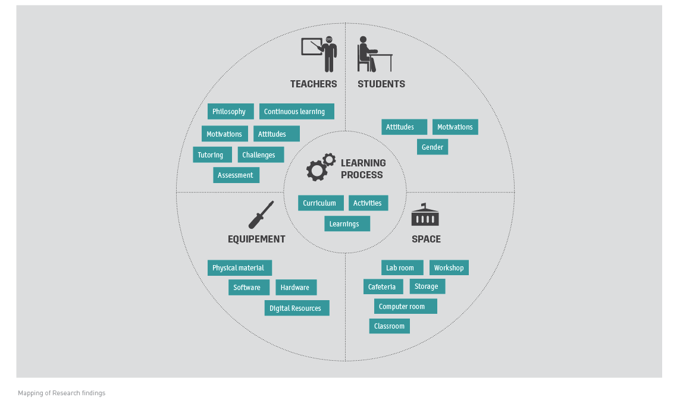

In what follows, explorative profiles of the three contexts are presented with their specific characteristics and the material is organized according to themes that have emerged from interviews and observations of the venues. As Marcus (1998) notes, ethnographic account is often a study of parts rather than wholes. Researchers cycle in and out of the field, skip certain areas entirely, and may rely on the recollections of participants in interviews to map out the space. Quotes from interviews are used to provide an insider's point of view (Van Maanen, 1988).

**4.2. High School learning context**

**HS CONCEPT MAP (on a separate page)**

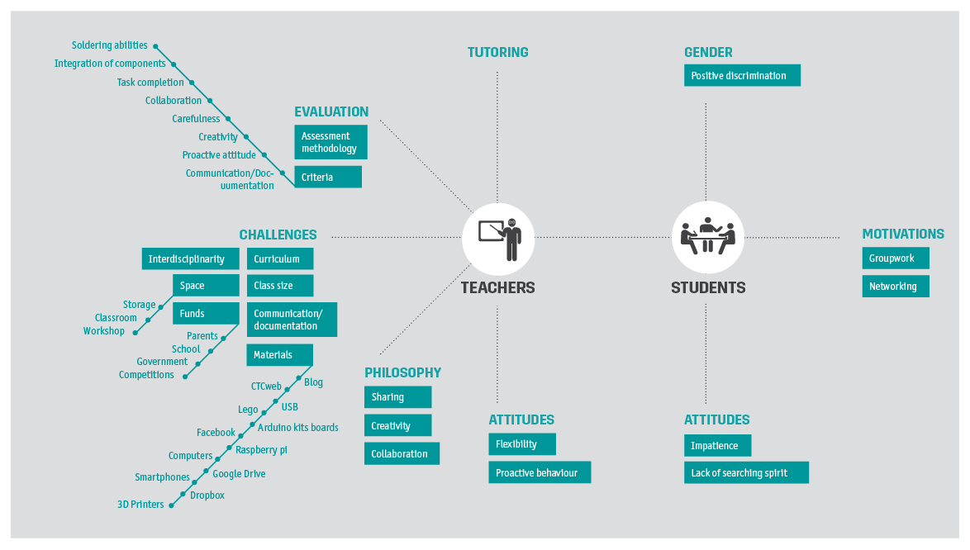4.2.1. Curriculum and learning activities

High school curriculum is usually structured and regulated by higher educational institutions and may vary depending on the country but project-based learning with programmable kits[1] is not yet a mainstream practice in Technology classes.

To get an overview of how project-based learning works in that environment and what kind of challenges faces, we have approached Spanish high schools that take part in the training program *Creative Technologies in the Classroom* (CTC), developed by Arduino for educational contexts and which have been implemented in several schools across not only Spain but also Sweden and Ecuador.

Participation in the program is voluntary and it depends on teachers' decision making and initiative. Currently, there are 100 teachers and 1200 students involved in it in Spain.

Traditionally, in 4th grade of Compulsory Secondary Education (CSE) in Spain, *Introduction to Robotics* is taught and the curriculum is divided in three main blocks: "a) Introduction to electronics (1st trimester), b) Robots (2nd trimester) and c) Modifications (3rd semester)" (HS_MJ). Students have 3 hours weekly distributed between 2h of classroom where they learn how to work with Picaxe and 1h of workshop.

Technology class is an optional subject, therefore its curriculum is not clearly established, especially in relation to workshops, according to teachers. This legal "hole" in the Spanish system allows integration of CTC program in the official curriculum of Technology in Spain, "in the official curriculum it is not considered what is the exact content of the workshops, so they can implement Arduino there" (HS_JV).

CTC program is focused on both Programming and Robotic topics but it is flexible and gives freedom to teachers to decide what to emphasize on. *"Each teacher does what he wants, if he likes programming he does more programming, etc" (HS_JV) . Its general aim is to " 'learn through success', to be able to do the stuff in 45 min., ... without necessarily know how everything works internally, can use it to make stuff" (HS_JV).*

Each teacher receives one kit for a class of 30 students divided in 6 groups. Along with the kit, the program offers technical support, platform for interaction and discussion among students and teachers and a website with all content. The platform is intended not only as a discussion board but also for documenting the process.

Teachers have 8 to 10 weeks to go through the content which consists of concept definitions and 30 experiments. The content is divided in blocks, one block per 2 weeks and each one contains at least 6 projects[2], supported by 1) instructional photos and tutorials, 2) list of materials to use and 3) video showing the final result. The program also considers the development of final projects in 6 weeks which students must build on their own starting with developing the idea. Final projects are considered by teachers the best part of the program as it is the only module where students can actually build an artifact without following instructions.

CTC program is heavily criticized by teachers for that reason and in their opinion it doesn't inspire proactive behavior, "that is one thing I don't like about the Arduino course, to work based on programs that are already done. Pedagogically it is not my philosophy. Let's see how it goes this year... I feel that if it works right away that's it, why should one try hard and find out how it actually works? That scares me a bit... "(HS_CC).

Despite the flexibility of its curriculum CTC experiments are often described as "copy and paste" activity which is considered by teachers an ineffective way of learning, "when you do it yourself, in a creative way, you feel more connected with your work. Which is what I am not so sure about the CTC (arduino) program." (HS_FJ)

Finally, a purely practical problem seen by teachers is the insufficiency of Arduino kits provided by the company. They believe that one kit per each pair of students or groups of 3, would be the best option for effective work in high schools with Arduino, “the problem is - depending what initiative we want to make - there is the problem of resources. [the ideal group for arduino is 2 or 3 students.](http://www.saturateapp.com/notebooks/1115/codings/new?paragraph_id=369696&sentence_index=1) so you need to have enough material.” (HS_FJ)

On the other hand, teachers inform that students often participate in extracurricular activities such as FIRST Lego League[3], an international competition for elementary and high school students. Each year a new challenge is announced that focuses on a real-world topic related to sciences. Students must design and program Lego Mindstorms robots to complete tasks and find solutions to various problems they are given. They meet for regional tournaments to share their knowledge, compare ideas and display robots.

Summer schools such as the one organized by Polytechnic University of Catalunya (UPC), seems to be popular among students in Barcelona too. Students spend a week at the automation lab of that university learning how to program.

**4.2.2 Teachers**

*Attitudes and philosophy*

Teachers try to solve all kind of problems related to the learning process with **flexibility** and **proactive** behavior. Often they supply more kits of their own and **redesign** not only CTC curriculum but official curriculum too, "the block is very static (it's a fixed curriculum), but we design and adjust things around this. We talk with each other and we also go to different courses or meet ups with teachers and we hear new ideas and tendencies, we participate in conferences, maker fairs, we go to citilab, fablab" (FJ,HS). This is done in order to fit students needs as sometimes teachers feel that students "just don't get anything" (Josep, HS). Simple tasks are considered to be more effective because "that's how students can see the evolution step by step" (Josep, HS).

Teachers find important to **inspire collaboration, knowledge exchange** **and team work** but also to guide students through the learning process in a **flexible and open way**, “we try to encourage the collaboration more than the competition. the good groups are easy to motivate and they just collaborate. The group of students which are not so good, there is a completely different way to motivate them - the competition. make them look at a ranking, compete, and they get crazy for getting first.“ (HS_FJ).

They do that by giving them the possibility to chose what kind of software to use, what topic to work on, showing them work of others but also acting transparent with them about grading: "they know about the rubric, the note is not hidden. The clearer they have it how the assessment works, the better. Later on they never protest because they know why they have received this grade." (HS_FJ)

Teachers act more like **advisors** and give students the freedom to find their own way of making things, "choice is totally free. Once they choose it, how they get to the result is their own way" (HS_FJ). They believe that freedom **inspires creativity and innovation,** "we try to consult them in the choice but try not to be very rigid in that type of structure, because if we oblige them to use a certain tool, there might be somebody who does not want it. if u give them more flexibility you allow more creativity."(HS_FJ).

*Tutoring and assessment*

Teachers are involved in two main activities - tutoring and evaluating students and these activities are influenced by their philosophy and attitudes.

Tutoring usually occurs in class and after class. Teachers are flexible with tutoring and react depending on the situation and the students' needs. There are different configurations when in class, "sometimes the teacher is in the front the students are around their tables, sometimes the teacher is moving around, sitting with one group or another. Sometimes everybody is gathered together at the back of the room playing with robots." (HS_FJ).

Teachers also give **examples** and make **demonstrations** in class as they believe it is stimulating for students to see the result of their work, "We have also the 3D printer (in 3rd[4]). We select the best designed objects and print them with it. We show them the process of preparing a file until it can get to the 3D printer. So they see, there is an object they have created, thought about, designed, and which they can afterwards have physical form its very motivating." (HS_FJ).

In terms of evaluation they consider not only the **final results (structure, integration of components, soldering abilities, task completion)** but also a set of soft skills such as **creativity, carefulness of work, collaboration, design, communication of progress/results and proactive attitude.**

Teachers consider the above mentioned criteria an integral part of the grade and not something supplementary to it, "they all need to make a bridge but each bridge is different. We are also grading the creativity, the carefulness of work, etc. and is part of the grade! it's not that it can enhance the grade, it is a part of it!" (HS_FJ).

Each teacher has his own assessment tool but performing evaluation on both hard and soft skills is common to all teachers. Different teachers have different assessment systems, some are using custom made assessment tables and others, use online teaching platforms such as <http://www.tecno12-18.com/> to support final grading. This particular platform is developed by a Spanish Technology teacher in 2001 and is widely known in Spain. The content is organized in didactic mini-units that treat specific aspects of the official Technology curriculum for CSE. Content is presented mostly as pictures, drawings and animations in order to make both learning and teaching process more attractive and easy. The platform allows teachers to do tests and teachers often use it as a supportive assessment tool.

On the other hand, custom made tables such as the table of a teacher from Torre de Palau High School, is composed by different sections for each element of the final product , "for the robot we have a table of rubrics, there are different elements of the robot which we evaluate. - how is the circuit solded? - how are the components integrated? - Is the structure well done?" (HS_FJ).

Also, there is a section to **measure communication and language** but also **creativity/collaboration** or **performance in class with others**, " I also put the class note - if they are collaborating, helping the others, which is also an item in the assessment table. there is also an item about the free design / creativity." (HS_FJ). Sections for such soft skills are filled in at the end of each trimester after continuous observation in class.

Communication of progress is usually measured by evaluating the quality of the documentation but most of the times, students face difficulties with written documents and teachers have to adapt relying on **verbal communication of progress in class** or **link/picture exchange**, "telling them to document stuff for 15 mins while others are tinkering or programming is difficult... what works better for us is the verbal communication, or peer to peer - exchanging links." (FJ, HS)

**4.2.3 Students**

*Attitudes*

According to teachers, students lack searching spirit and they are very impatient when it comes to watching long videos or document the advances of their work, "Here we have videos of the people that develop the software, but these videos are too long for them. They don't have patience for that." (HS_CC)

Students prefer to copy and follow an instruction, they feel more comfortable with the "trial and error" process, rather than relying on creative thinking, "now he is copying from the Germans. Copies from very good people and the best ones - he repeats them." (HS_JA)

Attitudes can serve knowledge function (Katz, 1960) and can be changed by experience and teachers try to accomplish this on a daily basis by stimulating and guiding them to find their own way of creating and expressing their work. The functional view of attitudes suggests that in order for attitudes to change, appeals must be made to the function(s) that a particular attitude serves for the individual.

*Motivations*

What seems to motivate students the most is an attractive and flexible curriculum which makes reference to their own interest, ”mentioning the video games is a trick to motivate them, not to see the curriculum as something strict” (HS_FJ )

Informal talks with students during observations have revealed that they feel motivated when "things can be used for something" (Student from Torre de Palau High school). In other words, they feel motivated when they see **technology as meaningful and useful** and **connected to the real world**. Teachers agree saying that "all things that are practical, useful and extrapolatable. When they understand this it's great. Also they have references - Steve Jobs, iPad, etc. so we say them we start like Steve Jobs or a popular game on the market - they want to do something similar - "(HS_JA)

During observations, students have shared that they enjoy **group work** because within a group they complement each other and "everybody knows something". Although some students think that groups of 5 are too big and they would prefer to participate ideally in groups of three.

**Networking** is another motivator for them and it is seen as a possibility to show other students their work and **reinforce their knowledge**, " we have noticed an incredible necessity of the students to "go out to the street" and show what they have done. Explaining to others what they have done, they a firming their knowledge." (HS_JA)

*Gender issues*

According to teachers, distribution in Technology and IT class is respectively 20-80% (girls-boys) and 40-60% (girls- boys) and has been a constant over the years. In terms of performance, teachers consider that girls are better than boys in Technology even if they are smaller in numbers, especially in *Bachillerato[5]*.

Teachers practice positive discrimination in order to encourage female participation in class and break schemes about science and technology as strictly male areas, "They all see this series - "Big bang theory", you see there freaky guys, as a girl you may think if you're going to do physics you are going to look horrible"(HS_M).

It seems that **girls** are more interested in topics related **to care or "stuff which can be useful"** (HS_J), "when they can see the technology that **helps people**"(HS_MJ) and less attracted to **abstract things** according to teachers.

**4.3.4 Class dynamics**

Classes involved in the current study, usually vary in size between 20 to 35 students per class. Students work in groups of 4/5. Observations have shown that discipline depends on **teachers' abilities** to keep students' interest but also **time management** and **organization** seem to be crucial.

Usually, teachers start the class with short explanation about what is going to happen in class and how the class will be organized. Depending on the activity, teachers show instructions on the blackboard or projector and then walk around during the session supervising the work of all groups one by one. They do several rounds, constantly interacting with students and to keep track on their progress and possible problems. ( some visual representation, perhaps some graphics with movements or class distribution?! here or in Space?!)

In the meantime students can ask questions and if teachers consider the answer relevant and useful for all students, they make a statement or write it on the blackboard. At the end of the class, students must return all kits and usually, it happens under the strict supervision of teachers.

**4.3.5 Space**

In high schools usually there are: 1)computer rooms, 2) workshops, 3) storage but sometimes regular classrooms are also used for Technology classes.

Space in general is small and furniture is old and often not so appropriate for Technology classes. Workshops are small too with no space between tables to move freely and sometimes cables hanging from the roof.

Tables are small and 4 or 5 people cannot fit around the same table. Usually students 1) split the group in two and sit around different tables which make them move around all the time in order to be able to work with the rest of the group or 2) they put together two tables when the space allows it. Chairs usually don't have back support or handles

**4.3.6 Materials**

Materials refer not only to physical objects but also to digital resources and software for teaching and learning. It was mentioned before that teachers are very flexible towards usage of tools and these can be very diverse in high schools. Although, there are some commonly used materials presented in the following graphic/...?!

ARDUINO KIT BOXES, LEGO, 3D PRINTER, MOBILE APPS WITH ARDUINO, SCRATCH, Moodle, Google Drive, BLOG, RASPBERRY PIE, projector, PICAXE, UBUNTU, CTC web, SMART PHONE, PICTURES, STUDENTS'LAPTOPS, LINK EXCHANGE, Dropbox, TEACHERS' WEBSITE

(Here, Cat can convert this list into something nice, like word cloud or something similar)

Teachers do a lot of **recycling** and try to use less perishable material. It is very common for teachers to offer their own blogs or websites as learning spaces but sometimes social networking sites like Facebook are used to support the class too. Link exchange and pictures are very popular way to document the progress and these are usually shared with teachers via Dropbox or Google Drive. Online tutorials are available for students at CTC web site or teachers websites/blogs.

**4.3.6 Challenges from user's perspective**

**Space and materials** are challenging quite often at high schools. Teachers report that there is not enough tables for students to fit into the workshop and sometimes there are only chairs to sit. Insufficiency of materials - not enough Arduino kits for students or missing Lego parts, is usually related to **lack of resources at schools**.

Challenging is also the size of the groups. Teachers think that groups of 5 are too big to work together, especially with Arduino because there are not enough work for all 5 students. Usually one is programming, another is building and the third is supposed to be documenting the process. Thus there are 2 more students without activity and it is challenging for teachers to keep them engaged.

Teaching students **how to document** seems to be also an issue as it is **the restricted High School curriculum** that doesn't allow teachers to experiment with different technologies, "we want to integrate Processing now in the 2nd of *bachillerato*. The problem in *bachillerato* is that it is very focused in the selected curriculum. So we don't have too much space to try out different technologies. This concept does not fit together with the innovation technology rhythm of today."(HS_FJ)

Finally, teachers believe that an **interdisciplinary approach** and **connection between different school departments** is necessary and useful but they still see it as impossible because of the lack of interest, "actually we have talked to the departments of visual arts and of performing arts in our schools to integrate the part of sensors and programming in their work but they do not want to participate." (HS_FJ)

**4.3. Interaction Design learning context**

**4.3.1 Curriculum, philosophy and outcomes**

Unlike high school context, Interaction Design education is defined by high degree of flexibility towards curriculum and learning activities. Often teachers have the freedom to make the content-oriented material decisions and thus, content and activities may highly vary from one school to another. For example, at MAH activities are designed as short lectures and lab sessions but at CIID instead of lectures, workshops about different concepts related to design are organized.

The main purpose of such approach is to give students a set of concepts about different aspects of the design process - research, documentation, computing, electronics, materials, design principles and let them experiment, "we don’t call our teaching lecture, but workshops, based on lab sessions. The aim is working hands-on, on content. You make something first, and then you learn from it. Not the other way around." (IxD_TO)

Interaction design education is seen by teachers more as an experience rather than a slow learning process. It is an intense and highly ambitious program where students must learn to be curious and "push themselves forward" (IxD_MH) by making things "and then you learn from it. Not the other way around" (IxD_MH)

Teachers believe not only in **learning by doing** but also in **knowledge exchange, sharing and collaboration**. In unison with the **openness of curriculum**, they try to inspire **creative thinking** by promoting **interaction and peer-to-peer learning** and making mistakes in the process as they believe that making mistakes is the way to learn things.

Thus, the most important outcomes of the learning process for future designers are to acquire a mind-set of a designer, that is to say to gain knowledge not only about materials, coding and prototyping but also to develop research skills, reflexivity, documentation skills and positive attitudes towards creativity and knowledge exchange and sharing by hands-on activities.

Especial emphasis is given to developing presentation and selling skills, "as a designer you have to elevate your skills at a level. Eventually you have to present something you're not proud of. But you still have to present it and to try to sell it." (IxD_TO).

Teaching students how to work in teams is also important and it is defined as intuitive process by teachers and they adopt different strategies when it comes to inspire group work, "case to case. Sometimes I split them up, sometimes I put together. "You laser cut, you weld, etc." (IxD_TO)

**4.3.2 Tutoring and assessment**

Thus, teachers' criteria for evaluation is a good presentation of the project where they measure students' abilities to reflect on their design process rather than evaluating the final object, "for us the object itself has very little value, unless you can prove that what you've made is good, and you do that by rationalizing your reasons behind." (IxD_TO)

In unison with the flexible spirit of Interaction design programs, assessment and tutoring is not so strictly regulated as in high schools. For that reason final presentation of projects plays an important role in Interaction design education and allows assessment not only by teachers but also critiques from peers and opinions of guests from other departments or companies that may have interest and have been invited on a presentation day.

Students work alone most of the times and usually tutoring by teachers is performed once a week and at the end of the project. Tutoring is also very flexible in terms of type of interaction. It may happens face to face or via Internet depending on the agreement between students and teachers. Observations and informal talks with students have shown that peer-to-peer tutoring is quite often event at the workshop while students are working on their projects.

**4.3.3 Attitudes and motivations**

Students are interested in doing technology that matters, "stuff that are useful for people" (Student from CIID). Working with others at the workshop could be frustrating sometimes for them as everybody can see their progress and they also tend to make comparisons. At the same time, students find this to be a motivator too as they can learn from other students' projects and progress.

Students can also adopt strategies to measure their own progress as was observed at the CIIID workshop. "Box of shame" is an excellent example of such self-regulated tutoring. It is a little storage box where students put all 3D printed failures just as a reminder of their errors and to motivate themselves to do better.

**4.3.4 Space**

*Appropriation and multiple uses*

In Interaction design context, space is an important part of the learning process and different places are used for multiple purposes. There are dedicated places for desk work/cabinets, workshops/lab rooms, storage but often informal places like cafeterias and lounge areas are also used as workplaces or to meet and exchange with peers and teachers.

Desks areas/cabinets are supposed to be used for desk research, programming or meetings but during observations we have noticed that workshop is also used for these activities along with regular hands-on activities such as soldering and prototyping/building. Especially when students are working on a prototype, they prefer to work simultaneously on the computer suggesting the necessity of a flexible and multifunctional environment. Also, workshops are used sometimes for lectures according to teachers.

*Co-working and self-regulation*

Observations have shown that desk areas are open spaces where sharing a desk is a usual practice. These places remind of co-working spaces where students can freely interact and make reunions to discuss their work.

Also, sometimes teachers and students share the same area in a non-hierarchical manner, "That's our desks. Quite flexibles. Alexander is sitting here and he's a student. He's good friend with Bo so he's using it as a shared desk." (IxD_MH).

Students are allowed to use workshops whenever they want without any kind of supervision. They can freely access the area and how is the workshop used depends on their own decisions. As everybody can access the space without previous notice, simple norms of usage and organization are necessary in order to keep the peace and not interfere with other students' work.

For example, at CIID workshop students have created a 3D printer queue (see Table...)

|  |  |  |  |  |
| --- | --- | --- | --- | --- |
| Let's take turns using the 3D printer! Please cross out your name & notify the person next in line when your print is done | | | | |
| Date | Time of queue | Name | Expected print time | Phone/E-mail contact (for texting, etc.) |

There are also notes on different boxes such as "Electronic trash" or "Only for stuff you would use later". These simple norms help student to organize materials but also to coordinate with others the usage of it.

**4.3.5 Materials**

*Reuse and recycle*

Access to materials is usually open and to reuse and recycle is a common practice for both teachers and students, "electronic trash box. This is where IT throw their stuff, and this is gold for us. I find a lot of great stuff. A computer that actually works etc." (IxD_TO)

Recycling is seen as a way to teach yourself how to use materials in a new, creative way, "you don't have to buy material, it's about the knowledge. You take something somebody discarded, and use that to teach yourself. That's why it's a teaching shelf. It's not something we use to teach, but that's where you can teach yourself about electronics, design..." (IxD_TO)

*Diversity*

Students have abundance of materials to work with at the workshops like dense foam, wood, Plexiglas but also micro-controllers, drone models and robot kits "from old projects to 50 drones to basic components like arduino boards, etc." (IxD_MH).

Laser cutter and 3D printer are also very popular at the workshop. Most commonly used software is CorelDraw for the laser cutter or Illustrator. There are also computers at the workshops but students used to work on their own laptops. Students have preferences for free wireframe tools for prototyping but also open-source office suites like Open Office. For presentations they use Keynote and PowerPoint. Taking pictures is the most popular way for documentation and sharing them happens via Dropbox. Google docs are mainly used for sharing code.

Teachers also try to educate students to use Internet as learning material and a source for inspiration at the same time, "we teach them how to use Internet as a material: finding the good blogs, other websites dedicated to making stuff, solely based on microelectronics & microprocessors" (IxD_TO).

*Facilitation and maintenance*

The job of the facilitator in Interaction design programs is usually to assist students when they need supplies or face problems with materials, This role could be assumed by professors implicitly, ¨maintenance: calibration. Mostly Mathias doing it. If it's software related, it's usually me or Johannes." (IxD_TO).

Sometimes, the facilitator is an individual who is contracted by the program especially for that purpose. In such cases, the person is in charge of the maintenance of both spaces and materials along with supporting students and teachers in their necessities. He remains neutral but at the same time necessary figure in the learning process.

**4.3.6 Challenges from user's perspective**

**Creating documentation** seems to be one of the main challenges for students in Interaction design programs and both teachers and students agree on that, "Tried making them write an instructable, document project, send us pictures, hand them out to everyone. It hasn't happened" (IxD_MH).

During observations, students have shared that not having someone to advise them on a daily basis is challenging for them too. When tutoring happens via Internet, they face difficulties not only because they miss face to face interaction but also because they are forced to document their progress.

According to teachers, when it comes to presenting the final project, students have problems with defining a framework and the lack of rigor is quite often issue too. There is also a certain tendency among students to define hypothesis that work instead of trying to define and defend an invalid ones.

On the other hand, students have stated that they miss more research and method background within the Interaction design programs but also philosophical questioning of the design process itself.

The diversity of students' background is another challenge that teachers face in this educational context. Students with humanities background as well as the "pure sciences" of non-applied mathematics for example, often show resistance to making things. Teachers attribute that behavior to the divide between theory and practice in different kinds of disciplines and students' comfort level regarding the making of mistakes or "wasting materials".

4.2.3. Engineering learning context

*Select photos to support description and analysis ( nice photos of materials, spaces and people)*

**V Design opportunities**

***Key findings / Research summary/*** (keep in mind tracking systems, education toolkits, curriculum )

*Curriculum*

After exploring the three educational contexts, we can summarize that the current project-based practice is built on open-ended activities with emphasis on collaboration, sharing and exchange. Even in cases such as High School learning context where curriculum is more fixed and restricted, teachers modify and adapt it suggesting the necessity for an open and flexible curriculum which allows teachers to design specific projects. Curriculum should allow alternation of short lectures/workshops with hands-on activities focused on useful and people-centered technologies.

*Space*

Space is essential for project-based activities too and current practices across the three contexts suggest that it should be multifunctional, support co-working and sharing, group work but also individual work and self-regulation in order to fit user`s needs.

*Materials*

Materials are also intrinsic part of the learning process and they are used for exchange/distribution, demonstration, prototyping and as learning resources and therefore can be adapted not only for teaching and learning but also for tracking and evaluating the learning progress.

*Learning activities and outcomes*

Learning outcomes include programming, circuiting, working with sensors, building/prototyping, soldering, documenting but also many "soft skills" which are considered crucial part of the learning activities. Such "soft skills" as collaboration, communication, language and reflexivity are difficult to track and assess but teachers adopt different strategies across contexts. From High school teachers, we have learned that performance in class is one way to assess collaboration and Interaction design teachers measure reflexivity and communication with final project presentations. Documentation is generally used to track communication of progress and language but creating it is challenging for learners and thus, often documentation adopt the form of picture/link exchange or verbal communication with teachers.

**Opportunity areas**

Given the findings from the contextual user study, we narrow down the following areas to be considered for the design of the PELARS learning analytic system. These areas are intended to provide designers with a starting point from which to generate new ideas. They are by no means mutually exclusive, and interweave and overlap in their focus and outcomes.

They aim to:

* Reframe needs
* Inspire innovative thinking

*Area 1: Tracking interaction between people and space*

When learners work alone or with a team on a project, it is challenging for teachers to be aware of what exactly students are doing even if teacher is physically present at the workshop. He cannot simultaneously supervise all learners but group by group and even so, it is difficult to observe which student is making progress or needs additional support individually. In the case of Interaction design programs where learners work alone at the workshop teachers don`t have understanding either of their activities and progress but rely on a weekly tutoring at best or distance tutoring which complicates sometimes even more what learners consider an appropriate guidance.

Therefore, providing information about what is happening at the workshop in real-time and in retrospective could support promptly intervention but also learners` self-regulation. This information could be also useful in providing understanding about successful activities and conditions and for assessment of learners` performance in class in terms of collaboration and engagement, especially for High School and Engineering (?!) educational contexts.

*Area 2: Self-tracking and recording learners progress (in real time and/or asynchronously?!)*

*Area 3: Tracking programming activities*

*Area 4: Tracking hands-on activities* (building, soldering, etc.)

**Design considerations**

*Group work and individual work*

In High School and Engineering educational contexts, learners often work in groups. High School learners work in groups of 4 or 5 but the optimal number considered for group work is 2-3. In Engineering education the size of the group may vary depending on the project(?!) In contrast to this, Interaction design projects are mostly individual.

*Collaboration, peer-to-peer learning and sharing*

Learners collaborate with others in both group work and individual projects. They exchange knowledge and learn from each other in the learning process. Learners also show preferences for digital tools for sharing pictures/links with peers and teachers.

*Documentation and presentation*

Documenting the work progress usually happens though pictures or verbal communication and presentations of final projects are an important part of the assessment process.

*Reflexivity and research*

Learners make use of online resources to do research across the three educational contexts involved in that study. Reflexivity about design decisions is especially important for assessment in Interaction design and Engineering education(?!)

***5.3 Next steps ?! ( prototyping, testing, etc.?!)***

***5.4 Conclusion/ Final remarks***

**References**

Katz, D., (1960). *"The Functional Approach to the Study of Attitudes".* Public Opinion Quarterly, 24 (2), pp. 163.

Marcus, G. (1998). *Ethnography through thick and thin.* New Jersey: Princeton University press.

Van Maanen, J. (1988). *Tales of the field: On writing ethnography*. Chicago and London: The University of Chicago Press.

1. see Deliverable 4.1 for more information on programmable kits
2. see http://bcn.verkstad.cc/es/ for detailed description of projects within CTC program
3. See <http://www.firstlegoleague.es/> for more details
4. Participant makes reference to 3rd grade of CSE
5. Spanish Bachillerato is the post-16 stage of education, comparable to the [A Levels](http://en.wikipedia.org/wiki/A_Levels) in the [UK](http://en.wikipedia.org/wiki/UK)