Factors impacting miles per gallon - a regression analysis

## Executive summary

Though there is a difference in fuel consumption between automatic cars, this difference is explained by automatic cars being heavier than manual cars. The impact of the type of transmission for cars of the same weight is neglible for the analysed cars. If one wants to maximize miles per gallon focus should be layed on decreasing the weight of the car.

## Data

I have explored the mtcars data set, which contains information on fuel consumption in miles per gallon (mpg) and 10 aspects of car design and performance for 32 car models. The dataset is described in the [R documentation](https://stat.ethz.ch/R-manual/R-devel/library/datasets/html/mtcars.html). All variables were treated as numerical values except the engine (V/S) and transmission (A/M) types.

## Exploratory analysis

I performed an exploratory analysis to investigate the properties of the data and get a first insight into what affects the fuel consumption and the differences between automatic and manual transmission.

At first glance (Figure 1), it seems that transmission type has a clear effect on the fuel consumption. But it is possible that this apparent connection is driven by other properties of the cars. Figure 2 shows the relationship between weight and MPG, it shows that fuel consumption for automatic cars (pink dots) is higher than that of manual cars, but we can also see that automatic cars tend to be heavier than manual cars. We can see from the weight histogram (Figure 3) that automatic cars are heavier than manual cars, with only a small overlap in weight.

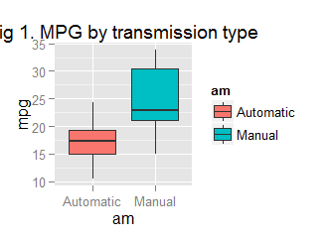

Taking this into account, automatic cars do not seem to have higher fuel consumption than manual cars of similar weight. The black line shows the result of fitting a linear regression model for mpg depending only on weight. This simple model seems to capture the patterns for both automatic and manual cars reasonably well, but are there other traits of the data that could tell us more about the mpg?

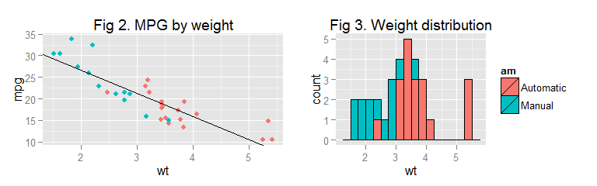

Figures 4-13 explore the relationship between the different variables and MPG. Based on these figures, I can not dismiss a relationship between any of them and MPG, but I can also not be sure of any relationships. Both number of cylinders and and engine type (V/S) (Figures 4-7) look related to mpg when looking at them alone, but when also considering weight, it is not so clear anymore.

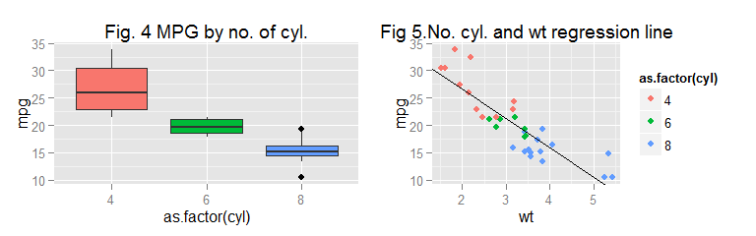

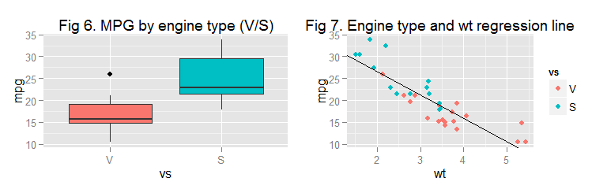

TFigures 8-13 explore the relationship between MPG and the variables displacement, horse power, read axle ratio, qsec, number of gears and number of carburetors. I have also computed the correlation between each variable and weight. Again, pink dots represent cars with automatic transmission and blue ones those with manual transmission.

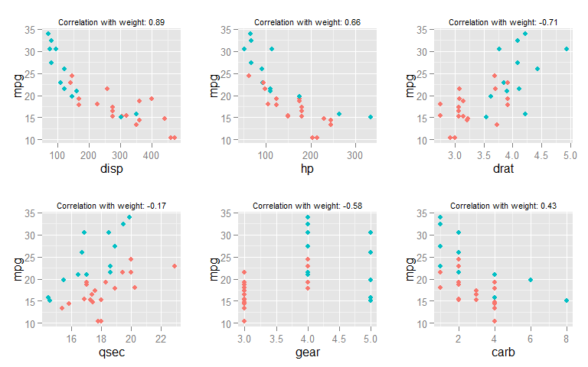

## Finding a representative model of the data

Based on the strong relationship between weight and MPG identified, I constructed a linear regression model of mpg depending on weight. This is the same model already used in the exploratory analysis, and as we saw in that section, it gives us a negative relationship (slope = -5) between the MPG and weight. The R-squared for this model is 0.75. We can interpret this as 'weight explains 75% of the variance of MPG in the data'.

I then investigated if the model could be improved by adding an interaction term between weight and transmission type. This model indicates that the relationship between weight and mpg is different between automatic and manual cars, with a stronger negative relationship for manual transmission cars. The R-squared now increases to 83% of variance explained.

Based on the results from the exploratory analysis I added the variable qsec, which was the variable with the lowest correlation with weight. In addition to this, I will construct a model that uses all variables.

Table 1 displays the R-squared for these 4 models as well as the p value generated by an anova analysis comparing the models.

|  |  |  |  |
| --- | --- | --- | --- |
| Model name | Included variables | R-squared (%) | PR(>F) |
| fit_wt | weight | 75 |
| fit_wt_am | weight * transmissiontype | 83 | 0.0026919 |
| fit_wt_am_qsec | weight * transmissiontype + qsec | 90 | 0.0019822 |
| fit_wt_am_all | weight * transmissiontype + all remaining variables | 90 | 0.9939286 |

We can see from this analysis that there is no evidence that including all variables gives us a more accurate model than the one we get when including only weight, transmission type and qsec. It can be noted that they both have an R-squared of 90%. Since both model number 3 and 4 explain the same amount of variance there is no reason to believe that adding more variables to the model would improve it and I will select model number 3. The coefficients for this model are:

|  |  |  |  |  |
| --- | --- | --- | --- | --- |
|  | Estimate | Std. Error | t value | Pr(>|t|) |
| (Intercept) | 9.723053 | 5.8990407 | 1.648243 | 0.1108925 |
| wt | -2.936531 | 0.6660253 | -4.409038 | 0.0001489 |
| amManual | 14.079428 | 3.4352512 | 4.098515 | 0.0003409 |
| qsec | 1.016974 | 0.2520152 | 4.035366 | 0.0004030 |
| wt:amManual | -4.141376 | 1.1968119 | -3.460340 | 0.0018086 |

Showing that a greater value of qsec (acceleration) will increase fuel consumption. As in model 2, we see that the connection between MPG and transmission type depends on the weight of the car. For automatic cars, MPG decreases with -2.94 for every 1000 lb increase in weight, and for manual cars MPG decreases with -7.08 for every 1000 lb increase.

## Difference in mpg between automatic and manual transmission cars

According to our model, the dependance of MPG on transmission type interacts with the weight of the cars. Due to this, it is difficult to determine the effect of only transmission. The 14.1 offset for manual transmission compared to automatic transmission only applies to cars with weight = 0, and so does not tell us much. For cars with weights within the span of the analysed cars the MPG values overlap each other.

Figure 14 illustrates this by plotting the dependence of weight for automatic and manual cars.

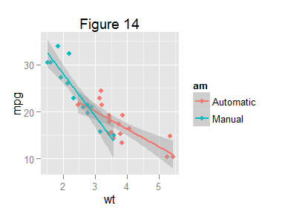

## Diagnostics of model

There is no obvious pattern in the residuals, so the model does not seem to be biased. There is no single data point that has an extreme influence on the model. All in all, the diagnostics indicate that this is a reliable model.

