Introduction to Kali Linux
Basic Commands
I executed several basic Linux commands in Kali Linux:
whoami
hostnamectl
uname -a
df -h
ip a
The commands displayed information about:
- logged in user
- operating system
- kernel version
- disk usage
- network configuration
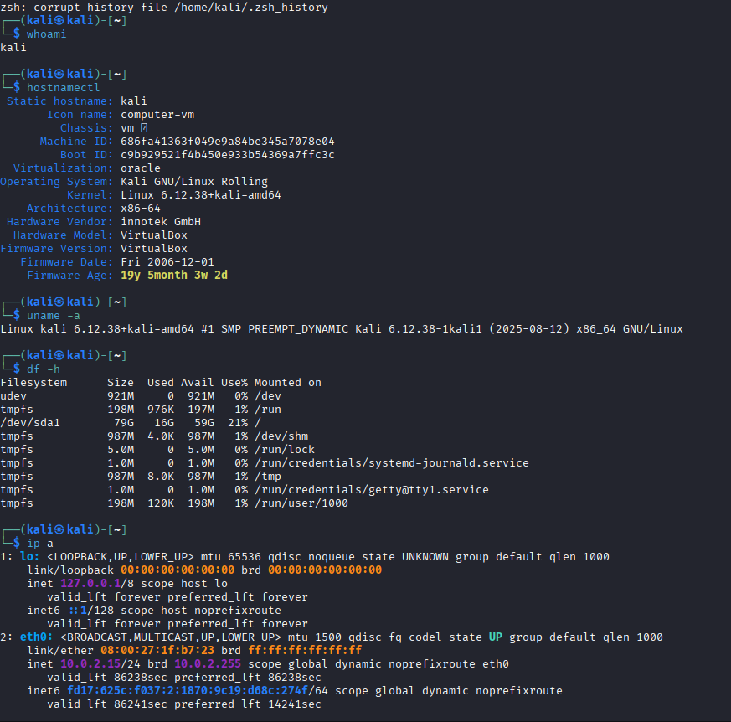

HTOP
I installed and tested the htop package.
sudo apt install htop -y
htop
HTOP displays running processes and system resource usage in real time.
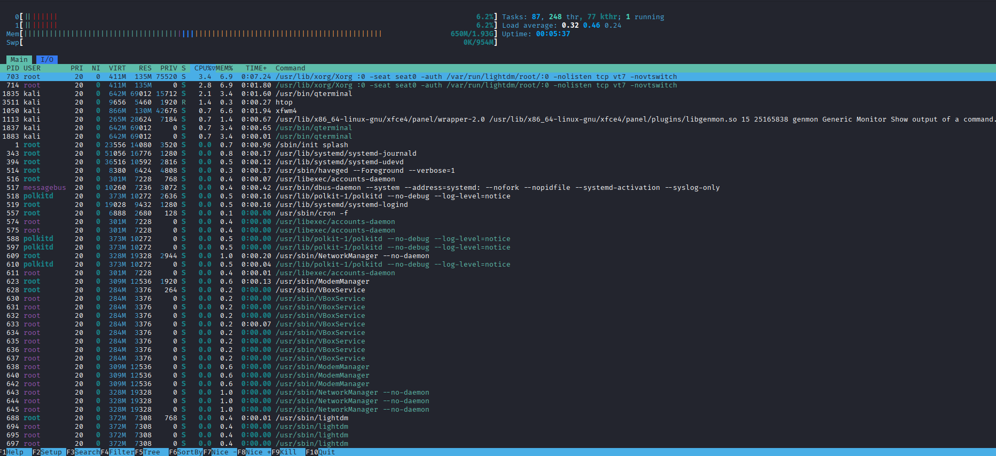

Traceroute
I tested network diagnostics using traceroute.
traceroute google.com
The command showed the route packets take through the network.
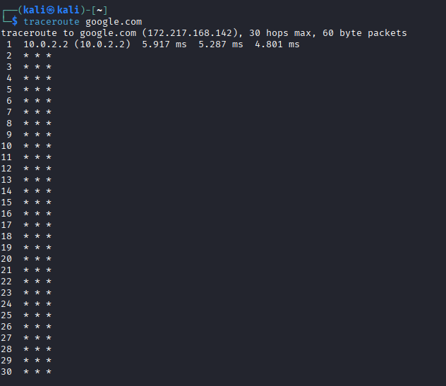

Nload
I tested the nload tool for monitoring network traffic.
nload
The tool graphically displayed incoming and outgoing traffic.
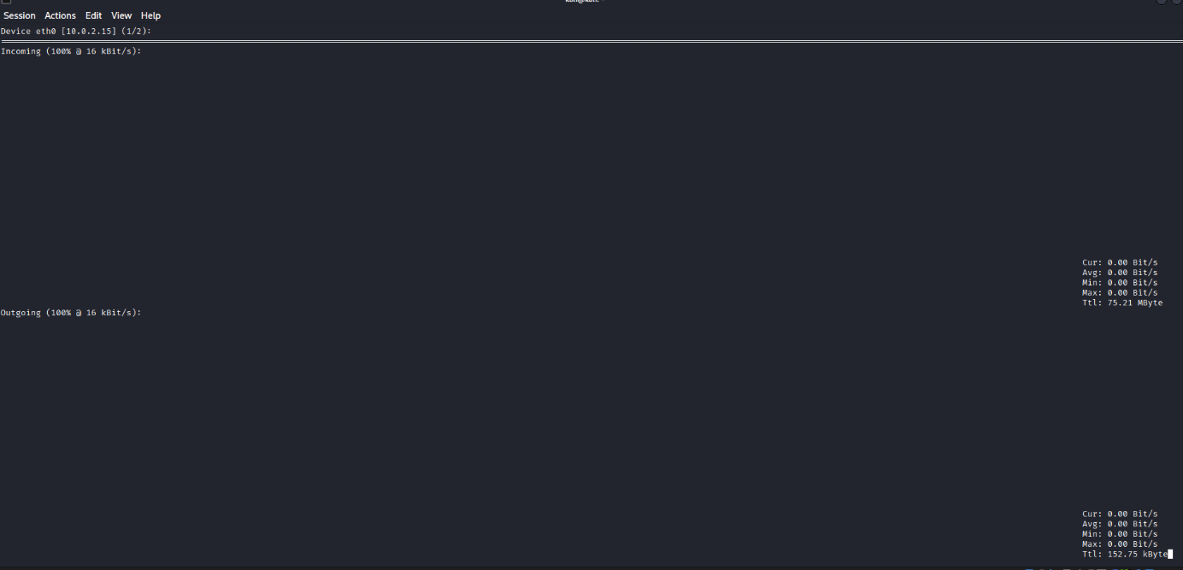

Searchsploit
I used Searchsploit to search for WordPress FTP vulnerabilities.
searchsploit wordpress ftp
The tool displayed several known vulnerabilities and exploits.
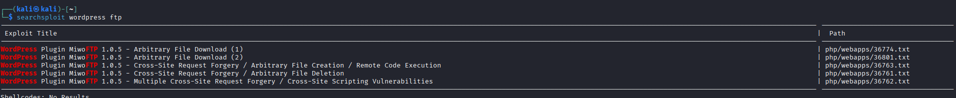

DNSenum
I tested DNS enumeration on the google.com domain.
dnsenum google.com
The tool displayed DNS records, mail servers, and nameservers.
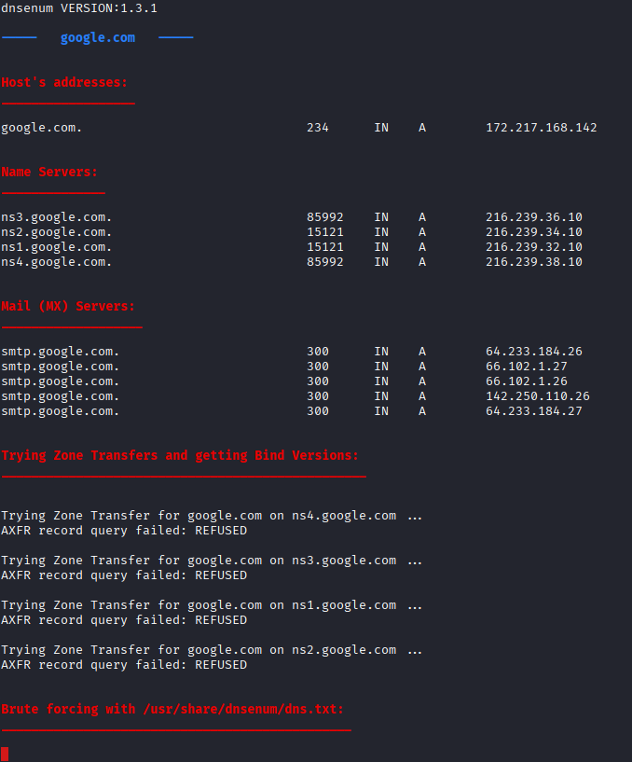

Name-That-Hash
I used the Name-That-Hash tool to identify a hash value.
nth -t ef487f75307f96954d3bb132e5f4b035
The tool identified the hash as most likely MD5/NTLM.

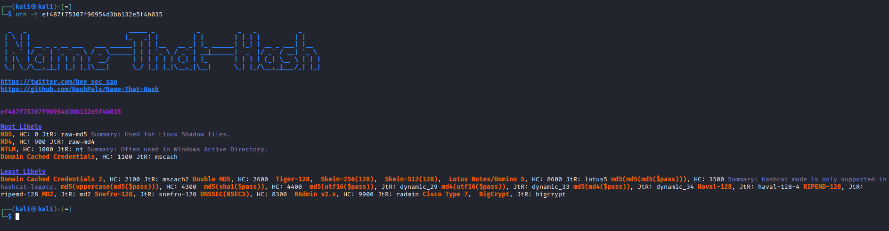

Reflection
Kali Linux is useful for cybersecurity testing because it contains many pre-installed security tools. The most interesting tools for me were HTOP, Searchsploit, and DNSenum.

